

Modul Profile Manager

MicroStep HDO s.r.o

júl 2025

Pracovné postupy

Content

Obsah 5

1. Aplikácia Profile Manager 11

1.1. Ako sa prihlásiť do aplikácie 11

1.2. Horná lišta aplikácie 12

1.3. Zmena farby hornej lišty aplikácie 16

1.4. Ako pridať na plochu okná prieskumník, tabuľka a graf 16

1.4.1. Pravidlá pre názvy okien 17

1.5. Ako sa odhlásiť z aplikácie 18

1.6. Ako zmeniť jazykovú verziu 19

1.7. Ako zmeniť predvolené nastavenia 19

1.8. Ako zobraziť profil prihláseného užívateľa 20

1.9. Globálny dátumový rozsah 21

1.9.1. Ako aplikovať dátumový filter vo vybranom okne 22

1.9.2. Ako aplikovať dátumový filter vo všetkých oknách naraz 23

1.10. Ako obnoviť viditeľné dáta 23

1.11. Všeobecné nastavenia 23

1.11.1. Globálne všeobecné nastavenia 23

1.11.2. Všeobecné nastavenia pre tabuľku 28

1.11.3. Všeobecné nastavenia pre graf 31

1.11.4. Všeobecné nastavenia pre prieskumník 33

1.12. Nastavenia pre sviatky 35

1.12.1. Ako vytvoriť profil pre sviatky 35

1.12.2. Ako vybrať profil pre sviatky 39

1.12.3. Ako odstrániť profil pre sviatky 40

1.13. Ako zobraziť informácie o statuse 40

1.14. Ako zobraziť upozornenia 41

1.15. Ako zväčšiť okno stromovej štruktúry 42

1.16. Synchronizácia panelov 44

1.16.1. Zarovnať časové rozsahy 44

1.16.2. Ako synchronizovať tabuľky 45

1.16.3. Ako synchronizovať grafy 47

1.17. Ako importovať, exportovať a ukladať zostavy 47

1.17.1. Ako importovať zostavu 48

1.17.2. Ako exportovať zostavu 50

1.17.3. Ako aktualizovať zostavu 50

1.17.4. Ako uložiť novú zostavu 52

1.17.5. Ako zarovnať zostavu do stĺpcov 54

1.17.6. Ako zarovnať zostavu do riadkov 56

1.17.7. Ako zarovnať všetko do jedného panelu 58

1.17.8. Ako rozdeliť zostavu do samostatných panelov 58

1.17.9. Ako nastaviť globálny časový rozsah pri zobrazení zostavy 59

1.17.10. Ako zatvoriť zostavu 61

1.18. Ako horizontálne zarovnať okná 62

1.19. Ako vertikálne zarovnať okná 63

1.20. Ako zobraziť a stiahnuť exporty 63

1.21. Ako zobraziť importy 65

1.22. Klávesové skratky 67

1.23. Ako vyhľadať profil v aplikácii 71

1.24. Informovanie užívateľa o odhlásení 71

1.25. Ako zobraziť čas, ktorý ostáva užívateľovi do odhlásenia 72

2. Práca s adresármi a profilmi 74

2.1. Ako pridať nový adresár 74

2.2. Ako premenovať adresár 76

2.3. Ako editovať adresár 77

2.4. Ako zmazať adresár 78

2.5. Ako kopírovať adresár 78

2.6. Ako vystrihnúť/presunúť adresár 79

2.7. Ako nahrať súbor 79

2.8. Ako zmazať dáta profilov 81

2.9. Ako filtrovať adresáre a profily 84

2.10. Ako zrušiť filter adresárov a profilov 85

2.11. Ako zobraziť komentáre 85

2.12. Ako zobraziť tooltip 86

2.13. Ako zobraziť charakter 88

2.14. Ako obnoviť zoznam 89

2.15. Ako nastaviť práva používateľov a skupín 89

2.16. Ako vytvoriť export 94

2.17. Ako vytvoriť import 98

2.18. Ako pridať nový profil 101

2.18.1. Ako zadať definíciu pre počítaný typ profilu 105

2.19. Ako pridať novú zostavu 112

2.20. Ako premenovať profil 113

2.21. Ako editovať profil 113

2.22. Ako zmazať profil 114

2.23. Ako zobraziť závislosti profilu 114

2.24. Ako vytvoriť nový profil 116

2.25. Ako nastaviť Politiku profilu 116

2.26. Ako zobraziť informácie o profile 117

2.27. Ako skopírovať profil 118

2.28. Ako vystrihnúť/presunúť profil 121

2.29. Ako zobraziť náhľad časovej rady v strome 122

2.30. Ako zväčšiť okno pre vytvorenie a úpravu počítaného profilu 123

2.31. Ako premiestniť okná 123

2.32. Ako premenovať dokument 124

3. Spoločné ovládacie prvky pre prieskumník, tabuľku a graf 125

3.1. Ako obnoviť dáta v oknách 125

3.2. Ako zmeniť dátumový rozsah 125

3.3. Ako zväčšiť okno cez celú plochu aplikácie 126

3.4. Ako zatvoriť okno 127

3.5. Nastavenie názvu a farby panelu 127

3.6. Ako exportovať zobrazené dáta z okna Prieskumník 129

3.7. Ako skryť horný panel s tlačidlami v okne prieskumník, tabuľka a graf 129

3.8. Ako pridať profil do grafu a tabuľky 130

4. Práca s oknom Prieskumník 132

4.1. Ako zobraziť profily z vybraného adresára v okne Prieskumník 132

4.2. Ako vytvoriť nový adresár 132

4.3. Ako synchronizovať prieskumník so stromom 132

4.4. Ako filtrovať profil 133

4.5. Ako zoradiť dáta v stĺpcoch 134

4.6. Ako vypočítať hodnoty v stĺpcoch Min, Max, Sum, Avg a Count v okne Prieskumník 134

4.7. Náhľad časovej rady 135

4.8. Ako presunúť profil z okna Prieskumník do okna Graf alebo Tabuľka 138

4.9. Ako upraviť pridať alebo odobrať stĺpce v okne Prieskumník 139

4.10. Ako upraviť polia Názov a Komentár 141

4.11. Funkcie pre prácu s adresármi v okne Prieskumník 141

4.12. Funkcie pre prácu s filtrami v okne Prieskumník 142

4.13. Tlačidlo Branch view 143

4.14. Ako zobraziť vymazané položky v okne Prieskumník 145

4.15. Ako skopírovať zobrazené dáta 146

4.16. Použiť ako východzie nastavenie Prieskumníka 148

4.17. Ako filtrovať v stĺpcoch pomocou * wildcard 149

5. Práca s grafom 152

5.1. Ako zobraziť profil v grafe 152

5.2. Ako zobraziť informačné okno s hodnotami pre konkrétne miesto v grafe 153

5.3. Ako zmeniť v grafe dátum od-do 155

5.4. Ako uložiť graf vo formáte JPG 155

5.5. Ako skopírovať celý graf do nového okna 155

5.6. Ako nastaviť parametre grafu 156

5.6.1. Ako nastaviť počet desatinných miest pre každú z Y-ových osí 158

5.6.2. Ako vypnúť vodorovné čiary 159

5.7. Funkcie pre prácu nad označenými profilmi 160

5.7.1. Ako vybrať profily 161

5.7.2. Ako zobraziť vlastnosti profilu 161

5.7.3. Ako zmeniť nastavenia označeným 162

5.7.4. Ako označiť všetky profily 164

5.7.5. Ako odznačiť všetky profily 165

5.7.6. Ako invertovať označené profily 166

5.7.7. Ako zobraziť len označené profily 167

5.7.8. Ako označené profily nezobrazovať 167

5.7.9. Ako odstrániť označené, všetky alebo chybné profily 168

5.7.10. Ako nastaviť koeficient označeným profilom 169

5.7.11. Ako nastaviť offset 171

5.7.12. Ako zobraziť štatistické čiary 172

5.7.13. Ako nahradiť text označeným 174

5.8. Funkcie pre prácu s jedným profilom 175

5.8.1. Ako upraviť nastavenia 176

5.8.2. Ako odstrániť profil 178

5.8.3. Ako presunúť profil na začiatok 179

5.8.4. Ako posunúť profil hore 180

5.8.5. Ako posunúť profil dole 181

5.8.6. Ako presunúť profil na koniec 181

5.8.7. Ako zobraziť komentár 182

5.8.8. Ako nájsť prvú hodnotu 183

5.8.9. Ako nájsť poslednú hodnotu 183

5.8.10. Ako zobraziť subprofily 184

5.8.11. Ako otvoriť umiestnenie profilu 185

5.8.12. Ako otvoriť info okno 187

5.8.13. Ako nastaviť koeficient 189

5.8.14. Ako zadať offset 190

5.8.15. Ako vymeniť profil 193

5.8.16. Ako editovať profil 194

5.8.17. Ako nastaviť farbu pre profil 196

5.8.18. Ako nastaviť veľkosť bodu 197

5.8.19. Ako zobraziť profil v tabuľke 201

5.9. Rýchla zmena typu grafu 203

5.10. Ako priblížiť vybranú časť grafu 205

5.11. Ako posúvať graf 206

5.12. Ako zrušiť zoom 207

5.13. Ako zobraziť/skryť legendu 207

5.14. Ako zobraziť/skryť tooltip 208

5.15. Ako nastaviť y-ovú os, aby bolo vidieť hodnoty 209

5.16. Ako vymeniť profil 211

6. Práca s tabuľkou 215

6.1. Ako zobraziť profil v tabuľke 215

6.2. Ako nastaviť stĺpcové zobrazenie 216

6.3. Ako prepnúť na jednoprofilové zobrazenie 217

6.4. Ako zmeniť časový formát zobrazenia 219

6.5. Ako nastaviť počet stĺpcov 219

6.6. Ako vybrať spôsob prevzorkovávania 221

6.7. Ako zobraziť prvú hodnotu 222

6.8. Ako zobraziť poslednú hodnotu 222

6.9. Ako zobraziť aktuálny deň 222

6.10. Ako zobraziť konkrétny dátum 223

6.11. Ako posúvať dátum o deň, týždeň, mesiac 224

6.12. Ako pridať stĺpec Suma, Priemer, Min, Max 225

6.13. Ako zapnúť/vypnúť tooltip 226

6.14. Ako zapnúť/vypnúť zvýraznenie riadku 227

6.15. Ako upraviť hodnotu profilu v tabuľke 228

6.16. Ako zmeniť definíciu profilu 229

6.17. Ako odstrániť profil z tabuľky 230

6.18. Ako zapnúť automatické nastavenie šírky stĺpcov 230

6.19. Ako otvoriť umiestnenie profilu 231

6.20. Ako pridať profil 232

6.21. Ako exportovať zobrazené dáta do CSV 235

6.22. Ako zmeniť definíciu 236

6.23. Ako zmeniť metadáta profilu 236

6.24. Ako odstrániť profil zo zobrazenia 238

6.25. Ako zobraziť profil v grafe 239

6.26. Ako nájsť pozíciu v grafe 240

6.27. Ako otvoriť profil v strome 241

6.28. Označiť blok pomocou ľavého tlačidla myši 241

6.29. Ako nastaviť, aby sa kurzor posúval v tabuľke pomocou kolieska myši 242

6.30. Ako zmeniť poradie profilov v tabuľke 244

7. Aritmetika počítaných profilov 247

7.1. Pravidlá prevzorkovávania 247

7.1.1. Pravidlá prevzorkovávania vstupného profilu na výstupný so zohľadnením charakteru 247

7.2. Počítaný profil 248

7.2.1. Spôsob zápisu výrazu 250

7.2.2. Vyčíslenie výrazu 250

7.2.3. Aritmetické operácie: 250

7.2.4. Funkcie 251

8. Príplatkové/doplnkové funkcie 262

8.1. Monitorovanie profilov 262

8.1.1. Ako vytvoriť nový monitorovací job 262

8.1.2. Ako editovať job v JMW 268

8.1.3. Ako zmazať job 269

8.1.4. Ako exportovať monitorovacie joby a výsledky jobov 269

8.1.5. Ako zobraziť všetky monitorovacie joby 270

8.1.6. Ako obnoviť zoznam jobov v okne „Monitoring“ 270

8.1.7. Ako zobraziť prehľad výsledkov monitorovacieho jobu 270

8.2. Analýza profilov 270

8.2.1. Ako vytvoriť analýzu profilov 271

8.2.2. Ako zobraziť existujúcu analýzu profilov 274

8.2.3. Ako zmeniť platnosť vytvorenej analýzy profilov 275

8.2.4. Ako exportovať zobrazené dáta v analýze profilov 275

8.3. Report Manager 276

8.3.1. Ako vytvoriť nový report 276

8.3.2. Práva pre Report Manager 283

8.4. Ako obnoviť vymazané položky z koša 284

# Application Profile Manager

"The 'Profile Manager' application is a tool serving for the presentation of profiles (time series) in graphical or table form as well as their basic management. A profile is an unbounded series of values of different significance. Documentation applies to version 4.3.301."

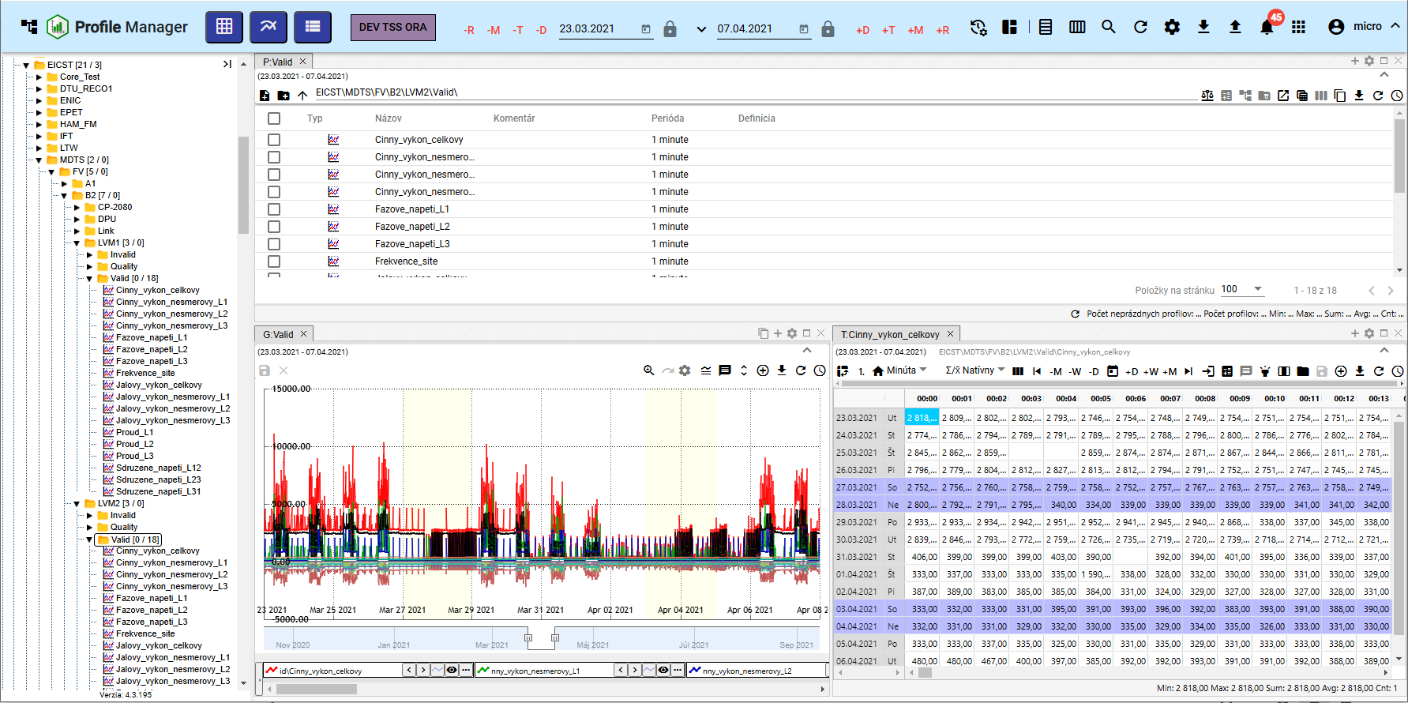

No valid translation found.

## I want to sign up for an application

No valid translation found.

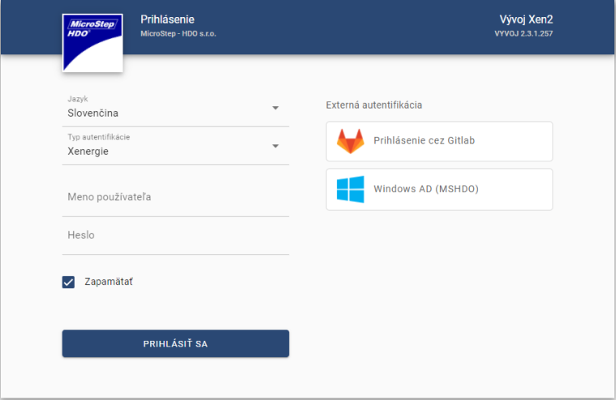

Image 2: Signing up for the application “Profile Manager”

## Upper list of applications

In the top menu bar of the application, you can find:

* "button that allows minimization and maximization of application menu"

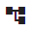

"Image 3: Button for hiding and displaying application menu"

* The name of the application is “Profile Manager” – after pressing a button, the application “Profile Manager” reloads itself.

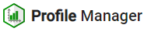

Image 4: Button "Profile Manager"

* "The button 'Add table' - by dragging the button to the screen, a window called 'Table' will be added."

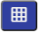

Picture 5: Button "Add table"

* The button "Add graph" serves for adding a "Graph" window to the application's workspace.



Picture 6: Add Graph Button

* "button 'Add Tracker' - by dragging the button to the application screen, you will add a window called 'Tracker'."



Picture 7: Add Spy Button

* The button representing the environment name - for the button, it is possible to set both the text and color.



Image 8: Environment title

* Global Date Range - represents a date filter, chapter 1.9



No valid translation found.

* The button "Sync panels" - allows to synchronize time ranges (1.16.1) and synchronize tables (1.16.2).



Picture 10: Sync button for panels

* No valid translation found.



Picture 11: Stay button

* "button for profile search - profile search is described in chapter 1.23"



"Picture 12: Button for searching profile"

* The "Refresh visible data" button - serves to refresh the data in the application, chapter 1.10



Picture 13: Refresh Visible Data Button

* "The 'Export' button contains an export list, chapter 1.20."



Image 14: Export button

* The button "Import" - contains the list of imports, chapter 1.21.



Image 15: Import button

* "The 'Alerts' button signals changes made to the application, Chapter 1.14"



Picture 16: Warning Button

* "Button to view the list of applications. Here is a list of applications for this environment. After clicking on an application in the list, the application will open in a new browser tab."



Image 17: Button for viewing list of applications

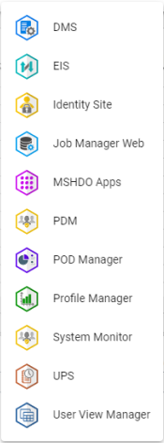

Image 18: List of applications

* No valid translation found.
  + Change language version of application, chapter 1.6.
  + Restore previously selected settings, chapter 1.7,
  + Display keyboard shortcuts,
  + Profile display, 1.8,"
  + "Displaying information about the state of the application and service, chapter 1.13,"
  + No valid translation found.

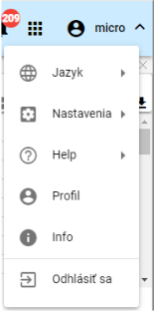

"Picture 19: Button with the name of registered user"

* "The 'Hide upper tool rail' button serves to hide the top rail. Subsequently, the appearance of the button changes and it is used for displaying the top tool rail. Figure 21."

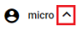

Picture 20: Hide upper tool bar button

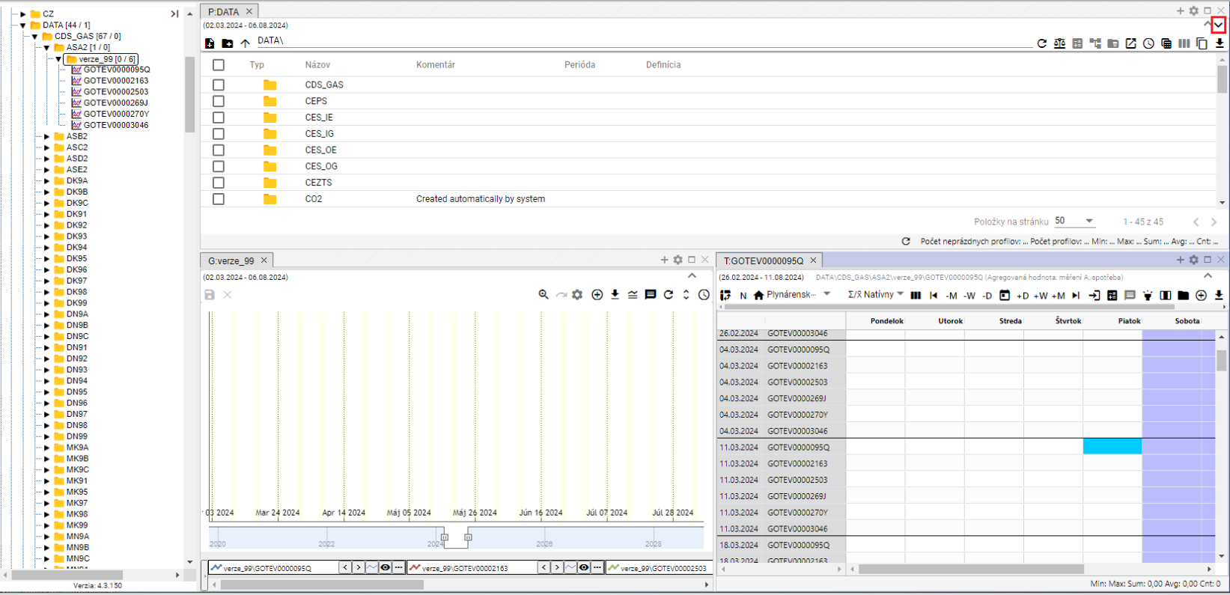

"Image 21: Button for displaying upper toolbar"



Picture 22: Application Top Bar

## Application color change (presumably referring to a user interface)

The customer may request a change of the top bar color of the tools. The change of the top bar color serves to differentiate between Development, Testing and Production environments.



"Image 23: Top row of application"

## To add to the window area a scanner, table and graph

"You can add as many widgets (such as explorer, table and graph) to the Profile Manager app's surface as you like. Proceed:"

1. "Click on the left mouse button and drag it to the application area."
2. Hold the button above the surface and move to where you want to add a window.
3. Choose the shape that the window should have.

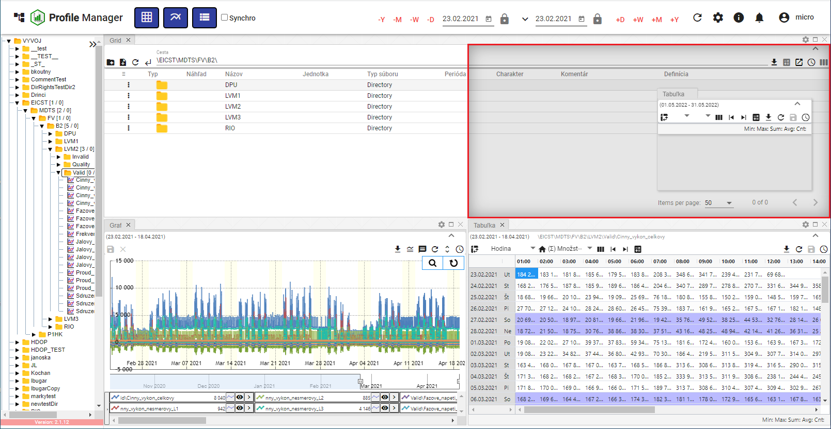

"Picture 24: Choice of window shape and location"

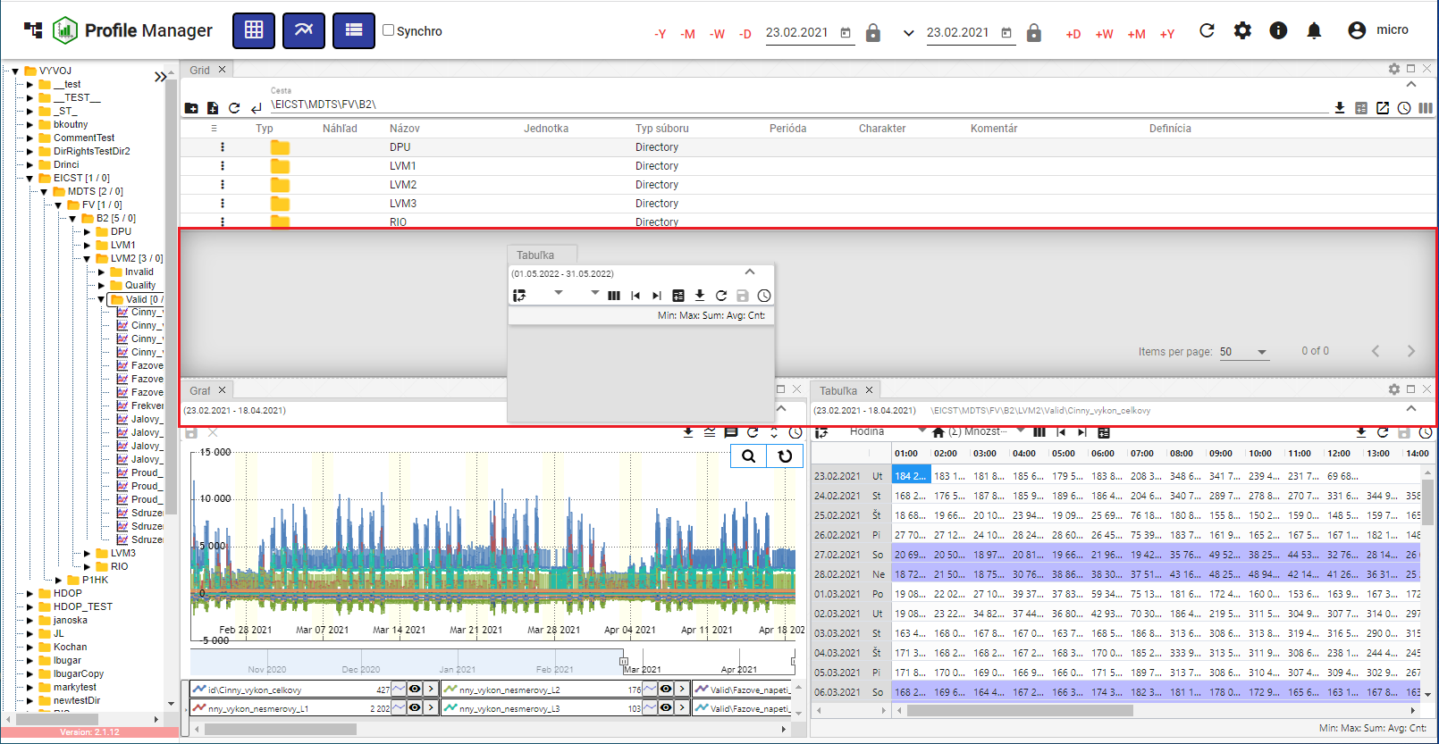

"Picture 25: Shape and positioning of a window table"

1. By clicking the button, a window will be added at the chosen location.

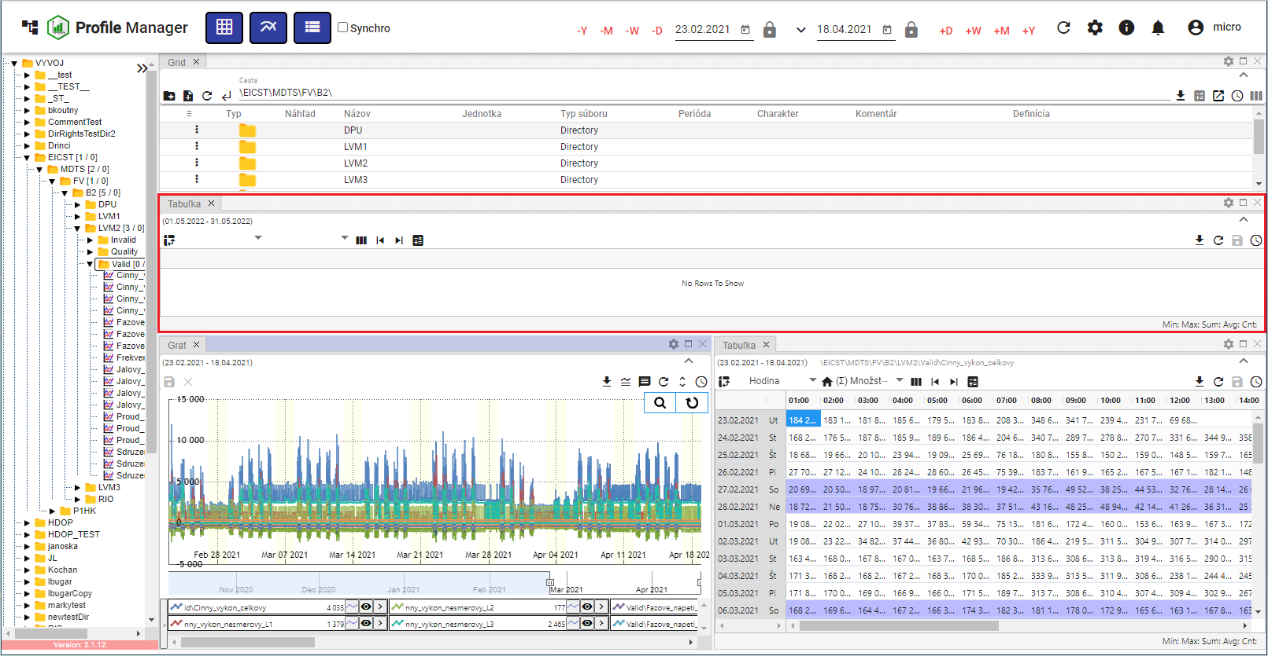

Picture 26: Added window table

### Window naming rules

"Window Explorer, Chart and Table are automatically called according to the following rules:"

Table

"The name for the table is 'T: <name of first profile in table>'."

Example: "T:ProfilHPFC"."

Chart

The title for the graph is "G: <name of first profile in graph>".

Example: "G:Profil HPFC"."

Explorer

No valid translation found.

Example: "P: AdressTest"."

In case of the addresser being root, then there will be the word "P:Root".

In English, the explorer has a name of "'E: <name of recipient where I am>'."

Example: "E:\Address TEST".

In case of an addresser being root, there would be the word "E:Root".

Explorer - Branch View

The Explorer - Branch view is named „B: <the name of the recipient in which the branch view was started>“.

Example: "B:\AddressTest". In the case of the root addresser, it will be named "B:\Root".

"For every change of profile or address, the corresponding window title will be adjusted. If the user enters a window title by clicking on it, from this time on, automatic setting will turn off and will no longer apply."

## I would like to log out of the application

"You will log out of the application by clicking on the user name button. A window will appear in which you click 'Log out'."

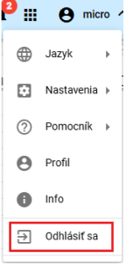

Image 27: Option "Log out"

## Change language version

"Before changing the language version, press the button with the name of the registered user and then set the cursor on the 'Language' option. In the displayed window, select the language version."

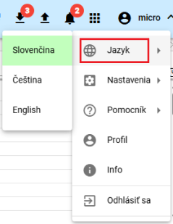

Picture 28: Change of language version

## How to change default settings

"Default settings in the 'Profile Manager' application will be restored as follows:"

1. Press the button with the name of the registered user.
2. Use the mouse pointer to navigate to the "Settings" point.
3. Press the button "Set preferred settings".

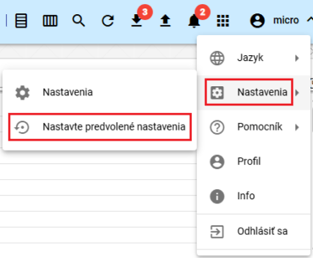

Picture 29: Item "Settings"

1. "A window will appear for confirmation, where you press the 'Yes' button."

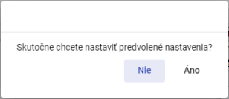

"Image 30: Confirmation for setting up of default settings"

## "Show profile of logged-in user"

Show profile of logged-in user

1. "Click on the button with the name of the registered user."
2. Click on the item "Profile".

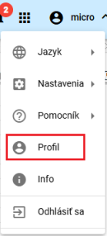

No valid translation found.

1. In the new tab of the browser, the profile of the registered user will be displayed in the "IdentitySite" application.

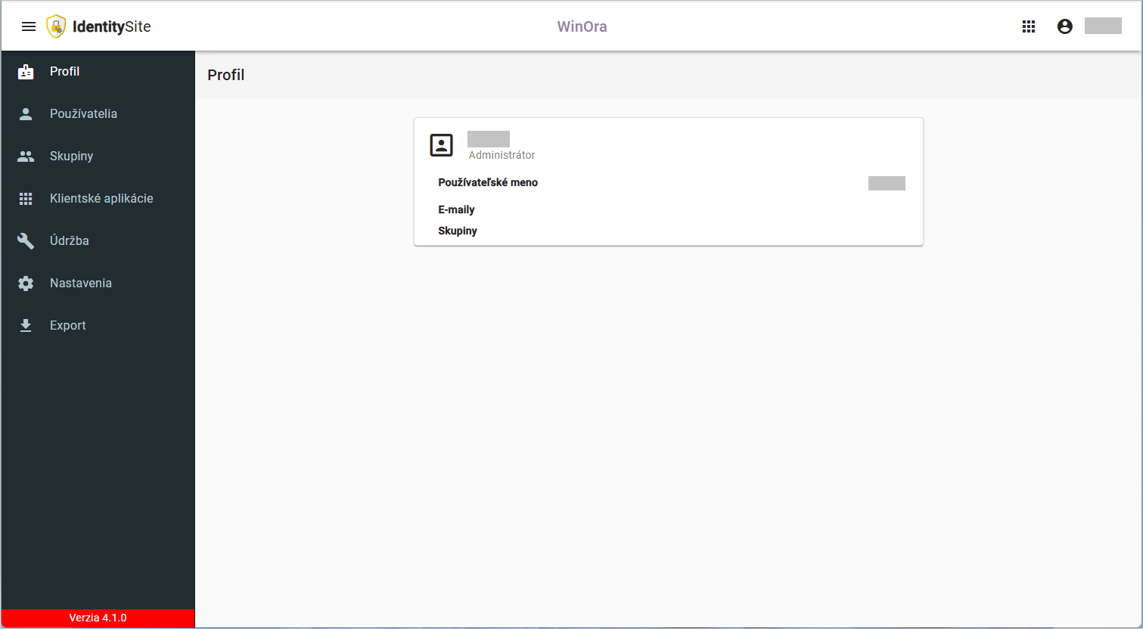

Picture 32: Profile of logged-in user in the application "IdentitySite"

## Global time range

The date filter is set to the current date.



"Image 33: Global Time Range"

By clicking on the button you will display the pre-set date range options, Figure 34.

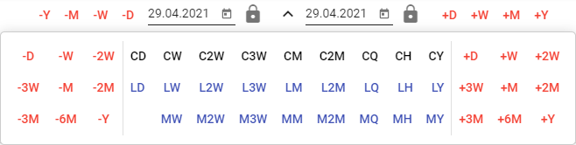

"Image 34: Default date range options"

You can lock the dates. When changing the date range, the locked date does not change.



Picture 35: Locking of date

### "How to apply date filter in selected window"

No valid translation found.

No valid translation found.

1. Mark the window where you want to apply the filter by clicking on the top part of the window, Picture 36.

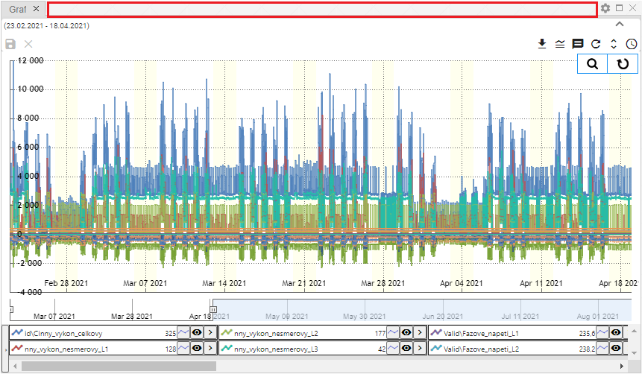

No valid translation found.

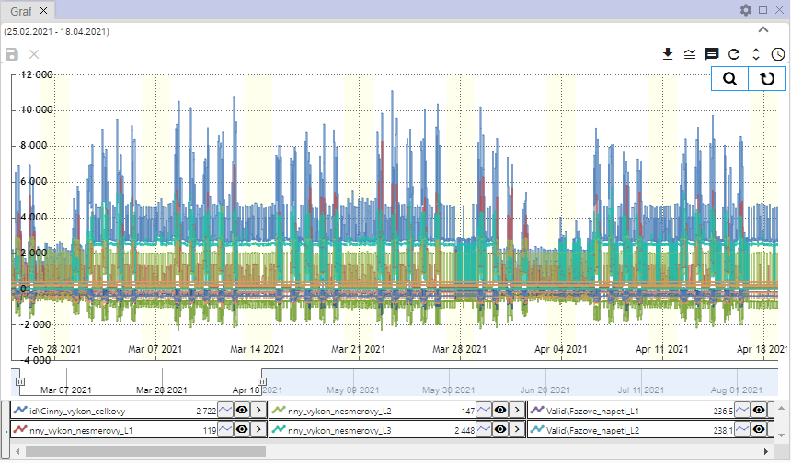

"Picture 37: Selected window for filtering"

1. In the topmost ribbon, select date filter.



"Image 38: Global Date Range"

1. "The data will be displayed in the designated window according to the selected date filter."

### I'm trying to apply a date filter on all windows and hitting a snag.

Follow:

1. Click on the "Sync" checkbox.



Image 39: Checkbox "Sync"

1. "Select one of the Explorer windows, Table, or Graph by clicking at the top of the window, Figure 36 and Figure 37."
2. Then enter a date filter in the top bar of the application.



Picture 40: Global Date Range

1. "The date filter is applied to all windows of the application."

## If I were able to restore visible data.

Press the "Refresh visible data" button, which is located in the top bar of the "Profile Manager" application, before synchronizing data.



Image 41: Restore visible data button

## General settings

"The 'General' tab in the 'Settings' window is divided into parts:"

* Global settings for the "Profile Manager" application,
* "Table – general settings for table,"
* General settings for graph,
* "Surveyor – general settings for surveyor."

"Individual settings are listed in the following subchapters."

### Global general settings

#### When to turn on automatic refresh after profile editing

"To restore data after saving, follow:"

1. "Click on the login user button located in the top menu of the application. Move your mouse cursor to the 'Settings' option and click on 'Settings' in the displayed window."

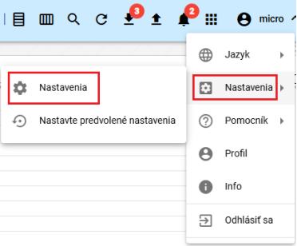

Image 42: Settings Item

1. "A window 'Settings' will be shown."
2. "In part 'General', click on the item 'Restore displayed data after saving'."

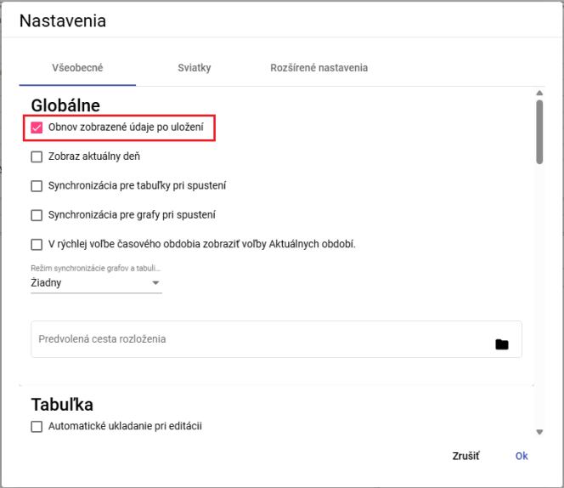

Picture 43: Reset displayed data after saving

1. Save changes by clicking on the "OK" button.

#### I will display new windows on current day

"If you want the new Explorer, Table and Graph windows to show up today, proceed:"

1. "Click the field 'Show current day' in the window 'Settings' in the tab 'General' in the part 'Global'. Picture 43."
2. Press the "OK" button to save changes.

#### I will synchronize time for boards

If you want to synchronize time for tables, proceed:

1. "Click the field 'Synchronization for tables on startup' in the 'Global' section of the tab 'General', in the window 'Settings', in the bookmark 'General'."
2. You will save changes by pressing the button “OK”.
3. "Then restart the application."
4. When you click the button for "Synchronization for tables at startup", it will also activate the button "Synchronize tables", 1.16.2.

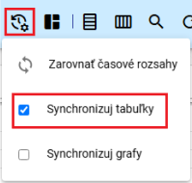

Picture 44: Pole "Sync tables"

1. The table will appear in the window with the text "SYNC".

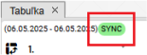

"Picture 45: In the table, the text 'SYNC' will be displayed"

#### Synchronize time for graphs

If you want to synchronize time for tables, proceed:

1. "Click the field 'Synchronization for graphs at startup' in the 'Global' section of the 'General' tab, in the 'Settings' window."
2. "Pressing the 'OK' button will save changes."
3. Restart the application afterwards.
4. When you click on the option "Synchronization for graphs at launch", the button "Sync graphs" will also be clicked, 1.16.3

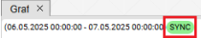

Picture 46: In the graph, the text "SYNC" will be displayed.

#### To turn on synchronization between chart and table

**[OLLAMA FORMATTING ERROR - MANUAL REVIEW NEEDED] Pre zapnutie synchronizácie medzi grafom a tabuľkou postupujte:**

1. In the "Settings" window in the "General" section of the "Global" tab, select an item from the "Synchronization mode for charts and tables" field. You can select:
   1. "Any synchronization between chart and table is turned off,"
   2. "start - synchronized with graph start,"
   3. Aligns with the middle of the graph.

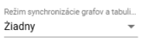

"Image 47: Synchronization Regime of Graphs and Tables"

1. "Changes will be saved by pressing the 'OK' button."
2. Restart the application afterwards.

#### "In a rapid choice of time period, showing the elections Current periods"

"In rapid time zone selection, elections for AR, AM, AT, AD will be displayed instead of +R, +M, +T, +D. Instead of -R, -M, -T, -D, MR, MM, MT, MD will be displayed."

Proceed:

1. Click on the tab "Show elections for current period" in quick view.
2. Save changes by pressing the "OK" button in the "Settings" window.
3. Restart the application. Then changes will be reflected in the application.



The image 48: Quick time selection

#### "To set up the path to the preferred layout"

The "Default layout path" pole serves to set the path to a saved profile of the "Profile Manager" application. Whenever the "Profile Manager" application is opened, the selected profile will be displayed.

No valid translation found.

1. In the "Settings" window, in the "General" section, of the "Global" tab, enter the path to your saved layout or click the button to show the "Layout selection" window, where you can search for your saved layout.

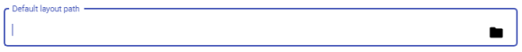

Image 49: Pole "Default layout path"

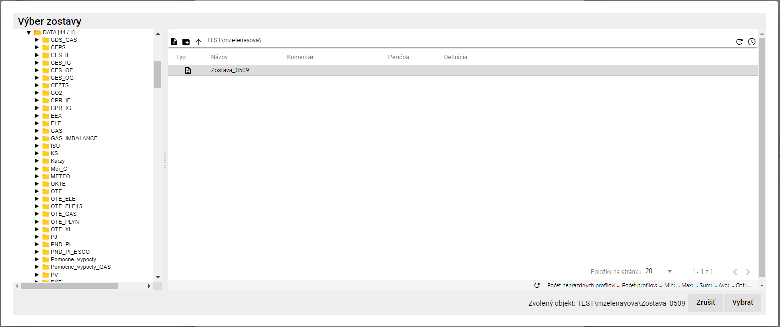

Picture 50: Team selection

1. In the window "Team selection", click on the button "Select".
2. "In the field 'Default layout path', there is a path to your selected set."



"Picture 51: Selected Team"

1. "Press the 'OK' button in the 'Settings' window before saving changes."

### General settings for the table

#### How to set up automatic saving of changes in a table

By setting up automatic saving in the table, changes made to the table are saved immediately. Proceed?

1. "In the 'Settings' window, under the tab 'General' in the section 'Table', click 'Automatic saving during editing'."

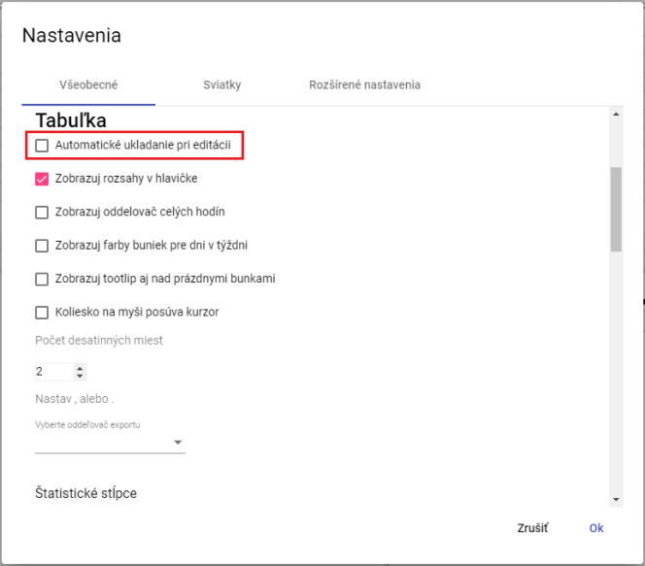

Image 52: Settings for table

1. "Save changes by pressing the 'OK' button."

#### "Show range in header for table"

You set the header range for window Tabuľka:

1. "In the 'Settings' window, in the 'General' tab of the 'Table' section, click on 'Show headers in the header', Picture 52."
2. Save changes by pressing the "OK" button.

#### "How to set whole hours separator for table"

"Displaying separator for whole hours on a Tab window you set:"

1. "Click on 'Show separator of whole hours' in the menu item 'Table' in the tab 'General' in the section 'Settings' in the window 'Adjustments'."
2. Press the "OK" button to save changes.

#### "How to set up color display for days of the week in a table"

You set up coloring of socks for days in the week:

1. "In the 'Settings' window in the 'General' tab of the 'Table' section, click 'Show cell colors for days of the week', Figure 52."
2. "Save changes by pressing the 'OK' button."

#### "To display tooltips even over empty cells in a table"

"Before setting up tooltips for display, proceed:"

1. "Click in the 'Settings' window in the 'General' tab of the 'Table' section, 'Show tooltips also over empty cells', Image 52."
2. Save changes by pressing the "OK" button.

#### "How to set up so that the wheel on the mouse moves the cursor"

"Moving the cursor through the mouse wheel will set:"

1. "Click on the option 'Wheel moves cursor' in the tab 'Table' in the bookmark 'General' in the panel 'Settings'."
2. Save changes by pressing the button "OK".

#### How to set decimal places in the table

"Before setting decimal places in the window Table, proceed:"

1. "In the 'Settings' tab in the 'General' bookmark of the 'Table' section, set the item 'Number of decimal places', Image 52."
2. Press the "OK" button to save changes.

#### "How do I set up an export delimiter for a table"

"Before setting up an exporter for a table, proceed with:"

1. In the "Settings" window in the "General" tab in the "Table" section of the "Choose export delimiter" field, select a delimiter.
2. Save changes by pressing the "OK" button.

#### "How do I set up used statistical columns in the table"

"Before setting up which statistical columns are to be used in the table, proceed:"

1. "In the 'Settings' window in the 'General' tab of the 'Table' section, select statistical columns to be used. You can choose columns for Sum, Average, Min and Max."

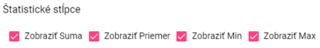

Picture 53: Statistical Columns

1. Save changes by pressing the "OK" button.

#### If I attach it on the right

"Adjust the alignment to the right in the table by:"

1. "Click on the field 'Show connection at right' in the section 'Table' under tab 'General' in menu item 'Settings'."



No valid translation found.

1. Save changes by pressing the "OK" button.

#### How to set default column widths of a table

"Before setting the default width of table columns, proceed:"

1. "If you want to set default values for column widths, click on the 'Use Default Values' field located in the 'General' tab within the 'Table' section of the 'Settings' window."

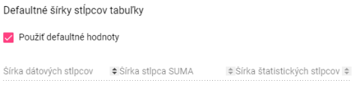

Image 55: Item "Use default values"

1. "If you want to set custom widths for columns, leave the 'Use default values' field unchecked. This will enable fields for setting column widths."

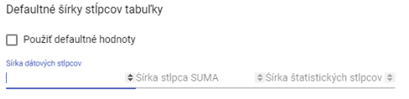

Picture 56: Tasking of one's own values for column widths

1. No valid translation found.

### General settings for graph

#### How to set standard line style of graph

The standard type of chart line can be "Line" or "Scatter Line". To set the standard line type, follow:

1. "In the 'Settings' window in the 'General' tab of the 'Graphs' section, you can select a standard line type."
2. No valid translation found.

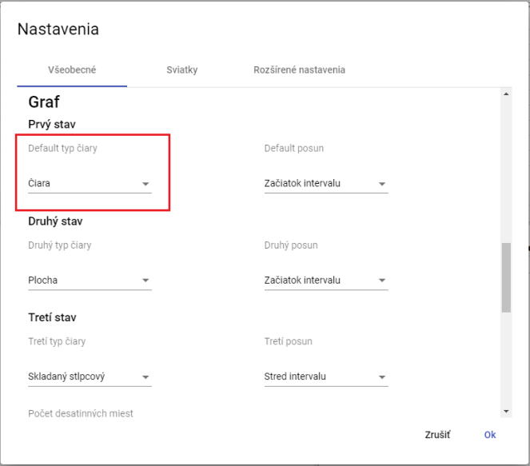

Image 57: Selection of standard line type for graph

1. "Changes will be saved by pressing the 'OK' button."

#### Set up second and third graph line type

"Before setting up the second and third line type proceed:"

1. "Click in the field 'Second line type' in the window that appears by clicking on the 'Settings' tab in the 'General' bookmark in the 'Chart' section."
2. "Before selecting the third line type click on the field 'Third Line Type', which will display a window where you select the line type."
3. Save changes by pressing the "OK" button.

#### To set standard shift, second and third shift for graph

No valid translation found.

1. "Click in the field 'Default offset' in the tab 'General' in the section 'Graph' of the menu item 'Settings' and select one of the options displayed."
2. In the game "Second Move" choose your move for the second move.
3. "In the village of 'Third Shift', choose the item for the third shift."
4. Save changes by pressing the "OK" button.

#### "How to set decimal places for graph"

Follow:

1. "In the tab 'Settings' in the bookmark 'General' in the section 'Graph' in the field 'Decimal places' enter the number of decimal places."
2. "Save changes by pressing the 'OK' button."

#### How to set display date start for line graph

No valid translation found.

1. "Click the 'Show start date of line' field in the 'General' tab in the 'Chart' section."
2. Save changes by pressing the "OK" button.

#### How to display current time

Proceed with it.

1. "In the 'Settings' window in the 'General' tab of the 'Graph' section, click on the 'Show current time' field."
2. Save changes by pressing the "OK" button.

#### "How to turn off zoom by clicking to the left"

No valid translation found.

Proceed:

1. "Click the 'Zoom out' box by left-clicking in the window 'Settings' in the tab 'General' in the part 'Chart'."
2. "Changes will be saved by pressing the 'OK' button."

#### "If configured to do so, it automatically switches to scroll when zoomed"

"The field 'Automatically switch to pan after zooming' means that if you click on the 'Switch to zoom' button in the graph window, the zoom function will automatically switch to pan mode when a location is magnified. If the field 'Automatically switch to pan after zooming' is not checked, the zoom function will run until it is cancelled."

Proceed:

1. "In the 'Settings' window, in the 'General' tab of the 'Graph' section, click on the field 'Automatically switch to zoom out'."
2. You will save changes by pressing the button „OK“.

### General settings for explorer

#### "Set decimal places in Finder window"

"Before statistics in the window Prieskumník you can set the number of decimal places according to the following procedure:"

1. "In the tab 'Settings' in the bookmark 'General' at the bottom of the window 'Settings' within the part 'Explorer', set the number of decimal places."

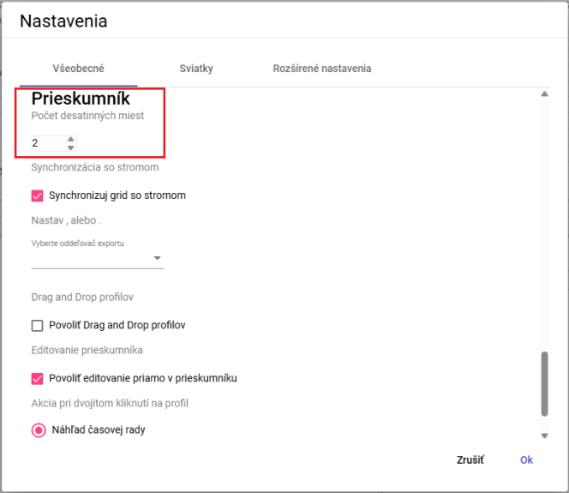

Image 58: Task - count decimal places in a window explorer

1. You will save changes by pressing the "OK" button.
2. "In the window Explorer will statistics be displayed with the specified number of decimal places."

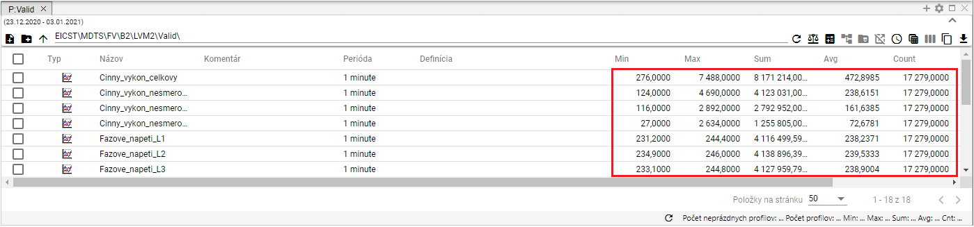

"Image 59: Selected decimal places in the Explorer window"

#### I synchronize the Explorer window with the tree

Before synchronizing the probe with the tree, proceed with:

1. "In the bottom part of the window 'Settings' in the tab 'General' in the section 'Explorer', click the field 'Sync grid with tree'."
2. "Save changes by pressing the 'OK' button."

#### "How do I set up an export separator for the Explorer"

Before setting up the exporter for an inspector follow:

1. In the lower part of the "Settings" window in the tab "General" in the section "Explorer", there is a field called "Select export delimiter", where you can choose either a dot or an underscore as the delimiter.
2. "Save changes by pressing the "OK" button."

#### "Enable functionality Drag and drop for profiles"

Before enabling the function "Drag and drop profiles", proceed:

1. "Click the 'Drag and drop profiles' field in the 'Explorer' section of the 'General' tab in the lower part of the window labelled 'Settings'."
2. "Save changes by pressing the 'OK' button."

#### "Allow editing directly in the Explorer window"

"The entry 'Enable editing directly in the inspector' is normally active. It allows you to edit fields 'Name', 'Comment', and 'Definition' directly in the Inspector window."

"Before disabling the function, proceed:"

1. No valid translation found.
2. "Save changes by pressing the 'OK' button."

#### "How to choose an action for double-clicking on profile"

"After double-clicking on the profile, you can select an action that will be triggered. Follow:"

1. "In the bottom part of the window 'Settings', in the tab 'General' in the section 'Safari', select one of the three actions."

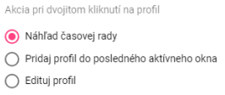

"Picture 60: Selection of stock for double-clicking on profile"

1. Save changes by pressing the "OK" button.

## Christmas preparations

### How to create a profile for holidays

"This profile allows you to display holidays in all profiles. To create a holiday, you need to have a created holiday profile, Image 61, where on the days when it is a holiday you enter the value 1 and on the days when it's not, the value NaN. Create a holiday profile with a period of DAY."

No valid translation found.

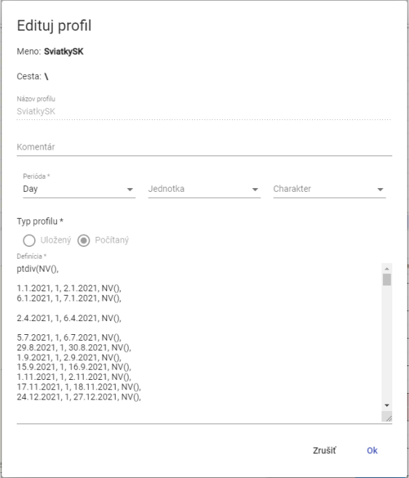

Image 61: Example definition of a festive profile

You will create a profile for holidays:

1. "Click on the 'Logged in user' button located at the top bar of the application. Using your mouse cursor, navigate to the item 'Settings', and within the displayed window, click on the item 'Settings', Image 42."
2. "A window titled 'Settings' will appear, where you click on the tab 'Holidays'."

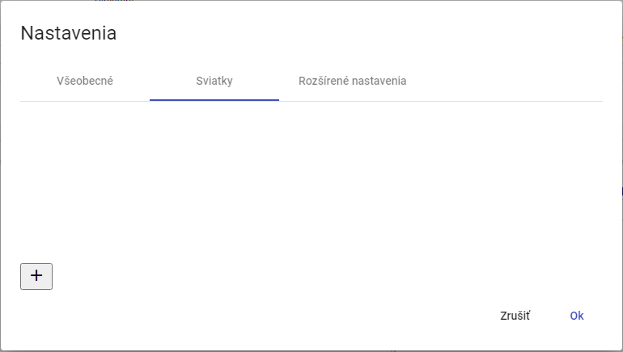

Picture 62: Bookmark "Festivities""

1. Create profile button.

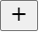

Image 63: Button for creating profile

1. The window "Christmas" will appear, which serves for the creation of a profile.

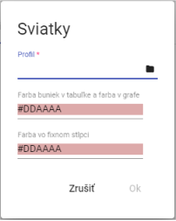

Picture 64: Creation of a profile

1. In the "Profile" menu, select profile or press the profile selection button.
2. After pressing the button, a window for selecting the profile will appear.

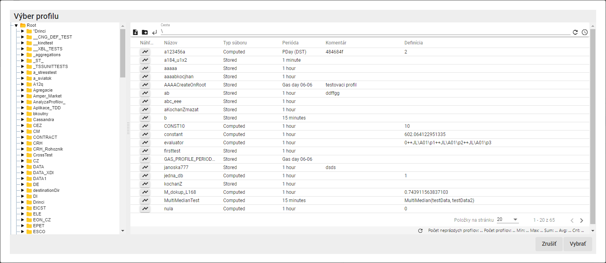

"Picture 65: Window for selecting profile"

1. "Select calendar profile and click on the 'Choose' button."
2. Choose the color for the fields "Color of bubbles in table and color in graph" and "Color in fixed column".

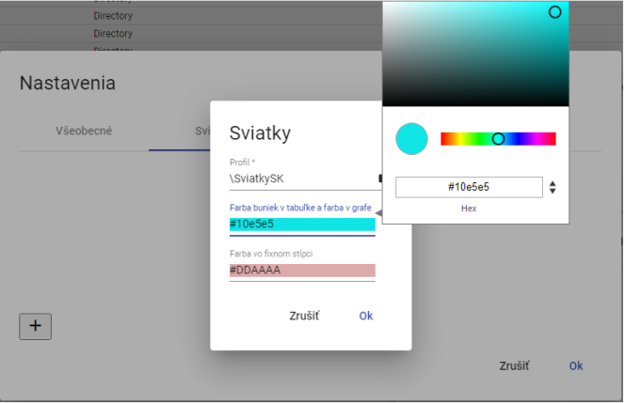

Picture 66: Colour selection

1. You will create a profile by pressing the button "OK".
2. "In the window 'Sviatky', a created profile for holidays will be displayed."

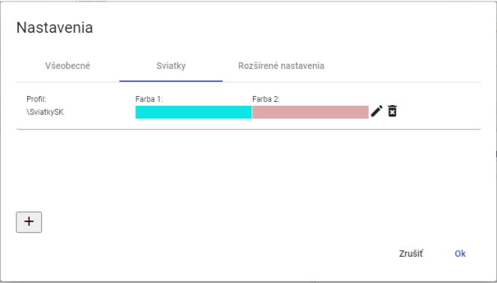

Picture 67: Created profile for Christmas

1. You will save the generated profile by pressing the "OK" button.

### How to choose a profile for New Year's Eve

"Profile for holidays will you fix:"

1. "Click on the button with the name of the registered user located in the top bar of the application. Position your mouse cursor at the item 'Settings' and, in the displayed window, click on the item 'Settings', Figure 42."
2. "A window titled 'Settings' will appear, where you click on the tab 'Holidays'."
3. "Click on the edit button next to the profile you want to change."



Picture 68: Button for editing profile

1. "A window called 'Holiday' will appear for editing a profile."

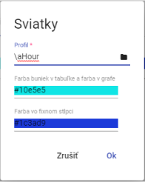

Picture 69: Editing profile for Christmas

1. Edit data.
2. "Changes will be saved by pressing the 'OK' button."
3. No valid translation found.

### "Delete my profile for holidays"

You will edit your profile for holidays:

1. "Click the login user button, which is located in the top bar of the application. Move your mouse cursor to the 'Settings' option and click on it in the displayed window. Picture 42."
2. "A window called 'Settings' will appear, where you click on the tab 'Holidays'."
3. "For the account you want to delete, press the delete button."



"Picture 70: Button for removing profile"

1. A window for confirmation of profile deletion will appear where you click the "Yes" button.

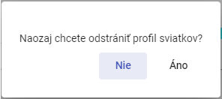

Image 71: Confirmation of profile deletion

1. "The profile will be removed from the list of profiles for Christmas."
2. "Confirm deletion of profile by pressing the 'OK' button in the 'Settings' window."

## To display information about status

No valid translation found.

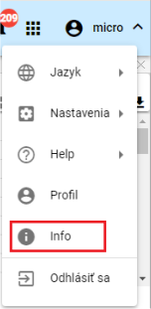

Image 72: Item "Info"

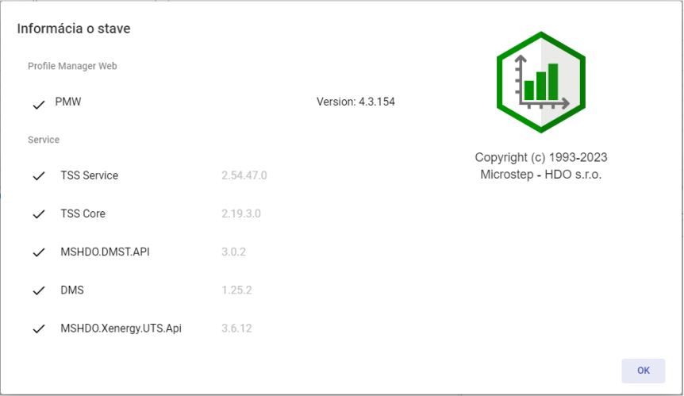

Picture 73: Information window

## I want to show notifications

The "Notifications" button signals changes made to the system. For example, creating an addressee and similar things. If there are notifications in the application, in the top right corner of the "Notifications" button is a red circle with the number of notifications.



Image 74: Warning button

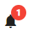

Picture 75: New warning

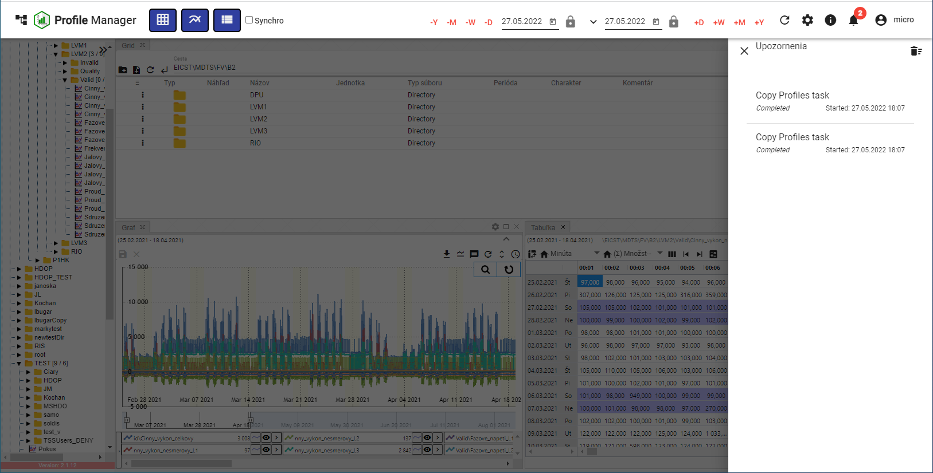

Picture 76: Block of Warning

"Remove the warning by pressing the button with a trash can icon located in the top right corner of the 'Warnings' block. A confirmation window will appear where you click the 'Yes' button."

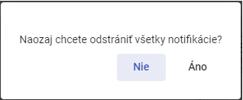

"Picture 77: Window for confirmation of notification removal"

## "I will enlarge the window of tree structure"

No valid translation found.

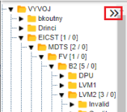

Image 78: Expansion button for tree structure

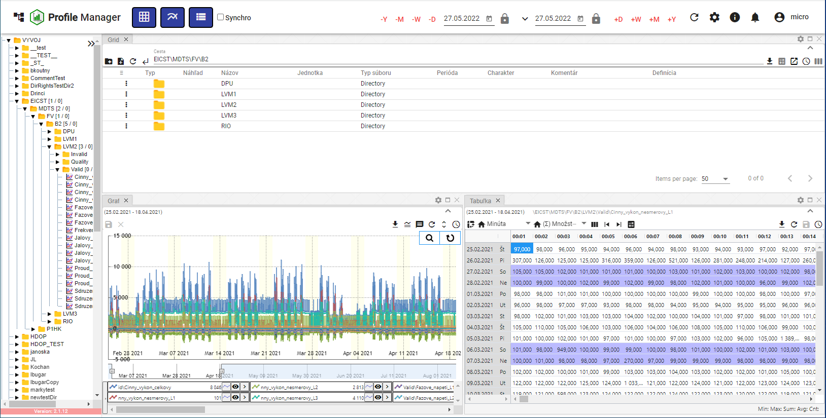

Picture 79: Standard window width of a tree structure

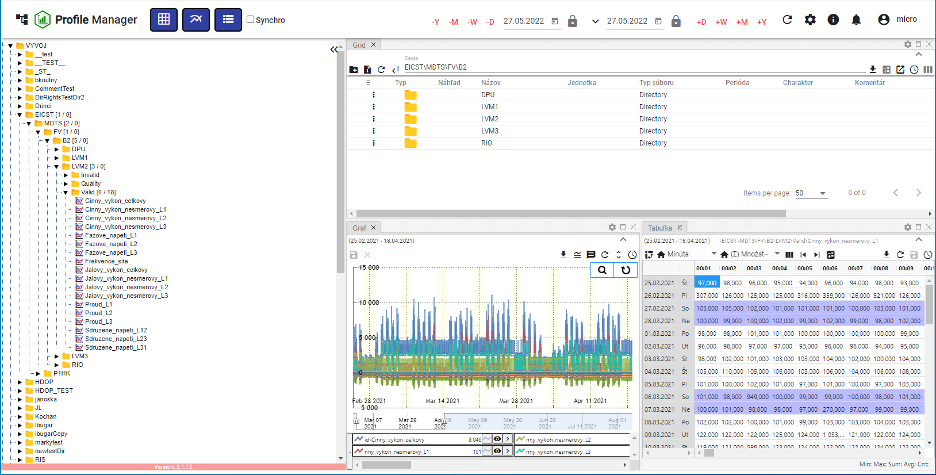

"Picture 80: Enlarged window of a tree structure"

## Panel synchronization

The "Sync Panels" button serves to synchronize open windows in the "Profile Manager" application. It allows time ranges (Chapter 1.16.1) to be merged and tables to be synchronized (Chapter 1.16.2).

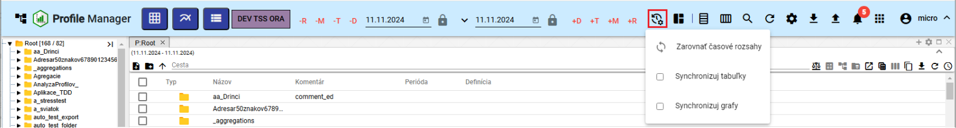

Picture 81: Synchronization button for panels

### Align temporal ranges

"If different date ranges are set in the windows and you want to set the same date range for all open windows, follow:"

1. Click on the window header whose date range you want to set in other windows.

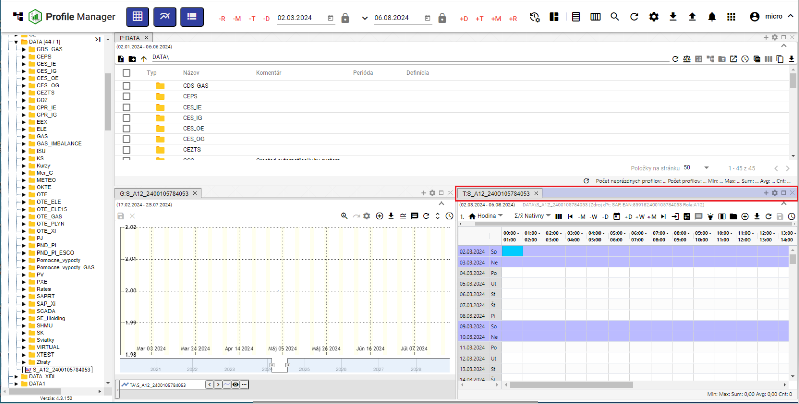

Image 82: Active window

1. Press the button "Sync panels" and click on the item "Align time ranges".

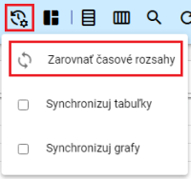

Image 83: Item "Resizing time ranges"

1. In all windows, the date range set up in the active window will be applied.

### I want to synchronize tables

"The entry 'Sync tables' means that the beginning of the range and the cursor are synchronized to all open tables."

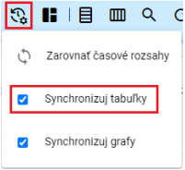

Image 84: Entry "Sync tables"

No valid translation found.

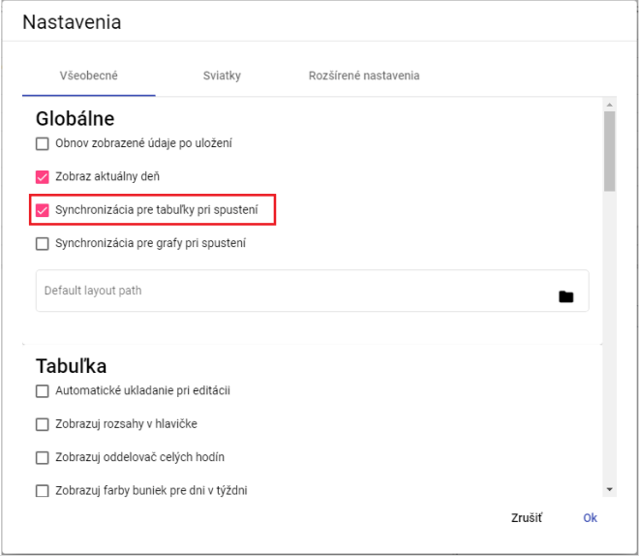

Image 85: Pole "Synchronization for tables at startup"

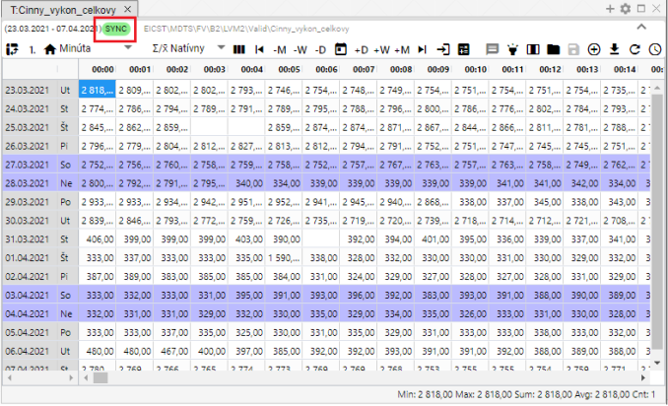

"Image 86: The text 'SYNC' will be displayed if table synchronization is enabled"

### Synchronize graphs

No valid translation found.

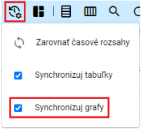

Image 87: Item "Sync graphs"

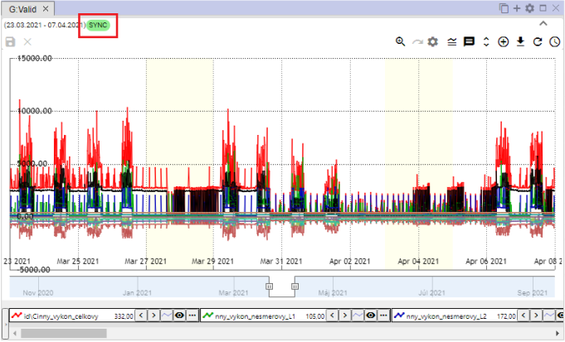

"Image 88: The 'SYNC' text will be displayed if graph synchronization is enabled"

## To import, export and store inventory

"Button, Image 89, serves for import, saving and downloading remains. The import of remains is elaborated in the following chapter 1.17.1 and the download of remains is described in chapter 1.17.2."

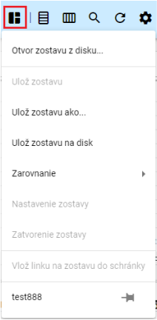

Image 89: Button "Stay Alert"

### To assemble/import a team

"Proceed before importing:"

1. "Click the button 'Save Setup', which will display a window where you select the item 'Open setup from disk...'."

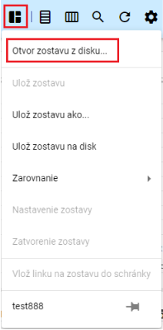

Picture 90: Item "Open CD collection..."

1. "A window will appear where you select the roster that you want to import."

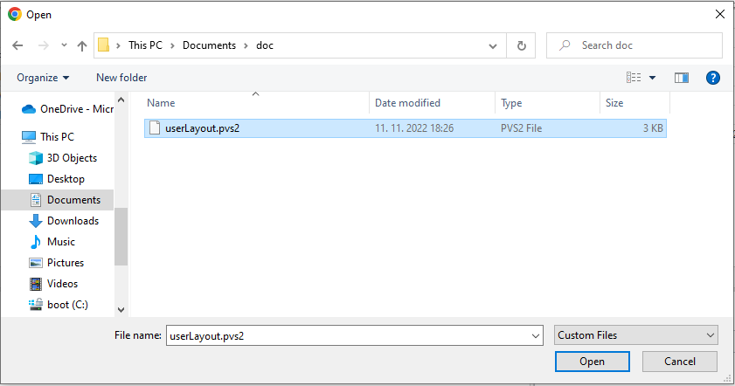

Picture 91: Team Selection for Import

1. "Confirm the selected team for import by pressing the 'Open' button."
2. "The selected group is imported and the appearance of the 'Profile Manager' application will change according to the settings of the chosen group - number and size of windows, data displayed in windows etc."
3. "Next to the button 'Report remains' will appear the name of imported report."



Picture 92: Title of Imported Flock

### To export the roster.

We are exporting the following:

1. Press the "Leave Message" button.
2. Choose "Save team to disk".

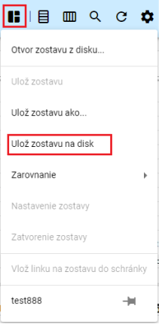

Image 93: Select "Save layout on disc""

1. "Next it gets stuck."

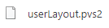

Image 94: Downloaded crew

### I will update the lineup

"Proceed with personnel update:"

1. "Click the left mouse button twice on the name of the project in the profile stream to open it for editing."

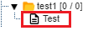

Image 95: Stay tuned for updates

1. "Subsequently, at the press of 'Leaving a message', it will display the name of the open group."

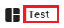

Image 96: Name of Open Camp

1. "Make changes to the formation that you want to save."
2. "You will save changes by pressing the button 'Save arrangement' and then selecting the item 'Save arrangement'."

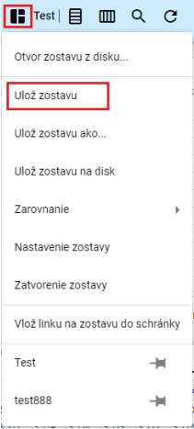

Image 97: Save assembly list

1. "A window will appear where you press the 'Yes' button."

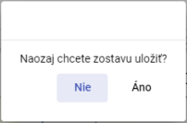

Picture 98: Window for confirmation of savings deposit

1. The database is being updated.

### I will submit a new roster.

"Appearance of the 'Profile Manager' application – number and size of windows displayed, data shown in windows can be saved as a layout."

"New roster will be saved to your profile stream as follows:"

1. "Set up settings in the application that you want to save as a collection."
2. Press the button "Save selection" and, in the displayed window, choose "Save selection as..."."

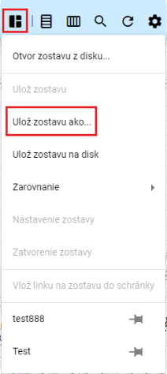

Image 99: Save composition as..."

1. "An 'Edit Team' window will be shown."

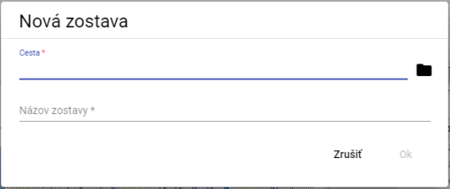

Picture 100: Window "New Team"

1. No valid translation found.

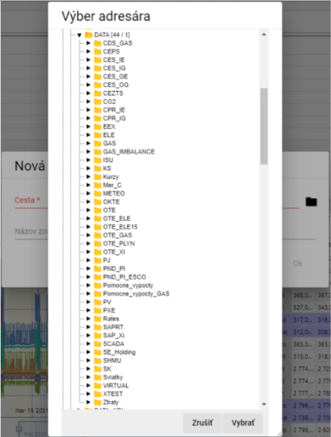

"Picture 101: Selection of addressee for savings account deposit"

1. Please name the team.

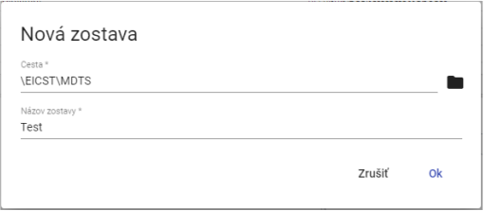

Picture 102: Given Data

1. Save the new setup by clicking the "OK" button.
2. "To show the folder in your profile stream, click on the folder in your profile stream and select 'Restore'."

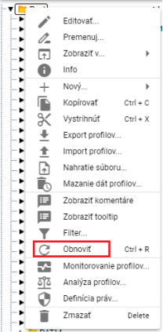

Image 103: Item "Restore"

### To assemble the team into columns

Follow:

1. Click on the button "Message Remains", which is located in the top bar of the application.
2. "The offer will be displayed, where with the mouse cursor you set to the item 'Alignment' and set the mouse cursor on the item 'To columns...'."
3. "The offer will be displayed, in which you select the number of columns."

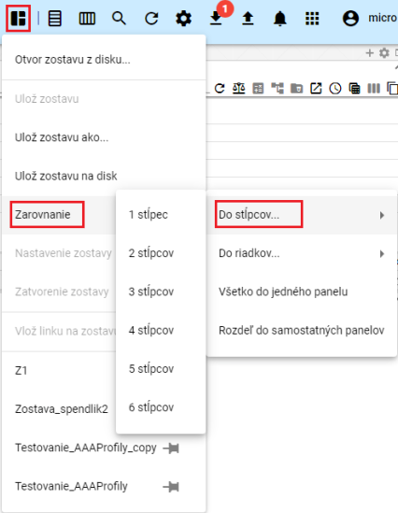

Image 104: Item "To Steps"

1. The windows in the "Profile Manager" application are aligned to a selected number of columns.

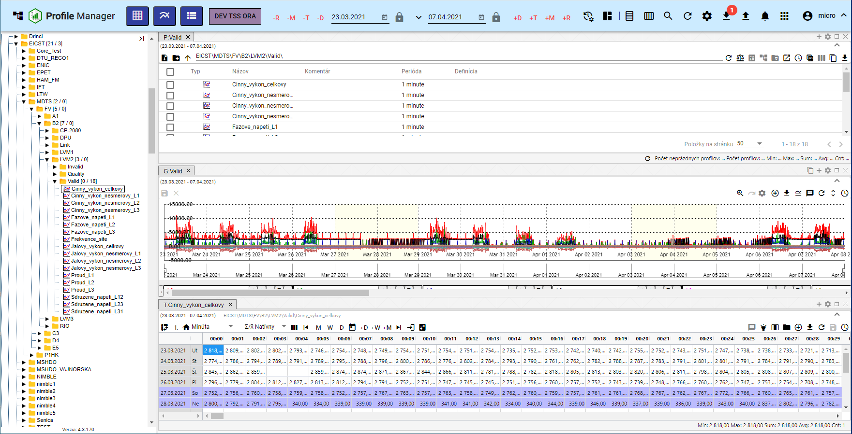

Picture 105: Harmonization of windows into one column

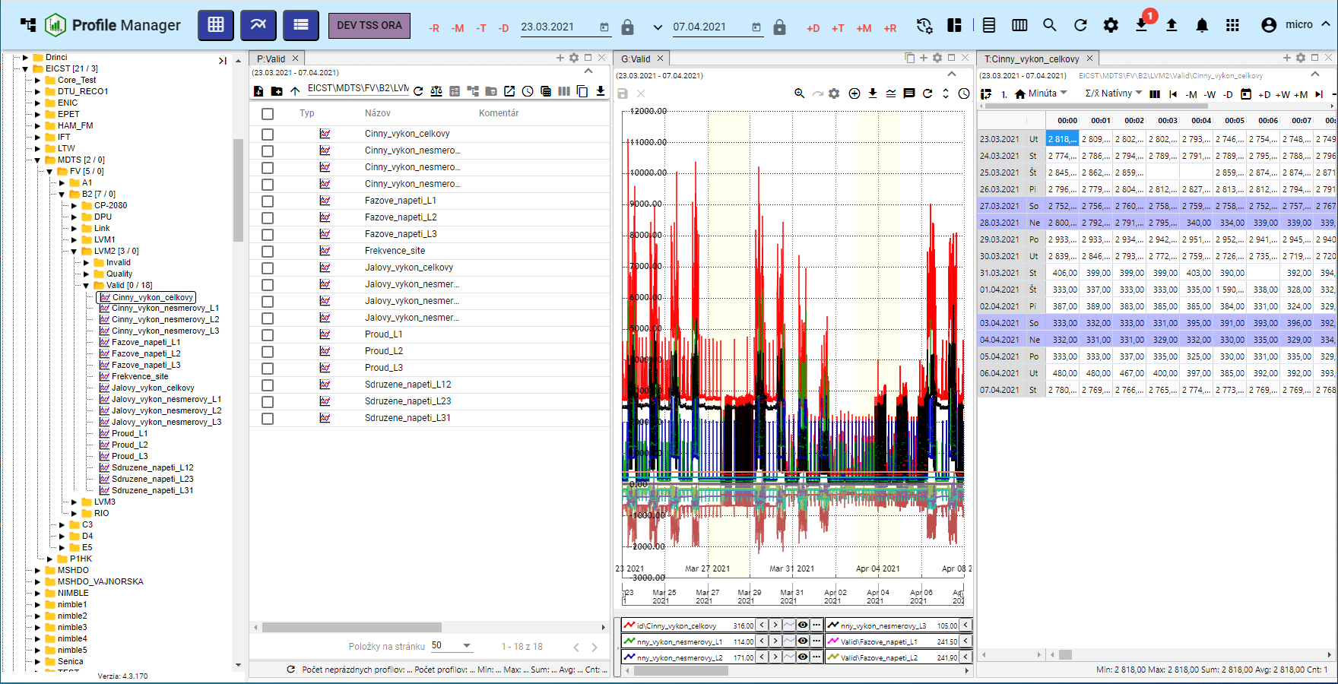

Picture 106: Alignment to three columns

### To assemble the team into lines.

Proceed:

1. Click on the "Message Remains" button, which is located in the top bar of the application.
2. "The offer will be displayed, where you navigate with the mouse cursor to the item 'Alignment' and set the cursor on the item 'To rows'."
3. "The offer will be displayed, where you select the number of rows."

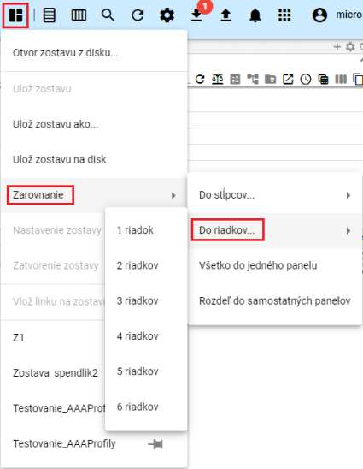

Picture 107: Item "In Line"

1. "Windows in the application are aligned to a chosen number of rows."

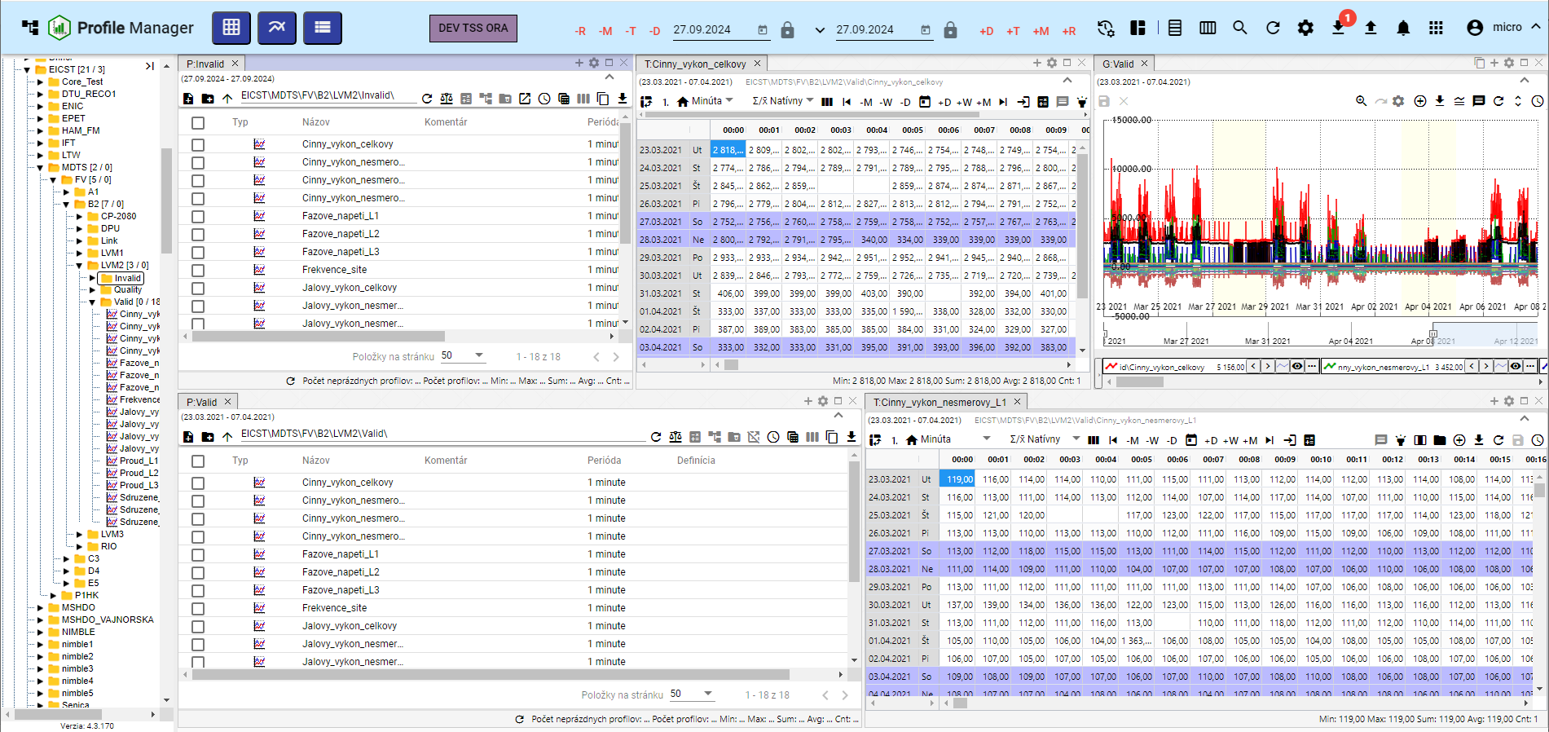

Picture 108: Alignment to two rows

### "To gather everything into one piece"

Proceed:

1. Click on the button "The news remains."
2. "A menu will be shown where you can select 'Alignment' with the mouse cursor and choose 'Everything to one tab'."
3. All windows will be displayed in one panel.

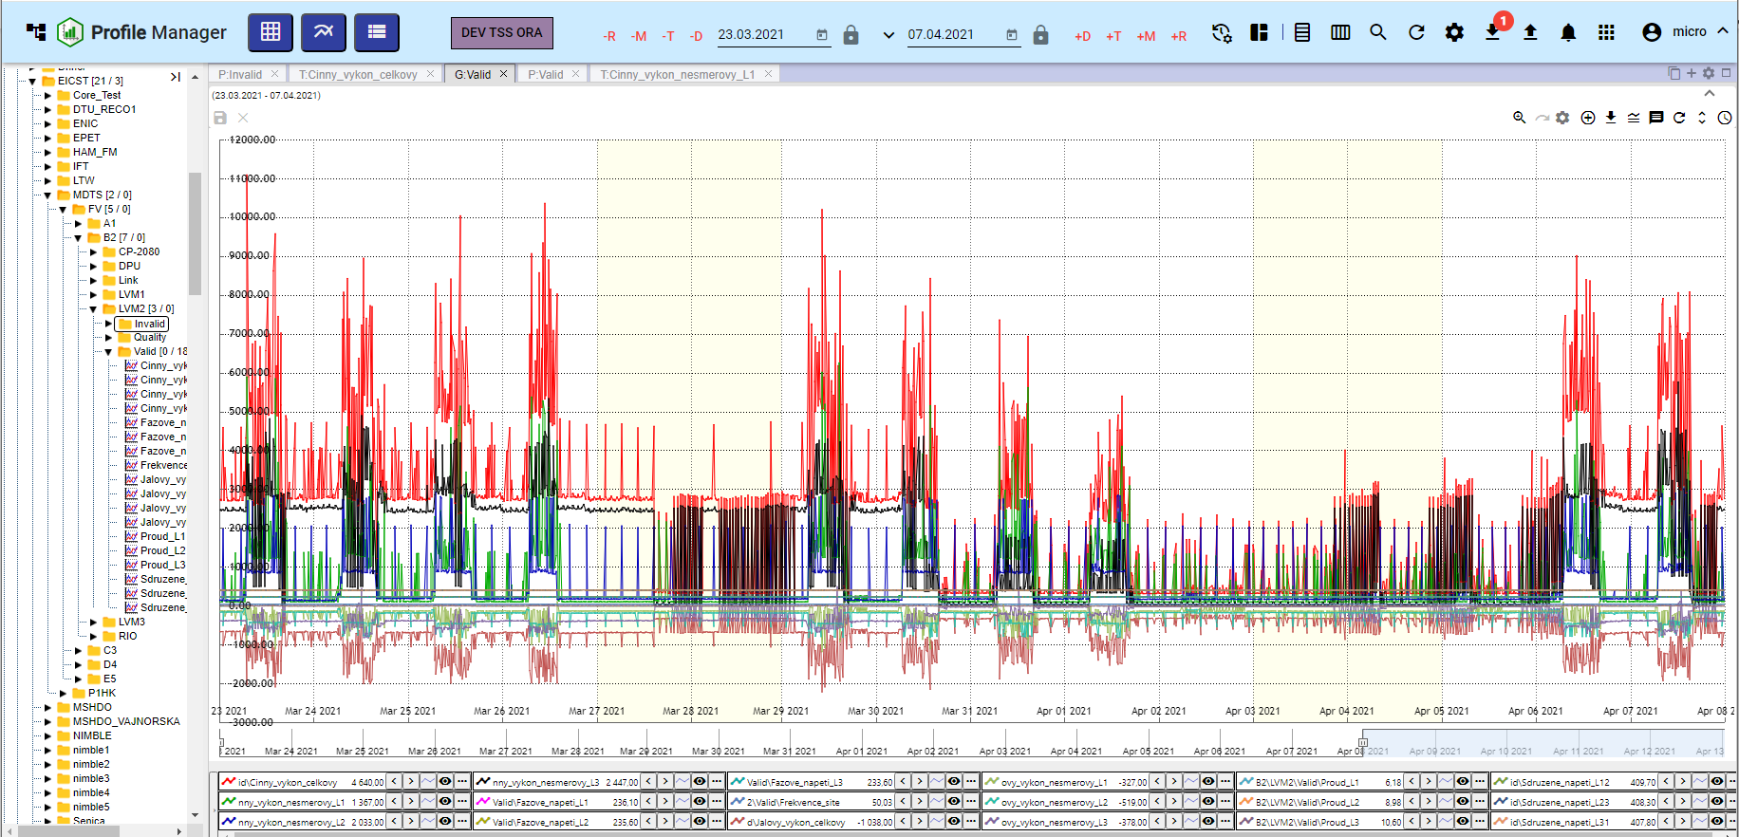

Picture 109: Alignment to one panel

### To divide the roster into separate panels.

Proceed:

1. Click on the button "Save for Later".
2. "An offer will be displayed, where you'll click on the item 'Alignment' with your mouse cursor and select the item 'Split into separate panels'."
3. "Each open window will be shown in separate panels."

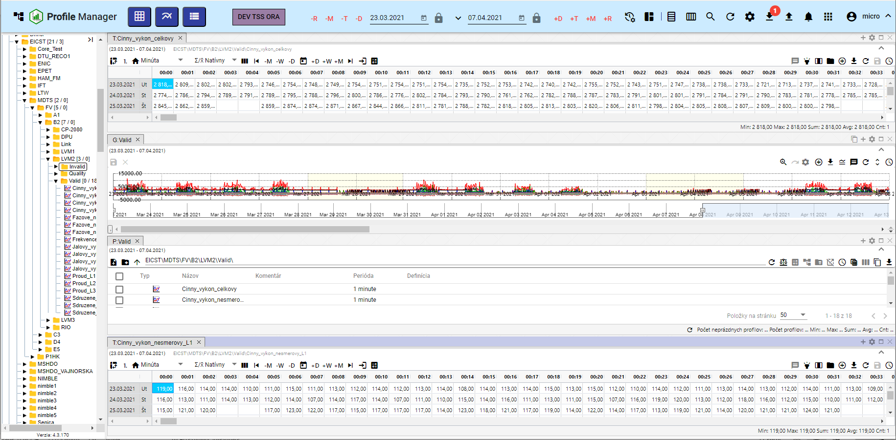

Image 110: Division into separate panels

### **[OLLAMA FORMATTING ERROR - MANUAL REVIEW NEEDED] Ako nastaviť globálny časový rozsah pri zobrazení zostavy**

"Before changing the global time scale for stored configuration proceed:"

1. Press the button "Message Remains".
2. Choose item “Squad settings”.

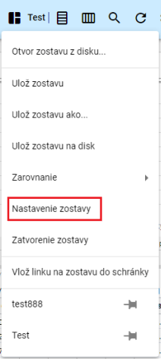

Image 111: Setting up the team

1. The window "Squad settings" will appear.

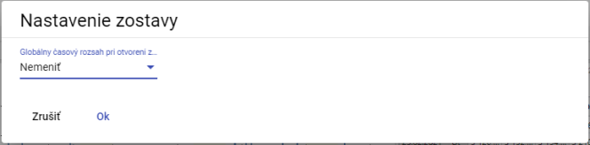

Picture 112: Window "Team Settings"

1. "Click on the field 'Global Time Range when opening the roster'."
2. "The offer will be displayed, where you can choose a date range."

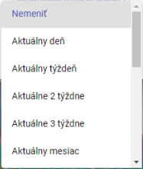

Image 113: Offers for setting up a global time frame

1. Press the "OK" button.
2. "A window will appear for confirmation, where you press the 'Yes' button."

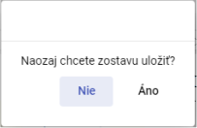

Image 114: Window for confirmation of saving

### **[OLLAMA FORMATTING ERROR - MANUAL REVIEW NEEDED] Ako zatvoriť zostavu**

"Before closing the club press the button 'Club information' and select the item 'Closing of the club'. The club will then be closed."

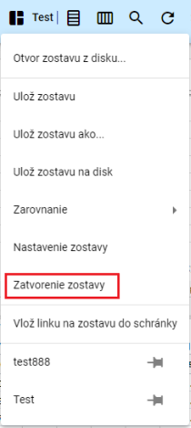

Image 115: Entry "Closure of the estate"

## **[OLLAMA FORMATTING ERROR - MANUAL REVIEW NEEDED] Ako horizontálne zarovnať okná**

"Press the 'Horizontal Alignment' button, which is located in the top bar of the application. The opened windows in the 'Profile Manager' application are horizontally aligned, Figure 117."



Image 116: Button "Horizontal Alignment"

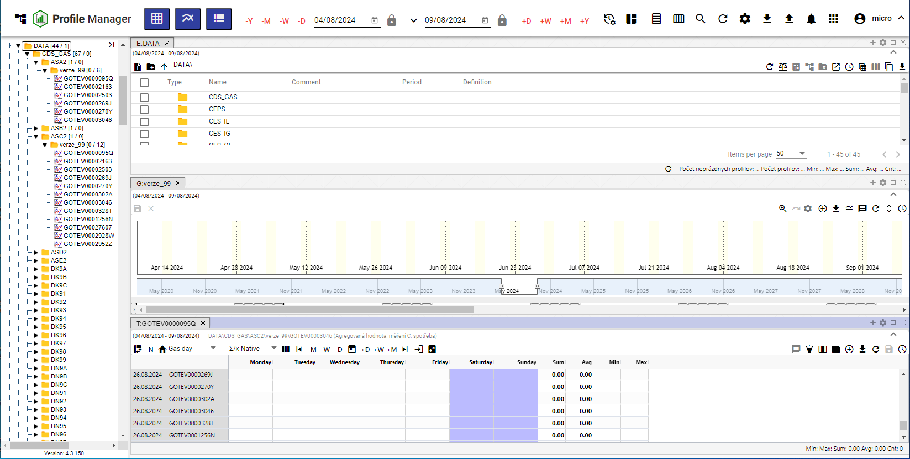

Picture 117: Horizontal alignment of windows

## To install windows vertically

"Click the 'Vertical alignment' button, which is located in the top bar of the application. The windows open in the 'Profile Manager' app are vertically aligned."



Image 118: Button "Vertical Alignment"

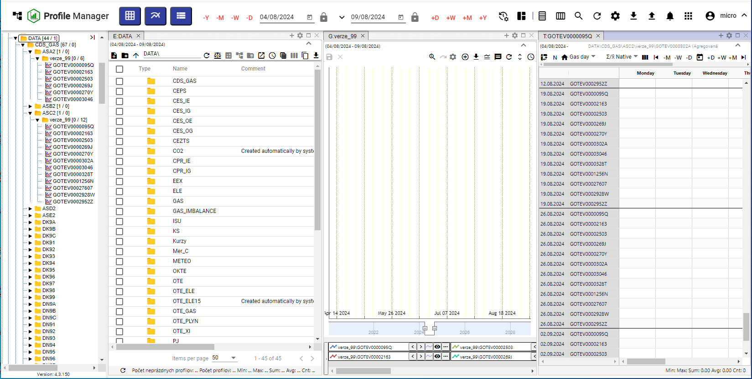

Picture 119: Vertical alignment of windows

## **[OLLAMA FORMATTING ERROR - MANUAL REVIEW NEEDED] Ako zobraziť a stiahnuť exporty**

"In the top menu of the application 'Profile Manager', there is a button called 'Export' which serves to display a list of exports in the window 'Exports'. If the export was successful, it can be downloaded by clicking on the green button 'Download'. The process for creating an export is detailed in Chapter 2.16."



Image 120: Export button

The number of unsent exports will be displayed as a figure in the red circle next to the "Export" button, Image 121. Unsents export in the "Exports" window has a red "N" at the "Download" button, Image 122.

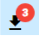

Picture 121: Three Exported Imports

Exports may be in a state:

* The turnover is running ahead of exports.
* "COMPLETED – successfully completed export, can be downloaded by clicking the “Download” button."
* "ERROR – an error occurred during export."
* The EXPORT was ERASED. Information about the erased export came from the Export Service application.

Exports are coming from the Export Service and in the "Profile Manager" application they only serve for display. The "Exports" window will close by pressing the "Cancel" button.

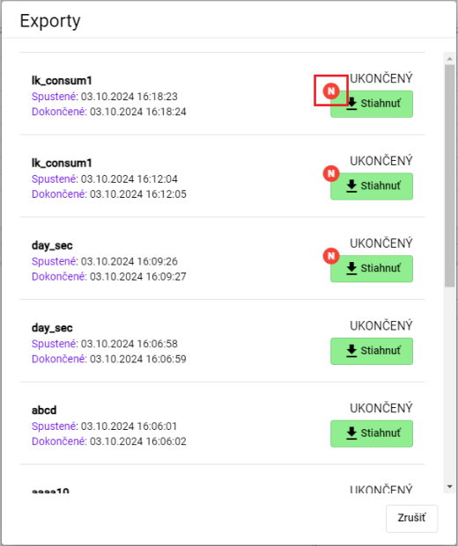

Image 122: Window "Exports"

## Show imports

"In the top menu of the application 'Profile Manager', the button 'Import' is located, which serves to display the list of imports in the window 'Imports'. The procedure for creating an import is located in chapter 2.17."



Image 123: Import button

After pressing the button "Import", the window "Imports" will appear in which it is possible to display details of imports, Image 125.

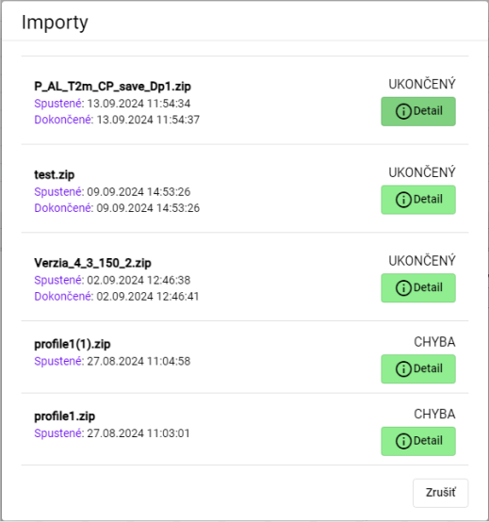

Picture 124: The "Imports" window

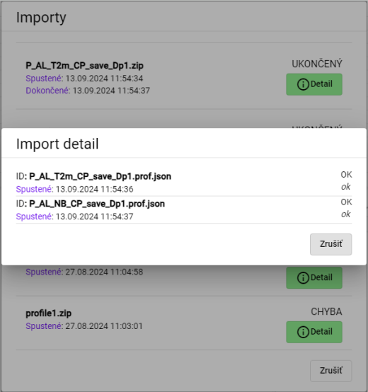

Image 125: Display of Import Details

## Keyboard shortcuts

"You can display a list of keyboard shortcuts by using the 'Profile Manager' application:"

1. Click on the button with the logged-in user's name, which is located in the top menu of the application.
2. A menu will be displayed where you click on the "Help" item with your mouse cursor.
3. Click on the item "Keyboard shortcuts"

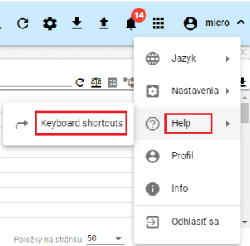

Picture 126: Item "Keyboard shortcuts"

1. "A window for 'keyboard shortcuts' will appear."

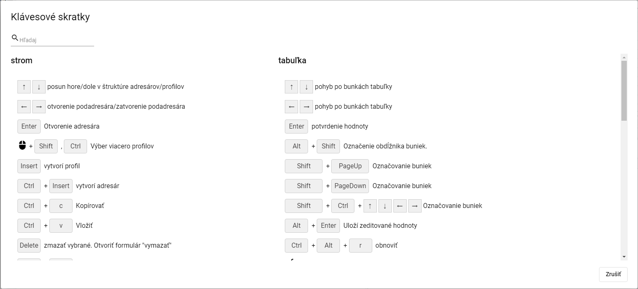

Image 127: Window "Keyboard Shortcuts"

1. "Keyboard shortcuts can be searched by typing text into the 'Find' field, which is located in the top left corner of the window. Automatically, a list of keyboard shortcuts will appear corresponding to the entered text."
2. "Close the window by pressing the 'Cancel' button."

In the application "Profile Manager", you can use shortcuts that are located in the following table.

|  |  |  |
| --- | --- | --- |
| Klávesová skratka | Časť aplikácie | Popis |
| šípky HORE/DOLE | strom | Posun hore/dole v štruktúre adresárov/profilov |
| šípky HORE/DOLE | prieskumník | Posun hore/dole v štruktúre adresárov/profilov |
| šípky HORE/DOLE | tabuľka | Pohyb po bunkách tabuľky |
| šípky HORE/DOLE | graf | Hore zoom OUT, dole zoom IN |
| šípky Doprava a doľava | strom | Otvorenie podadresára/zatvorenie podadresára |
| šípky Doprava a doľava | prieskumník | Posun celej tabuľky doľava a doprava, aby bolo možné vidieť schované stĺpce |
| šípky Doprava a doľava | tabuľka | Pohyb po bunkách tabuľky |
| šípky Doprava a doľava | graf | Posun grafu o jedno zobrazené časové okno doľava a doprava |
| ENTER | strom | Otvorenie adresára |
| ENTER | prieskumník | Otvorenie adresára/Otvorenie editačného okna profilu |
| ENTER | tabuľka | Potvrdenie hodnoty |
| ENTER | graf | Bez akcie |
| Výber myšou pomocou Shift, Ctrl | strom | Výber viacero adresárov/profilov |
| Výber myšou pomocou Shift | prieskumník | Výber viacero adresárov/profilov |
| Výber myšou pomocou Shift, Ctrl | graf | Výber viacero profilov |
| Alt + Shift | tabuľka | Označenie obdĺžnika buniek |
| Insert | prieskumník | Založí profil |
| Ctrl + Insert | prieskumník | Založí adresár |
| Insert | strom | Založí profil |
| Ctrl + Insert | strom | Založí adresár |
| Ctrl + ALT + K | graf | Zmena koeficientu označeného profilu / označených profilov |
| Ctrl + ALT + W | graf | Skryje označený profil / označené profily |
| Ctrl + ALT + Q | graf | Odkryje označený profil / označené profily |
| Ctrl + ALT + T | PMW | Nové okno Tabuľka |
| Ctrl + ALT + G | PMW | Nové okno Graf |
| Ctrl + ALT + E | PMW | Nové okno Prieskumník |
| Ctrl + C | strom/ prieskumník | Kopírovať |
| Ctrl + ALT + C | prieskumník | Export prieskumníka do clipboardu |
| Ctrl + V | strom/ prieskumník | Paste |
| Ctrl + S | PMW | Uloženie zostavy. Ak nie je žiadna otvorená ponúkne formulár na uloženie do stromu. |
| Ctrl + O | PMW | Otvorenie zostavy z disku |
| Ctrl + ALT + F4 | PMW | Zavretie grafu/tabuľky |
| Ctrl + šípka NAHORU/DOLŮ | graf | Posun/radenie zobrazovaných profilov pod grafom |
| Alt + ENTER | graf | Uloží rozkreslenú čiaru |
| Alt + ENTER | tabuľka | Uloží zeditované hodnoty |
| Delete | graf | odoberie z grafu vybrané profily |
| Delete | strom/prieskumník | Zmazať vybrané. Otvoriť formulár "Delete" |
| CTRL+ R | strom/prieskumník | Refresh |
| CTRL+ ALT + R | graf/tabuľka | Refresh |
| Koliesko myši | graf | Zmena rozsahu časovej osi |
| Koliesko myši + CTRL | graf | Zmena rozsahu ľavej osi |
| Koliesko myši + CTRL + ALT | graf | Zmena rozsahu pravej osi |
| SHIFT + šípka NAHORU/DOLŮ | prieskumník | Výber adresárov/profilov |
| SHIFT + HOME | prieskumník | Výber viacero adresárov/profilov |
| SHIFT + END | prieskumník | Výber viacero adresárov/profilov |
| CTRL + X | prieskumník /strom | Presun adresárov/profilov |

## How do I find my profile in the application?

"Before searching for your profile, proceed:"

1. Press the button located in the top menu of the application.
2. "A field called 'search profile' will be displayed, into which you write the name of the profile."

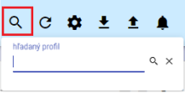

Image 128: Go to profile search

1. "Please enter the text you'd like to search profiles for."
2. No valid translation found.

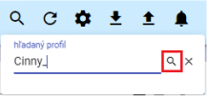

Picture 129: Search button

1. "In the active window, a tab labeled 'B:Root' will be displayed containing profiles matching the given text."

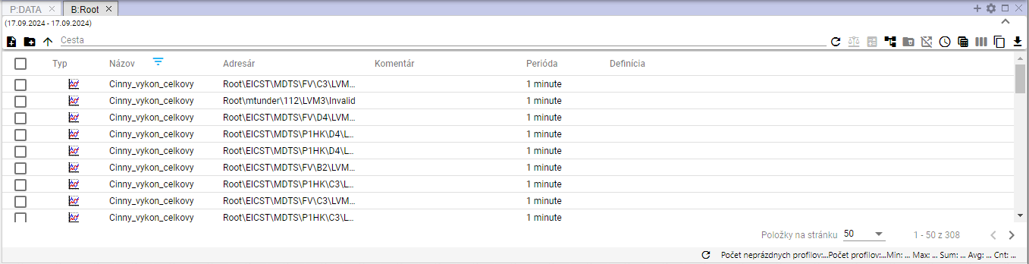

Picture 130: Found Profiles

## User notification of withdrawal

No valid translation found.

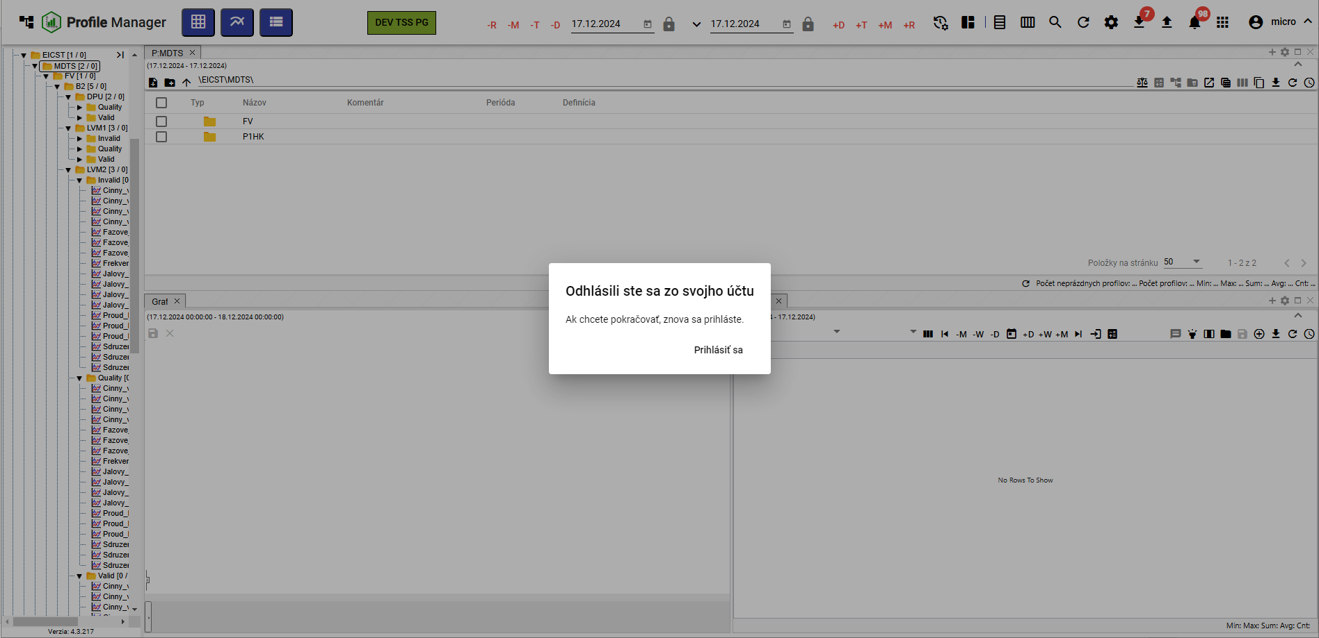

Picture 131: Window "You have unregistered from your account"

## **[OLLAMA FORMATTING ERROR - MANUAL REVIEW NEEDED] Ako zobraziť čas, ktorý ostáva užívateľovi do odhlásenia**

**[OLLAMA FORMATTING ERROR - MANUAL REVIEW NEEDED] Ak s aplikáciou „Profile Manager“ aktívne nepracujete, odpočítava sa čas, ktorý ostáva do odhlásenia užívateľa z aplikácie „Profile Manager“. Ak s aplikáciou pracujete, čas sa obnovuje.**

**[OLLAMA FORMATTING ERROR - MANUAL REVIEW NEEDED] Koľko času do odhlásenia ostáva si môžete skontrolovať:**

1. **[OLLAMA FORMATTING ERROR - MANUAL REVIEW NEEDED] Kliknite na tlačidlo s názvom prihláseného užívateľa.**
2. **[OLLAMA FORMATTING ERROR - MANUAL REVIEW NEEDED] Zobrazí sa menu, v ktorom sa nachádza informácia o aký čas vyprší doba prihlásenia, Obrázok 132.**

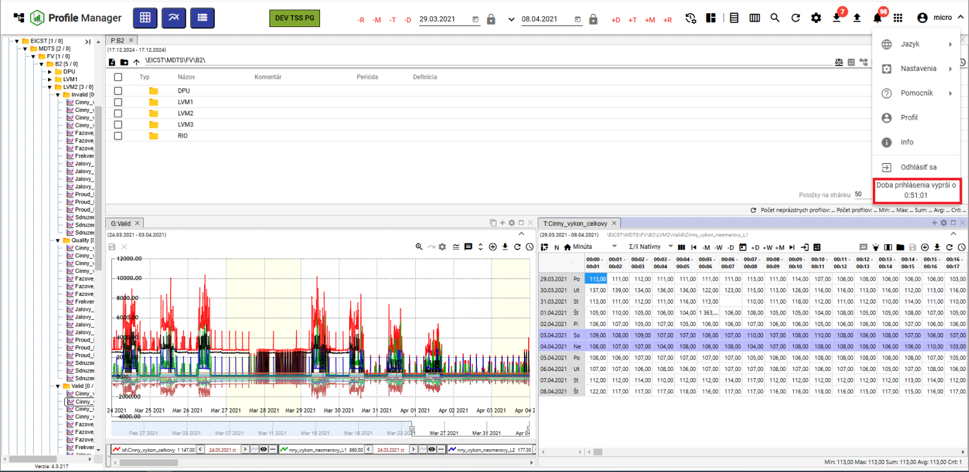

Picture 132: Information about the time that remains until user logout.

"If the user has not actively worked with the 'Profile Manager' application and login time has expired, the user is logged out of the application. The window 'Login Time Expired' will appear. If you want to log in again, click the 'Log In' button."

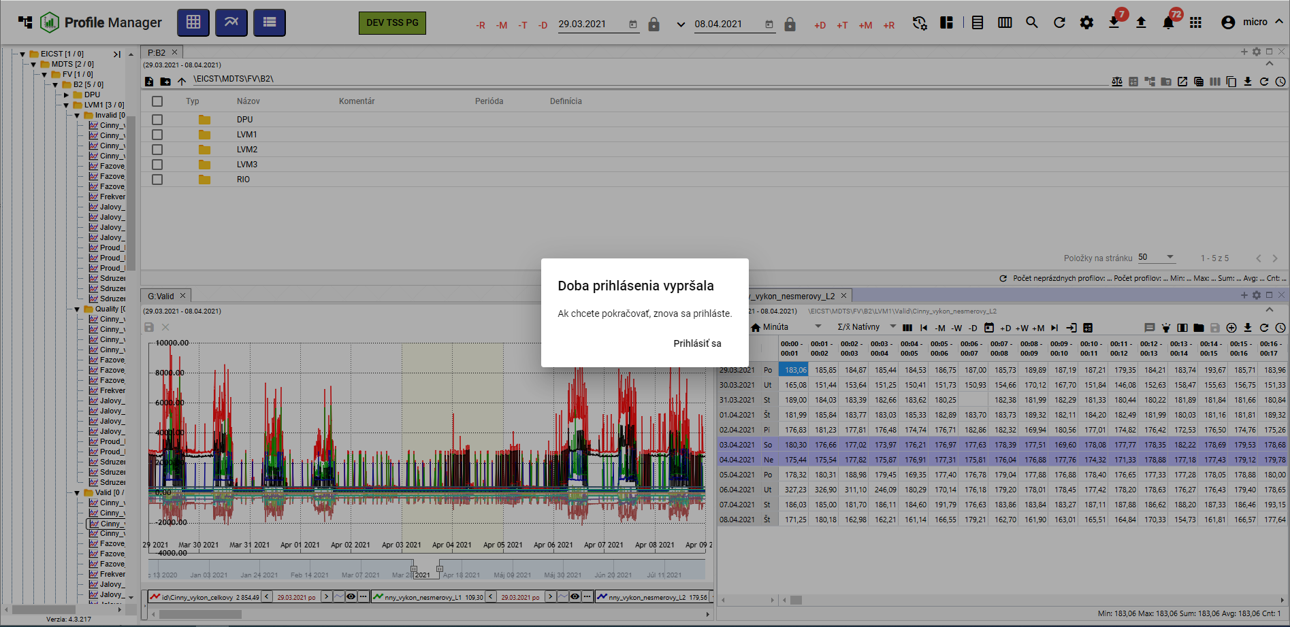

Picture 133: Notification of deadline for registration

# Work with address books and profiles

"In the stream structure there are addresses and profiles that you can create, convert, edit and delete. You can filter addresses."

"The address book allows logical grouping of data into one group. Each address book can contain further address books or profiles."

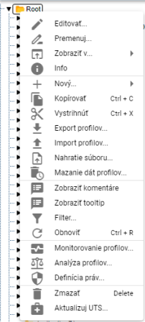

Image 134: Window with functions for the addressee and profiles

## I want to add a new folder

"Before adding a new recipient, proceed:"

1. No valid translation found.
2. Choose item "New" and then "Address Book".

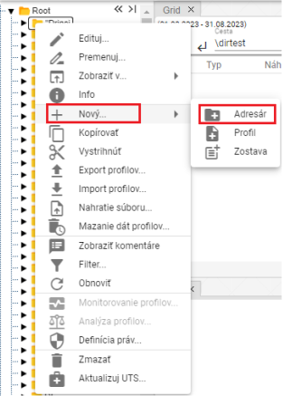

Image 135: Item "Address Book"

1. "A window for creating an address will appear."

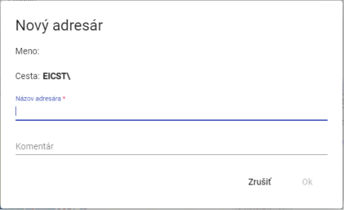

Picture 136: Window for creating an addressee

1. No valid translation found.

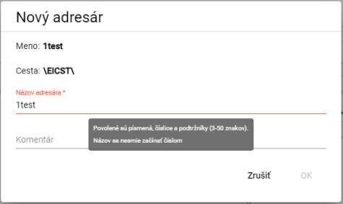

Picture 137: Information about submission rules for addressee name

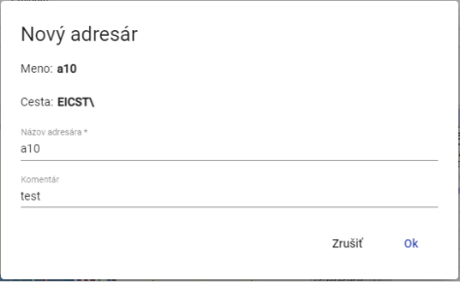

Image 138: Assignment of title and commentary

1. You will create an address book by pressing the "OK" button.

## How to convert a directory

The procedure for renaming the addressee:

1. "Click the left mouse button on the address name and press the 'F2' key or click the right mouse button on the folder you want to rename and select the item 'Rename'."

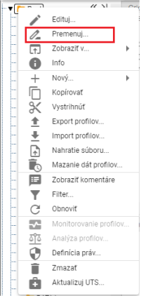

Image 139: Option "Rename"

1. No valid translation found.

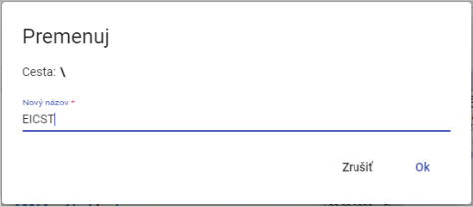

Image 140: Window for address conversion

1. Save changes by pressing the "OK" button.

## I want to edit an address book

Before editing the recipient, proceed with:

1. "Click on the folder with your right mouse button that you want to edit."
2. Click on "Edit" in the menu.
3. No valid translation found.

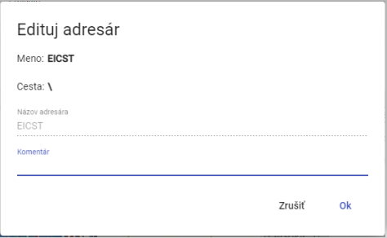

Picture 141: Window for address editing

1. "Changes will be saved by pressing the "OK" button."

## I will delete the folder

"Clear Address Book:"

1. Click with the right mouse button on the directory that you want to delete.
2. "An offer will appear where you choose 'Delete'."
3. "In the window, click on the 'Yes' button to confirm deletion."

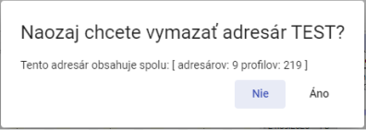

Picture 142: Window for confirmation of erasure

## I want to copy a folder

Before copying the recipient, proceed:

1. No valid translation found.
2. "In options, choose 'Copy'."
3. No valid translation found.
4. "A window 'Move/Copy' will appear."

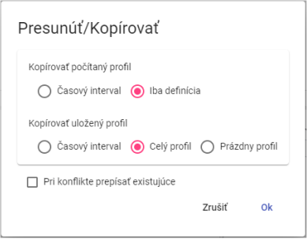

Image 143: Window for copying an address

1. Press the button "OK".

## To pull out/to move the address book

"For the presumptuous addressee, from one location to another location in a tree-like structure, serves the item 'Cut out'. To cut out the addressee, proceed:"

1. Click on the right mouse button on the folder you want to drag out.
2. "By clicking on it, select the option 'Expand'."
3. No valid translation found.
4. Choose the item "Insert".
5. "A window for confirmation will appear, where you click the 'OK' button."

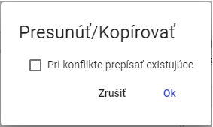

Image 144: Move/Copy Window

## To save the file

"Before feeding collections, proceed:"

1. No valid translation found.
2. It will display a window in which you select "Importing of file...".

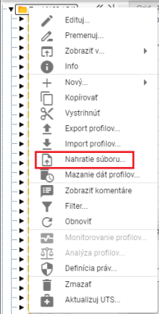

Picture 145: Item "Contribution of the society..."

1. The upload window will be displayed, which you click and select the file that you want to upload. You can also drag the file into the "Upload" window.

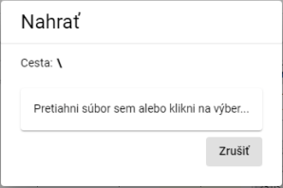

Image 146: "Insert" window

1. The window closes and at the bottom of the screen an announcement appears: "The recording request has been sent."

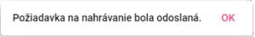

Picture 147: Notification "The recording request was sent."

Recognized types of document extensions:

* Piglet's Report
* "Pavol Vörös' grave"
* Excel template for groups

## No valid translation found.

"The 'Cleaning data profiles' function will delete data from all profiles within a specified time interval in the selected folder(s). You can also select multiple folders or profiles at once. Data can be deleted even from subfolders."

"Before profile deletion, proceed with:"

1. "If you want to delete data only in one selected folder (or even its subfolders) or one profile, click the right mouse button on the selected folder or profile. A window will appear where you select the item 'Profile data wipe...'."

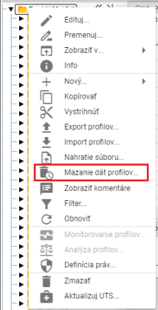

Picture 148: Item "Smearing data on profile..."

1. If you want to delete data in multiple folders or profiles at the same time, proceed:
   1. "Mark the records or profiles where you want to delete data."
   2. "To select items that follow one after the other, click on the first item with the left mouse button, hold down the SHIFT key and then click on the last item you want to select. All items between them will be marked."

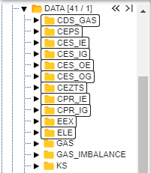

Image 149: Selection of several sandwiches

* 1. No valid translation found.

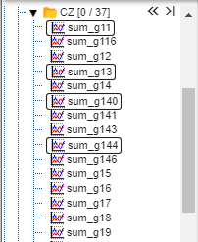

Image 150: Selection of various profiles

* 1. "On the selected criteria or profiles, click the right mouse button and select the item 'Clearing date from profiles...'.

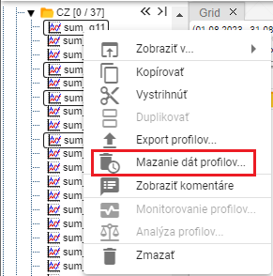

Picture 151: Item "Polishing date profiles..."

1. A window titled “Range Period Cleaning” will appear, in which you select a daily or hourly time interval. By default, an hourly time interval is selected.

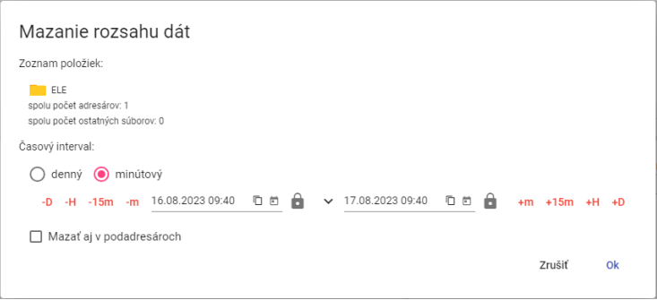

Image 152: Range search window for one selected folder

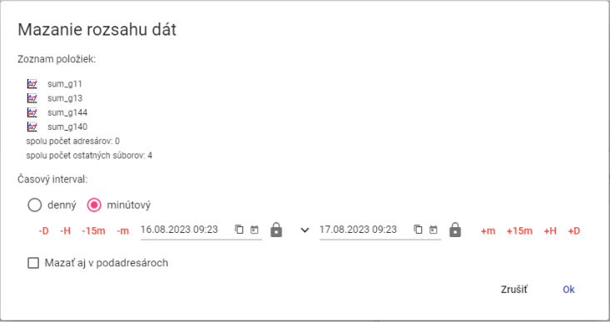

Picture 153: Window "Data Range Merging" for multiple selected profiles

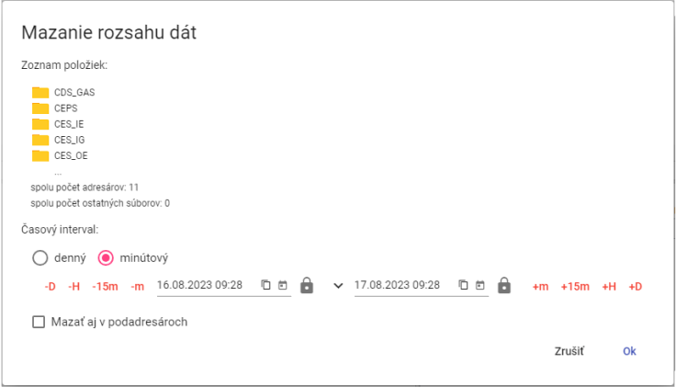

Picture 154: Window "Date Range Mowing" for multiple selected cells

1. "Then enter the time interval in which the data should be deleted."
2. "If you tick the box 'Also delete in sub-addresses', then sub-addresses will also be deleted and according to the chosen time interval, data will be deleted from profiles."
3. "Press 'OK' button."

## I filter email addresses and profiles

Before filtering addresses and profiles proceed:

1. Click the right mouse button on the folder.
2. From the offer select item "Filter".
3. No valid translation found.

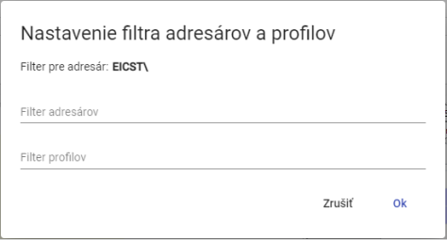

Picture 155: Window "Filter settings for recipients and profiles"

1. "Confirm by pressing the 'OK' button."

## "Disable address and profile filters"

Before filter cancellation proceed:

1. Click on the right mouse button on the folder where the filter is set.
2. Choose the item "Filter".
3. "Turn off the assigned filter."
4. Save changes by clicking on "OK".
5. "Without filtering, all senders and profiles will be displayed in the tree structure."

## Show comments

"When creating addressers and profiles, you can enter a comment. Displaying comments in tree structure toggle:"

1. No valid translation found.
2. An window will be shown, where you click with the mouse cursor on the point "Show" and select "Show comments".
3. "When displaying comments is enabled, the names of commenters and their profiles appear in parentheses before each comment; see Figure 156. If a comment has not been entered, only the name of the commenter or profile appears in parentheses; see Figure 157."



Picture 156: Address book with comments disabled



Picture 157: Address book without comment

1. "You can disable comments by clicking the right mouse button on any folder or profile in the tree. In the window that appears, use your mouse cursor to select the 'View' option and choose 'Hide Comments.'"

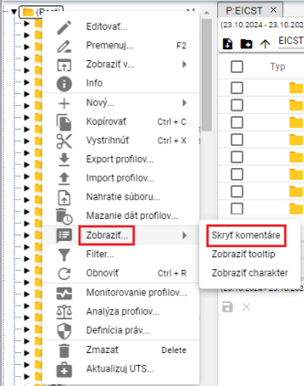

Picture 158: Hide comments item

1. Comments will then be hidden and the names of recipients or profiles will appear without round brackets.



Image 159: Address book with hidden comments

## How to display tooltip

"Before displaying a tooltip for profiles in the tree structure, proceed with:"

1. Click the right mouse button on any folder or profile in the tree structure.
2. An window will appear. In it, use the mouse cursor to select the item "Show..." and click on the item "Show tooltip".

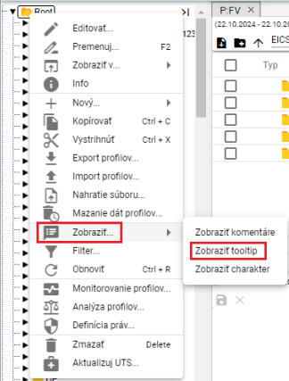

Image 160: Item "Show tooltip"

1. A tooltip will be displayed when you move the mouse cursor over a profile name.

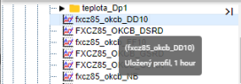

Image 161: Displayed tooltip

1. You can disable the tooltip display by clicking on the right mouse button in any folder or profile in the tree. In the window that appears, use your cursor to select the "Show" option and then click on "Hide tooltip".

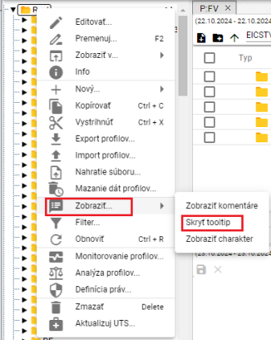

Image 162: Item "Hide tooltip"

## To display character

Character profile may be "Numerical" or "Flowing", which are represented by marks.

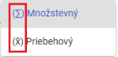

Picture 163: Symbols representing multiplicative and sequential characteristics.

"Before showing character to profiles in tree structure, proceed:"

1. No valid translation found.
2. A window will appear. Click the "Show character" item with your mouse cursor on the "Show..." item and click the "Show character" item. Image 160.
3. "An account is marked with a character badge, which appears before the profile name."

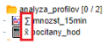

Character 164: Shown character on profiles

1. "Turn off character display by clicking the right mouse button on any folder or profile in your browser. In the window that appears, select 'Hide character' from the dropdown menu and click it."

## "If I restore the list"

Click with the right mouse button on the folder in the tree structure and press the "Restore" button to restore the list of profiles and addresses.

## How to set user and group rights

"User rights and user groups set:"

1. "Click with the right mouse button on the folder for which you want to set up permissions."
2. Choose item "Definition of rights".

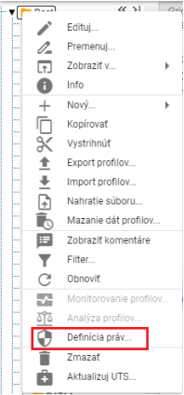

Image 165: Item "Definition of Rights"

1. "A window 'Rights settings' will appear."

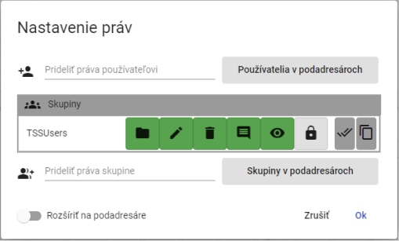

Image 166: Window Settings Rights

1. "Click on the field 'Add user rights' before granting rights to the user and start typing in the username. Automatically, a list of matching the entered text will be displayed."

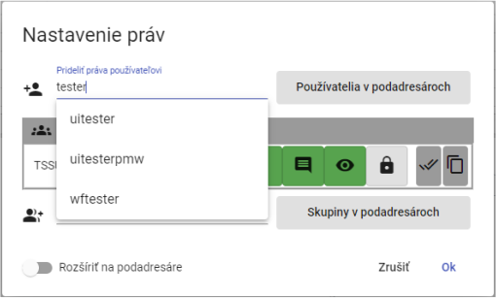

"Picture 167: In the village of Pridiali, grant user rights start writing the name of the user"

1. Select user, which will display the table "Users" containing the selected user.

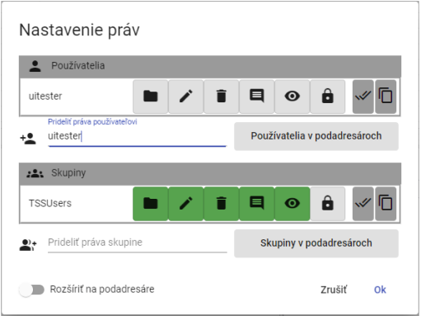

Picture 168: Selected user

1. By clicking on the button, add user rights.

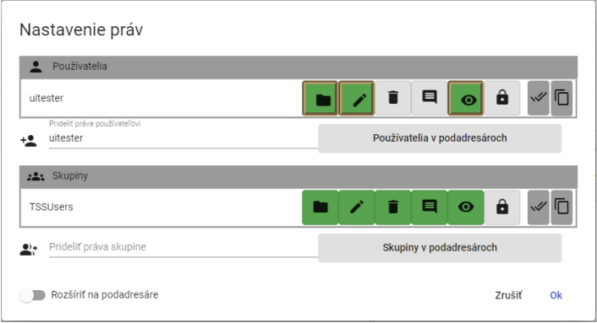

Image 169: Granting rights to the user

1. "Before assigning rights to a group, select the group from the 'Assign rights to group' field."

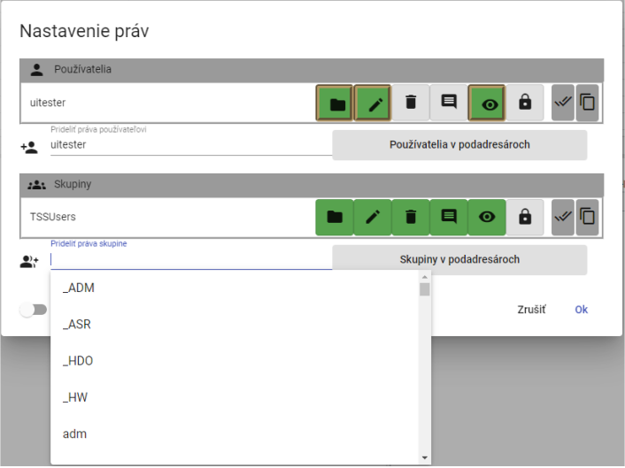

Image 170: Selection of a group

1. "The selected group will appear in the table 'Groups'."

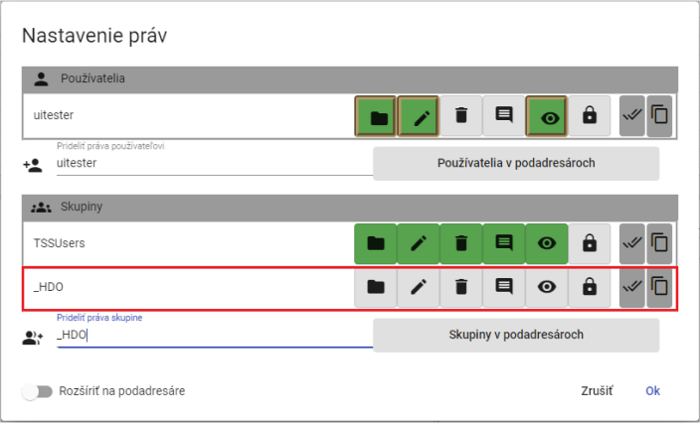

Image 171: Selected Group

1. By clicking on the buttons, set rights for selected group.

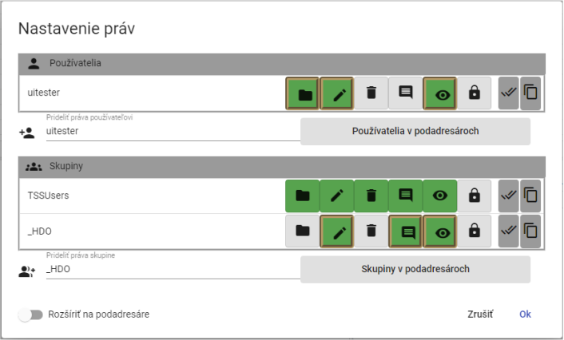

Image 172: Granting rights to a group

1. "If you want to set rules for sub-users as well, click the button 'Extend to sub-users'."

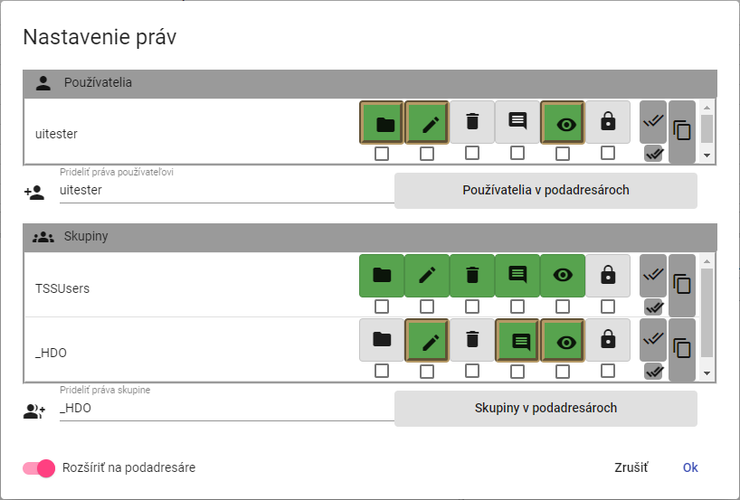

Image 173: Permission to "Extend to Submitters"

1. "Below the buttons representing user rights and group permissions will be checkboxes to tick. Tick the checkboxes below the buttons at which you want the right to be extended to subaddresses."

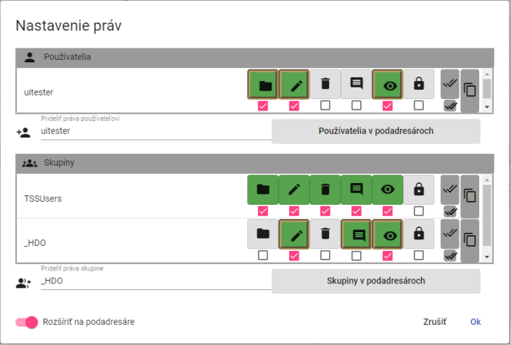

Image 174: User and group settings for sub-addresses

1. Press the "OK" button to save changes.

## How to create an export

"Before exporting profiles, proceed:"

1. No valid translation found.
2. Select item "Export profiles..."

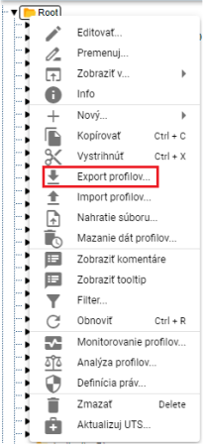

Image 175: Item "Export Profiles..."

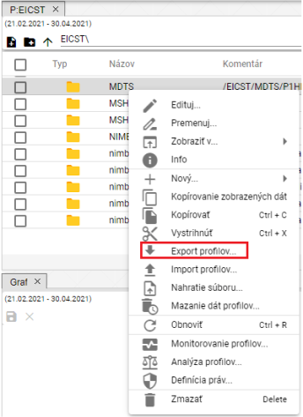

Image 176: Export item in Explorer's window

1. It will display the "Export" window, which contains two tabs, "Everything" and "Profiles (CSV)". The standard tab "Everything" is displayed by default. The "Everything" tab allows exporting counted profiles in a formula format. The "Profiles (CSV)" tab exports only data.

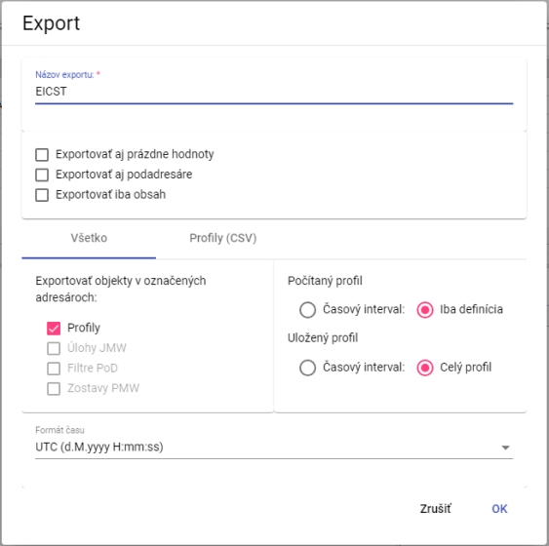

Image 177: Export window Tab All

1. "The field for 'Export name' is normally filled with the recipient's name from which you want to export profiles. You can also change the export name."
2. In the top part of the window, select what is to be exported (both subaddresses and empty values, or just content).
3. "In the 'All' checkbox in the 'Export objects to selected recipients' section, select which objects are to be exported."
4. Choose "Calculated profile" and select whether to export the "Time interval" or just the "Definition".
5. In the part "Saved Profile", select whether to export "Time Interval" or "Full Profile".
6. Choose time format in the “Format Time” area.
7. If you want to export profiles in CSV format, click on the tab "Profiles (CSV)".
8. "In the part 'Time Interval (mm/dd/yyyy)' select dates in fields 'Date from' and 'Date to'."
9. No valid translation found.
10. Click on the field "Decimal separator divider" and select the separator.
11. Choose time format from "Time Format".

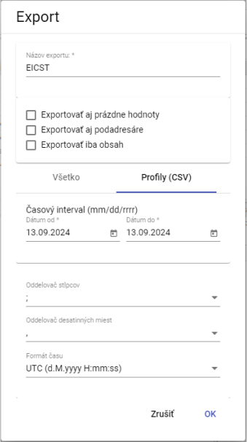

Picture 178: Export window Bookmark "Profiles (CSV)"

1. "Export is triggered by pressing the 'OK' button."
2. No valid translation found.

## How to create an import

Before creating an import, proceed with:

1. No valid translation found.
2. Select item "Import profiles..."

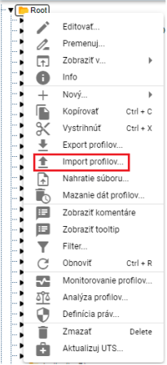

Image 179: Item "Import profiles..."

1. An import window will be displayed.

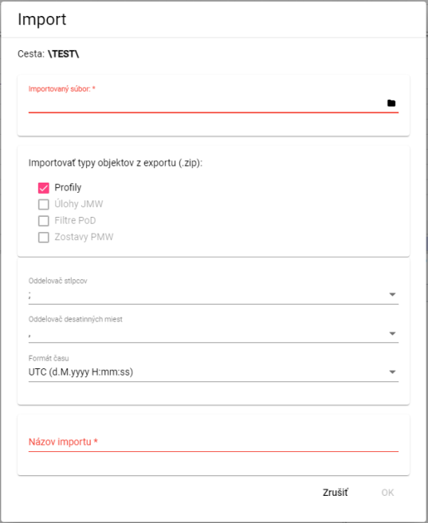

Picture 180: Window "Import""

1. **[OLLAMA FORMATTING ERROR - MANUAL REVIEW NEEDED] V časti „Importovaný súbor“ kliknite na čiernu ikonu súboru a vyberte súbor, ktorý chcete importovať.**
2. In the section "Import object types from export (.zip)" select what you want to import. The standard selection is "Profiles".
3. Click on the field "Column separator" and select a separator.

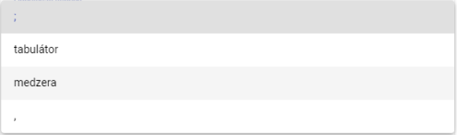

Image 181: Offer for item "Column separator"

1. No valid translation found.
2. In the field "Name of Import", enter a name for the imported file.
3. You will install by pressing the "OK" button.
4. "The selected recipient will display the imported file."



Image 182: Imported file

"Information about the state of imports will be displayed in the 'Imports' window, which is dealt with in Chapter 1.21."

## I'll add a new profile

Before adding a profile, proceed:

1. "Click on the right mouse button in the folder where you want to add a profile."
2. Choose item "New" and subsequently "Profile".

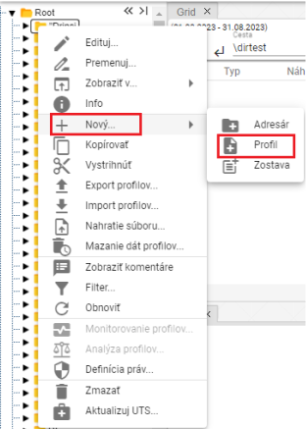

Image 183: Creation of Profile

1. "A window for creating a profile will appear."

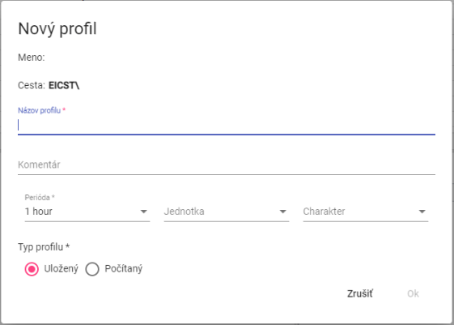

Picture 184: Window for profile creation

1. Enter data.
2. "The 'Profile name', 'Period' and 'Profile type' are mandatory."
3. No valid translation found.

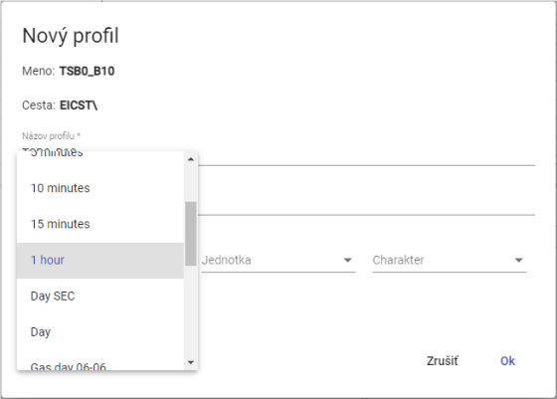

Image 185: Selection period

1. "If you choose a calculated profile type, enter the definition. For example, profileA+2*(profileC-2). The arithmetic options are described in the document „Xenergie TSS Kompl_prehl_fnc_G2 R12.xlsx“. Chapter 2.18.1 deals with creating a definition for a calculated profile."

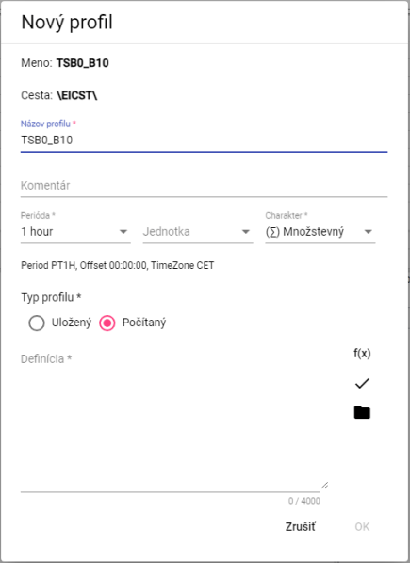

Image 186: Calculated profile type

1. Create a profile by pressing the "OK" button.

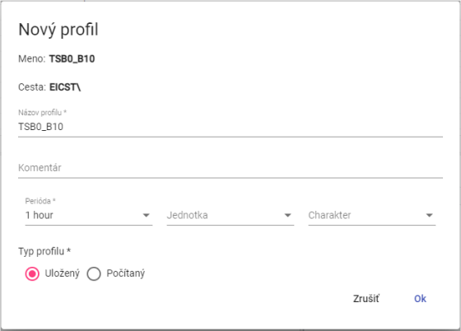

Image 187: Stored profile type

No valid translation found.

"• Quantitative - represents the amount of something, for example energy consumption over a certain period."

"• State-dependent – represents the state of a certain quantity at a specific point in time. For example, temperature trend"

"Unregistered – If the profile does not explicitly define one of the two above-mentioned characteristics, the system will behave towards it as to an Event-based. This behavior was chosen with regard to maintaining back-compatibility from older versions of the Xenergie system and allows for a trouble-free transition to newer versions of the system."

The characteristic profile is used for identifying how values from the profile are converted to finer or coarser sampling. For example, values of 15-minute energy in MWh should be summed up at conversion to hours, while values of 15-minute power in MW should be averaged out.

"Character profile is used exclusively and only in conjunction with a need for profile conversion (conversion of the profile to another period) of the profile. In case of using the profile in its native period, this setting is irrelevant."

### What is the definition for a counted profile type?

"Before defining the profile type being counted, proceed:"

1. "Click the 'Wizard on Functions' button in the 'New Profile' window, which will display a window for entering functions."



Image 188: Wizard button on the menu

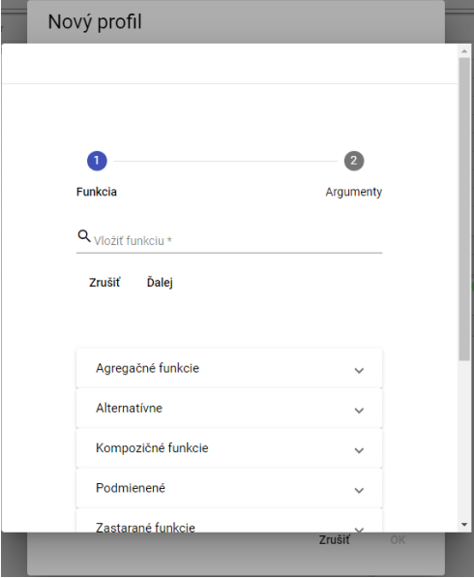

Image 189: Wizard before function assignment

1. Click into the field "Insert function".

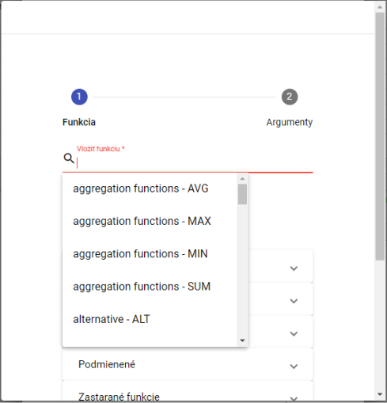

Image 190: Function selection

1. "A list of functions will be displayed, from which you select a function."
2. "After selecting a function, its description will be displayed."

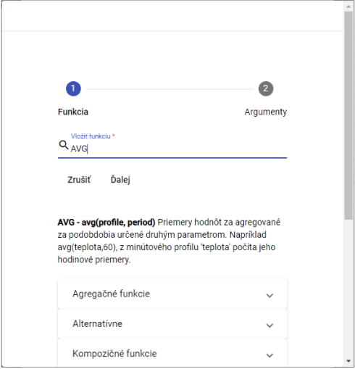

"Image 191: After selecting the function, a description of the function will appear"

1. By clicking on the function group, you will see a list of functions with descriptions.

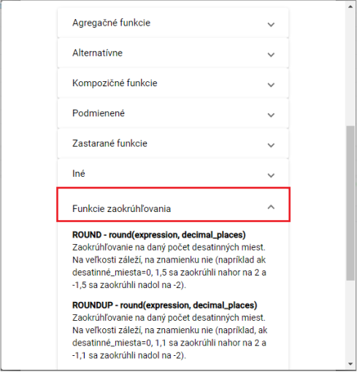

Picture 192: Description of functions

1. "Fill out the path to the profile or click on the button , which will display a window called 'Select Profile', where you select a profile."
2. Fill out the period.

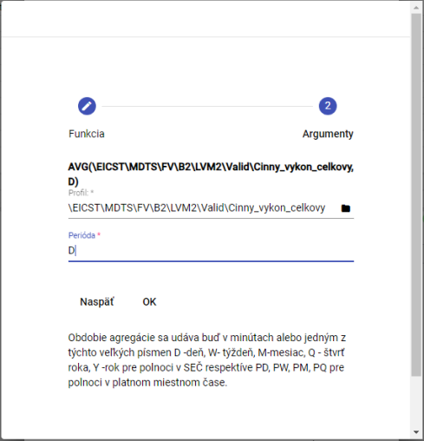

Picture 193: Assignment period

1. Press the "OK" button.
2. In the window "New profile" after entering the definition press the button "Check definition".

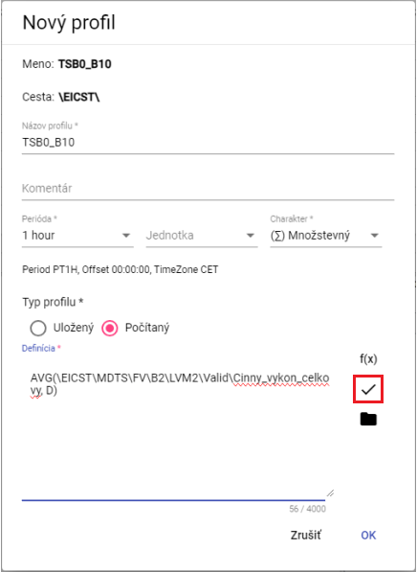

Image 194: Check Definition Button

1. "A window called 'Status' will be shown, which can be closed by pressing the 'OK' button."

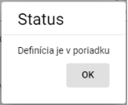

Image 195: The "Status" window

1. The button serves for adding profile.
2. **[OLLAMA FORMATTING ERROR - MANUAL REVIEW NEEDED] Profil uložíte stlačením tlačidla „OK“.**

## Add a new team

You will form a new team.

1. Click on the folder you want to add a new playlist to with your right mouse button.
2. Select the item "New..." and then select "Remain".

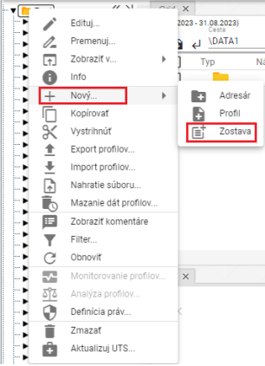

Picture 196: Item "Stay"

1. "A window 'Name of the list' will be displayed."

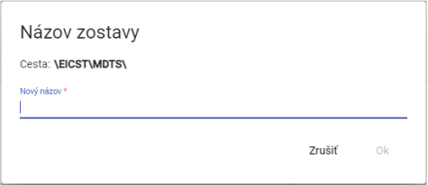

No valid translation found.

1. Enter a name for the new team. The team name must not start with a number. It can contain letters, numbers and underscores. The name must have at least 3 characters and at most 50 characters. If you do not enter a name or would enter an invalid name, information about the rules of naming will be displayed. Rules for submitting names may vary depending on the configuration of the given environment.

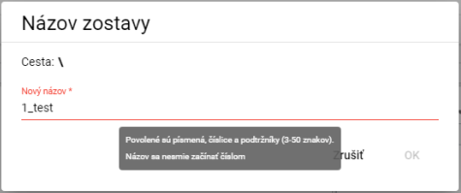

"Image 198: If the name is invalid, an information with naming rules will be displayed"

1. Press the "OK" button.
2. "A new team will be added to the selected player."

## How to change the profile

"Profile for you:"

1. "Click with the right mouse button on the profile you want to transform."
2. In menu, choose item "Rename".
3. No valid translation found.

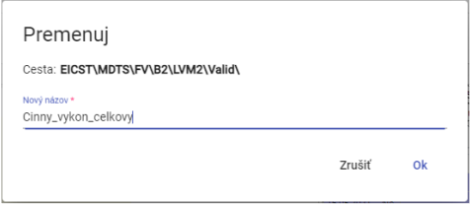

Image 199: Profile redefinition

1. "Changes will be saved by pressing the 'OK' button."

## Edit my profile

Before editing profile proceed

1. No valid translation found.
2. "Click on "Edit" in the right-hand menu."
3. "A window will appear where you can edit the data."

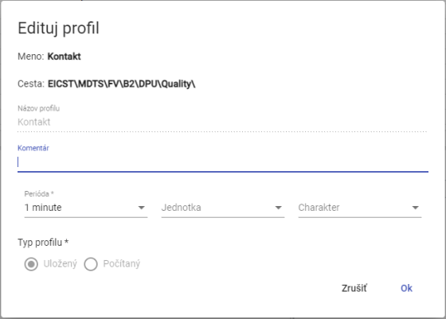

Picture 200: Edit window for profile

1. You will save changes by pressing the "OK" button.

## "To delete my profile"

Procedure for deleting profile:

1. No valid translation found.
2. Choose the option "Delete" in full screen mode.
3. "A window will appear where you confirm the deletion of your profile by clicking on the button 'Yes'."

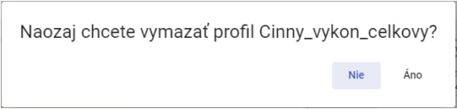

"Picture 201: Window for confirmation of erasure"

## "To show dependency profile"

"Show profile dependencies:"

1. No valid translation found.
2. Select the item "Dependencies".
3. A window with three tabs labeled "Used profiles", "Full definition" and "Dependent profiles" will appear. The first tab contains a list of used profiles.

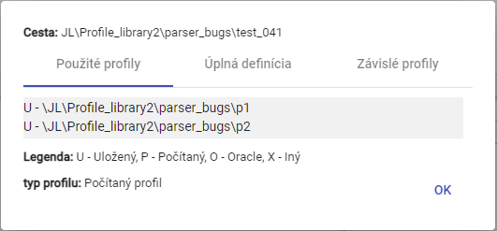

Image 202: Bookmark "Used Profiles"

1. "The second tab 'Full definition' contains the profile definition entered when creating a profile."

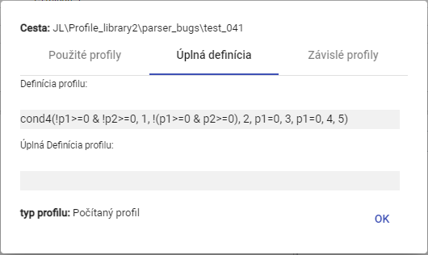

Image 203: Bookmark "Complete Definition"

1. The third tab "Dependent profiles" contains a list of dependent profiles.

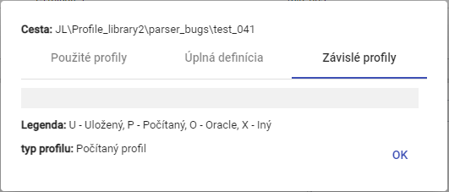

Image 204: Bookmark "Dependent profiles"

## How to create a new profile

In the inspector window, you create a new profile by clicking the "Create New Profile" button located in the top left corner of the inspector window. A "New Profile" window will appear. The process of creating a profile is detailed in Chapter 2.18.

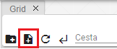

Image 205: Button "Create new profile"

## Set up my policy profile

"Politics define the special behavior of a profile. Politics are added to the system based on specific customer requests."

Time policy profile:

Profile time policy is a feature of the profile that allows for the solution of very specific cases of data transformation in profiles.

"One of the uses of politics is the possibility to change the time period stored in a profile from 1 hour to a 15-minute one without the need for gradual and slow data transformation. After applying the policy '1h to 15min', the originally hourly stored profile becomes a 15-minute one, across the board. All applications that use this profile will see it as 15 minutes since the moment of transformation. The policy is therefore fully transparent to other apps outside of TSS."

"The '1h to 15min' policy must have a fixed date of change in it, from which the profile will be used as fully 15-minute-long. Before this date, the profile will show up as 15-minute long, but all four values within the hour will always be identical. Their value will depend on the specified character of the profile."

No valid translation found.

No valid translation found.

"According to this, the "Process-type" character is set for the period of ten hours. Therefore, after setting the policy, a 15-minute profile will return a value of 100 MWh every 15 minutes in each hour."

Before setting policy, proceed:

1. "Click the right mouse button on a profile in the hierarchical structure you want to set up policies for."
2. Select item "Policy".
3. "A window called 'Policy settings' will appear."

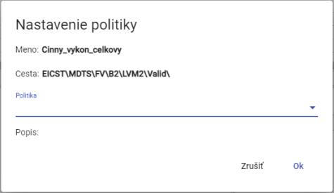

Image 206: Window "Policy Settings"

1. "Currently, two policies are available"

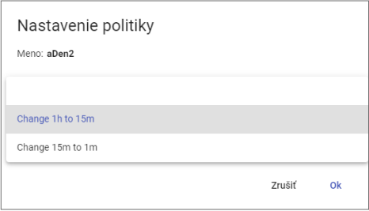

Image 207: Selection of Politics

1. You will save changes by clicking on the button „OK“.

## How do I view information about my profile?

No valid translation found.

1. No valid translation found.
2. Choose the item "Info"
3. "A window with information will appear."

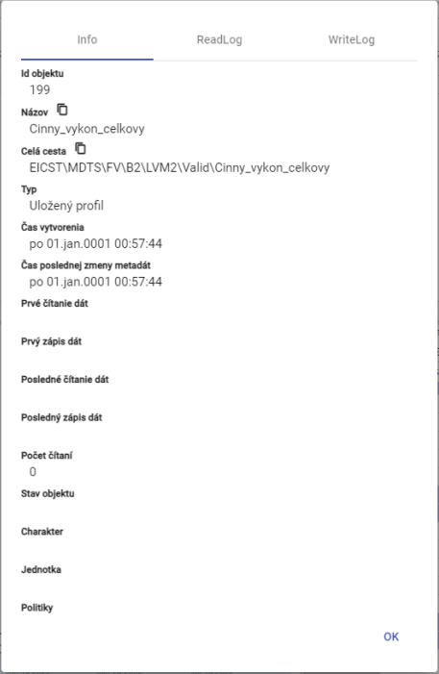

Profile information 208: Picture

## Copy profile

"Before copying your profile, proceed:"

1. No valid translation found.
2. Choose the item "Copy"
3. Click the right mouse button on the folder to which you want to paste the copied profile and select the item "Insert".
4. The window "Move/Copy" will appear.

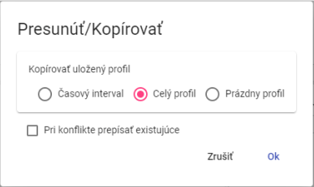

Image 209: Move/Copy Window

1. "Choose whether to copy only the time interval, the full profile or an empty profile. The standard selected item is 'Full Profile'."
2. Press the "OK" button.

"The saved profile can be copied from one recipient to another by catching the profile with the left mouse button and dragging it over the folder where you want to copy the profile."

"Before copying the addressee, proceed:"

1. "Copy the directory and move it into the one where you want to paste your profile."
2. "Next click on the address book over the addressee, which will then display a window called „Move/Copy“."

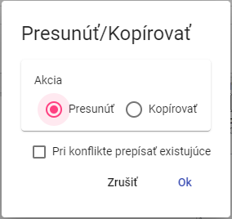

Image 210: Window for profile transfer

1. Click on the action "Copy".

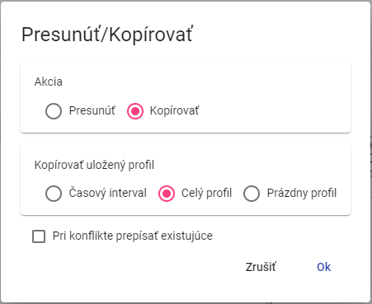

Image 211: Window for copying profile

1. No valid translation found.
2. "Choose a time interval and enter the time interval to be copied."

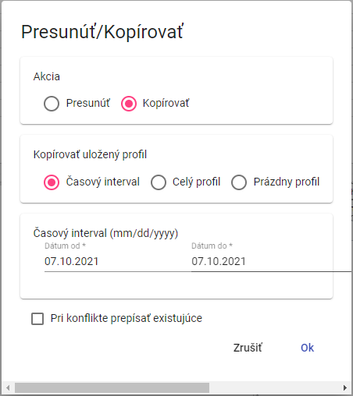

Image 212: Window for copying a stored time interval profile.

1. "Checking the box 'Overwrite existing in conflicts' means that if there's an account with the same name as the one you're trying to copy, it will be overwritten. If you don't check the box and a conflict occurs, the original account will remain intact."
2. "Copy the profile by clicking on 'OK'."

## "Refresh/Move profile"

"Proceed with profile creation:"

1. "Click with the right mouse button on the profile you want to pull out."
2. Choose item "Eject" on your behalf.
3. Click on the right mouse button on the folder where you want to insert the profile.
4. Choose the item "Insert".
5. "A window will appear for confirmation, where you click the 'OK' button."

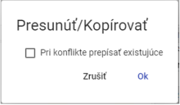

Window "Move/Copy" #213

"You can move the saved profile from one recipient to another by catching the profile with the left mouse button and moving it over the folder where you want to move it."

Please address the receiver:

1. Take the profile and move it into the recipient you want to move the profile into.
2. "Next, delete the recipient's profile over them, which will display a window "Move/Copy"."



Image 214: Window for profile transfer

1. "Checking the box 'Rewrite in conflicts' means that if there's an account with the same name as the one you're trying to move, it will be overwritten. If the conflict arises and you don't check this box, the original profile will be left unchanged."
2. You will save the profile by pressing the "OK" button.

## How to display a timeline in a tree structure

No valid translation found.

## "To enlarge the window for creating and editing the calculated profile"

"You can enlarge the window for creating and editing your calculated profile. Proceed:"

"Click the left mouse button - and drag. Resize the window to desired size and click the left mouse button."

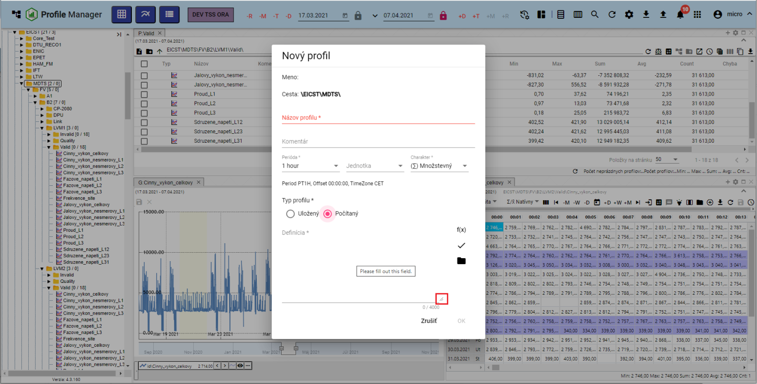

No valid translation found.

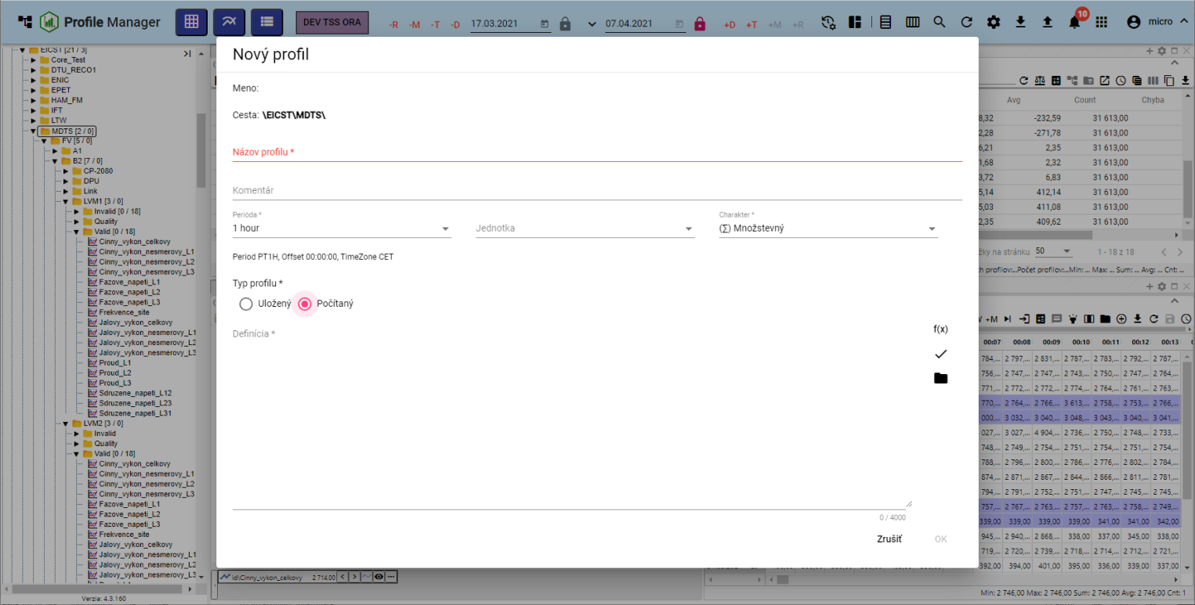

Image 216: Enlarged window "New Profile""

## I want to install windows.

"Move the windows in the application 'Profile Manager' by catching the top of the window with the left mouse button and moving the window to the desired location."

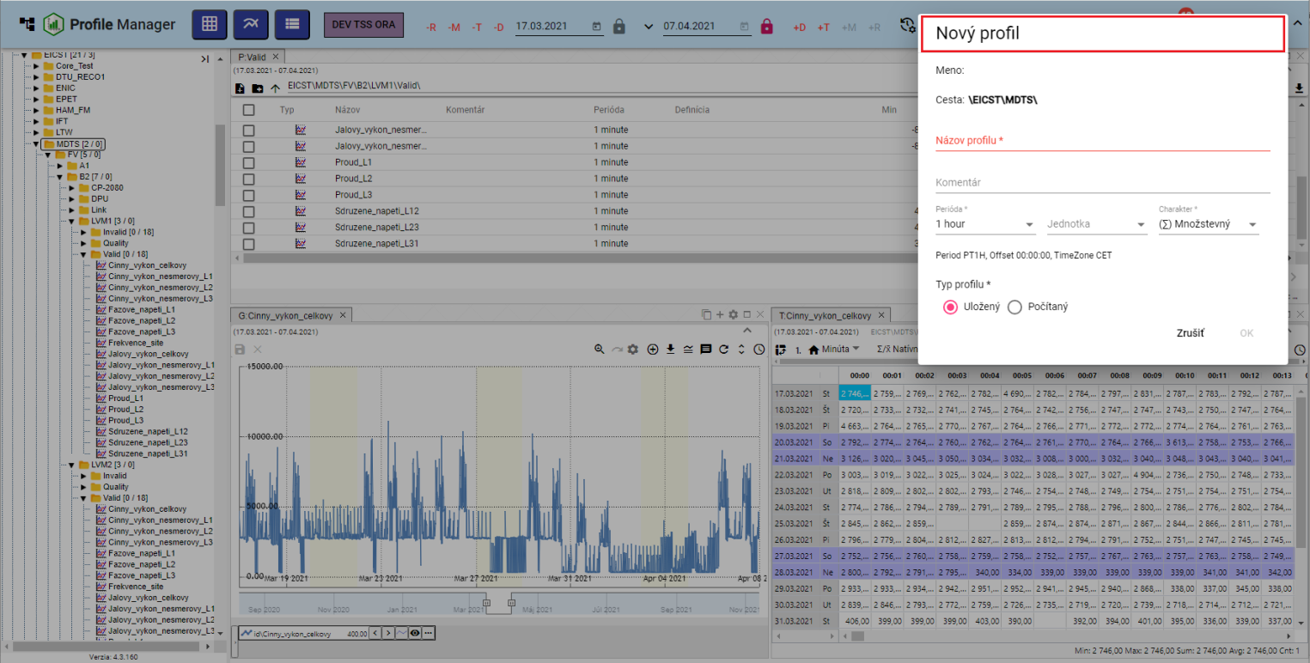

Image 217: Replacement of the window "New Profile"

## How to translate a document

"Document (for example, a roster or report), translate:"

1. Click on the document you want to convert with your right mouse button.
2. Select item "Rename" in properties.
3. "A window called 'Convert' will appear."

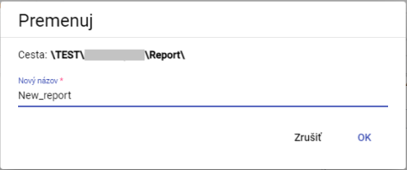

Window "Renew"

1. Change the title.
2. Press the "OK" button.

# No valid translation found.

"In the upper part of the window, a tool bar, table and graph are located along with buttons for manipulating windows. The work with buttons is elaborated on in the following subchapters."

## "Restore data in windows"

"Before the data download click on the button showing Image 219."



Image 219: Restore button for data in the browser's inspector, table, graph

## How to change the date range

"Date range in explorer window, table or graph you will change:"

1. "Click on the button 'Change time frame', which is located in the top-right corner of the window."



Picture 220: Button "Change time span"

1. "A window for setting date range will be shown."

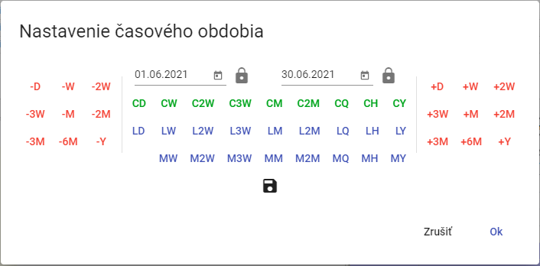

"Picture 221: Window for changing date range"

1. "You can set the date by pressing buttons, selecting a date or by typing it in directly."
2. You can save a new date range by pressing the floppy disk button. A maximum of 3 date ranges can be saved.



Image 222: Save date range button

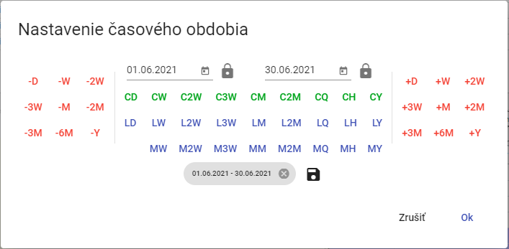

Image 223: Stored date range

1. "Date range is started by pressing the 'OK' button."

## "If I enlarge the window across the whole app surface"

"Click the 'Maximize' button (Figure 224) or double-click on the top bar of the window (Figure 226) to enlarge the graph, inspector and table. The window will then appear across the entire application area. After clicking the 'Maximize' button, a 'Restore Size' button will appear in its place, which serves to restore the original size of the window. You can also minimize the enlarged window by double-clicking on the top bar of the window."



Image 224: Maximize button



Image 225: Button "Restore size"

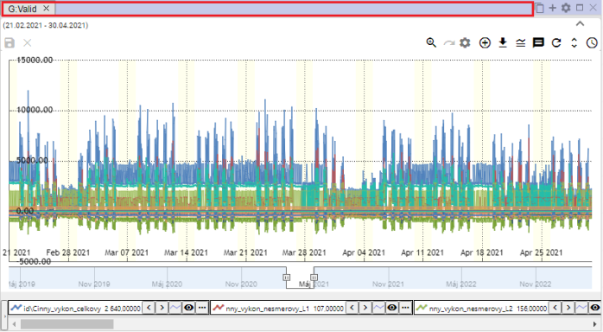

Picture 226: Top row of the panel

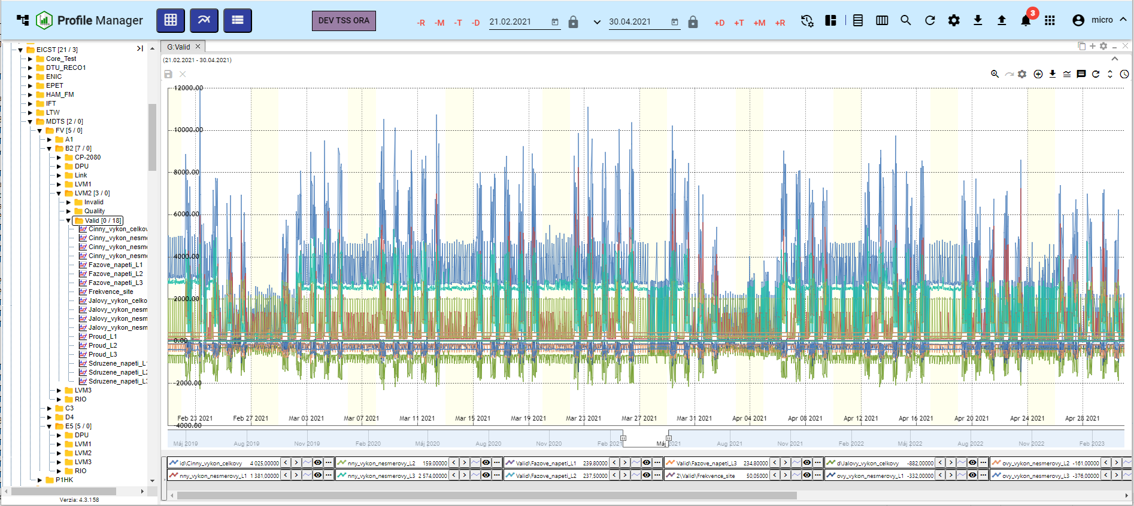

Image 227: Window enlargement of chart

## If you close the window

"Click the 'x' button located above and to the right of the window's title bar to close the graph, explorer, and table."



Image 228: Close button for closing the window

## Setting name and color of the panel

The panels have standard names Explorer, Table and Graph. You can change the name and color of the panel as follows:

1. "Click on the button 'Panel settings', which is located in the top right corner of the window."



Image 229: Button "Panel settings"

1. "A settings window will appear."

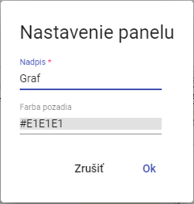

Picture 230: Settings window

1. In the field "Title", please enter your title.
2. "You can set the background color by clicking on the field 'Background Color' and selecting a color."

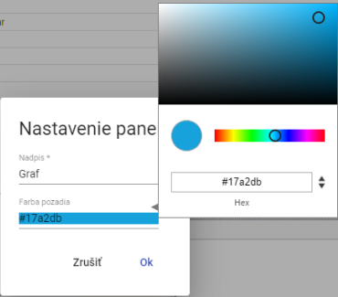

Image 231: Color selection

1. "Save changes by pressing the 'OK' button."

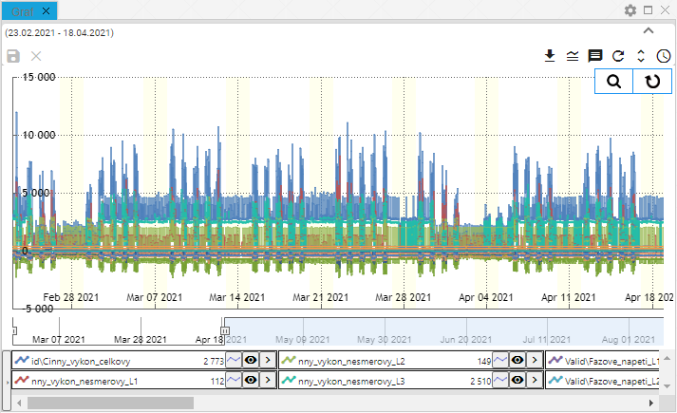

Picture 232: Altered paint color of the panel

## How to export shown data from Explorer window

"The data displayed can be exported to a window, table or graph by clicking the export button. Image 233."



Picture 233: Export button

## No valid translation found.

"The top part of the explorer, table and graph can be hidden using a button that displays Image 234. To display the upper part in windows again, click on the button again, Image 235."

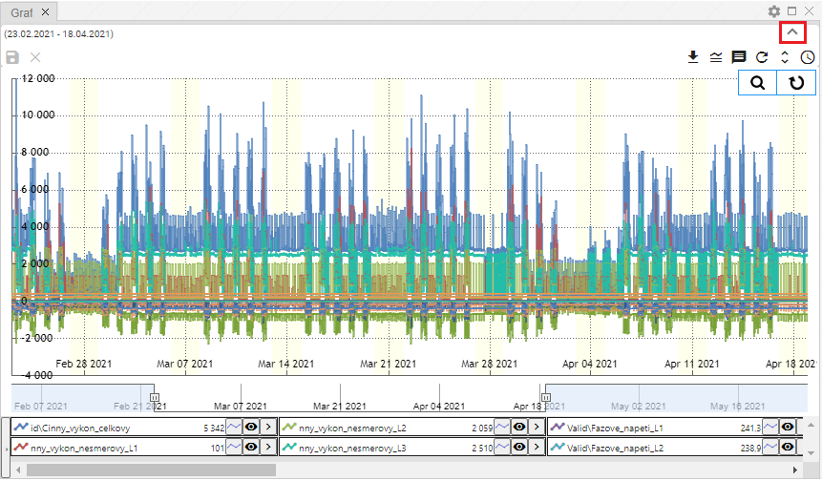

Image 234: Button to hide the upper part in windows, explorer, table and graph.

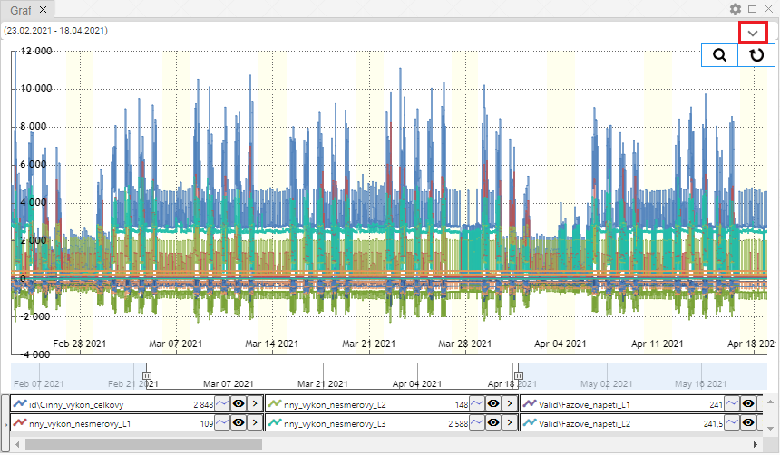

Image 235: Button to display top section in Explorer, table, and graph

## No valid translation found.

"In the graph window and table you can add a profile according to the following procedure:"

1. "Click the 'Add Profile' button, which can be found at the top part of a chart or table."



Image 236: Add Profile Button

1. An "Add Profile" window will be shown.

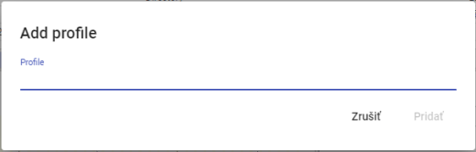

Image 237: Add Profile window

1. "Provide the path where the profile is stored."

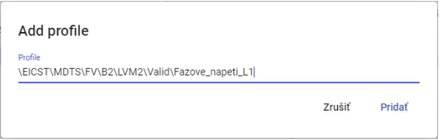

Image 238: Task Path Profile

1. Click on the "Add" button.
2. The selected profile will be added in the graph/table window.

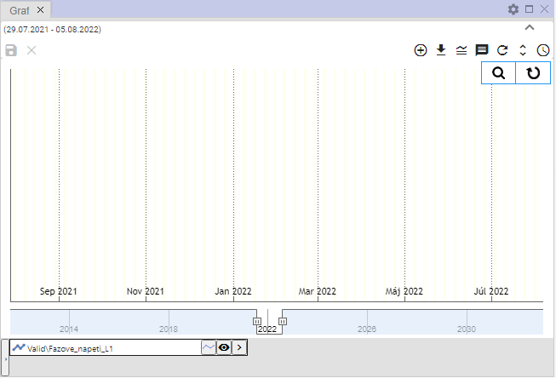

Picture 239: Added profile in graph window

# "Work with a window Detector"

After launching the "Profile Manager" application, the window explorer is filled with directories and profiles from a tree structure. During work with the application you can open any number of windows explorer.

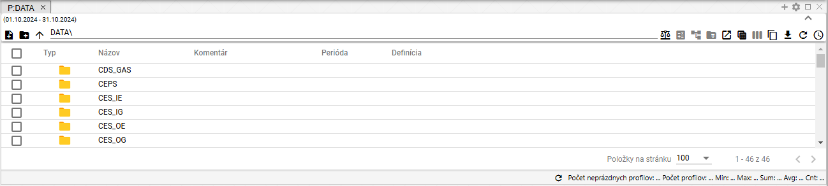

No valid translation found.

## No valid translation found.

In the Prieskumník window, addresses and profiles from a tree structure are standardly displayed. You will display the profile of the selected address by double-clicking on the left mouse button on the "Type" column's button.

"You can reverse-list the recipients by clicking on the arrow"

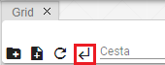

Image 241: Back button

## How to create a new folder

"In the Search window you can create a new folder by clicking on the 'Create New Folder' button. A window titled 'New Folder' will appear. The process for creating a folder is described in Chapter 2.1."

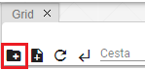

Image 242: Create New Folder button

## I synchronize the scanner with the tree

No valid translation found.



Picture 243: Synchronization button with tree"



"Picture 244: Broken synchronization with tree"

## I'm filtering my profile

You can filter the displayed profiles in the explorer window by individual columns. Proceed:"

1. "Use your mouse pointer to select the name of the column on which you want to apply a filter."
2. "Click on the button and a window for entering the filter will appear."



Image 245: Button for filtering

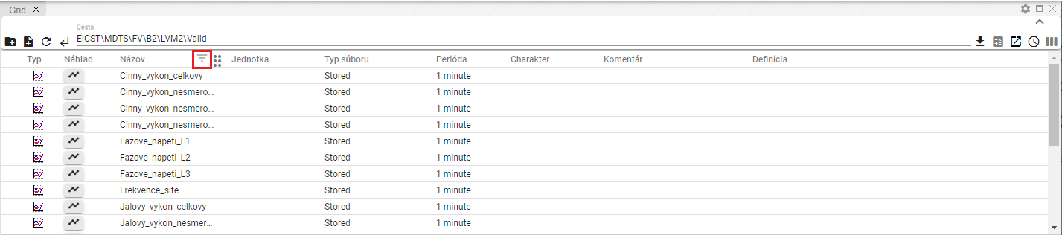

Image 246: Button for filtering over the column "Name"

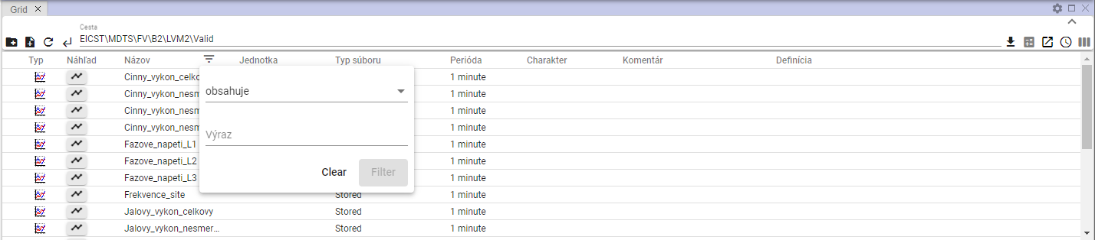

Image 247: Window for filtering

1. Enter filtering criterion.

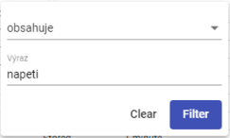

Image 248: Task of filtering criteria

1. Press the "Filter" button or press the Enter key.
2. "The profiles appear that meet filtering criteria."

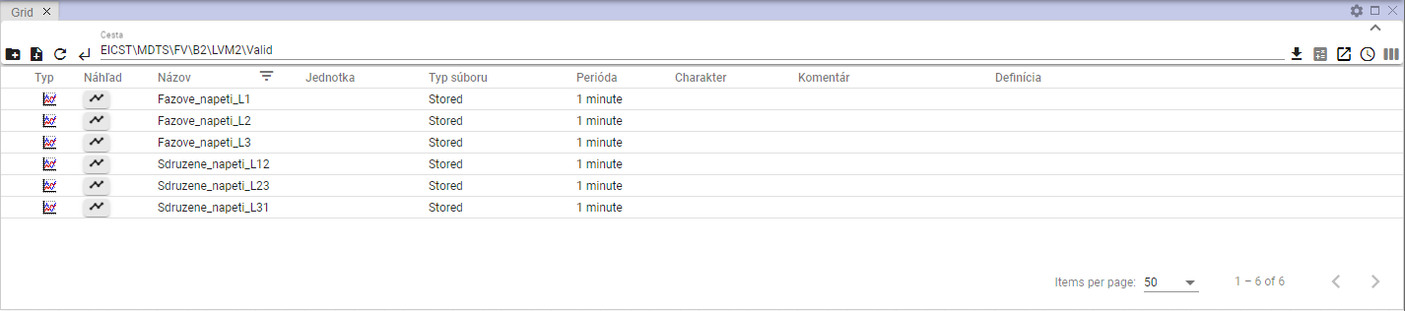

Image 249: Applied Filter

1. Under the button, on which an applied filter is shown.
2. "You will cancel the filter by clicking on the button, which will then display a window for filtering and subsequently pressing the 'Clear' button."

## I want to sort data by columns

"Before sorting the data in the column, place the mouse cursor on the name of the column and click on the arrow icon that appears next to the column name."



Picture 250: Sort button for sorting data in a column

## How to calculate values in columns Min, Max, Sum, Avg and Count in the window Explorer

"Before calculating values in columns in the explorer window, proceed:"

1. In the window, display profiles of the recipient(s) to whom you want to calculate total values.

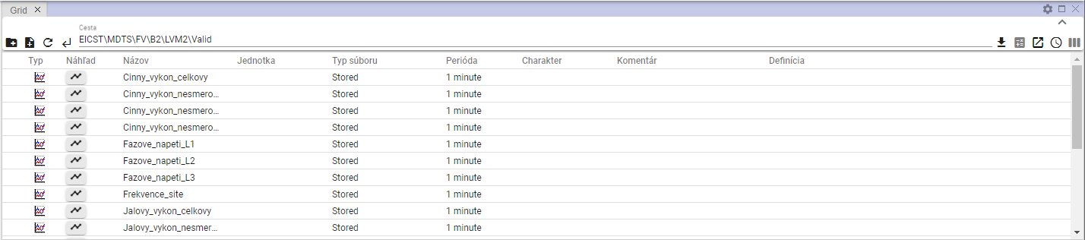

Image 251: Displaying recipient in a browser window

1. Press the button "Statistics".



Image 252: Statistics button

1. These values are supplemented in the columns "Min", "Max", "Sum", "Avg" and "Count".

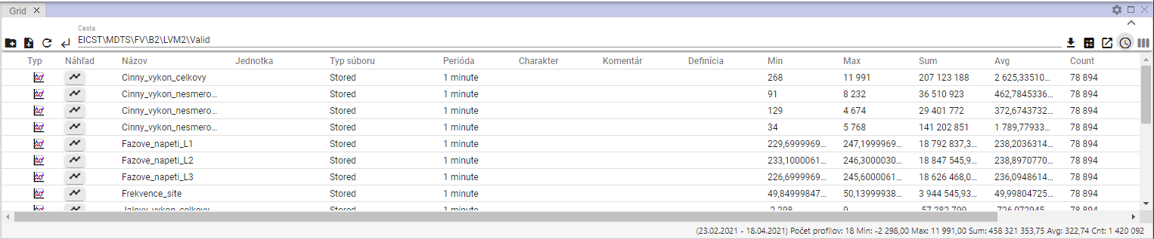

Image 253: Calculation of statistics in the explorer window

## A glance at the time line

"Before viewing the time table, proceed:"

1. "In the window 'Explorer' in the column 'Type', click twice with the left mouse button on the profile button whose time chart preview you want to display."

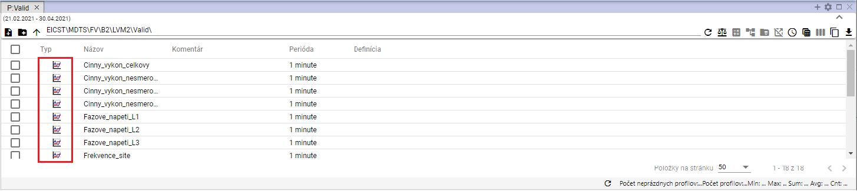

Image 254: Button for displaying the "Timeline Preview" window

1. "A window called 'Time line preview' will appear."

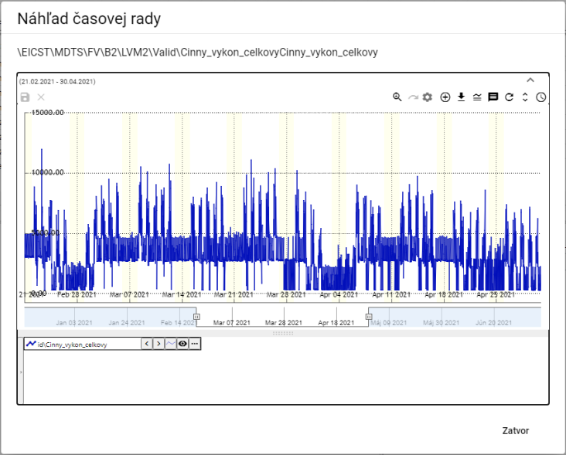

Image 255: Window "Timeline Viewer"

1. The tasks relating to the buttons located in the upper right corner of the graph are dealt with in Chapter 5.



Picture 256: Tools for working with graph

1. "At the bottom of the window, you can see the profile name. Clicking on the right mouse button at the profile name will show a list of functions related to the profile work. These functions are detailed in chapter 5.7."

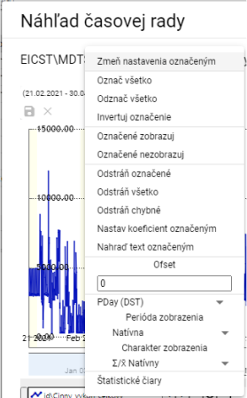

Image 257: Functions for working with profiles

1. "Clicking on the arrow next to the profile name will display a window with features that are detailed in chapter 5.8."

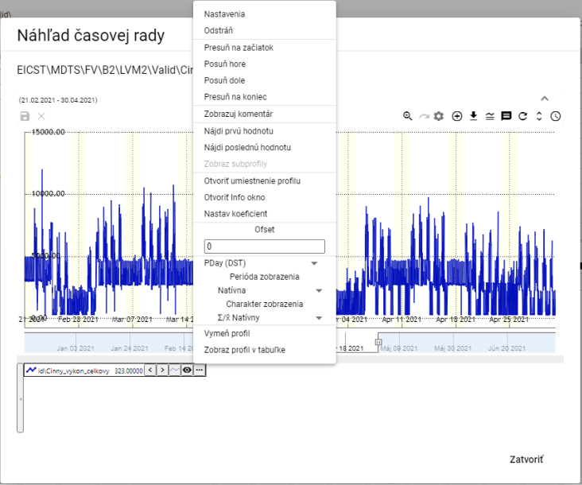

Image 258: List of features for working with profiles

## "Move profile from Explorer window into Graph or Table window"

You can drag the Browser into the Browser or Table views. The Address Book in the Browser view can be dragged into the Chart window. The Profile located in the Browser view can be selected and dragged into the Chart or Table window.

Proceed:

1. "In the Prieskumník window you set the cursor on the address line or profile of which you want to move into the Graph or Table window."

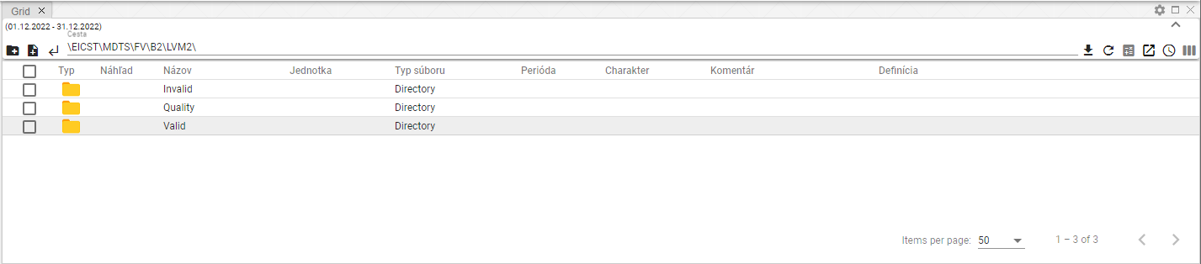

Image 259: Selected Profile

1. No valid translation found.

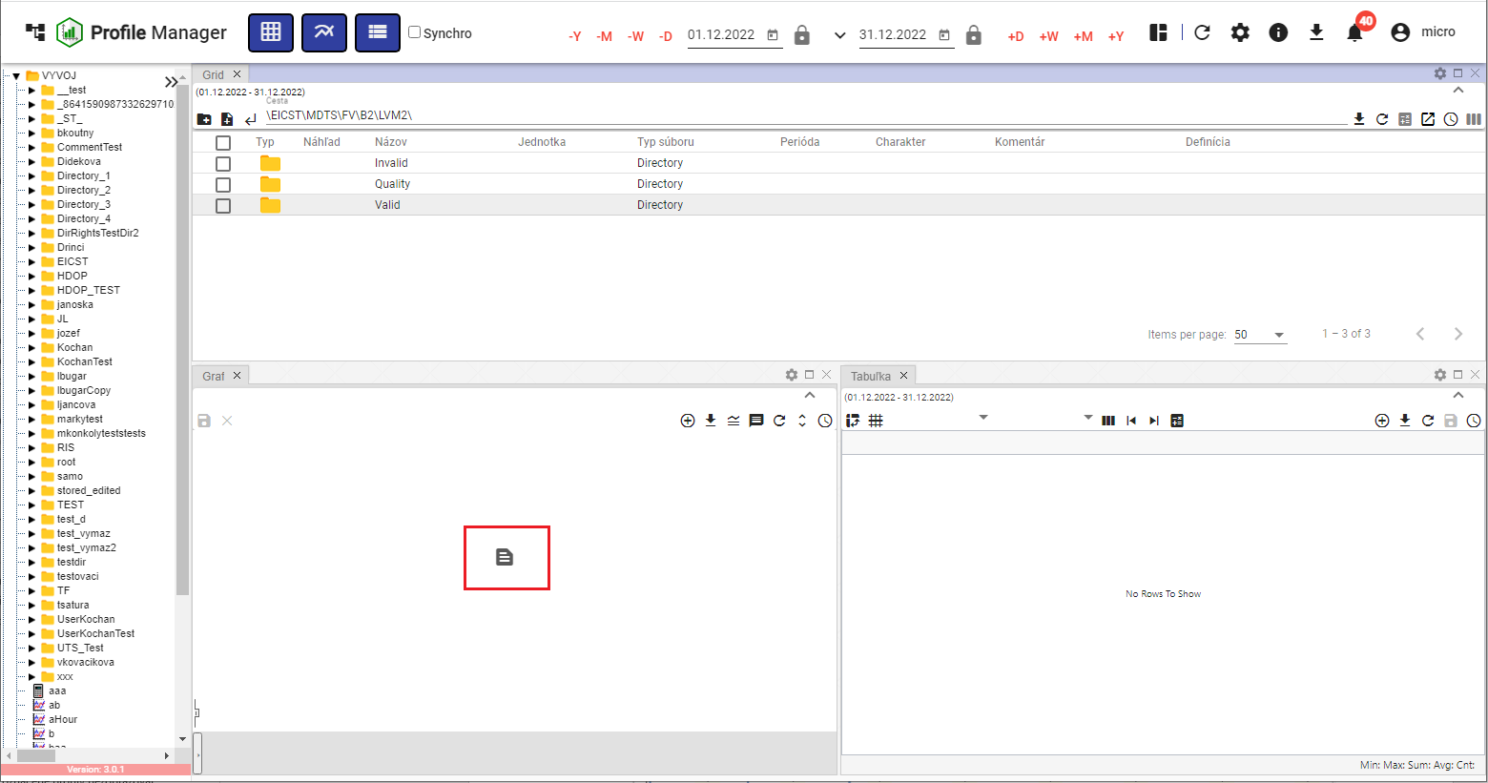

The Image 260: Profile moved into the Window of Graph

1. "The profile will be displayed in the selected window."

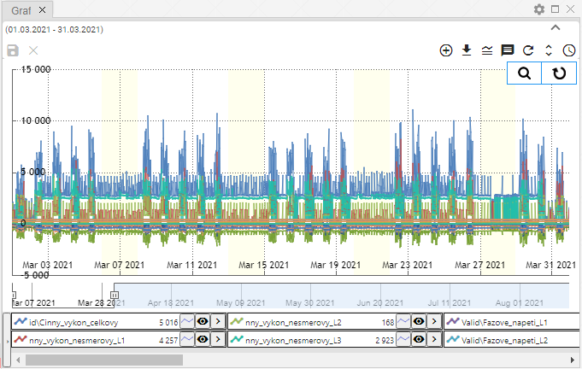

"Image 261: Profile moved from Window Explorer to System Information window"

## How to add, remove or pin a column in the Windows Explorer window.

"You can change the list of columns shown in the window Explorer. You can add columns or remove them."

"Before change of shown columns:"

1. "Press the 'Columns selection' button, which is located in the right top corner of the Explorer window."

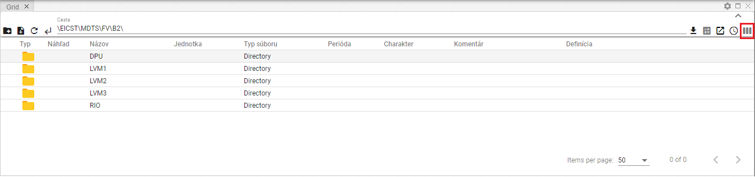

Picture 262: Select columns button

1. It will display a block with a list of columns.

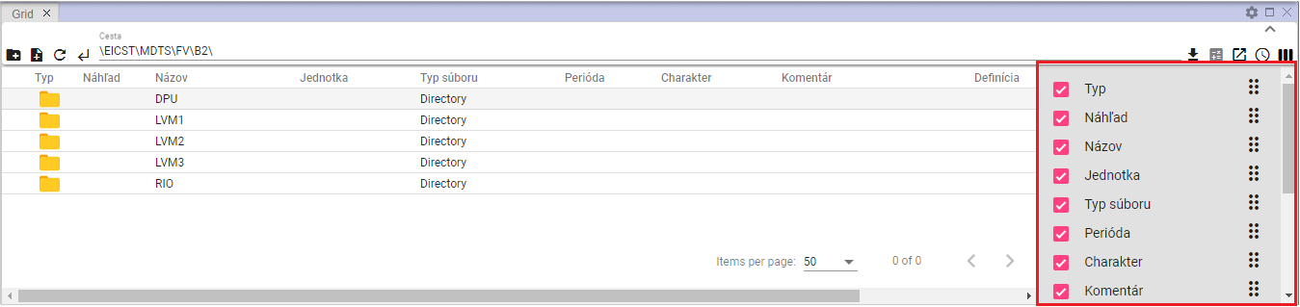

Picture 263: Column List

1. "Add/Remove columns that are supposed to appear. When editing the list of selected columns, it will automatically affect the window inspector."
2. "You can change the column order in the preview window. If you want to change the column order, grab the 'move column' button and drag the column to its desired position in the list."

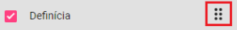

"Image 264: Button for column relocation"

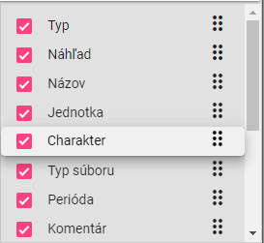

Image 265: Relocation of the "Character" pillar

## Edit fields Name and Comment

"For profiles and addresses, you can edit 'Name' and 'Comment' in the Finder window."

"Proceed with caution:"

1. Click twice with the left mouse button on the field to access it for editing.

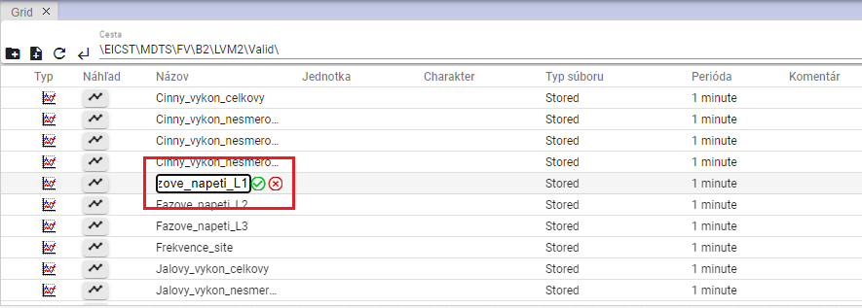

Profile picture edit (note: Obrázok is Slovak/Slovenian for "picture/image" and Úprava názvu profilu translates directly to "profile name edit")

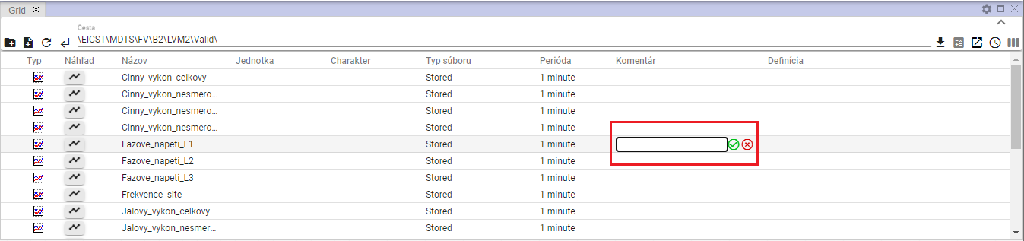

Image 267: Assignment of comments for profile

1. Edit the text.
2. Save changes by pressing the button .

## No valid translation found.

"Functions for work with your address will be displayed by clicking the right mouse button on the folder in the File Explorer window. Working with functions is detailed in Chapter 2."

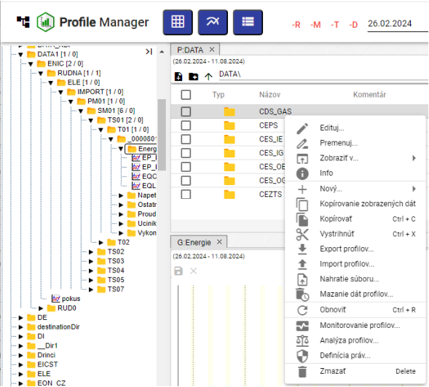

Picture 268: List of functions for working with address books

## Functions for work with filters in Prieskumnik window

"Functions for working with profiles are shown by clicking the right mouse button on a profile in the Explorer window. Working with functions is further discussed in Chapter 2."

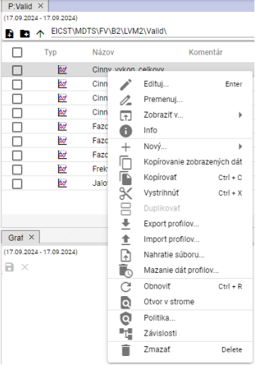

Image 269: List of features for working with profiles

## The button View branch

"The 'Branch view' button allows batch operations to be performed on all profiles in the database, regardless of which address book the profile is located in. From these batch operations, it is possible to use 'Edit' and 'Delete'."

"Clicking the 'Branch view' button will show items from the selected address book without categorization into subfolders, Image 271. For standard address book display in the Explorer window click again on the 'Branch view' button."

"Procedure for mass editing profiles:"

1. "Click on the 'Branch View' button, which will display a list of profiles without senders."

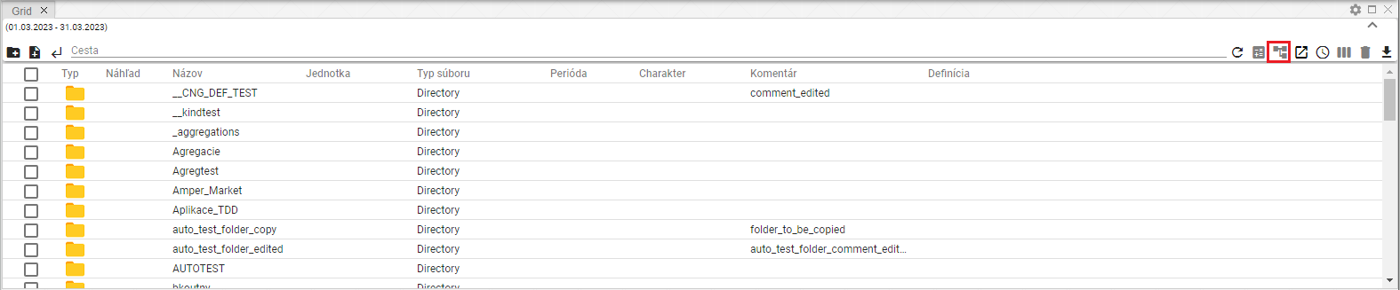

"Image 270: Button 'Branch view'"

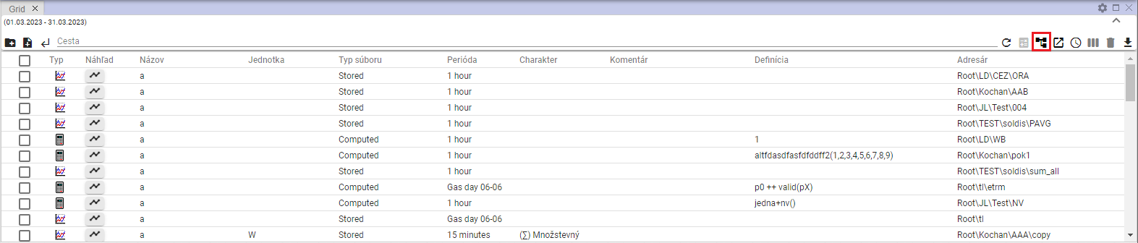

Image 271: Displaying profiles without dividing them by recipients

1. "Apply a filter so you can get the list of profiles on which you want to perform mass operations."

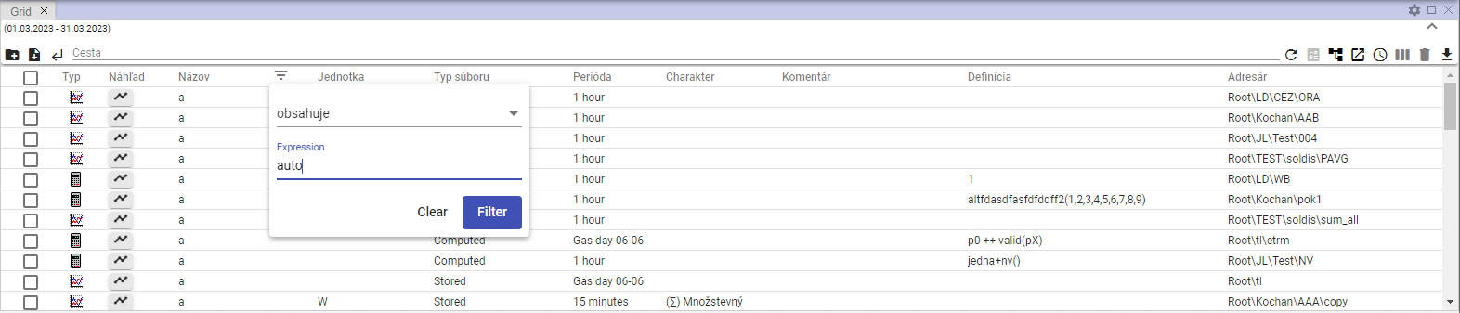

Image 272: Filter task

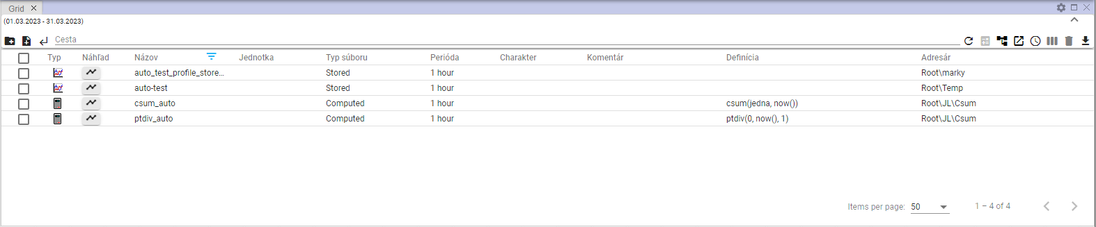

Image 273: Filtered items

1. By clicking the first checkbox, select profiles that will be operated collectively. If you want to select all profiles, click the first checkbox and other checkboxes will be marked automatically.

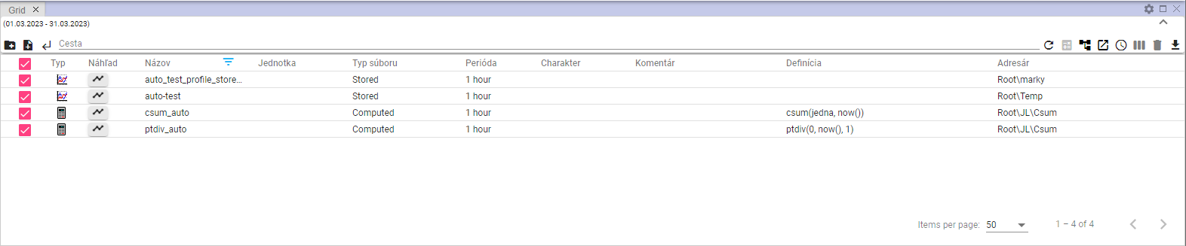

Image 274: Selected Profiles

1. Click the right mouse button anywhere on the selected profiles and select the item "Edit".

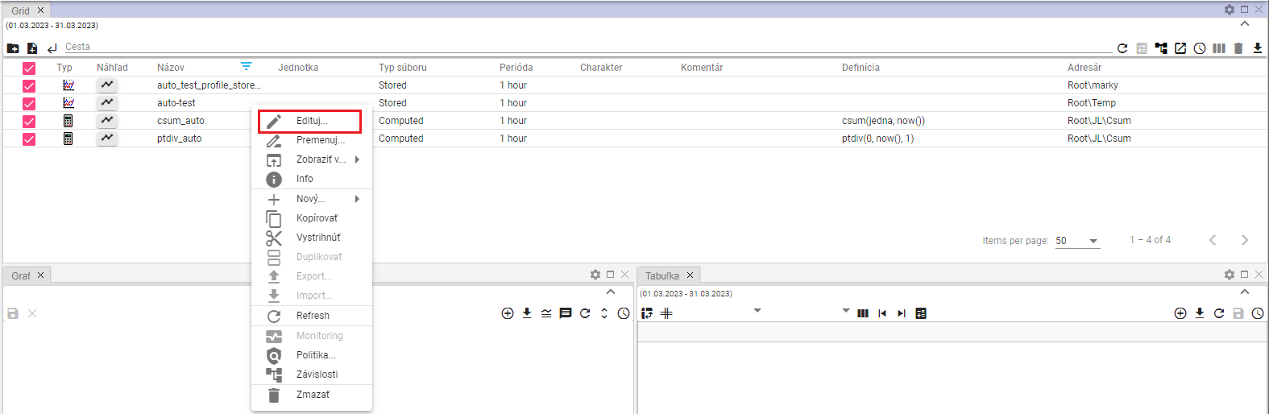

Image 275: item "Edit"

1. "A window called 'Bulk Editing' will appear."

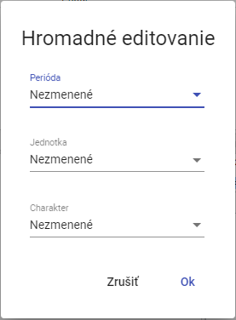

Picture 276: Window "Mass Editing"

1. You can edit fields “Period”, “Unit” and “Character”.
2. "Save changes by pressing the 'OK' button."

## "Show deleted items in Explorer window"

"The 'Trash' button in the Explorer window is used to show deleted items. The button is normally inactive (gray). After clicking, it turns black. To stop displaying deleted items, click on the 'Trash' button again. Subsequently, the addresses and profiles from the tree structure will be displayed in the Explorer window."



Image 277: "Pencil" button - inactive



Picture 278: Button "Kôš" – active

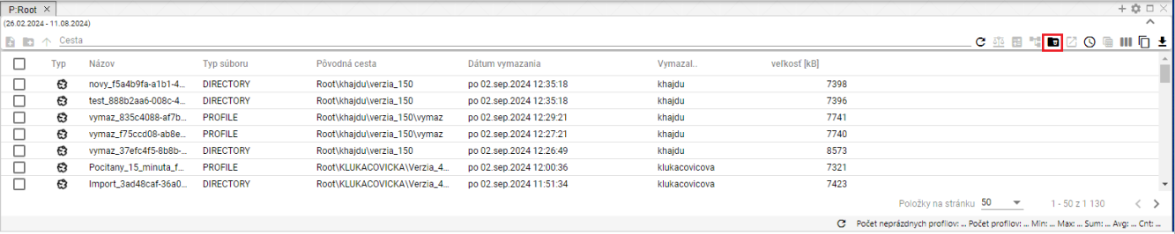

No valid translation found.

## I will copy the displayed data

"The 'Copy displayed data' button, Image 280, serves to copy data from the 'Explorer' window. Image 282 shows the copied data."

Proceed:

1. "In the window explorer show data that you want to copy."
2. If you want to copy all the displayed data, click on the button labeled "Copy Displayed Data".

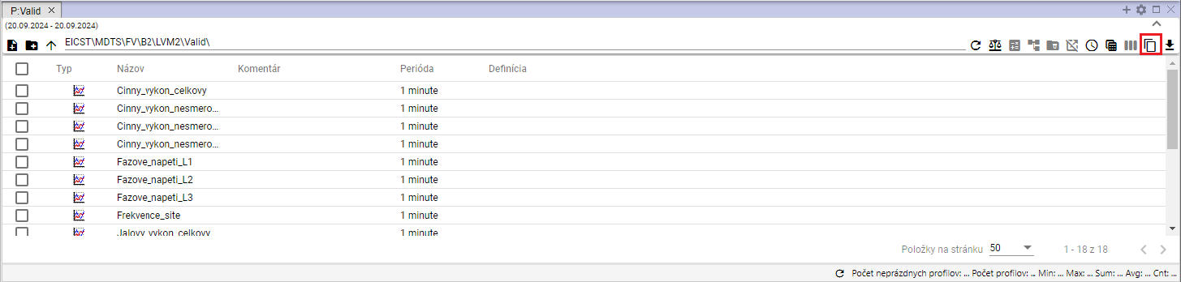

Image 280: Button "Copy shown data"

1. "If you want to copy a specific folder or folders, select the selected files in the explorer window. Click on the selected files with the right mouse button and select the item 'Copy displayed data'."

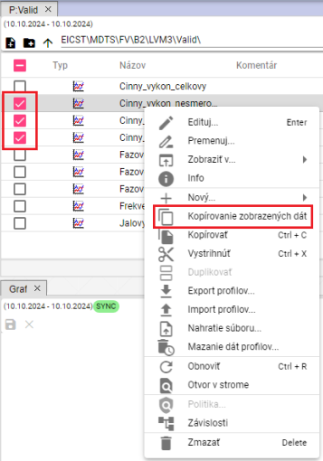

No valid translation found.

1. Copied data can be inserted into the Microsoft Excel program.

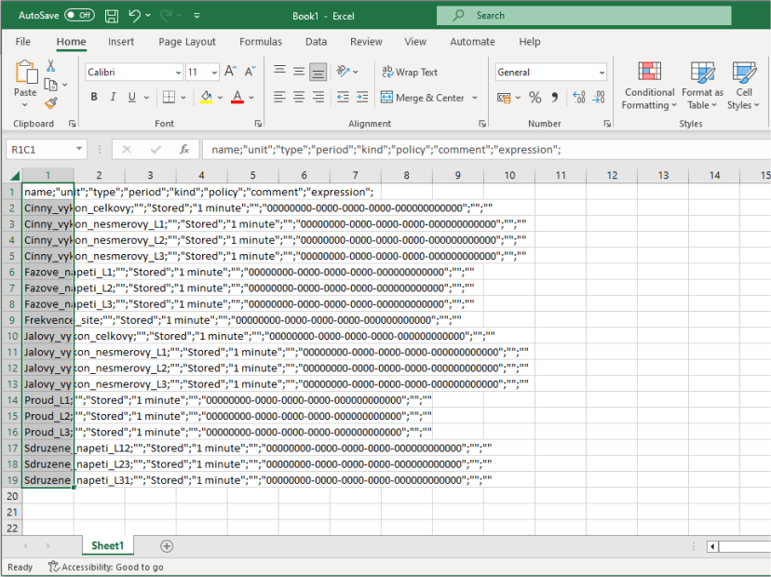

Picture 282: Data copied into MS Excel

## Use as default settings Scanner

"Currently, you can set up column settings as default. When opening a new explorer or the 'Profile Manager' application, saved column settings will be displayed."

"If you want to set the Explorer columns configuration as default, follow:"

1. "Click the button 'Use as starting settings of Explorer', which is located in the top right corner of the window of Explorer."



Picture 283: Button "Use as starting settings Scouting"

1. No valid translation found.

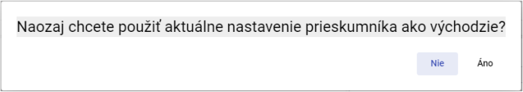

"Image 284: Window for confirming the saving of outgoing scanner settings"

## I filter columns using the * wildcard

"In the search bar you can filter through columns using wildcard, using *."

No valid translation found.

* "All that starts with the entered text will be found"
* **[OLLAMA FORMATTING ERROR - MANUAL REVIEW NEEDED] *Text - vyhľadá sa všetko, čo končí na zadaný text**
* **[OLLAMA FORMATTING ERROR - MANUAL REVIEW NEEDED] *Text* - vyhľadá sa všetko, čo obsahuje zadaný text**

"Example: Cinny* - search everything that starts with 'Cinny'"

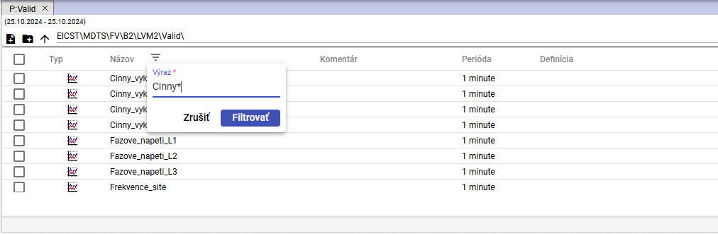

Image 285: Filter task for searching profile names starting with "Cinny"

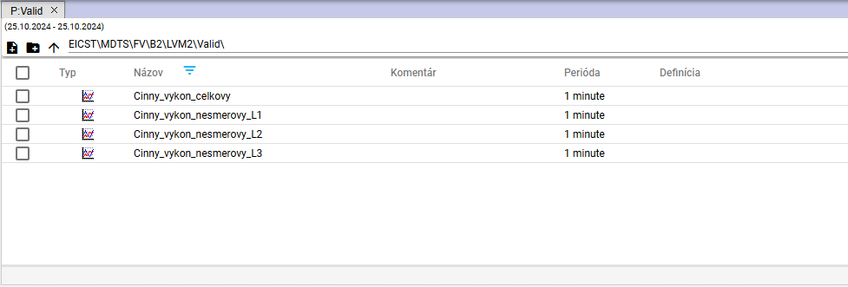

Image 286: Search profiles starting with "Cinny"

**[OLLAMA FORMATTING ERROR - MANUAL REVIEW NEEDED] Príklad: *L2 - vyhľadá všetko čo končí s textom „L2“**

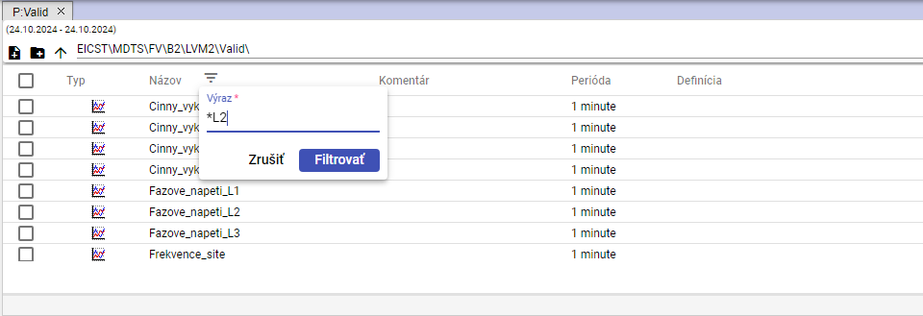

Picture 287: Task of the filter for searching names of profiles ending with "L2""

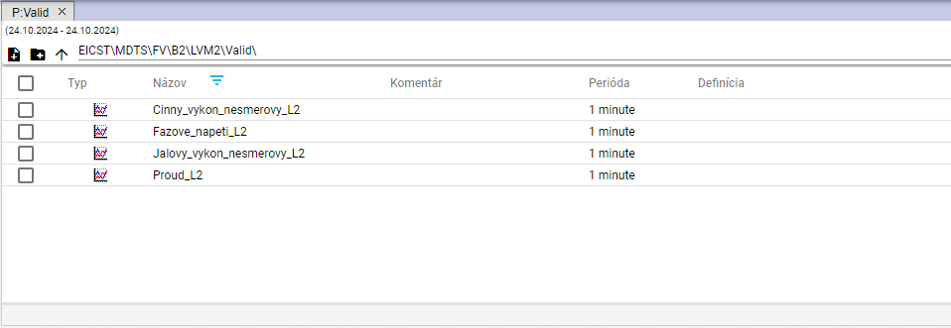

"Image 288: Search for profiles ending with 'L2'"

Example: *tension* - search for everything that contains the text "tension"

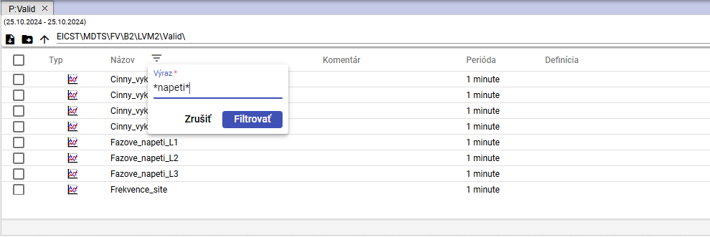

Image 289: Task of the filter for searching profile names containing the text "napeti""

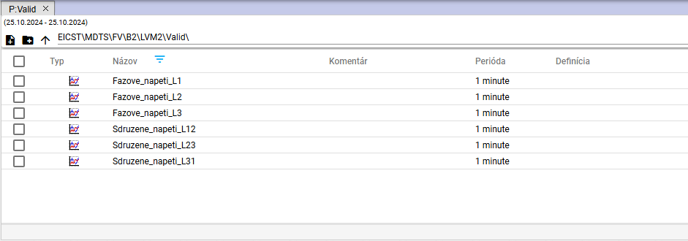

Picture 290: Search for profile names containing the text “napeti”

# No valid translation found.

"After launching the 'Profile Manager' application, a working window with an empty graph canvas will open. When working with the application, you can add any number of graph windows. In one graph, you can display any number of profiles."

## To view your profile in the graph

"Before displaying the profile in the graph window, follow:"

1. "The standard window is empty."

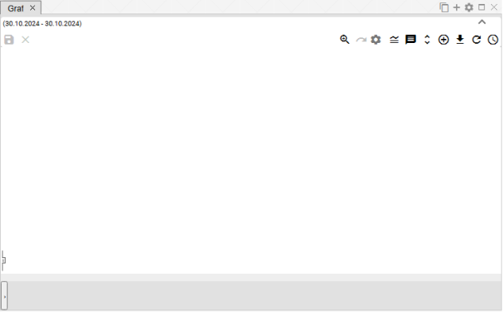

Image 291: By default, the window for displaying a graph is empty.

1. "In the profile stream, click on the left mouse button on the profile or address book icon and drag it into the graphics window. Dragged profile or address book icon in the graphics window, let go."

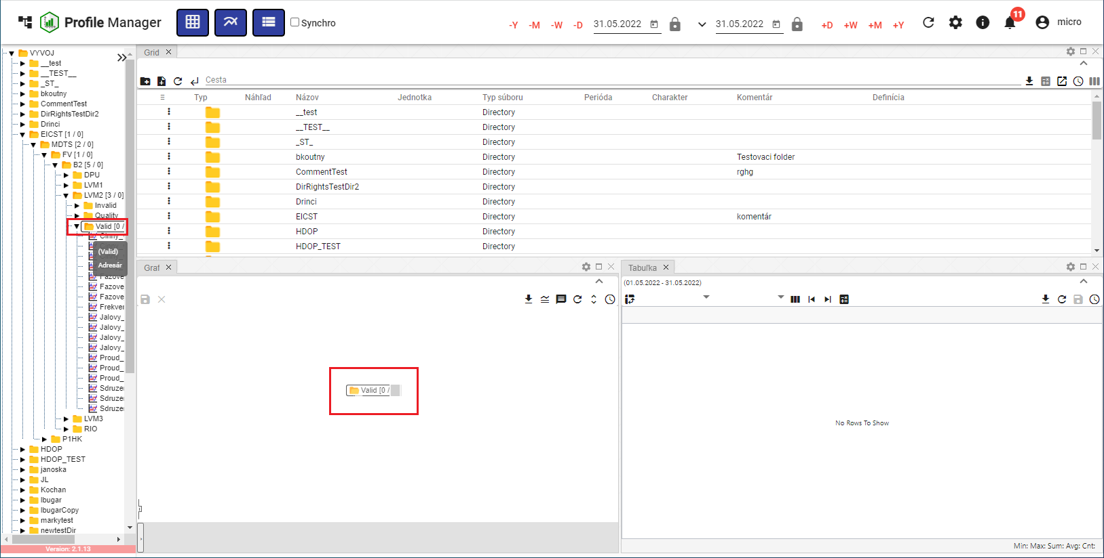

Figure 292: Redirecting the addressee to the graph surface

1. "On the graph window, it draws a graph."

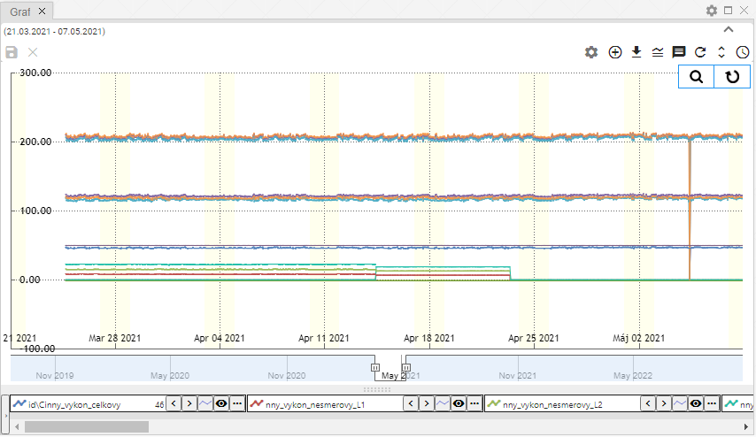

Image 293: Graphical representation of profiles

## "How to display an information window with values for a specific location in the graph"

"To see the values for a specific location on the graph, move your mouse cursor to the desired location."

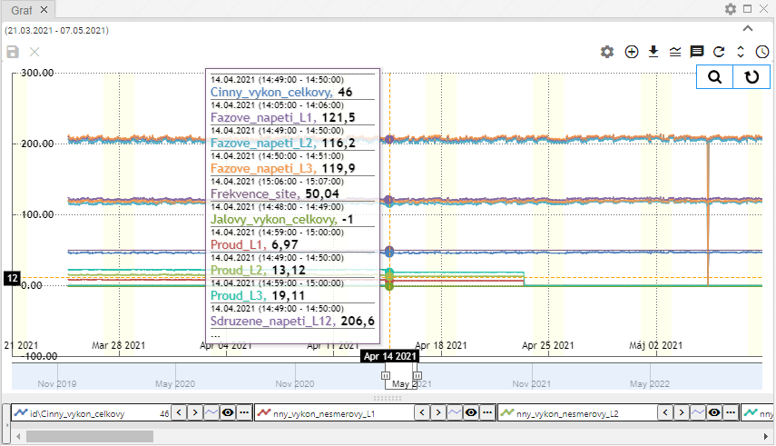

Picture 294: Displaying profile values at a specific point on the graph.

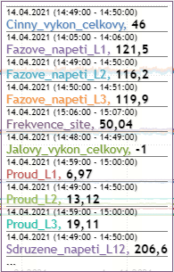

"Image 295: Values of profiles at a chosen location in the graph"

"Data is incomplete in this range (decimal), a yellow warning sign will be displayed (Figure 296)."

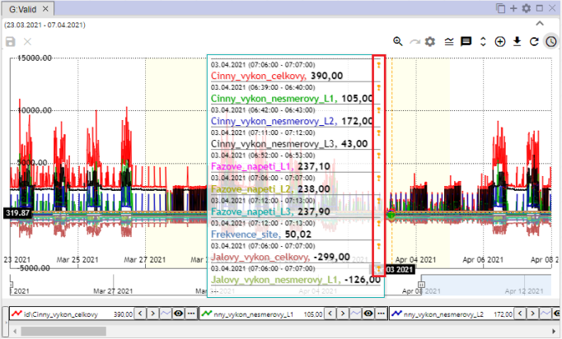

Picture 296: Yellow Trumpet Flower

## How can I change date range in chart from-to

"The time range for which the graph is shown can be changed by clicking on the 'Change Time Range' button, located in the top right corner of the graph window. The procedure is detailed in chapter 3.2."



Picture 297: Time Range Button

## I will save the graph in JPG format

You can save it as an image in JPG format. Proceed:

1. "Click on the 'Export graph to JPG' button, which is located in the top right corner of the graph window."



Image 298: Export button "Graph to JPG"

1. An image of the graph will be created and saved among downloaded files on the computer.

## "I want to copy the entire graph into a new window"

You can copy the whole chart into a new window:

1. Press the button "Copy entire graph into new window".
2. "The graph copies and displays it in a new tab in the graphics window."

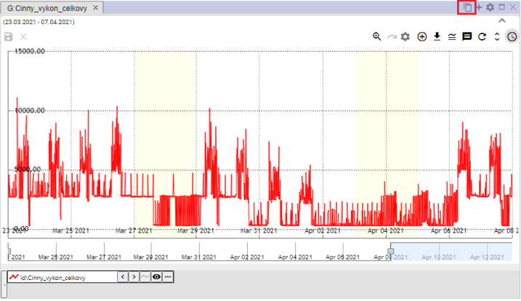

No valid translation found.

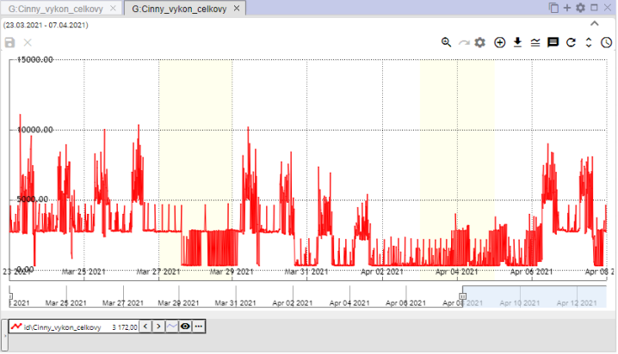

"Image 300: Copied graph in new tab"

## To set graph parameters

You can set parameters such as the size of the title font for the graph:

1. "Click the 'Graph Settings' button, which is located in the top right corner of the 'Graph' window."



Picture 301: Settings button for graph

1. "A window called 'Graph Legend' will appear, where you can set parameters."

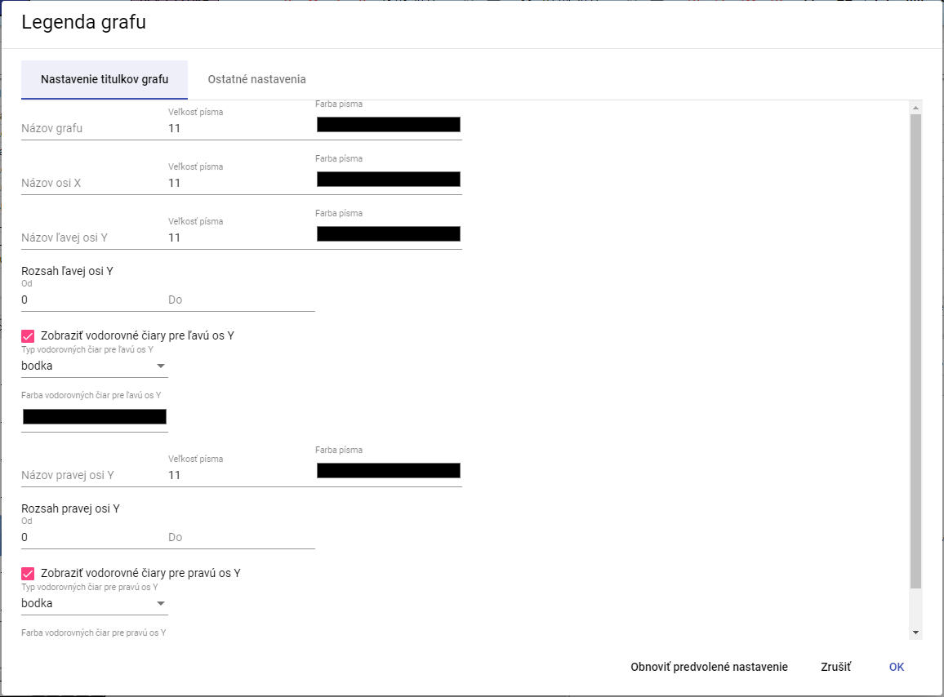

Image 302: Window "Legend of graph"

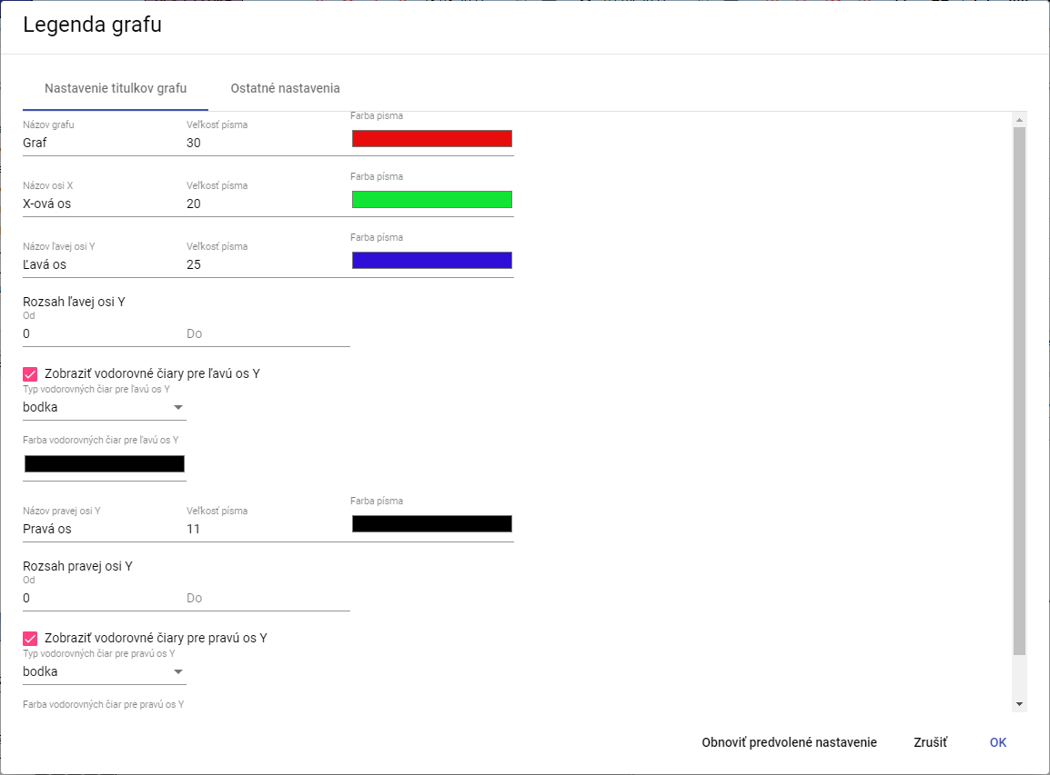

Picture 303: Changes in the window "Legend of the graph"

1. "Changes will be saved by pressing the 'OK' button."

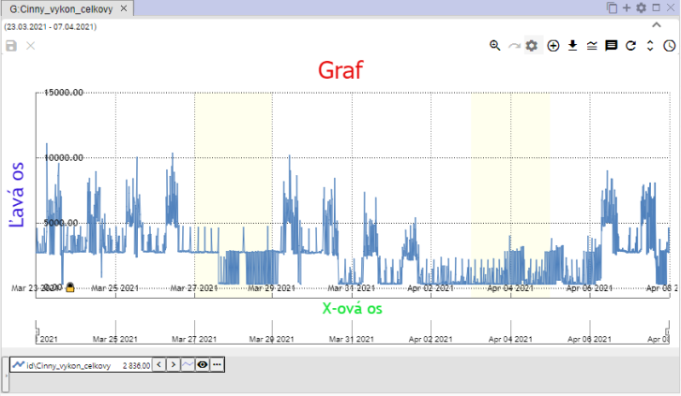

No valid translation found.

### "How to set decimal places for each of Y-axis"

**[OLLAMA FORMATTING ERROR - MANUAL REVIEW NEEDED] Postupujte:**

1. **[OLLAMA FORMATTING ERROR - MANUAL REVIEW NEEDED] V okne „Legenda grafu”, zadajte počet desatinných miest pre ľavu a pravú os Y.**

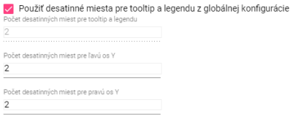

Image 305: Settings for Y-axis

1. **[OLLAMA FORMATTING ERROR - MANUAL REVIEW NEEDED] Ak chcete zadať hodnotu pre pole „Počet desatinných miest pre tooltip a legendu”, odkliknite pole „Použiť desatinné miesta pre tooltip a legendu z globálnej konfigurácie”.**

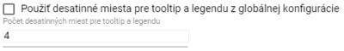

Image 306: Task for setting new value for field "Number of decimal places for tooltip and legend"

1. **[OLLAMA FORMATTING ERROR - MANUAL REVIEW NEEDED] Zmeny uložte stlačením tlačidla „OK”.**

### **[OLLAMA FORMATTING ERROR - MANUAL REVIEW NEEDED] Ako vypnúť vodorovné čiary**

**[OLLAMA FORMATTING ERROR - MANUAL REVIEW NEEDED] Pre vypnutie vodorovných čiar v grafe postupujte:**

1. **[OLLAMA FORMATTING ERROR - MANUAL REVIEW NEEDED] Stlačte tlačidlo “Nastavenie grafu”, Obrázok 301.**
2. **[OLLAMA FORMATTING ERROR - MANUAL REVIEW NEEDED] V okne “Legenda grafu” odkliknite polia “Zobraziť vodorovné čiary pre ľavu os Y” a “Zobraziť vodorovné čiary pre pravú os Y”.**

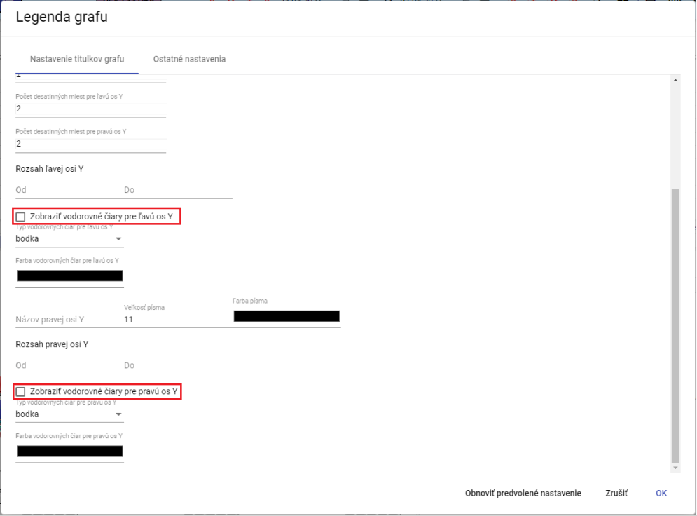

Picture 307: Erasing horizontal lines from a graph

1. **[OLLAMA FORMATTING ERROR - MANUAL REVIEW NEEDED] Zmeny uložte stlačením tlačidla “OK”.**

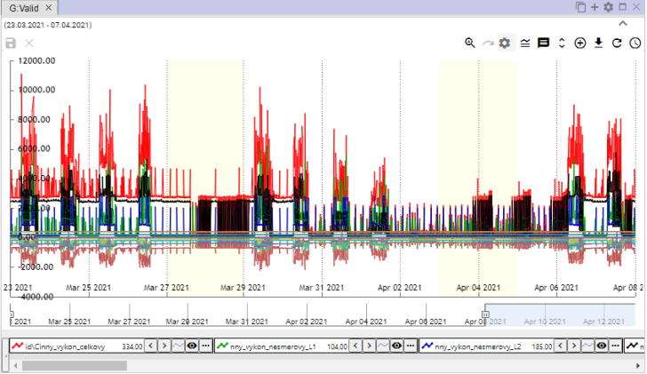

Image 308: Dashed horizontal lines on a graph

## No valid translation found.

Before displaying functions over multiple profiles, proceed:

1. Press the Ctrl key and select the profiles by clicking the left mouse button on the names of the selected profiles. After selection, the name of the profile has blue color.
2. Click on the button located in the lower left corner of the chart window.

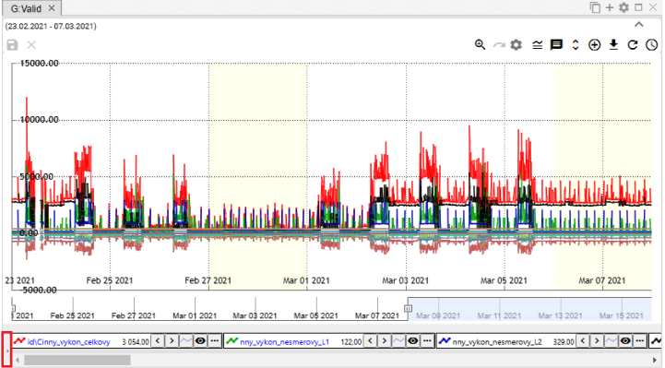

Image 309: Button for displaying functions for designated profiles

1. "A list of functions will be displayed for designated profiles. The functions are elaborated in the following chapters."

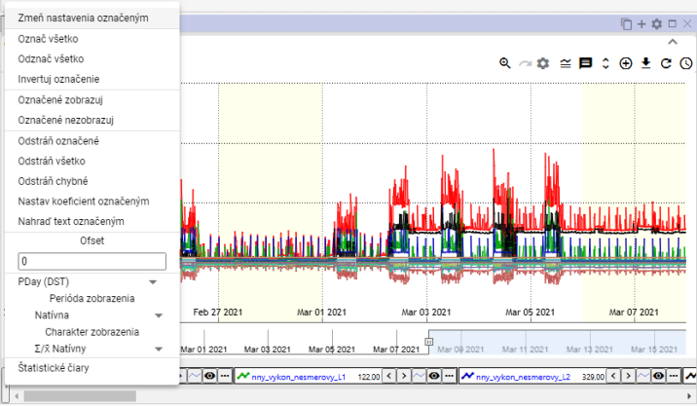

Image 310: List of functions for designated profiles

### To choose profiles

"Press the Ctrl key and click on the profile name to mark it. You can select multiple profiles at once. The text color of the selected profile will change from black to blue."

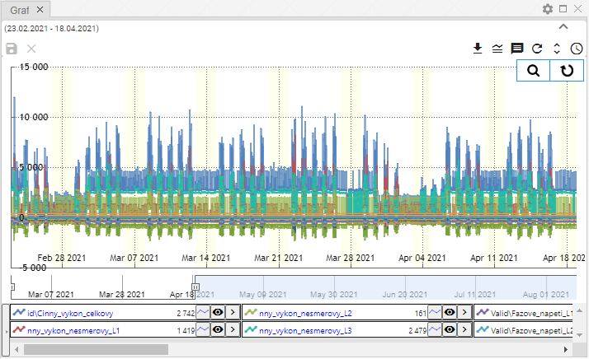

Image 311: Marking multiple profiles

### Show profile properties

"Properties of profile will be shown:"

1. Click on the button located before the profile name at the bottom of the window Graph.

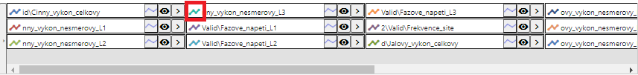

Picture 312: Button for profile properties display

1. "A window called 'Properties of Profile Line' will appear."
2. Update data.
3. "Changes will be saved by pressing the 'OK' button."

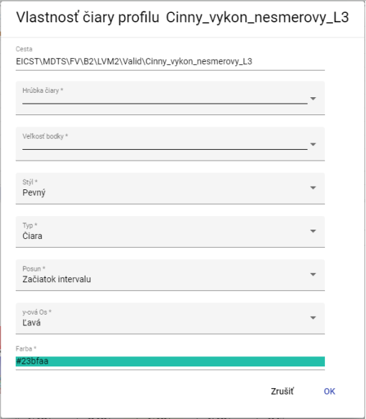

Picture 313: Window "Property of line profile"

### How do I change these settings?

"Setting up for more marked profiles will change at the same time:"

1. "Mark profiles that you want to change settings for."
2. Click on the name of one of the profiles with the right mouse button.
3. Select the item marked "Change settings shown" from the window displayed.

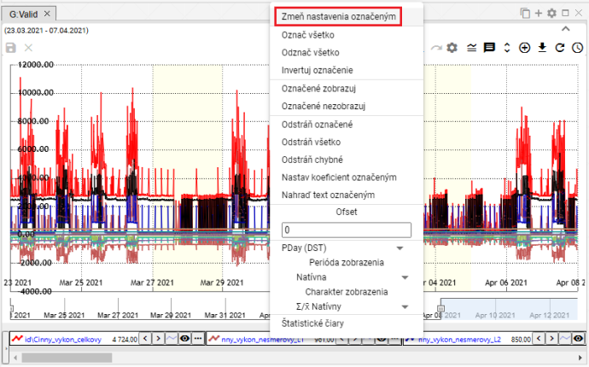

Picture 314: Item "Change settings marked"

1. "A window will appear where you can change settings for the marked profiles."

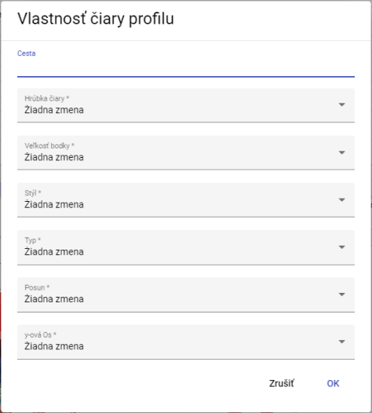

Image 315: Window for setting marked profiles

1. "Changes will be saved by pressing the 'OK' button."

### If I mark all profiles

Click on the profile name with the right mouse button and select "Mark all" from the menu, Picture 316. All profiles are highlighted, Picture 317.

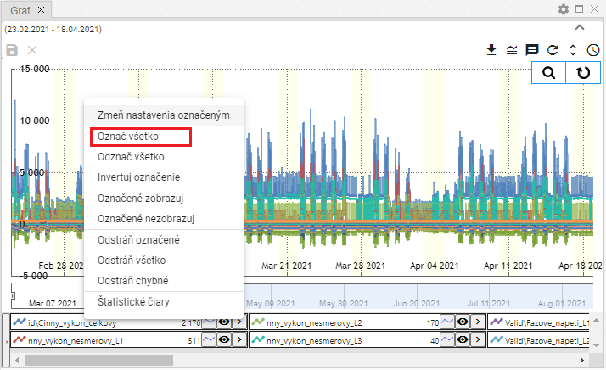

Picture 316: Item "Mark everything"

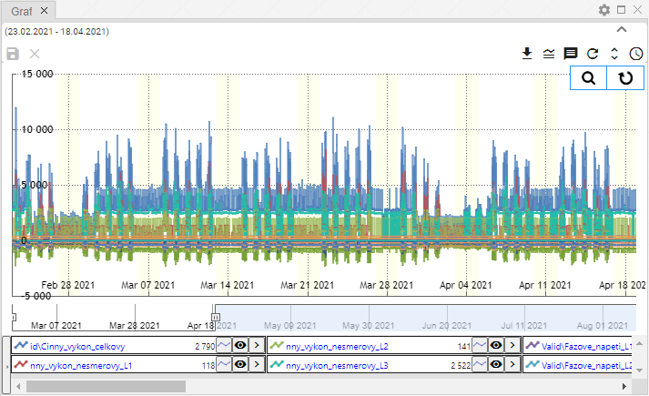

Image 317: Marked Profiles

### "Mark all profiles"

"The 'Unmark all' option serves to remove the marking from all marked profiles."

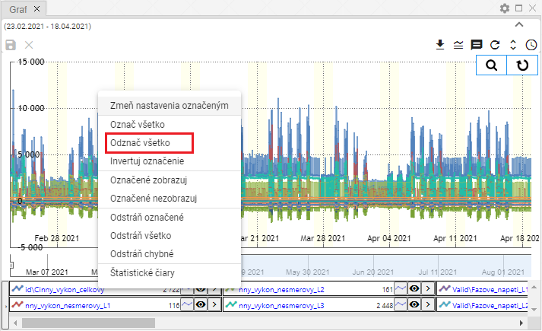

Image 318: Item "Mark all as read"

### I am going to invert marked profiles

"Setting 'Invert label' will swap the labels of profiles. Profiles that were labeled are unlabeled and unlabeled profiles are labeled, Image 320."

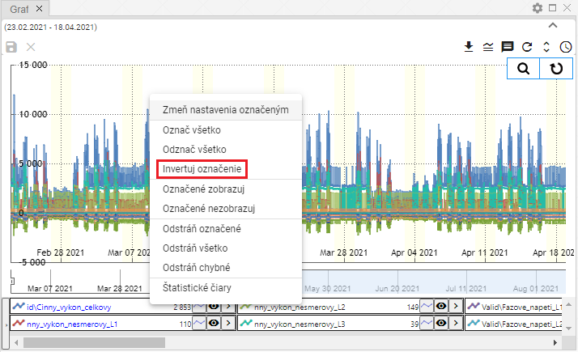

Image 319: Item "Invert designation"

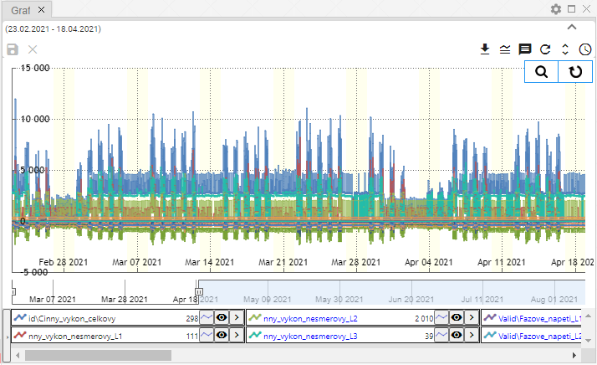

Image 320: Inverted profile designation

### "Show only marked profiles"

"The item 'Show marked profiles' serves for displaying marked profiles."

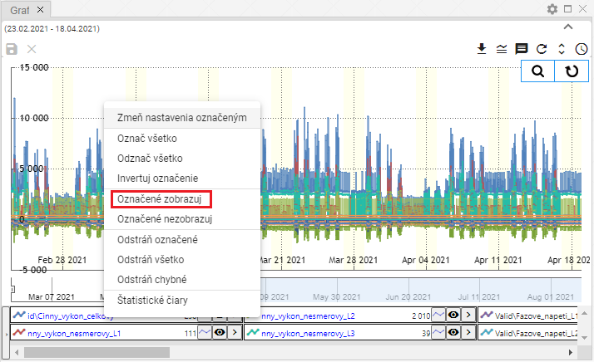

Image 321: Item "Mark as displayed"

### Do not show marked profiles.

"If you do not want to display marked profiles in the graph, proceed:"

1. "Mark profiles you don't want to display."
2. "Click on the name of the profile with your right mouse button."
3. Select item "Hide marked"

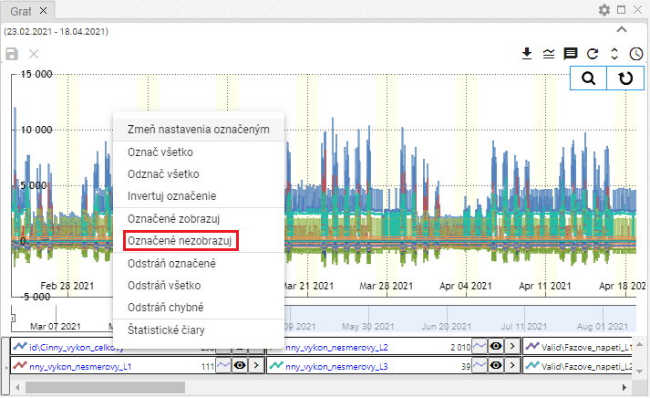

Image 322: Category "Not shown marked"

1. Selected profiles hide themselves.

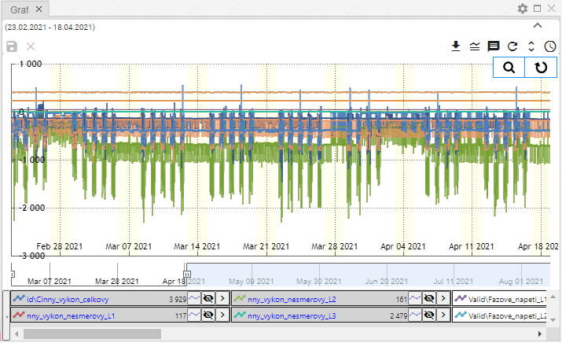

Image 323: Untitled Profiles

### No valid translation found.

"Before profiles are removed, you can use three functions:"

* "Remove marked - serves for removal of marked profiles,"
* No valid translation found.
* "Remove faulty - only faulty profiles will be removed."

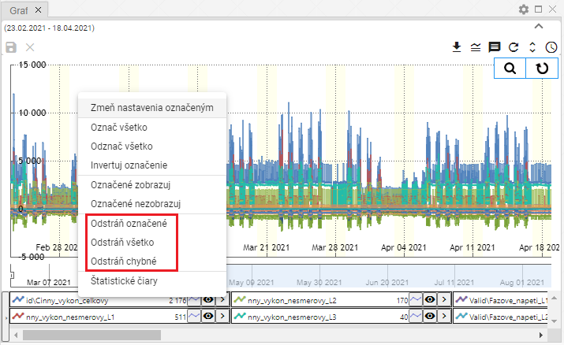

Image 324: Options "Remove marked", "Remove all" and "Remove incorrect"

Before removing profiles, proceed:

1. "If you want to delete the marked profiles, mark the profiles you want to delete."
2. "Click on the profile name with the right mouse button."
3. Select the option "Remove marked", "Remove all" or "Remove incorrect".
4. Your profile will be removed.

### "How to set up the coefficient with the designated profile"

"Before setting the coefficient, proceed:"

1. By clicking on the name of the profile, mark the profiles which you want to set coefficient for.
   1. "If you want to select more profiles, click the left mouse button on the profile name, hold down the Ctrl key and by clicking the left mouse button mark the names of the profiles that you want to select."
   2. No valid translation found.
2. The marked names of profiles will fade out blue.
3. "Click on the right mouse button on the name of one of the marked profiles."
4. "A window will appear where you select 'Set the coefficient marked'."

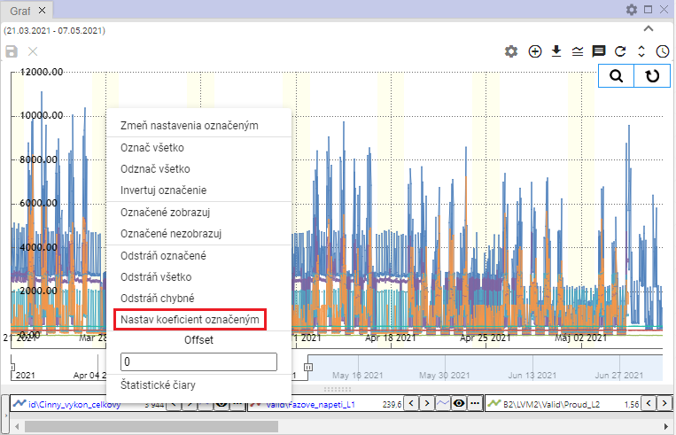

Image 325: Item "Set designated coefficient"

1. "A window titled 'Coefficient settings' will be shown."
2. No valid translation found.

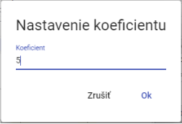

Picture 326: Window "Coefficient settings"

1. The coefficient will be set for the selected profiles. Under the names of profiles, information about the set coefficient will be displayed.

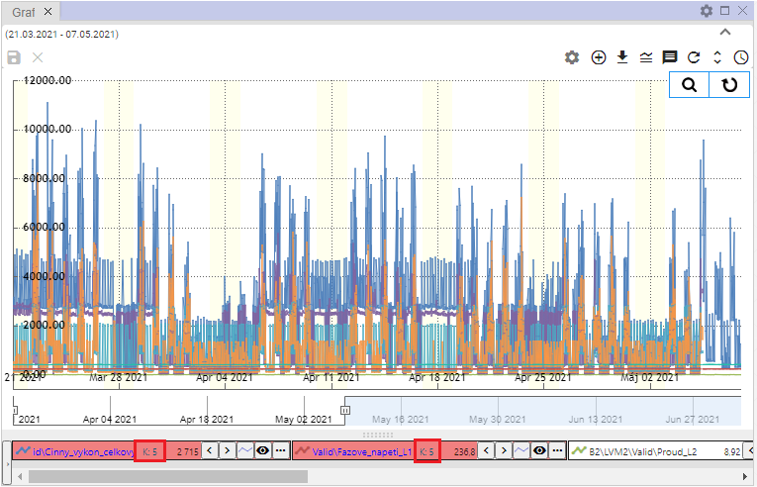

Image 327: Configured coefficient

### Set up offset

**[OLLAMA FORMATTING ERROR - MANUAL REVIEW NEEDED] Pre nastavenie offsetu postupujte:**

1. Click on profile names to mark profiles for which you want to set an offset.
2. "Click on the name of one of the selected profiles with the right mouse button."
3. "A window will appear where you enter an offset and press the Enter key."

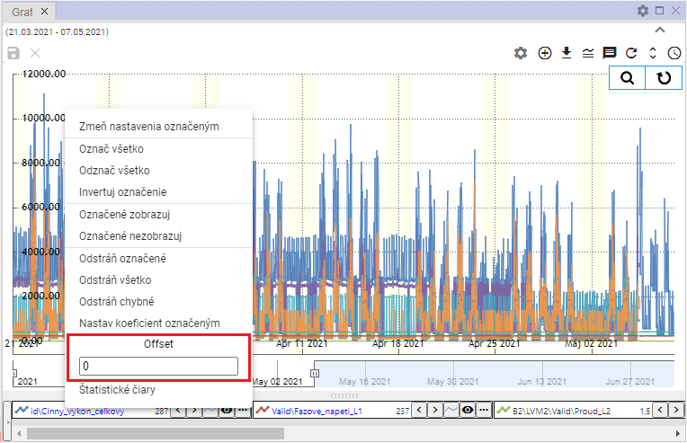

Image 328: Pole "Offset"

1. "On selected profiles, information about the set offset will be displayed."

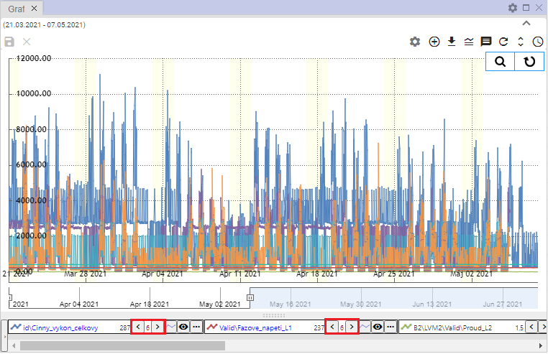

Image 329: Set Offset

### To show statistical lines

Before displaying statistical lines, proceed:

1. "If you want to display statistical lines only for certain profiles, hold down the Ctrl key and click on the names of the profiles for which you want to display the statistical lines."
2. No valid translation found.
3. Choose item "Statistical lines".

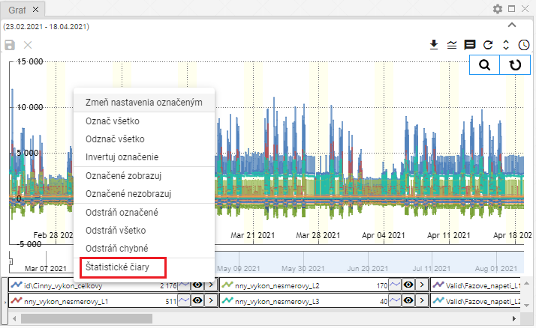

No valid translation found.

1. "A window called 'Statistical lines' will appear."

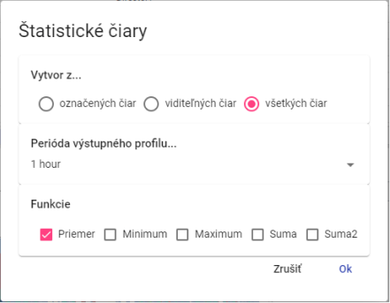

Picture 331: Window of "Statistical Lines"

1. Choose whether statistical lines should be created from the marked visible or all lines.
2. Choose a function. You can select multiple functions at once.
3. Click on the button "OK".

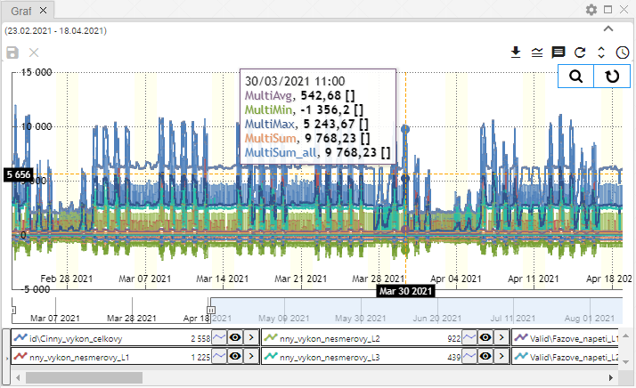

Picture 332: Statistical lines

### I will translate the marked text

"Function serves for collective change of profile names. Proceed:"

1. "Mark the profiles whose text you want to change on the profile path."
2. No valid translation found.
3. "An offer will be displayed where you select the item 'Replace the marked text'."

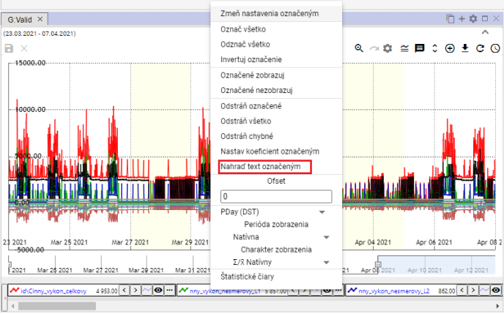

Image 333: Item "Replace selected text"

1. "A window titled 'Replace text on profile path' will appear."
2. In the field "Find" enter the text you want to replace.
3. "In the field 'Replace', enter the text to replace the text in the field 'Find'."

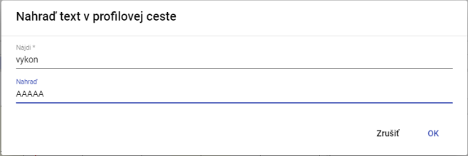

Image 334: Window "Replace text in profile path"

1. "Click OK."
2. The assigned text will be replaced by a new text.

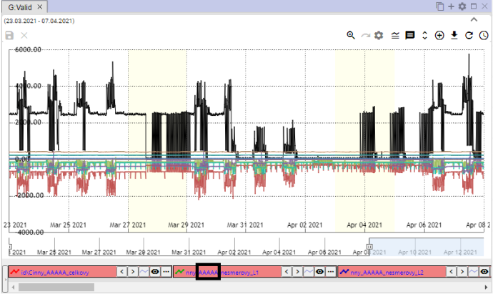

Image 335: Replaced text

## Functional position with one profile

"Each profile has a button next to its name, which serves for displaying functions. The functions serve for work with selected profile."

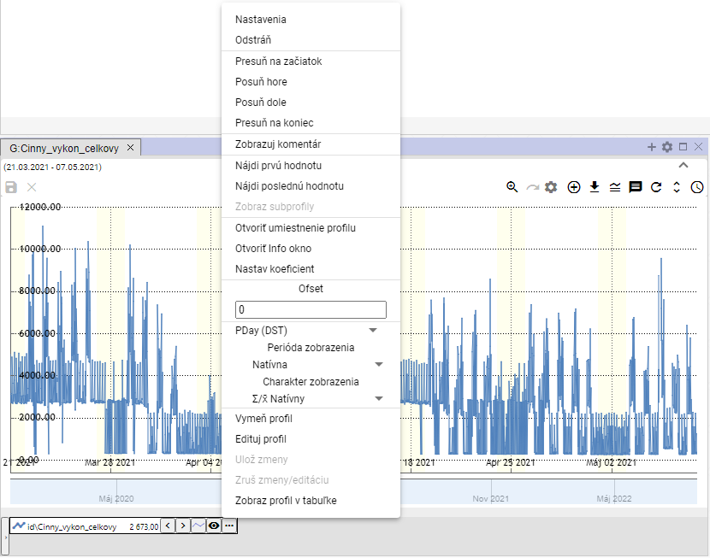

No valid translation found.

### How to set things right

"You can change the display of profile data in the chart by settings in a window. For example, you can change the color with which the profile is displayed, the line style..."

Before changing settings, proceed with:

1. Click on the button next to the profile name that you want to change settings for.
2. "A window will appear in which you select the item 'Settings'."

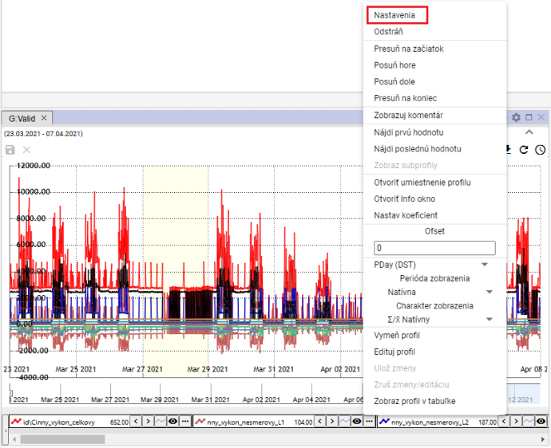

Image 337: Settings item

1. In the window that appears, change your profile settings.
2. Press the "OK" button to save changes.

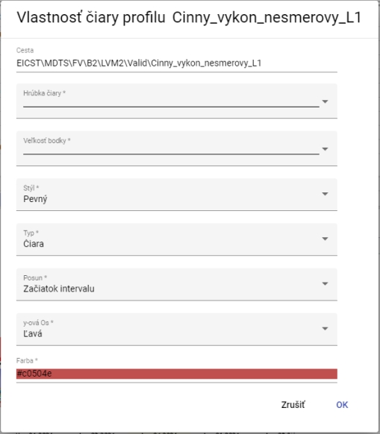

Profile Settings 338: Image

### To delete profile

Remove Profile:

1. Click on the button next to the profile name you want to delete.
2. The profile will be removed from the list of profiles in the lower part of the Graph window and from the display of profiles.

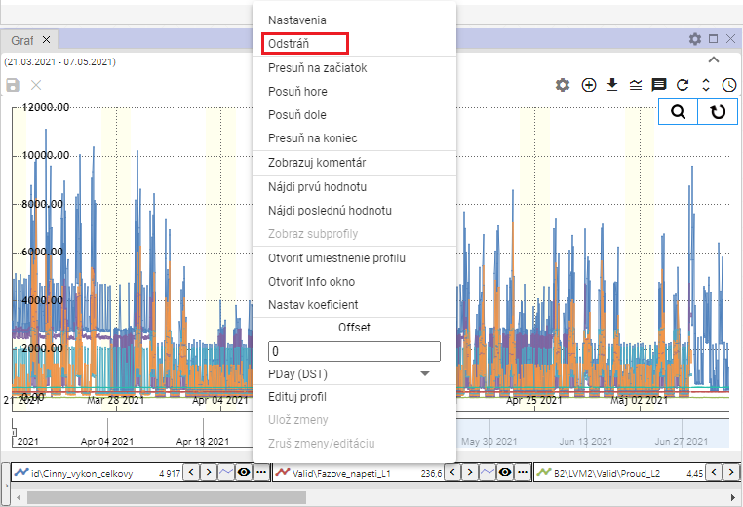

Image 339: Remove item

### I'll move the profile to the beginning.

If you want to move the profile to the top of the profiles list, click on:

1. Click on the button next to the profile name you want to move to the top.
2. Choose item "Move to start".
3. The selected profile will move to the beginning of the list.

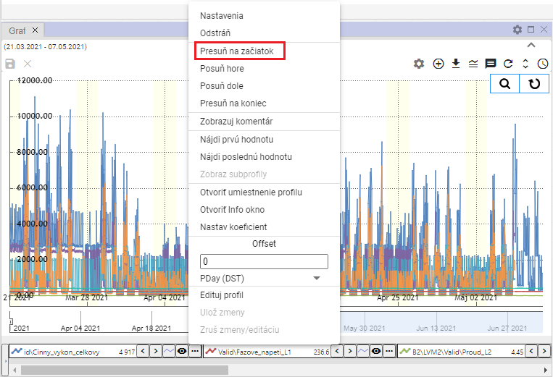

Picture 340: Item "Move to start"

### To shift the profile upwards

"The entry 'Move up' serves to move the profile name in the list of profiles at the bottom of the window 'Graph' one position higher, for example from the third position to the second position."

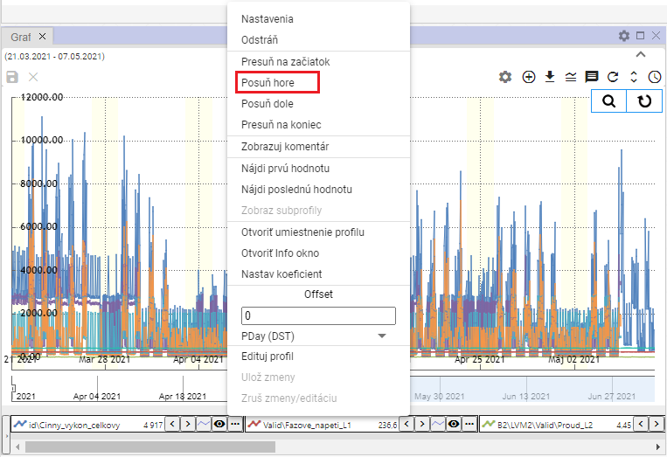

Image 341: Item "Push the Horn"

### "Slide profile down"

"The 'Move down' entry serves to move the name of a profile in the list of profiles at the bottom of the 'Graph' window one position lower, for example from second place to third."

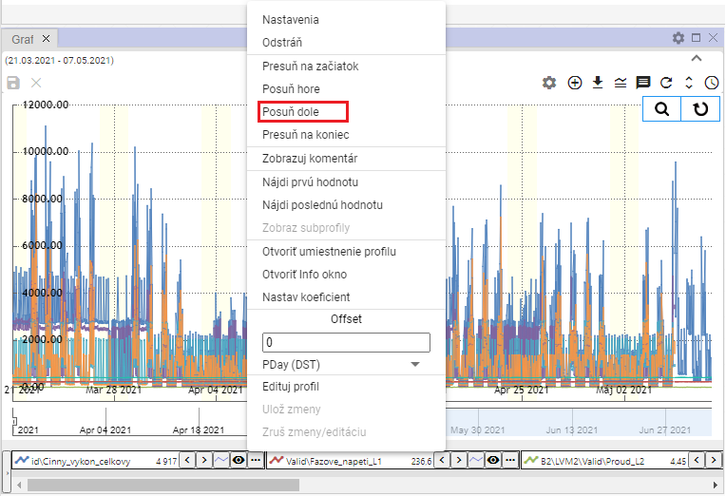

Image 342: Option "Slide down"

### I'll move my profile at the end

"The item 'Move to the end' serves for moving a profile to the end of profiles list in the bottom part of the window 'Graph'."

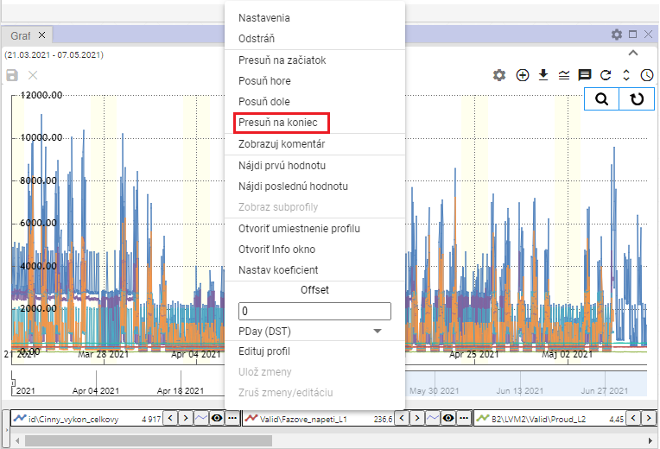

Image 343: Item "Move to end"

### Show comments

"The 'Display profile name' option determines the display of the profile name. When you select 'Display profile name', instead of the profile name, a comment, Picture 345 will be displayed. To show the profile name again, click on the 'Display profile name' option once more."

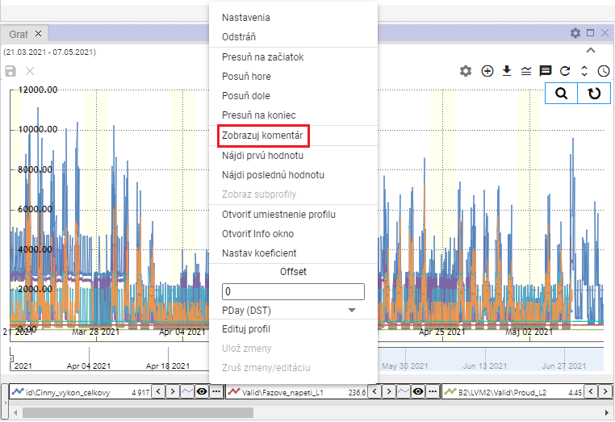

Image 344: Comment Display Item

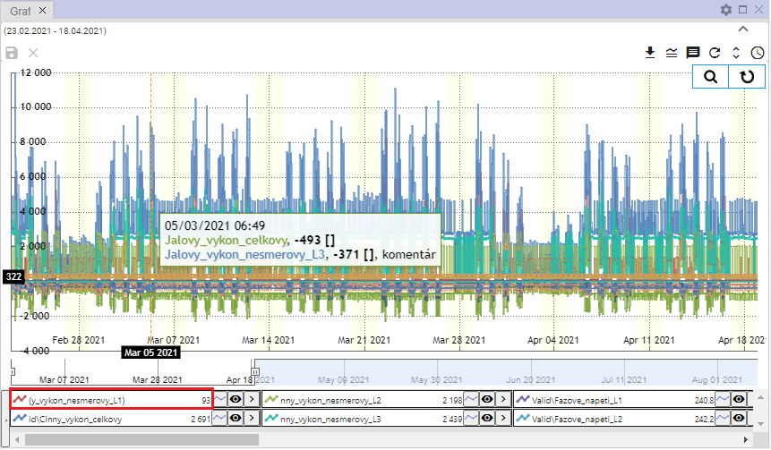

Image 345: Commentator profile displayed

### How to find the first value

"The item 'Find first value' serves to find the first profile value in a graph."

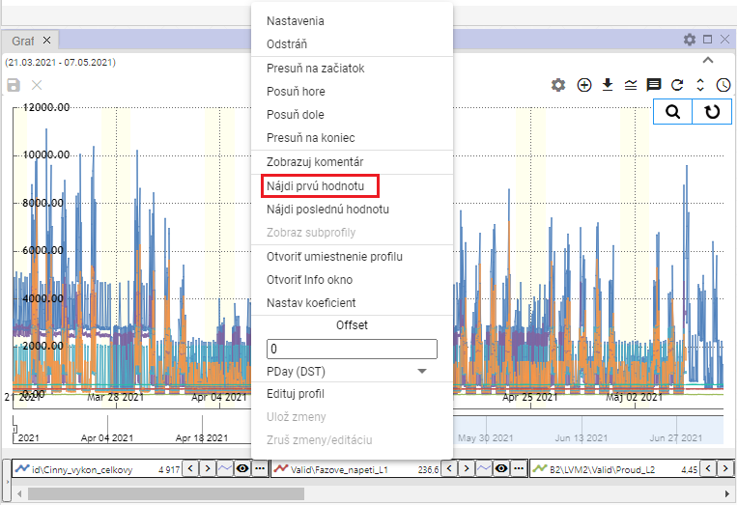

Image 346: Find First Value item

### Find the last value

"The item 'Find Last Value' serves to find the last value of a profile in a graph."

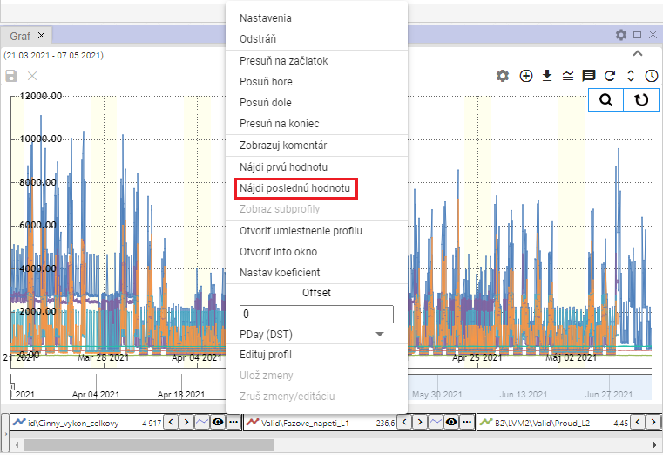

Image 347: Find Last Value Item

### Can display subtitles

"The calculated profile may have other profiles, called subprofiles, used in its definition. To display them, proceed with:"

1. Click on the button next to the profile name that you want to change settings for.
2. "A window will appear where you select the item 'Show Subprofiles'."
3. No valid translation found.

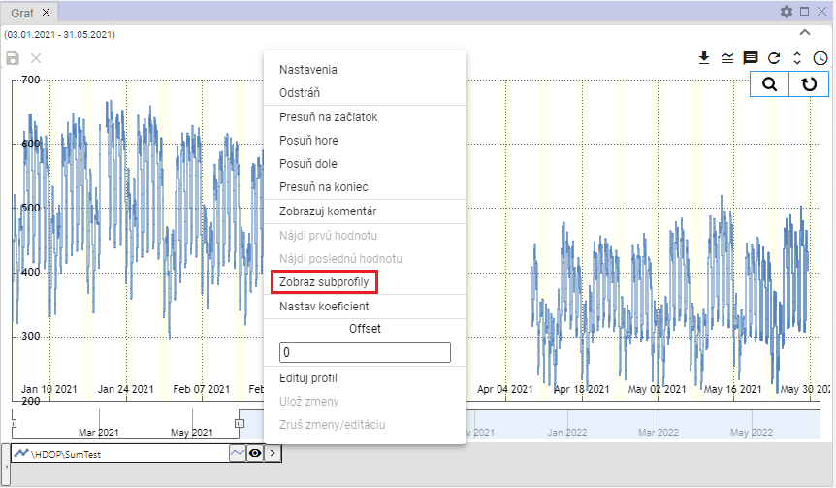

Image 348: Item "Show subprofiles"

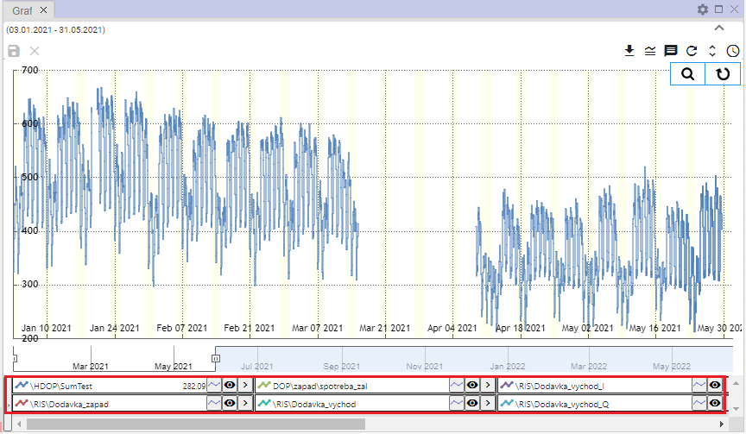

Picture 349: Shown subsurface profiles

### To open account profile

"Profile setup in the stream structure will display:"

1. Click on the button next to the name of the profile you want to open in the tree.
2. It will show a window where you select the item "Open profile location".

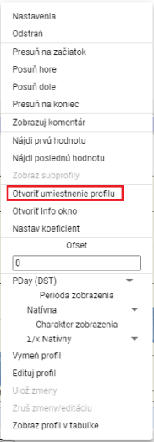

Picture 350: Open location profile item

1. In the stormy structure, the address book will open, which contains the profile.

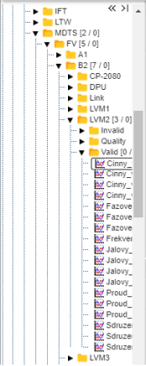

Image 351: Placement of profile within a stream structure

### How do I open an information window.

No valid translation found.

"Window with information, open:"

1. "Click on the button with three dots, which is located next to each profile."



Image 352: Button for function display

1. Select the item "Open Information window".

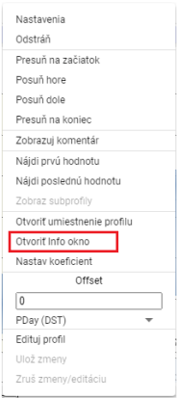

Picture 353: Item "Open Info window"

1. In the riverine structure, the address book will open, in which there is a profile, Image 351.
2. "Next will appear window with informations about profile, which contains three tabs: 'Info', 'ReadLog' and 'WriteLog', Image 354."
3. You can copy the name of the profile and path to the profile by clicking on the "Info" tab.

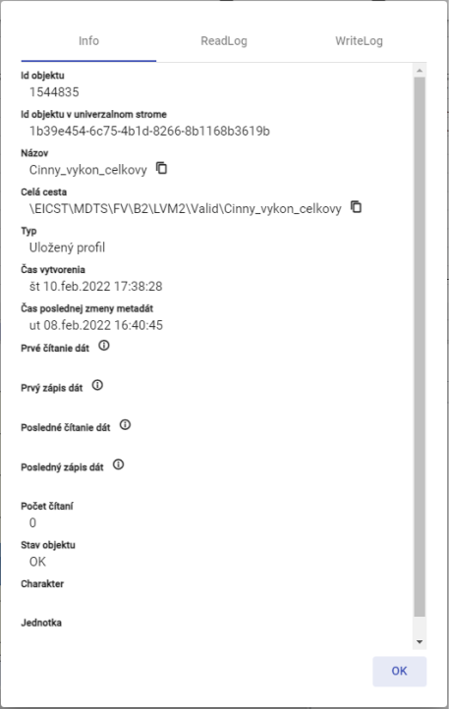

No valid translation found.

### If I set the coefficient

"Before setting the coefficient, proceed:"

1. Click on the button next to the profile name that you want to set the coefficient for.
2. Choose the item "Set coefficient"

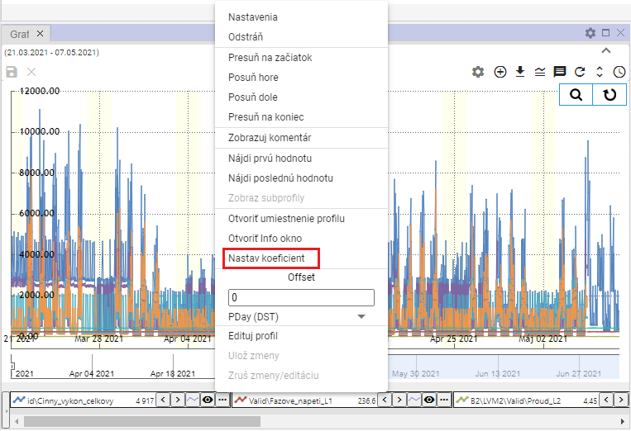

No valid translation found.

1. "A window will appear in which you enter the coefficient."

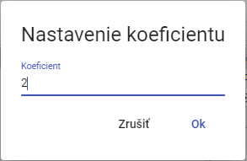

Image 356: Setting coefficient

1. No valid translation found.
2. The information about the set coefficient will be displayed on profile name.



Image 357: Set coefficient

### How to set an offset

Before setting the offset, proceed with:

1. "You can enter the offset by clicking on the arrows next to the profile name or click on the button and in the 'Offset' section, enter a value and press the 'Enter' key."



Image 358: Settings for Offset Printing

1. "The value you entered for the offset via arrows next to the profile name will also be displayed after clicking on the button in the 'Offset' section."

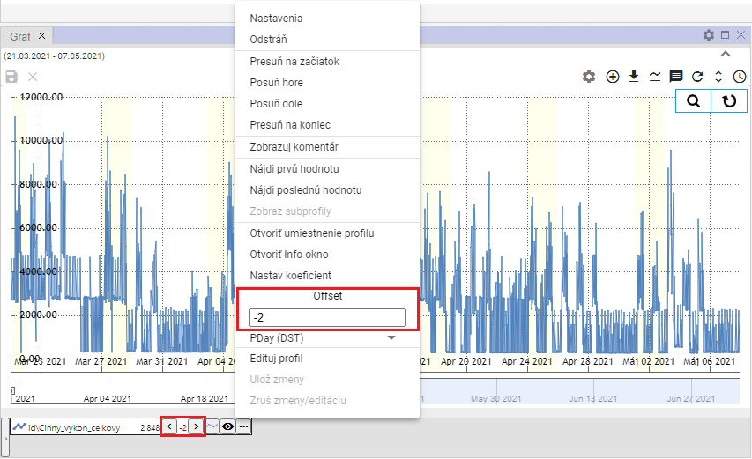

Image 359: Set offset

1. "Under the forest Offest there is a field for selecting period for offest, Picture 360. After clicking on the field, a list of time periods for offest will be displayed, Picture 361."

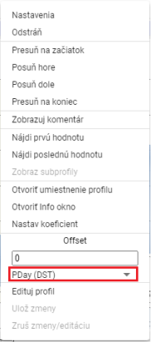

"Image 360: Selection period for offset"

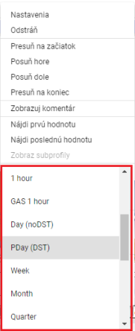

Image 361: Selection of time period for offset printing

### Change my profile

"Proceed to exchange one profile for another:"

1. Click on the button next to the profile name you want to change.
2. Choose the item "Edit profile".

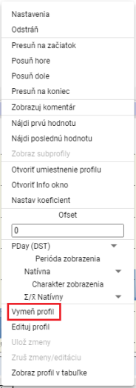

Image 362: Item "Mark Profile"

1. The window "Change Profile" will appear.

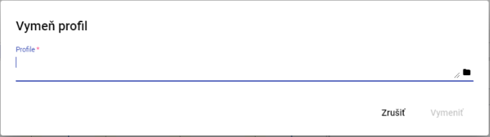

Picture 363: Profile window

1. Write your way to the profile or click on the button .
2. Click the "Replace" button after confirmation.

### I'll update my profile

Before editing the profile, proceed:

1. Click on the button next to the name of the profile you want to edit.
2. Choose the item "Edit profile".

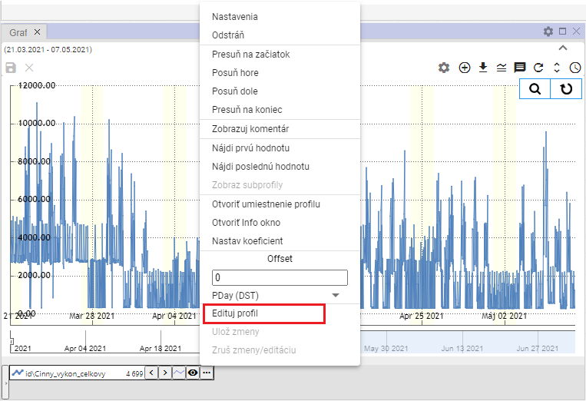

Image 364: Item "Edit Profile"

1. A copy of the profile will be created. Fields with names of the original and copied profiles will be highlighted in green colour.

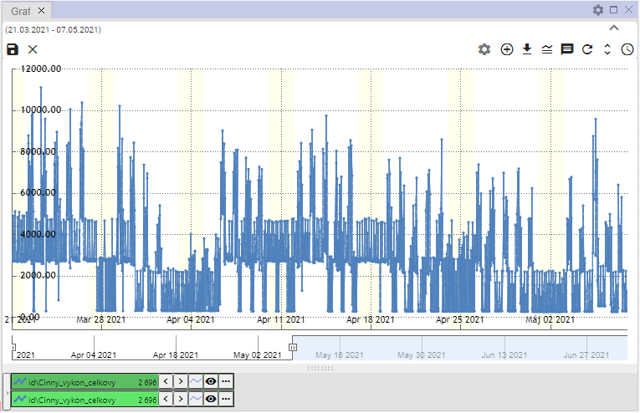

The image 365: A copy of the profile is being created.

1. Update profile.
2. "Changes will be saved by clicking on the button and selecting the item 'Save changes' or by pressing the button with a floppy disk icon located in the upper left corner of the graph."

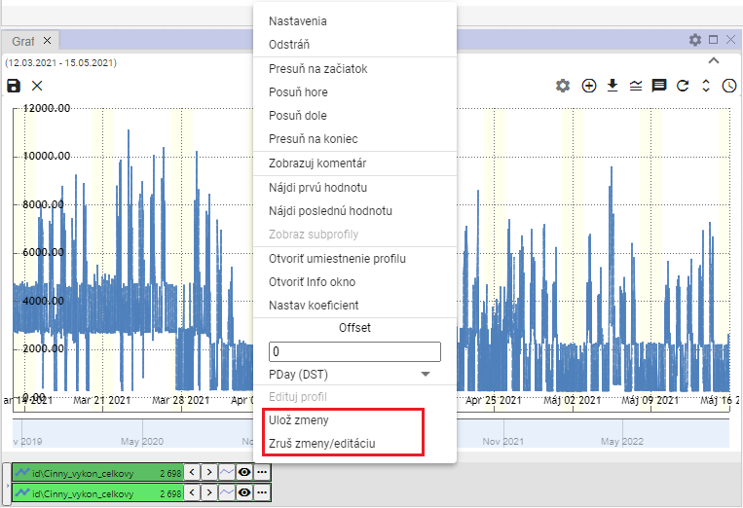

Image 366: Options "Save changes" and "Discard changes/editing"

1. If you want to undo the changes, select the item "Undo edits" or press the "x" button in the top left corner of the graph.

### Set profile color

"Before setting up the profile color, proceed:"

1. "Click on the button at the profile you want to set the color for."
2. Choose the item "Settings", which will display the window "Properties of profile line".



Image 367: Settings item

1. Click on the field "Color" in the window "Line Profile Property".
2. No valid translation found.

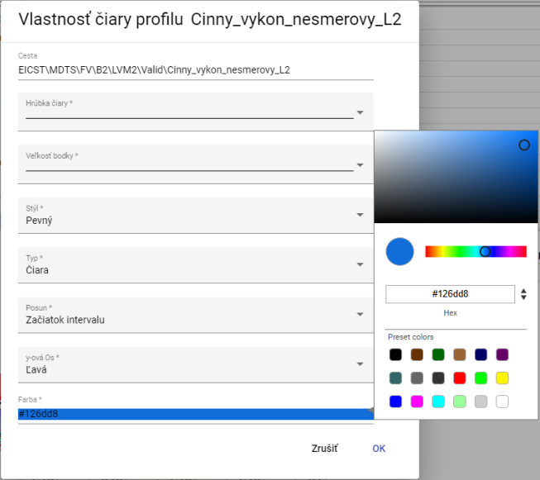

Image 368: Color selection

1. "Click on selected color."
2. Changes will be saved by pressing the button "OK".

### How to set the point size

"Before setting size, proceed with dots:"

1. Press the button next to the profile name for which you want to set the font size.
2. Choose the item "Settings", which will display the window "Profile Line Property".



No valid translation found.

1. Click on the field "Size of point".

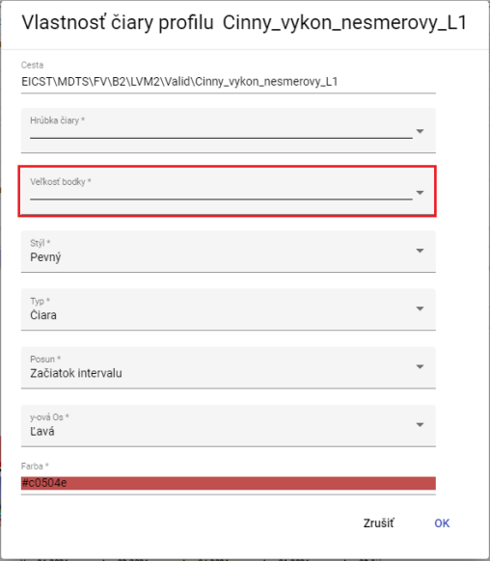

No valid translation found.

1. "A window will appear where you can select the display size for a point by clicking."

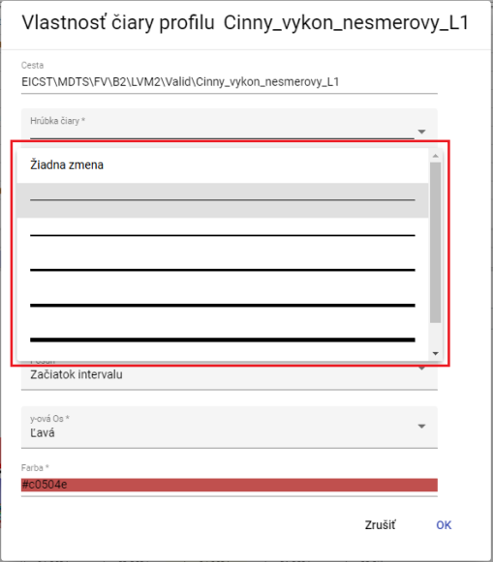

Picture 371: Selection of dot size

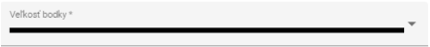

Image 372: Chosen size

1. You will save changes by pressing the "OK" button.

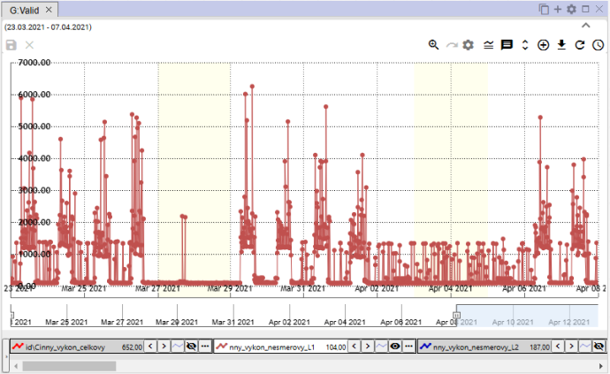

Picture 373: Set point size

### I'll display my profile in the table.

"Profile in the window graph will be shown in the table as follows:"

1. "Click on the button at the name of the profile you want to display in the table."
2. Choose the item "Show profile in table".

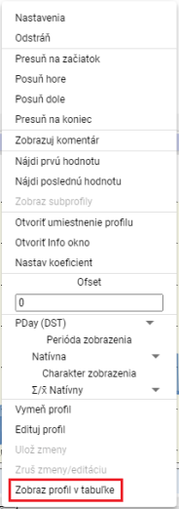

No valid translation found.

1. In the window Graph, add new tab Table.

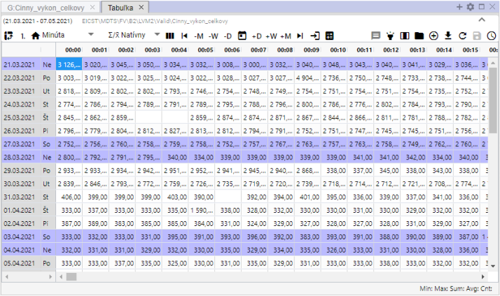

Image 375: Displaying profile in table

## Rapid change of graph type

"At the bottom of the Graf window, a button is found next to each profile's name that allows for quick switching between graph types. A button with a graph icon allows for toggling the graph between StepLine, StepArea, and StackedColumn. The graph type can also be toggled via the 'Type' field in the Profile Properties window; this process is detailed in Chapter 5.8.1."



"Image 376: Button for quick switch of graph type"

Standardly, in Graph window, the chart type is set to "StepLine", Image 377. Pressing the button sets the chart type to "StepArea", Image 378 and the button's appearance changes to . Subsequent pressing of the button sets the chart type to "StackedColumn", Image 379 and the button's appearance changes to .

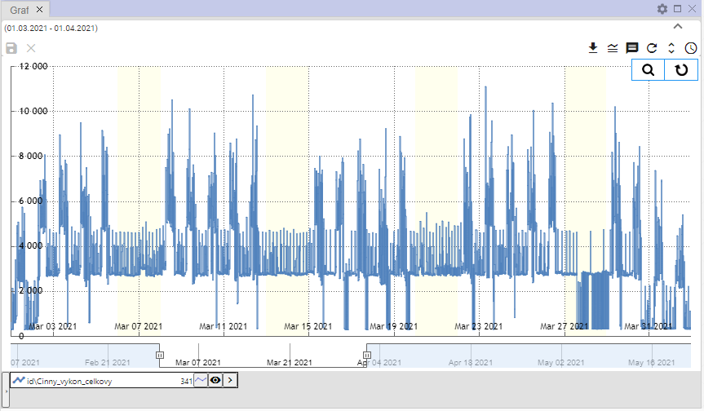

Picture 377: Type of graph "StepLine"

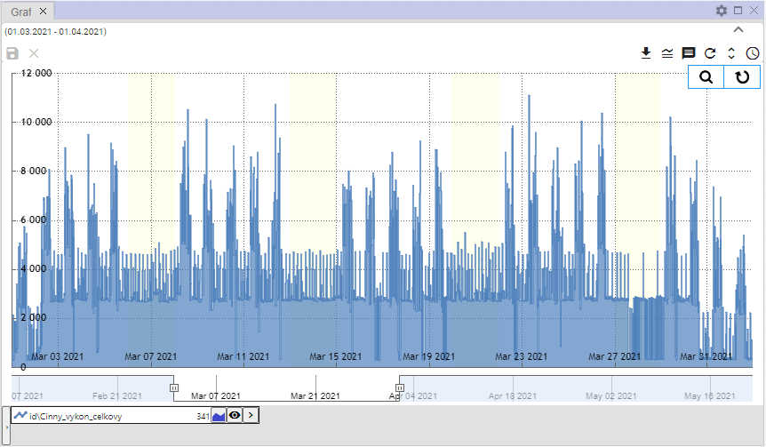

Image 378: Type of graph "StepArea"

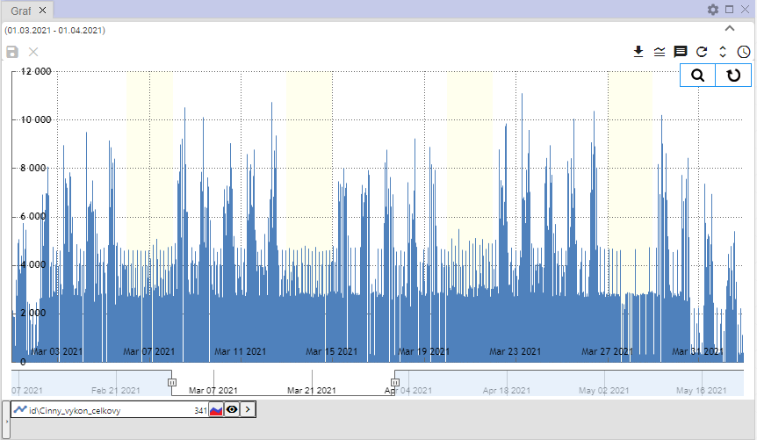

Picture 379: Type of graph "StackedColumn"

## To approximate the selected part of the graph

"Before enlargement of selected part in graph:"

1. "Click on the button 'Join on Zoom', which is located in the top-right corner of the chart."

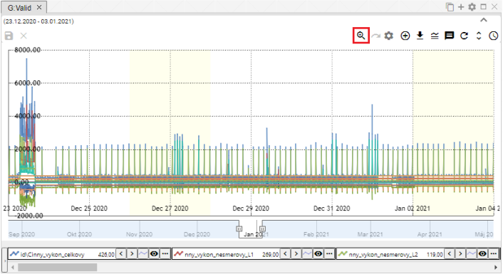

Picture 380: Zoom button

1. Press the left mouse button and mark an area on the graph.

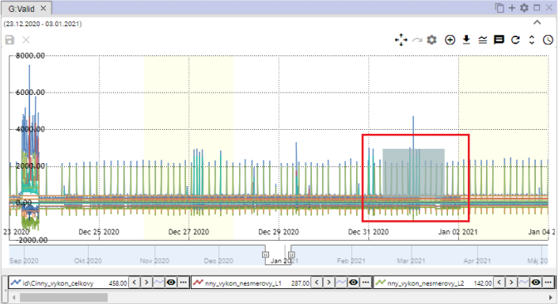

Image 381: Marked location on graph

1. Click the left mouse button.
2. The selected area will get closer.

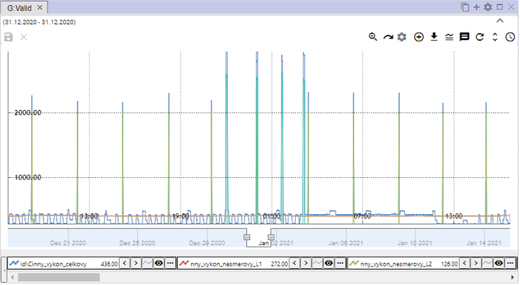

Picture 382: Enlarged area in graph

1. "Before re-setting y-axis press the 'reset zoom' button, chapter 5.12."

## I am plotting a graph

By clicking on the button "Switch to zoom", Image 380, the button will switch from magnify to "Switch to pan", Image 383. It allows you to move around in the chart. To move around in the chart, click on a place in the chart with your left mouse button and drag the graph.

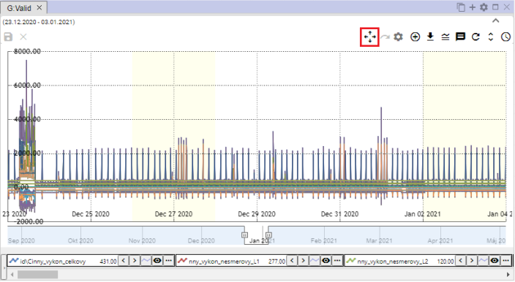

Picture 383: Button "Set to Slide"

## Can you cancel the meeting?

"After you've brought the selected area closer in the graph using the zoom function, the graph will be restored by pressing the 'Reset zoom' button."

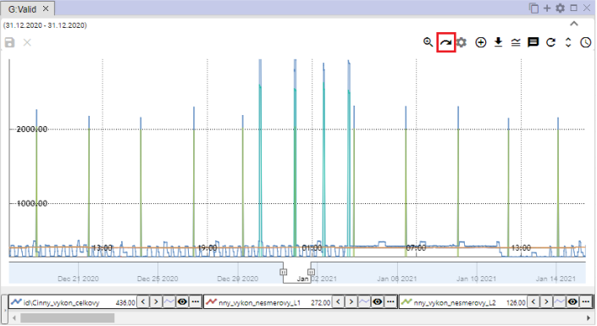

Image 384: Reset Zoom button

## Show/Hide Legend

At the bottom part of the graph window, there is a list of displayed profiles called a legend. To hide this list of profiles, click on the "Show/Hide Legend" button located in the top right corner of the Graph window. To display the legend again, click on the "Show/Hide Legend" button once more."



Picture 385: Toggle button Show/hide legend

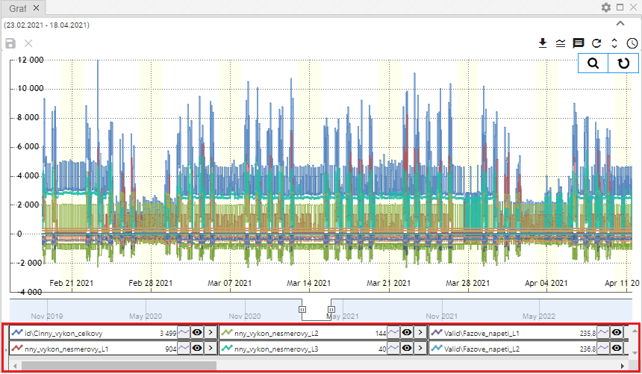

No valid translation found.

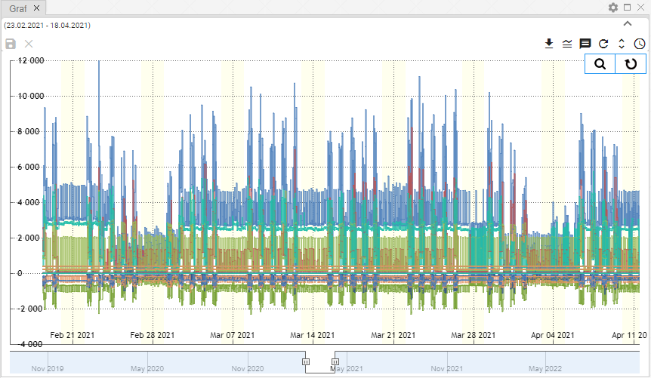

Picture 387: Hidden Legend

## Show/Hide tooltip

No valid translation found.



Picture 388: Button "Show/Hide Tooltip"

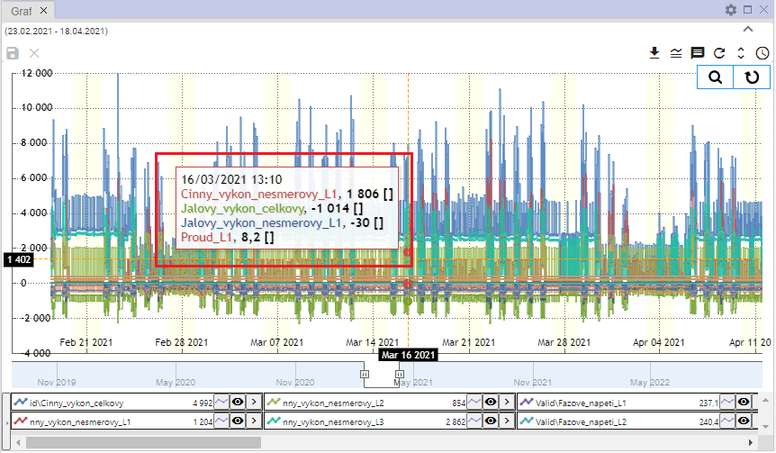

Picture 389: Shown tooltip

## How do I set up the Y-axis so that values are visible

The "Adjust y-axis to be visible values" button serves to zoom out the y-axis in case it is not possible to see all values (all lines) when zooming. The y-axis is then zoomed out so that all values are visible. The x-axis remains unchanged.

Proceed

1. Click on the "Zoom" button, which is located in the top-right part of the window named "Graph."



Image 390: Zoom button

1. Mark the place on the chart that you want to zoom in.

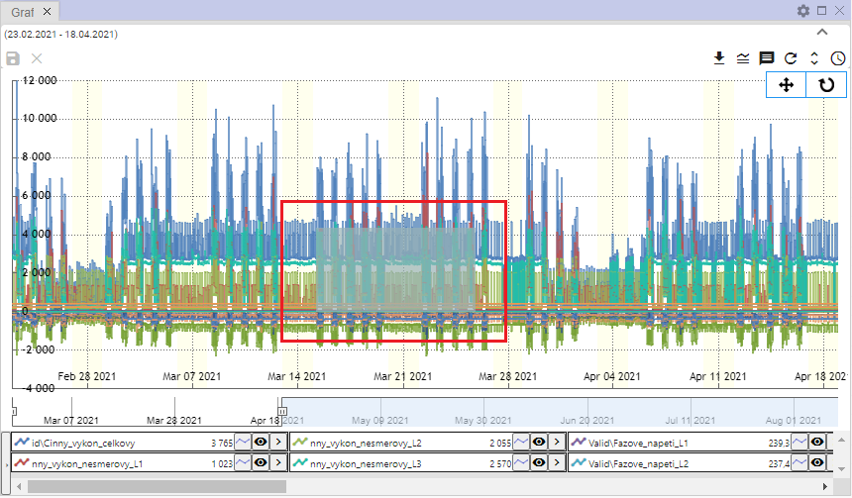

Find location on graph 391: Image

1. The place is getting closer in the graph.

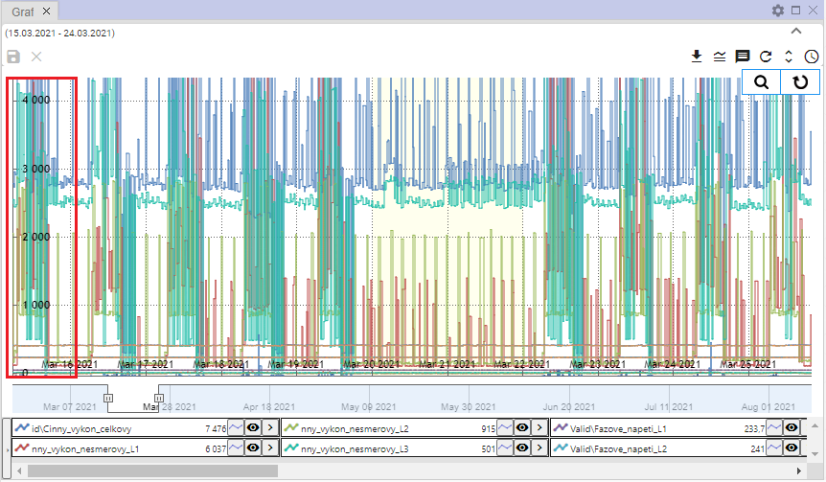

Figure 392: Enlarged area from chart

1. "Click on the button 'Set up Y-axis so that values are visible'."



Picture 393: Button "Set Y-axis to visible values"

1. The "I"-self is being zoomed out/expanded.

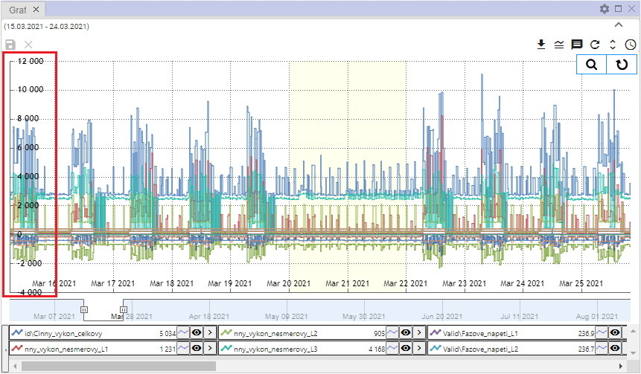

Picture 394: Altered y-axis

## To change profile

Before profile change, proceed with:

1. Click on the button next to the profile you want to replace.
2. Choose item "Leave profile".

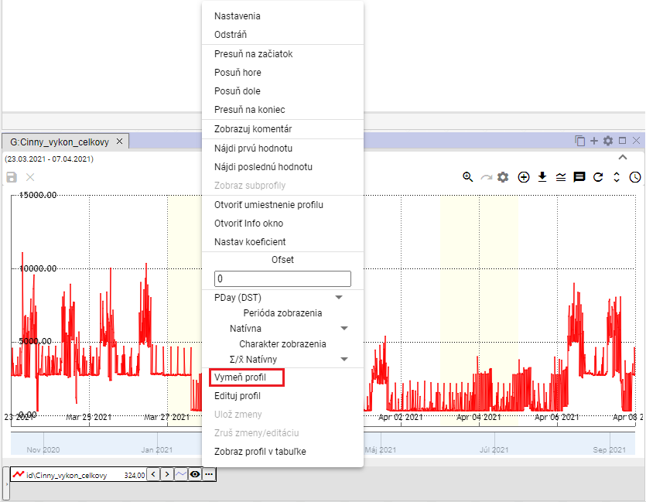

Image 395: Section "Edit Profile"

1. "A window called 'Edit Profile' will appear."

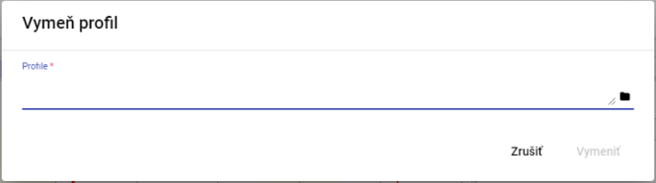

Image 396: Window "Outline Profile"

1. "Please enter path to profile or click on button and search for profile."

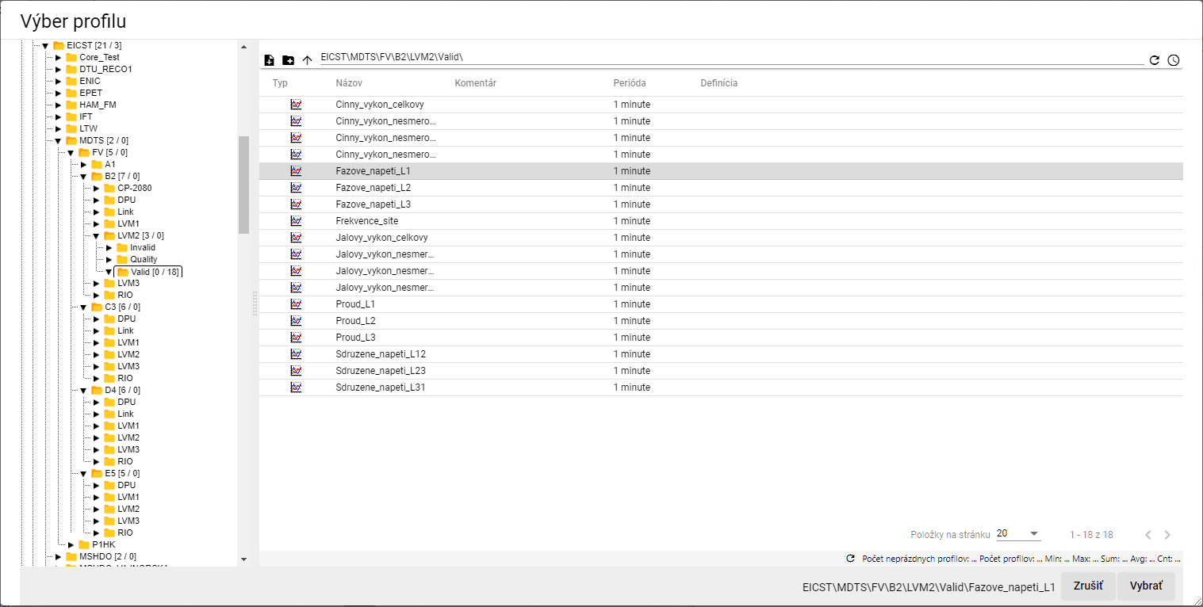

Image 397: Profile selection window

1. In the window "Change profile" click on the button "Replace".

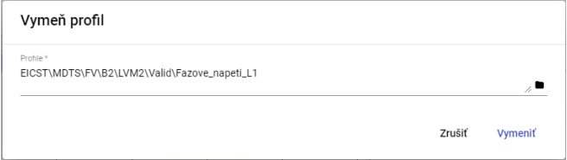

"Picture 398: Selected Profile"

1. The profile switch in the window Graph changes with selected profile.

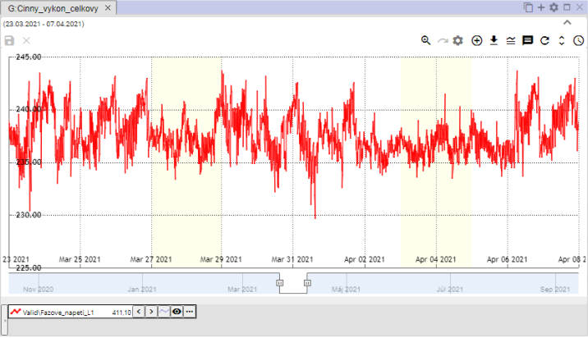

Image 399: Profile of a merged thread

# Work with a tablet

"The 'Profile Manager' application offers, in addition to work with graph and browser, the possibility of working with data in a table. Each table contains data from one profile and is created in a separate window."

The user closed the table with uncommitted data window; a window - Image 400 will appear.

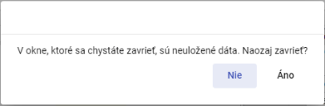

Image 400: I'm reporting on unverified data

## To display profile in table

No valid translation found.

"Before viewing your profile from the profile tree in the table, please proceed:"

1. "The standard window table is empty."

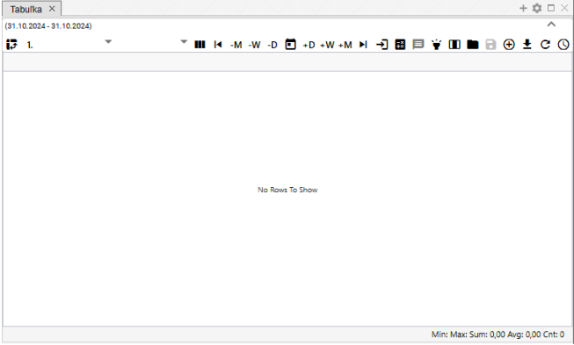

"Image 401: The window for displaying a table is normally empty"

1. "Click on the profile in the stream with your left mouse button to view it in the table."
2. Move the profile over the table window and let it go.

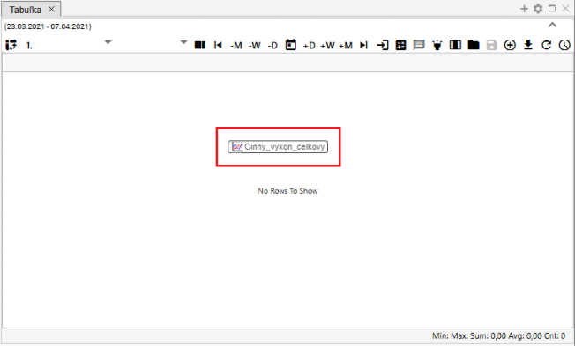

Image 402: Adding profile to table

1. In the window table, the profile values will appear.

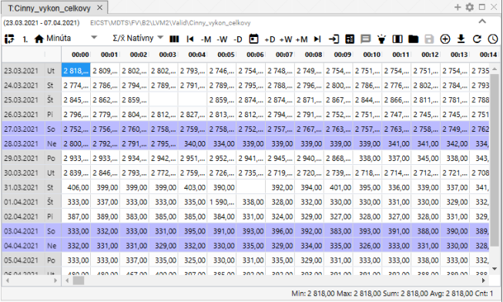

"Image 403: Profile display in table"

## To adjust column display

Standard view is set in the table. Column view can be set by pressing the button "Switch to column view". To return to standard view, press the button "Switch to column view" again.

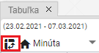

"Image 404: Button 'Switch to column view'"

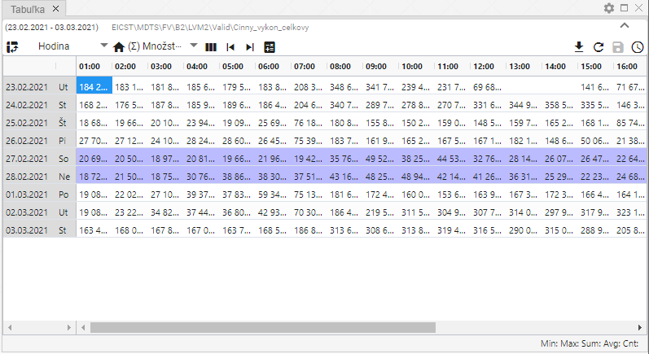

Picture 405: Emergency Display

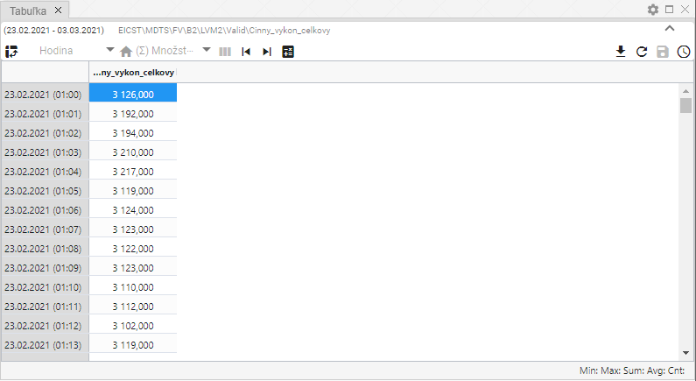

Picture 406: Pillar image

## I'll optimize for single-profile display

Standardly the table is set to single-profile display, Figure 409. Pressing the button showing Figure 407 turns the table into a multi-profile display, Figure 410. Switching back to a multi-profile display changes the appearance of the button Figure 407 to that of button Figure 408, which serves for switching the table back into a single-profile display.



Picture 407: Button "Switch to Multiprofile Display"



Image 408: Button "Switch to single profile view"

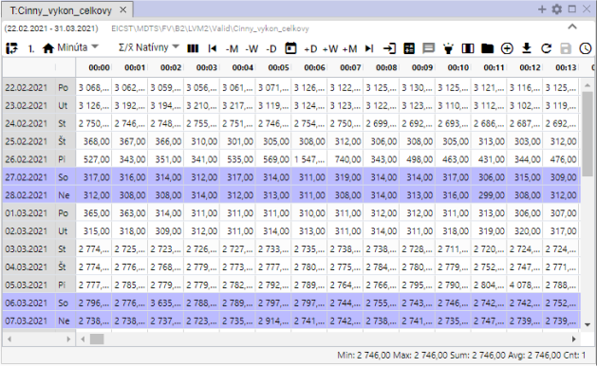

Picture 409: One-profile display

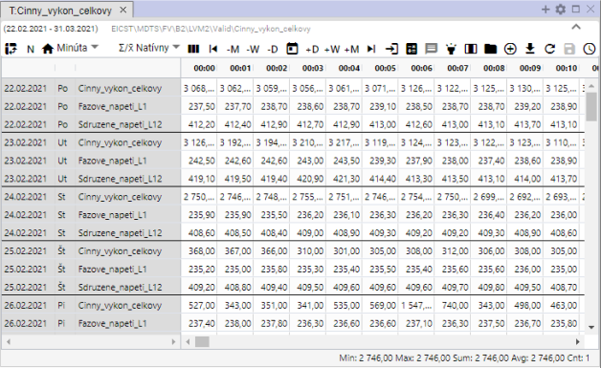

Image 410: Multifunctional display

## Change the time format display

No valid translation found.

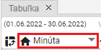

Image 411: Button for changing time format

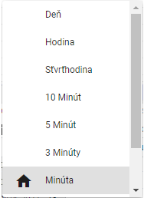

Picture 412: List of time formats in a table

"Data can be browsed even in periods:"

* "Day – daily overview of data"
* Hour - hourly overview of data
* Quarter-hour - 15-minute overview of data
* "10 Minutes - 10-minute overview data"
* 5 minutes - 5-minute overview of data
* 3 minutes - 3-minute review of data
* "Minute - minute overview of data"
* "Second - second-by-second overview"
* "Unknown – it will be shown if the table does not recognize the period of the profile. At that time, the values of the profile are stretched into one column and the time axis is filled according to the data."

## How to set the column count

In the "Tabuľka" window you can set the number of columns to be shown. Proceed:

1. No valid translation found.

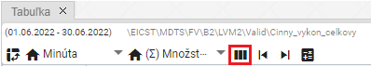

Image 413: Button "Number of Columns"

1. "A window 'Column count settings' will appear."

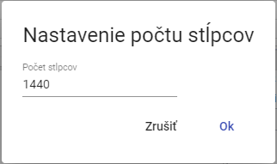

Image 414: Window "Setting number of columns"

1. Please enter the number of columns that should be displayed.

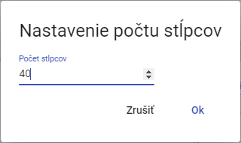

Image 415: Altered number of columns

1. The number of columns will be adjusted. Above the "Number of Columns" button, the set number of columns will appear.

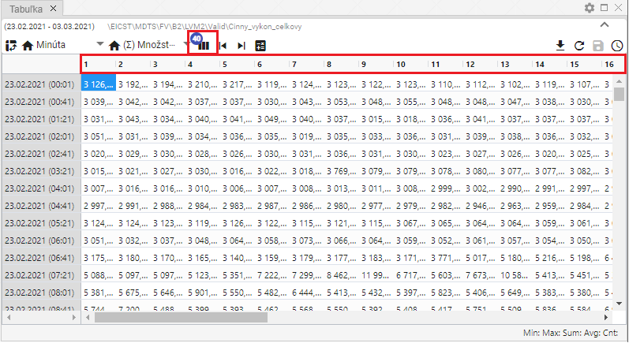

Image 416: Number of columns set

1. "Press the 'Number of columns' button before re-establishing the number of columns and press the 'Cancel' button in the 'Column settings' window."
2. "Then, the original number of columns will be restored."

## How to choose a method of vaccination

The method of prefetching determines how the profile will be prefetched when shown in other periods than its "natural" period.

"In the 'quantitative' mode of resampling, the underlying profile will be interpreted as quantitative (e.g. energy), and when displayed in smaller periods it will have its values divided by the corresponding ratios. In the 'behavioural' mode of resampling, the underlying profile will be interpreted as behavioural (e.g. temperature), and when resampled to lower periods it will keep its value on the same level."

No valid translation found.

"This setting affects only the display of the profile in a table. The change does not affect the behavior of the underlying profile in the system or the behavior of profiles dependent on it."

"To select the method of scrolling click on the button 'Scrolling Method' and choose from the window that appears, Figure 418."

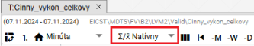

Picture 417: Button "Method of forwarding"

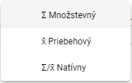

Image 418: Selection of a method for conjugation

## Show the first value

"The 'Set to first value' button serves to display the first measured profile value."

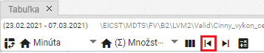

Picture 419: Button "Set first value"

## Show last value

The "Show last value" button serves to display the last measured profile value.

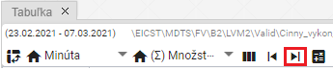

Image 420: Button "Go to zero value"

## How to display today's date

"Before displaying today's date, press the button 'Go to current date'. The cell in the table representing today's date and time will be highlighted."

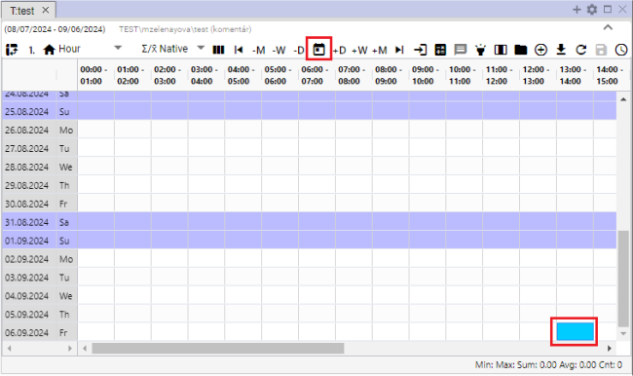

Image 421: Item "Go to current date"

## What is the exact date?

"Show specific date on table:"

1. Press the button "Go on a specific date".

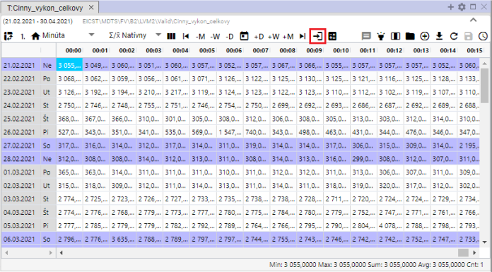

Image 422: Button "Go to specific date"

1. Choose date.

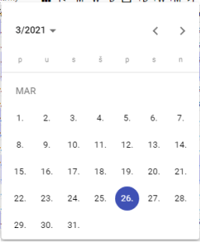

Picture 423: Task date

1. No valid translation found.

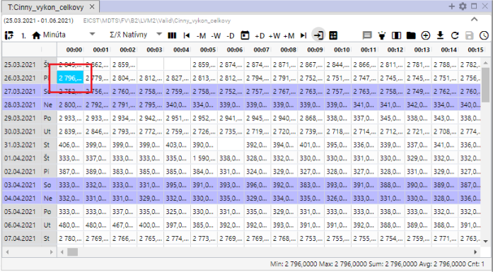

"Image 424: Display of selected date"

## I am setting the date by day, week, month.

Date range for which data is displayed in the table can be adjusted using sliders.

* No valid translation found.
* No valid translation found.
* No valid translation found.
* No valid translation found.
* No valid translation found.
* No valid translation found.

Proceed:

1. Click on the bucket that represents the date from which you want to add or subtract the chosen date range. The bucket is highlighted in blue color.
2. Press the selected button for date shift.
3. "The display of dates in the table will shift by the selected date range."

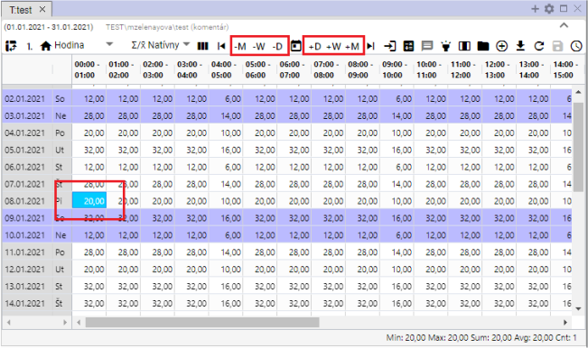

Image 425: Calendar icons for date shifting by one day, week, month

## Add column Sum, Average, Min, Max

Can you add columns?

* "Summary - switches/switches off the daily summary counting in the table. A new column called 'Summary' will be added to the table."
* The example – switches/turns on/off the daily average calculation in the table. In the table, a column "Average" will be added.
* "Min - turns on/off display of the minimum value from values for a given day. In table, column 'Min' will be added."
* "Max - toggles the display of maximum value for values within a given day. A 'Max' column is added to the table."

Standard table does not contain columns Sum, Average, Min and Max. To add them, proceed:

1. Press the button "Emergency statistics" at the top of the table window.
2. "A window will appear where you can select which columns are to be displayed."
3. "You can pin columns to the right side of a table by clicking on the 'Pinned Right' field. If you don't select 'Pinned Right', columns Sum, Average, Min and Max will be added at the end of the table. If you do select it, selected columns will be pinned to the right side of the table."

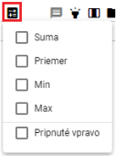

Image 426: Emergency Statistics Button

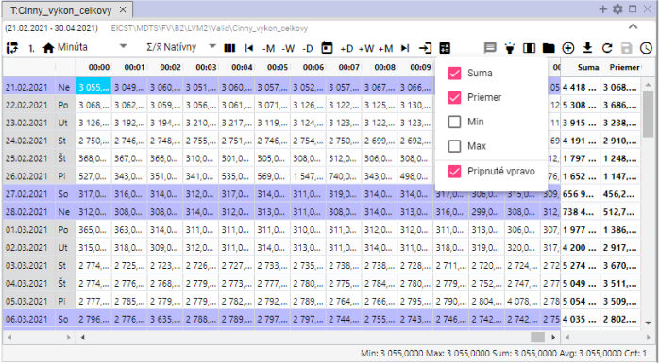

Image 427: Attached pillars "Height" and "Average"

## "How to turn on/off tooltip"

No valid translation found.

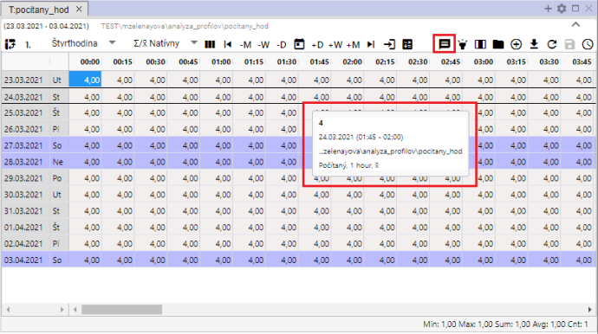

"Picture 428: Tooltip shown in table"

## How to turn on/off line highlighting

Highlighting a row means that the row will be highlighted when you position your mouse cursor on it. If the "Turn Highlighting On/Off" button is black, highlighting is turned on. The button is off if it's gray.

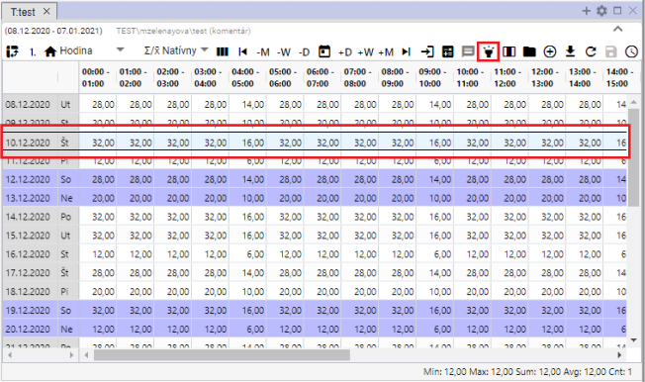

Image 429: Toggle button “Turn on/off row highlighting” and highlighted row

## "How to correct the profile value in the table"

You can modify the values of the stored profile in the window Table. The calculated profile cannot be modified.

Follow:

1. Click on a cell in the table window.

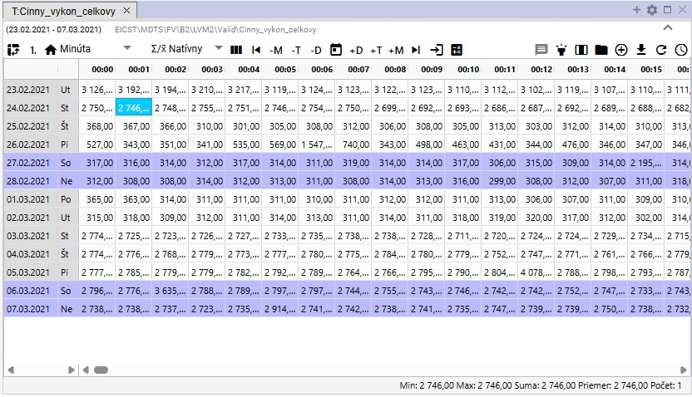

Picture 430: Selection of a bunker

1. Click on the bunker and write down the value.

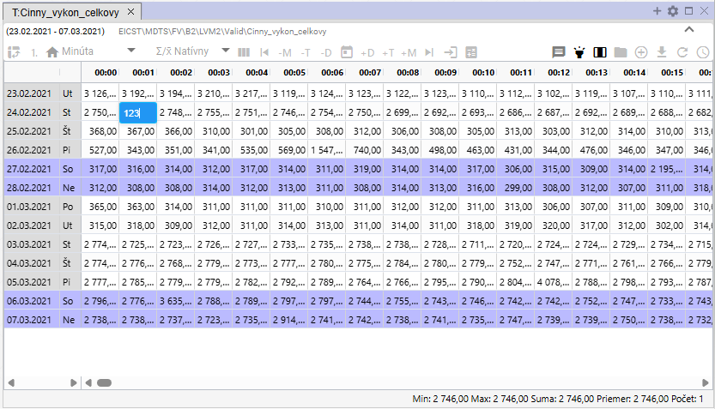

Image 431: Setting Value

1. Click on a different cell in the table after value correction. The floppy disk icon button will become active.

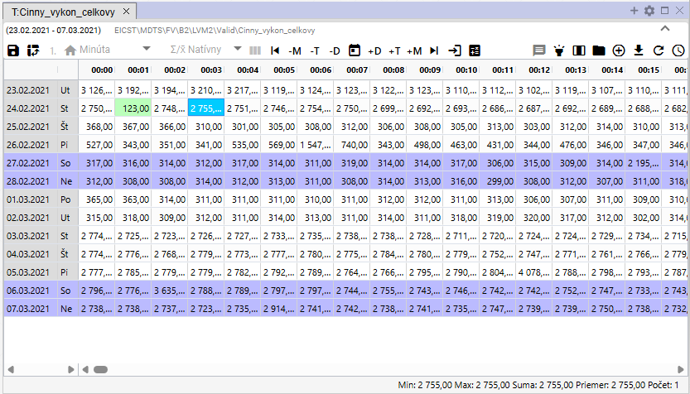

Image 432: Adjusted value in table

1. "You will save the changes by pressing the button 'Save changed values', which is located in the top part of the Tabulator window."



Image 433: Save changed settings button

## Change profile definition

You can edit the definition of the calculated profile in the Table window. Proceed:

1. Click on the right mouse button on the profile in the Table window.
2. "A window will appear where you select the item 'Edit definition'."

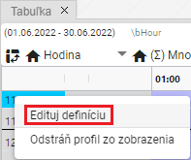

Image 434: Item "Edit Definition"

1. "A window 'Change profile definition' will appear."

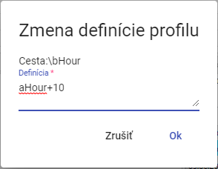

Picture 435: Window "Change Profile Definitions"

1. "Adjust the definition and confirm by pressing the 'OK' button."

## "Remove my profile from the table"

Before deleting your profile, proceed:

1. "Click with the right mouse button on the profile row that you want to delete."
2. "A window will appear where you can choose the option 'Remove profile from view'."

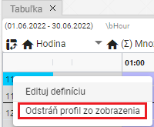

Image 436: Remove profile from view

1. The profile is removed from the window "Table".

## How to enable automatic column width settings

"Standardly, cells in a table have a fixed width. By means of the "Automatic column adjustment" button, image 437, you can set it so that the entire content of a cell is visible, image 438."

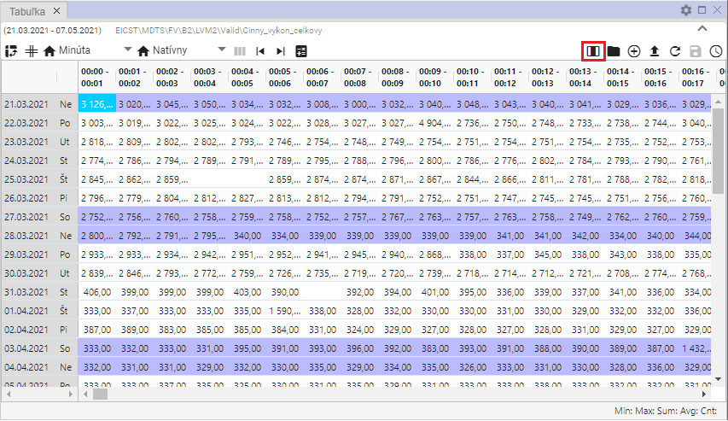

Image 437: Button "Set column width automatically"

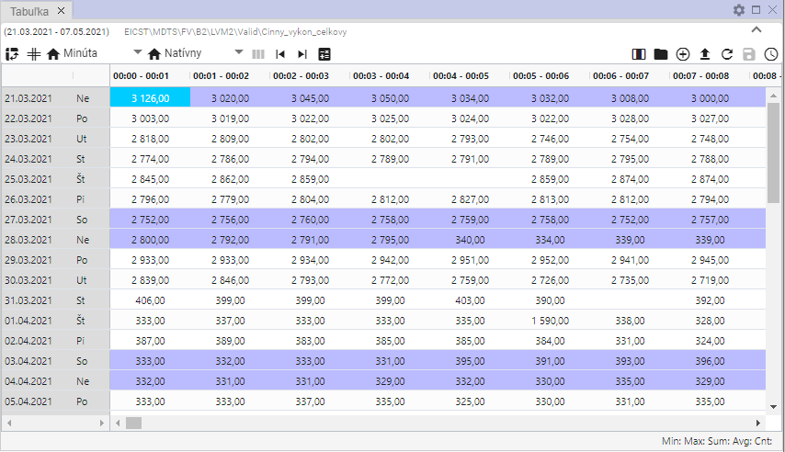

Image 438: Autofit column width settings are enabled

## "How to open user profile"

"The button 'Open user profile', Image 439, serves to open the user profile from a table window in a tree structure, Image 440."

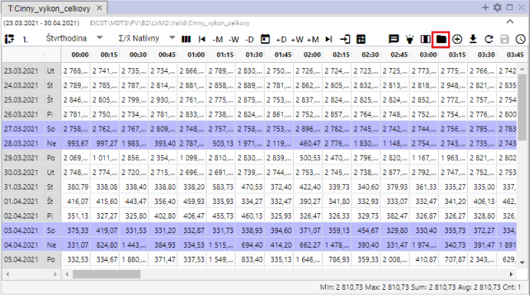

Picture 439: Open profile location button

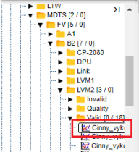

Picture 440: Opening profile in a web structure

## Add profile

"Before adding the profile to the 'Table' window, proceed:"

1. "Click on the 'Add profile' button, which can be found in the top right corner of the 'Table' window."

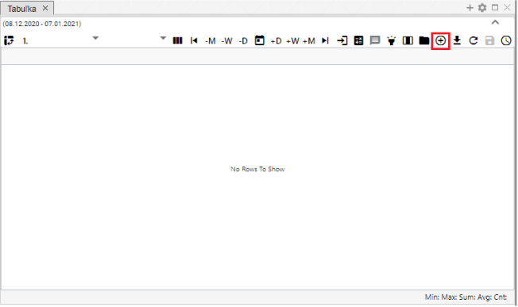

No valid translation found.

1. "A window titled 'Add profile' will be displayed, where you enter the path to the profile in a tree-like structure or press the button which will display a window titled 'Select profile'."

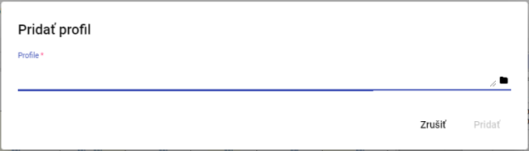

Picture 442: Add Profile Window

1. In the window “Profile selection” search for a profile and click on the button “Select”.

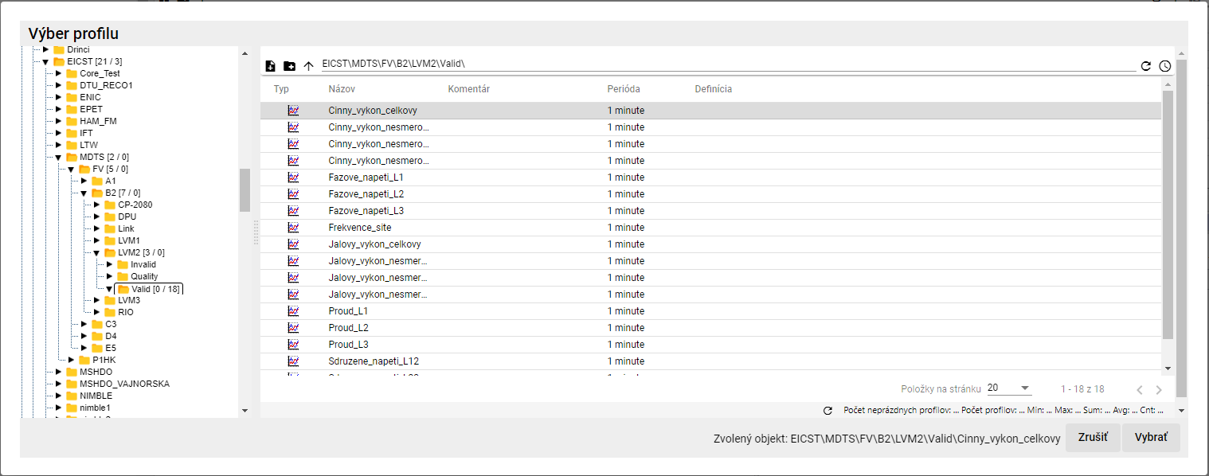

Picture 443: Profile Selection Window

1. "In the 'Add profile' window, a link to the profile will be displayed."

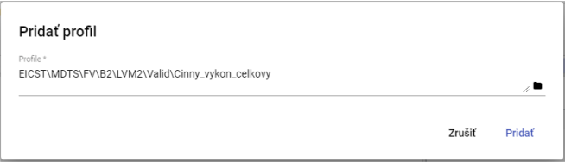

"Image 444: Road to Profile"

1. Click the "Add" button.
2. "In the window 'Table' will be displayed an added profile."

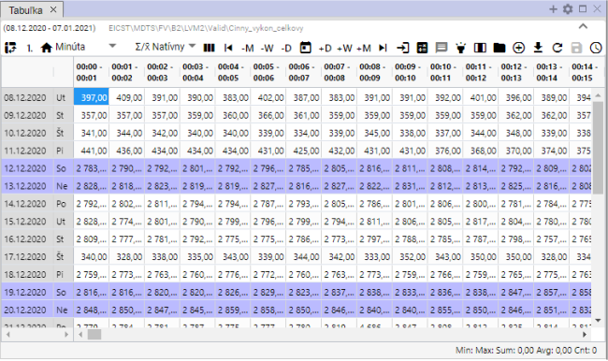

"Picture 445: Added profile in window 'Table'"

1. If the profile is shown in the table and you add another profile, multiple-profile display will be automatically activated.

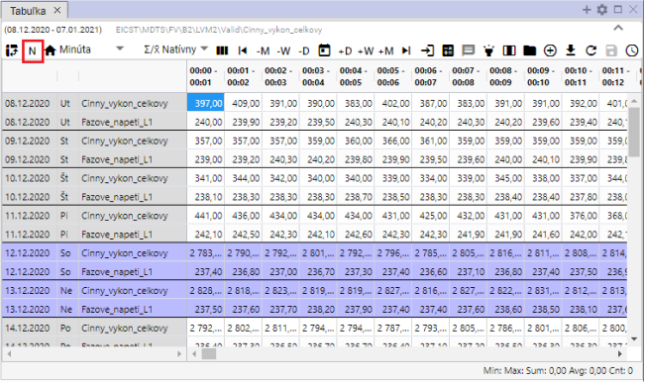

Image 446: Multi-profile display

## Export shown data into CSV

"The data displayed in the 'Table' window can be downloaded by clicking on the 'Export current view to CSV'. A file will then be downloaded, Image 448."

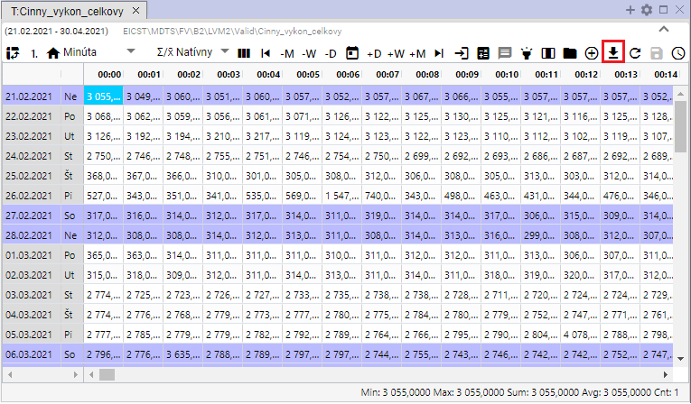

Image 447: Button "Export displayed data to CSV"



Image 448: Exported screenshot

## Change definition

"Before calculated profile you can adjust definition:"

1. No valid translation found.
2. "An offer will be displayed where you select the item 'Change definition'."

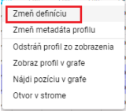

Picture 449: Item "Change definition"

1. "A window called 'Change face expression' will appear, in which you can adjust the definition of the counted profile."

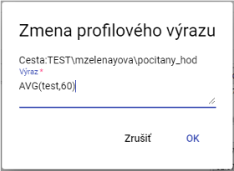

Picture 450: Change Profile Expression Window

1. "Changes will be saved by pressing the „OK“ button."

## "How to change profile metadata"

Proceed:

1. No valid translation found.
2. "The offer will be displayed where you click on the item 'Change profile metadata'."

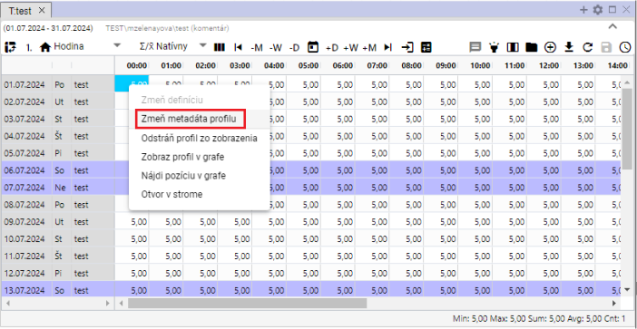

Image 451: Item "Change Profile Metadata"

1. "An edit profile window will appear."

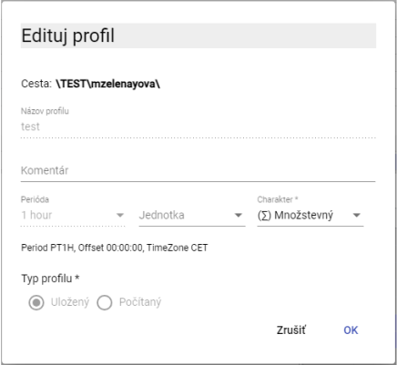

Picture 452: Edit Profile window for saved profile

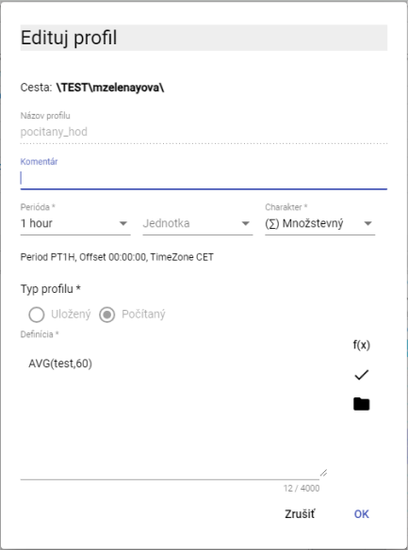

Picture 453: Edit profile window for computed profile

1. You can edit fields: Comment, Unit and Character for pre-saved profile. For calculated profile you can also edit the field "Definition".
2. Changes will be saved by pressing the "OK" button.

## Remove profile from view

Before deleting profile from table:

1. No valid translation found.
2. "The offer will be displayed, where you select 'Remove profile from view'."

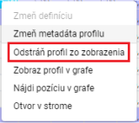

Picture 454: Item "Remove profile from view"

1. The profile is removed from the table.

## To show profile on the graph

If you want to display a profile from a table in a graph, proceed:

1. "Click on the window's header where you want to display a chart. This will activate the window. If the table window is active, the graph will be displayed in the table window."

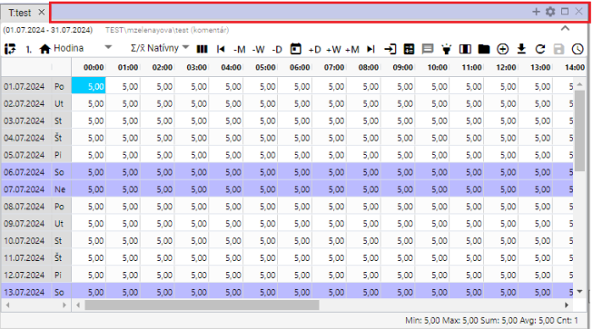

Picture 455: Active window

1. No valid translation found.
2. "An offer will be displayed, in which you select the item 'Show profile in graph'."

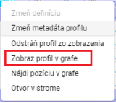

Image 456: Item "Show profile in graph"

1. "In the active window, a new tab with graph display will be added."

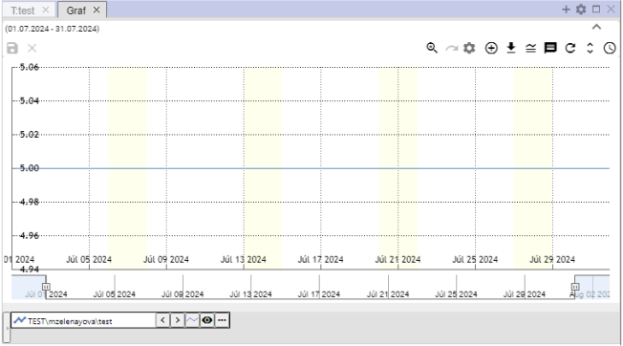

"Image 457: Displaying profile from table in graph"

## How do I find my position on the chart?

No valid translation found.

1. Show profile also in table and graph.
2. "Click the right mouse button on a cell in the table/location you want to display in the graph."
3. "The offer will be displayed, where you select the item 'Find position in graph'."

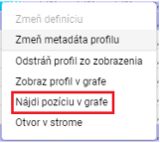

No valid translation found.

1. "In the graph will be displayed a place representing a cell from the table. The graph will shift so that the selected place is in the center of the graph. In the center of the graph a line will appear for one second."

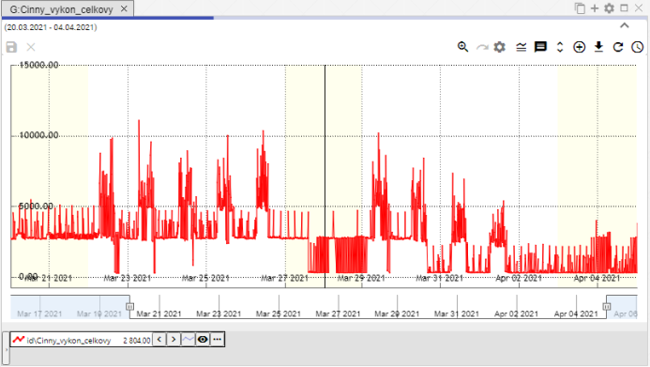

"Image 459: Displays a line in the center of the graph representing a selected cell from the table"

## "Open my profile on Steam"

"Before opening your profile in stream:"

1. "Click on any cell in the table window with the right mouse button."
2. "The offer will open, where you can select the item 'Open with Internet'."

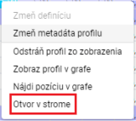

Image 460: Item "Gap in the fence"

1. In stream will open address book, in which is profile displayed in the table.

## "Select block using left mouse button"

No valid translation found.

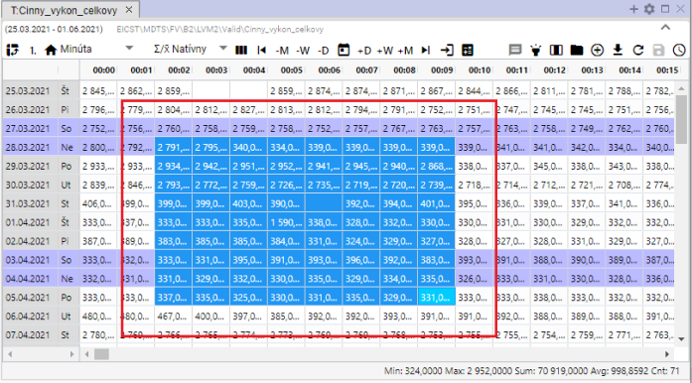

Image 461: Cell designation in table

## To scroll a cursor through a table using the mouse wheel.

You can scroll through the table using your mouse cursor. Scrolling is done one day at a time. You can also scroll outside the set range in the table. It's necessary for an active cell to be set up in the table.

Proceed:

1. "Click on the 'Settings' button, which is located in the top bar of the application."



Picture 462: Settings button

1. "A settings window will appear."
2. "In the part 'Table', click on the item 'Mouse wheel scrolls cursor'."

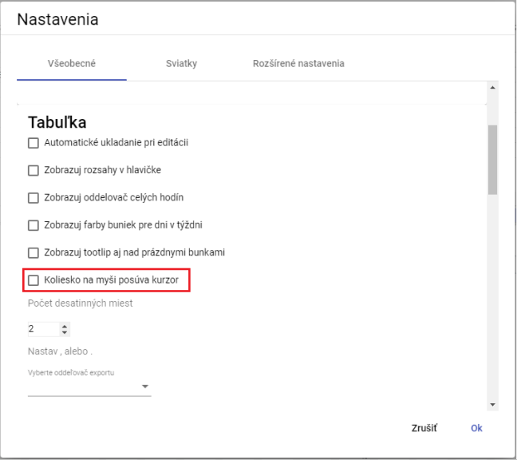

Image 463: Item "Wheel for mouse moves cursor"

1. Save by clicking on the "OK" button.
2. "Next, you move the cursor in the table by clicking on the mouse wheel. The cursor is an active cell in the table. This cell has a blue color."

No valid translation found.

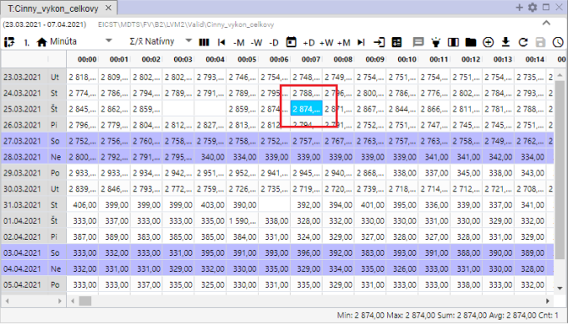

Image 464: Activated cell in a dish

## "How to change the order of profiles in the table"

"Before changing the order of columns in a table, you need to switch to column mode. Each profile represents one column. The order of columns can be changed. After changing the column order, you can turn back to row display."

Proceed:

1. "Show required profiles in table."
2. Press the button "Switch to column view".

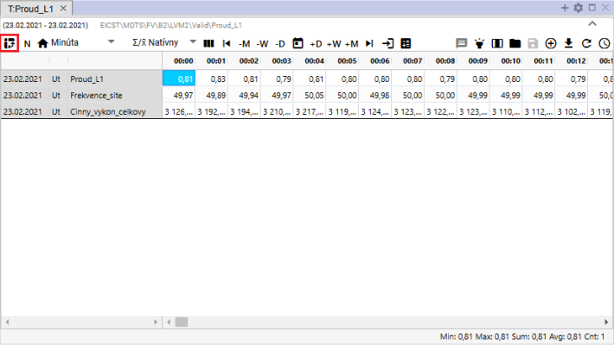

Image 465: Button "Switch to column view"

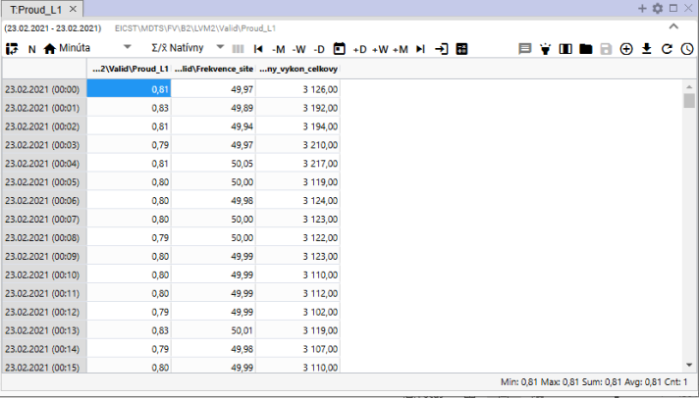

Image 466: Column chart in table

1. "Click on the left mouse button to select the column and drag it to its required place, then release."

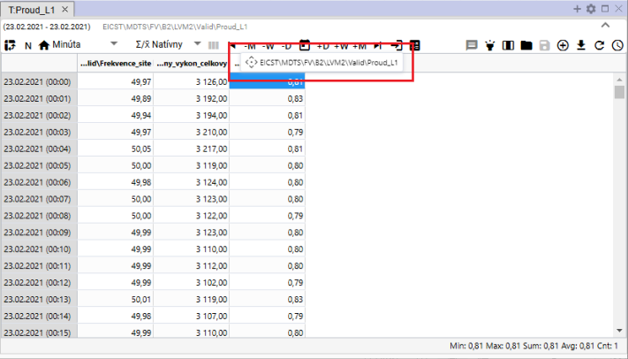

Picture 467: Pillar Pursuit

1. "After moving the column, you can turn on the grid view of profiles again."

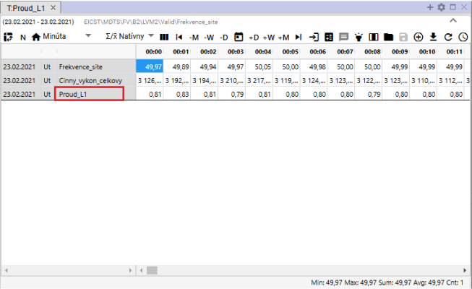

Image 468: Changed order of profiles

# Arithmetic counted profiles

## Pre-implementation procedures

"In arithmetic operations with profiles that have different periods, rounding occurs in their calculations. This rounding has its own rules, which mainly depend on the set character of the input profiles to the operation. The detailed rules of rounding are described in the following text."

### The rules of transferring an input profile onto the output one with consideration of character

Example: Output_profile := input_profile1 + input_profile2 * input_profile3 ...

1. "The copying of an input profile within an aggregate function (avg, sum, min, max, count) or cp(), is determined explicitly by its parameter and the following rules are not taken into account."
2. "If not, the input profile is yet converted to sampling of output profile according to the following rules:"
3. This is the default character and thus was looked at even before character introduction.
4. "If the periods of entrance and exit profiles are equal, there is no overwriting and no characters are considered at all. Values are copied 1:1."
   1. They have different profiles and we want to convert between them, so we must do it manually by a pattern in profile arithmetic. The most common is the conversion from 1/4-h power to 1/4-h energy via input_profile/4
5. "As periods of entry and exit are different, it will be constantly changing:"
   1. "Down-sampling: it involves sampling from finer to coarser resolutions, that:"
6. "In quantity, an aggregation will be used by means of SUM"
7. In accordance with circumstances, aggregation through AVG will be used.
8. Up-sampling: it involves interpolation from coarser to finer sampling.
9. Before multiplication, the input value is multiplied by the ratio of the output period to the input period.
10. The input value increases (unchanged) during the process.
11. "At higher levels, only the character of the input profile is taken into account. The character of the output is completely disregarded."

## Calculated profile

You will create the profile according to the following procedure:

1. "In the stream structure, click on the recipient's name with your right mouse button where you want to create a new counted profile. A window will appear where you can set the cursor to the 'New' item and select 'Profile', Figure 469. The 'New Profile' window will open, Figure 470."

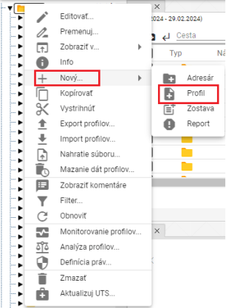

Image 469: Profile item

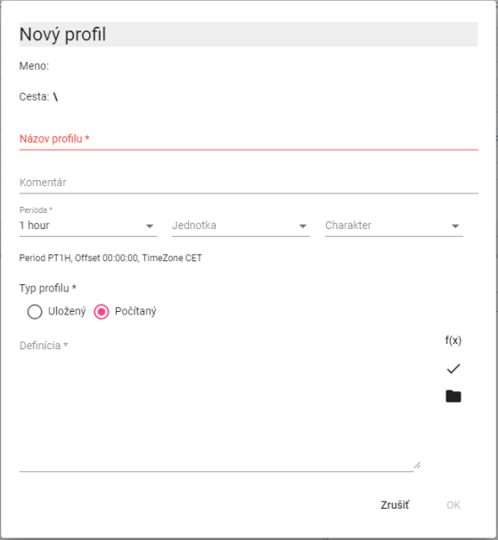

Image 470: Window for creating calculated profile

1. No valid translation found.
2. You can enter a comment.
3. Select period, unit and character.
4. "In the section 'Profile type', select 'Calculated'."
5. "For defining the calculated profile we can use buttons:"
6. **[OLLAMA FORMATTING ERROR - MANUAL REVIEW NEEDED] ak chceme pracovať so štandardnými funkciami pre počítaný profil**
7. **[OLLAMA FORMATTING ERROR - MANUAL REVIEW NEEDED] ak chceme použiť v definícii iný uložený alebo počítaný profil. Pre počítaný profil môžeme použiť v definícii aj iný počítaný profil.**
8. You will create a profile by pressing the "OK" button.

My profile is defined by the name, optionally followed by the path to the profile and name (path/profile)."

* "In addition to the calculated profile, you can also use plugin functions (described later) in definition."

Warning

"Creating an Oracle profile is not possible for Vo version Xenergie G2. Depending on the specifics of a particular implementation of Xenergie G2, it is possible to preserve their backward compatibility."

### Method of writing expression

We write down the definition of calculated into the window "Definition".

"The profile name must start with a letter, and can then contain digits and the underscore character "_". The profile name may contain up to 22 characters. A profile is identified by its name, or alternatively by specifying a path to the profile and its name (path/profile)."

"In the creation of definitions, uppercase and lowercase letters are not distinguished."

No valid translation found.

**[OLLAMA FORMATTING ERROR - MANUAL REVIEW NEEDED] \cez**

Link to profile via main address book

**[OLLAMA FORMATTING ERROR - MANUAL REVIEW NEEDED] ..\cez**

"link to profile above one level in directory"

**[OLLAMA FORMATTING ERROR - MANUAL REVIEW NEEDED] ..\..\oprava\cez**

"link to profile above two levels of addresses, in sub-address "repair""

**[OLLAMA FORMATTING ERROR - MANUAL REVIEW NEEDED] 100**

"The profile will contain a value of 100 for the entire time range."

No valid translation found.

This expression may contain spaces, tables and new line characters. These are ignored.

### Calculation of an expression

The expression is counted separately for each time period (hour, minute) requested.

The account at the calculated time has no value, it works with an invalid value.

"If any of the values entering the operation +, -, *, /, >, <, >=, <=, =, !=, |, & or ! is invalid, the result is an invalid value."

Division by zero produces an invalid value.

The program will always calculate all values, even though they are not necessarily needed, for example alt (100.0, unknown_profile) is an incorrect expression.

### Arithmetic operations:

* Counting + More
* Subtracting
* Multiplication
* The word "delenie" in Russian translates to "division", and the symbols "//" represent a division sign, indicating division by two.
* Parentheses ( )

Operations are counted left to right. Highest priority have parentheses, then "*, **, and /, //".

"Operations ++, --, **, // replace an invalid value with a value of 0."

### Functions

By clicking on the button will open a window where you can choose one of the standard functions. Functions are stored in categories.

* Aggregative functions
* Alternative
* **[OLLAMA FORMATTING ERROR - MANUAL REVIEW NEEDED] Kompozičné funkcie**
* **[OLLAMA FORMATTING ERROR - MANUAL REVIEW NEEDED] Podmienené**
* **[OLLAMA FORMATTING ERROR - MANUAL REVIEW NEEDED] Zastarané funkcie**
* **[OLLAMA FORMATTING ERROR - MANUAL REVIEW NEEDED] Iné**
* **[OLLAMA FORMATTING ERROR - MANUAL REVIEW NEEDED] Funkcie zaokrúhľovania**
* **[OLLAMA FORMATTING ERROR - MANUAL REVIEW NEEDED] Funkcie znaku**

"After selecting a category, a list of functions with help to functions will open."

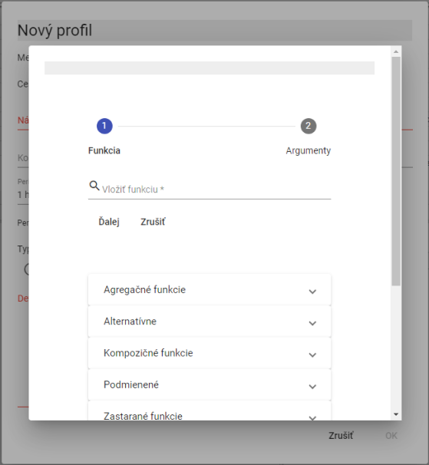

Image 471: List of Functions

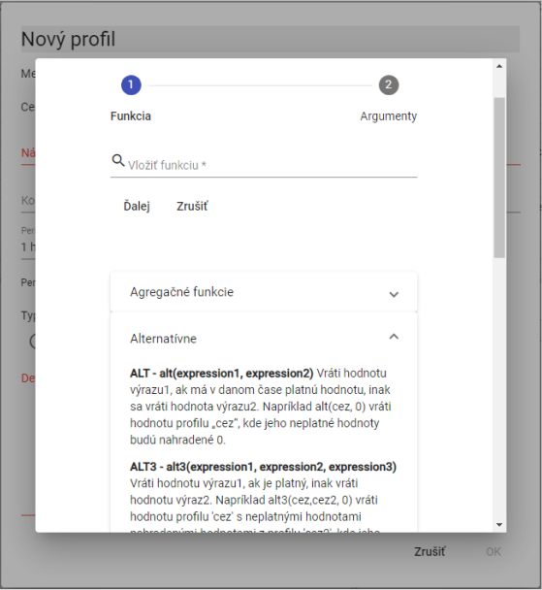

Image 472: List of functions with links to functions

#### Additive functions

Aggregate functions have two parameters.

1. **[OLLAMA FORMATTING ERROR - MANUAL REVIEW NEEDED] profil – názov profilu,**
2. **[OLLAMA FORMATTING ERROR - MANUAL REVIEW NEEDED] perióda – perióda, s ktorou sa má daná funkcia počítať. Perióda sa zadáva nasledujúcimi konštantami (pre počítanie v platnom čase sú konštanty začínajúce písmenom „P“):**

"Constants for setting a period must always be entered with uppercase letters."

**[OLLAMA FORMATTING ERROR - MANUAL REVIEW NEEDED] D, PD – denná perióda (v SEČ a v platnom čase – v lete v LSEČ)**

**[OLLAMA FORMATTING ERROR - MANUAL REVIEW NEEDED] W, PW – týždenná perióda /týždeň začína v pondelok a končí v nedeľu/**

**[OLLAMA FORMATTING ERROR - MANUAL REVIEW NEEDED] E, PE – týždenná perióda /týždeň začína v sobotu a končí v piatok/**

**[OLLAMA FORMATTING ERROR - MANUAL REVIEW NEEDED] M, PM – mesačná perióda**

**[OLLAMA FORMATTING ERROR - MANUAL REVIEW NEEDED] Q, PQ – štvrťročná perióda**

**[OLLAMA FORMATTING ERROR - MANUAL REVIEW NEEDED] Y, PY – ročná perióda**

"On calculated profiles, we can enter the period in minutes. It does not have to be entered as an abbreviation."

**[OLLAMA FORMATTING ERROR - MANUAL REVIEW NEEDED] sum(profil, perioda)**

"Synchronization with local time zone in CET."

(Period: D, W, E, M, Q, Y, while in calculated profiles you can enter the period in minutes.)

We will calculate the function sum(merging, M) with an hourly time profile. The resulting profile for all values in a month will contain the sum of the profile measurement values for the given month.

**[OLLAMA FORMATTING ERROR - MANUAL REVIEW NEEDED] avg(profil, perioda)**

Standardization with given time interval in CET (Central European Time)

We will calculate the function avg(temperature, 60) in which temperature profile has a minute period. In the resulting profile we get hourly average temperatures.

**[OLLAMA FORMATTING ERROR - MANUAL REVIEW NEEDED] min(profil, perioda)**

"Minimum duration during CET period."

"For each period, the minimum value is calculated."

**[OLLAMA FORMATTING ERROR - MANUAL REVIEW NEEDED] max(profil, perioda)**

Maximum value during period. Function works in UTC.

For each period, the maximum value is calculated.

**[OLLAMA FORMATTING ERROR - MANUAL REVIEW NEEDED] csum(profil, perioda)**

Cumulative summation of profile values on time units given by the parameter period. The output profile at a given point in time brings a value that is the sum of all preceding values of the input profile, from the beginning of the time interval (determined by the period parameter) up to and including the specific point in time.

"Note that if it is an entry profile with a one-hour period, then the exit profile defined by "csum(profile_entry, PD)" will have in every day, at its last hour (in valid time), value equal to the sum for this whole day)."

**[OLLAMA FORMATTING ERROR - MANUAL REVIEW NEEDED] pavg(profile,perioda)**

"Synchronization with given period in real time."

**[OLLAMA FORMATTING ERROR - MANUAL REVIEW NEEDED] pcsum(profile, perioda)**

"Scheduling with given period. Function works in real time."

"At any given time, the sum of values is determined by the period from the beginning to the time t."

**[OLLAMA FORMATTING ERROR - MANUAL REVIEW NEEDED] pmax(profile,perioda)**

"The maximum value within a period of continuous time."

**[OLLAMA FORMATTING ERROR - MANUAL REVIEW NEEDED] pmin(profile,perioda)**

"The minimum value within a period of continuous time."

**[OLLAMA FORMATTING ERROR - MANUAL REVIEW NEEDED] psum(profil ,perioda)**

"Synchronization with the given period in real time."

(Periods: D, W, E, M, Q, Y, while in calculated profiles possible period to enter in minutes.)

"Functions with P at the beginning of the series cause the division of time into intervals which are to be aggregated."

"P stands for Valid Time, which during summer switches from UTC+1 to UTC+2."

The functions of PSUM, PAVG, PMIN, PMAX are outdated. (others, like PHOUR, PDAY, PTDIV, etc. are not).

We recommend instead of them to use functions without the letter P in their name and to use P as a prefix for time parameters.

Instead of using the expression PAVG(profile, X), we recommend using AVG(profile, PX).

"Under the term 'outdated', we mean that these functions are no longer recommended for use when creating new calculations."

"Those 'obsolete' functions will remain in the system as they are, but we won't be adjusting their behavior."

"Functions without P, which we recommend as a replacement, have wider use and will be gradually extended to new periods."

Old functions can still be used. However, we recommend using the new universal versions for creating new patterns.

#### Alternative

**[OLLAMA FORMATTING ERROR - MANUAL REVIEW NEEDED] alt(vyraz1,vyraz2)**

**[OLLAMA FORMATTING ERROR - MANUAL REVIEW NEEDED] alt3(vyraz1,vyraz2,vyraz3)**

**[OLLAMA FORMATTING ERROR - MANUAL REVIEW NEEDED] ...**

**[OLLAMA FORMATTING ERROR - MANUAL REVIEW NEEDED] alt9(vyraz1,vyraz2,...,vyraz9)**

This expression has no valid value, the calculation continues with expression 2 and if that also has no valid value, another expression is used...

**[OLLAMA FORMATTING ERROR - MANUAL REVIEW NEEDED] alt(vyraz1,vyraz2)**

This expression 1 does not have any real value, it is taken instead by expression 2.

ALT(Data_DGC2000_cez, 0)

The profile "...sez" does not have a valid value; the function will use a value of 0 for processing.

**[OLLAMA FORMATTING ERROR - MANUAL REVIEW NEEDED] alt3(výraz1, výraz2, výraz3)**

"If the value of expression 1 is not valid, then use expression 2; if that one also does not have a valid value, then take expression 3."

Alternative functions can sometimes be appropriately replaced by:

No valid translation found.

**[OLLAMA FORMATTING ERROR - MANUAL REVIEW NEEDED] alt(dodavatel1,0)+alt(dodavatel2,0)**

They will compensate

Supplier1, supplier2

"Sum up two profiles by replacing an invalid value with 0."

No valid translation found.

IF ( ceiling(1.25*ceiling(0.8*price/100),0) = 4,IF ( ceiling(1.25*ceiling(0.8*price/100),0) = 5,0))

Or

Alt+3 (or Alt+C) to access the menu options "Copy" and "Copy 2", respectively.

"The non-valid value in the 'cez' profile will be replaced by a value from the 'cez2' profile; otherwise, if 'cez2' also does not contain a valid value, it will use the value 0. The second variant is, of course, more effective."

#### Error containment / error suppression

**[OLLAMA FORMATTING ERROR - MANUAL REVIEW NEEDED] nv()**

A function that returns an empty (invalid) value. (NO_VALUE). All operations with invalid values produce invalid values.

No valid translation found.

**[OLLAMA FORMATTING ERROR - MANUAL REVIEW NEEDED] nv()**

**[OLLAMA FORMATTING ERROR - MANUAL REVIEW NEEDED] nv()+100**

The result will be a profile containing invalid values. (Not containing any values).

Valid Profile

"If there is an error in retrieving the profile values (for example it does not exist), then the result are invalid values. If the VALID function is not used and the specified profile does not exist, the program will display an error message (the definition of the calculated profile is incorrect) and the expression will not be executed."

No valid translation found.

**[OLLAMA FORMATTING ERROR - MANUAL REVIEW NEEDED] test**

Or

**[OLLAMA FORMATTING ERROR - MANUAL REVIEW NEEDED] alt(test,0)**

"If the 'test' profile is incorrect (or does not exist), the program will notify an error when entering the following expressions."

"If the profile 'test' turns out to be incorrect even after entering this term, an error message will be displayed in the information window of the resulting profile."

No valid translation found.

Valid test

The resulting profile will be fine, but it won't contain a valid value.

if (valid(test), 0)

No valid translation found.

#### A simple condition

**[OLLAMA FORMATTING ERROR - MANUAL REVIEW NEEDED] cond(logicky_vyraz,vyraz1,vyraz_nepravda)**

If the logical expression is true, then expression1 will be executed. If it's false or has an invalid value, expression_false will be executed.

A logical expression may contain

* Expressions and numerical values
* Comparison operators: ">", "<", ">=", "<=", "=", "<>"

Logical expressions can be combined using logical operations:

* logical product (and simultaneously): AND
* Logical sum (or): |
* No negotiation: !

The evaluation order of logical operations is: !, &, | and we can adjust it with ().

No valid translation found.

Use min(czez, 0), 0, max(czez, 0))

"All values below zero in the profile will be replaced with a value of 0."

Example:

SELECT COUNT(*) FROM cez WHERE cez = 1

"The account profile through contains the actual value, the result will be 1, otherwise the result will be 0."

Example

If ((value < 0) | (value > 1000)), then null; else value.

If (cez is greater than or equal to 0 and cez is less than or equal to 1000), then return cez, otherwise return nv.

No valid translation found.

#### Multiple condition

**[OLLAMA FORMATTING ERROR - MANUAL REVIEW NEEDED] cond2(logický_výraz1, výraz1,logický_výraz2, výraz2, výraz_nepravda)**

**[OLLAMA FORMATTING ERROR - MANUAL REVIEW NEEDED] ...**

**[OLLAMA FORMATTING ERROR - MANUAL REVIEW NEEDED] cond9(logický_výraz1, výraz1,…logický_výraz9, výraz9, …výraz_nepravda)**

"If statement 1 is true, then execute statement 1. If statement 2 is true, then execute statement 2. ... If none of the statements are true, then execute false statement."

No valid translation found.

No valid translation found.

No valid translation found.

No valid translation found.

#### Warehouse functions

**[OLLAMA FORMATTING ERROR - MANUAL REVIEW NEEDED] day(výber_dní)**

No valid translation found.

Record day (136) will create such a 0-1 profile, which will have units on Monday (1), Wednesday (3) and Sunday (6).

**[OLLAMA FORMATTING ERROR - MANUAL REVIEW NEEDED] hour(výber_hodín)**

"The output is a profile containing units and zeros. The function returns 1 for hours of the day mentioned in the argument. The function works in UTC."

No valid translation found.

**[OLLAMA FORMATTING ERROR - MANUAL REVIEW NEEDED] month(výber_dní)**

The output is a profile containing units and zeros. The function writes 1 for those days in the month which are listed in the argument. The function works in UTC.

"Log entry: month(1, 3, 10–13, 30) will return a value of 1 for the days 1, 3, 10, 11, 12, 13, 30."

**[OLLAMA FORMATTING ERROR - MANUAL REVIEW NEEDED] pday(výber_dní)**

No valid translation found.

"Record :pday(136) will therefore return such a 0-1 profile, which will have units in Tu(1), We(3) and Su(6)"

The function works during business hours.

**[OLLAMA FORMATTING ERROR - MANUAL REVIEW NEEDED] phour(výber_hodín)**

"The output is a profile containing ones and zeros. The function writes 1 for those hours of the day that are specified in the argument. The function works during regular time."

No valid translation found.

The function works within office hours.

**[OLLAMA FORMATTING ERROR - MANUAL REVIEW NEEDED] pmonth(výber_dní)**

No valid translation found.

"Note: pmonth(1, 3, 10 - 13, 30) returns the value 1 for days 1, 3, 10, 11, 12, 13, 30."

The function works during office hours.

**[OLLAMA FORMATTING ERROR - MANUAL REVIEW NEEDED] ptdiv(výraz0, čas1,výraz1,...., časX, výrazX )**

"Profile creation based on time. Up to time time1 it uses profile values expression0, from time1 inclusive to time2 it uses profile values expression2, ..., from timeX inclusive uses profile values expressionX."

Time is entered in the format DD.MM.YYYY[YYYY] [HH:MM]. The year may be entered in full form (1990-2030), or shortened (00-30, 90-100).

The function ptdiv works in paid time.

**[OLLAMA FORMATTING ERROR - MANUAL REVIEW NEEDED] tdiv(výraz0, čas1,výraz1,...., časX, výrazX)**

"Profile construction based on time. Up to time time1 it will use profile values value0, from time1 inclusive until time2 it will use profile values value2, ..., from timeX inclusive will use profile values valueX."

Time is entered in the format DD.MM.YYYY[YY] [HH:MM]. The year may be entered in full form (1990-2030), or shortened (90-100, 00-30).

The third function works at night.

**[OLLAMA FORMATTING ERROR - MANUAL REVIEW NEEDED] vdiv(vstupny_výraz, výraz0, hodnota1, výraz1,... hodnotaX, výrazX)**

Profile creation based on value. If the input_expression is smaller than value1, it will be replaced by expression0. If it is larger (equal to) than value1 and smaller than value2, it will be replaced by expression1, ... . If it is larger (equal to) than valueX, it will be replaced by expressionX.

The pre-computed profile function assigns the value NO_VALUE for values of NO_VALUE.

#### Smoothing functions

The parameter počet_desatinných_miest determines the position to which we round. If this number is positive - we round to ones, tens, ..., if it's negative, we round to tenths, hundredths...

"If a number before the decimal point represents 2, then rounding functions will round up to whole tens."

**[OLLAMA FORMATTING ERROR - MANUAL REVIEW NEEDED] round(výraz, počet_desatinných_miest)**

Mathematical rounding (from 5 upwards absolute value). If the parameter number of decimal places = 0, the number 1.5 rounds up to 2. The number -1.5 rounds up to -2.

**[OLLAMA FORMATTING ERROR - MANUAL REVIEW NEEDED] roundup(výraz, počet_desatinných_miest )**

"Rounding up always in absolute value. If the parameter number_of_decimal_places = 0, the number 1.1 rounds to 2. The number -1.1 rounds to –2."

**[OLLAMA FORMATTING ERROR - MANUAL REVIEW NEEDED] trunc((výraz, počet_desatinných_miest )**

"Rounding the assigned number of places. If parameter number_of_decimal_places =0, then the number 1.1 is rounded to 1 and the number -1.1 is rounded to -1."

#### Warning functions

**[OLLAMA FORMATTING ERROR - MANUAL REVIEW NEEDED] abs(výraz)**

"Absolute value of each value in profile."

**[OLLAMA FORMATTING ERROR - MANUAL REVIEW NEEDED] minus(výraz)**

Values greater than 0 will replace 0.

**[OLLAMA FORMATTING ERROR - MANUAL REVIEW NEEDED] plus(výraz)**

Values less than 0 will be replaced by 0.

No valid translation found.

No valid translation found.

No valid translation found.

No valid translation found.

"cond (offset<0,0,offset)"

I am like a minus (with)

Example:

No valid translation found.

That's like saying minus a whole lot (odch)

# Supplemental/ancillary functions

"Additional functions are not a standard part of the delivery of "Profile Manager", but they need to be ordered separately."

## Profile monitoring

"This function serves for monitoring profiles. The monitoring job serves to maintain the profiles. It controls, for example, that the value in the profile does not fall below zero or is higher than 100. The following chapters deal with creating, editing, deleting and exporting the monitoring job."

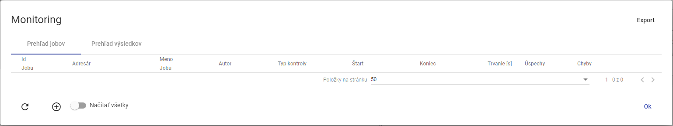

No valid translation found.

### I need to create a new monitoring job

**[OLLAMA FORMATTING ERROR - MANUAL REVIEW NEEDED] Pre vytvorenie nového monitorovacieho jobu postupujte:**

1. No valid translation found.
2. "An offer will be displayed in which you select the item 'Monitoring Profiles'."

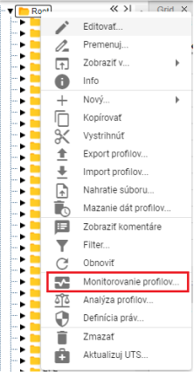

Image 474: Item "Profile monitoring"

1. "A window 'Monitoring' will be displayed."
2. "Click the button or right-click on an existing job and select 'Create New Job'."

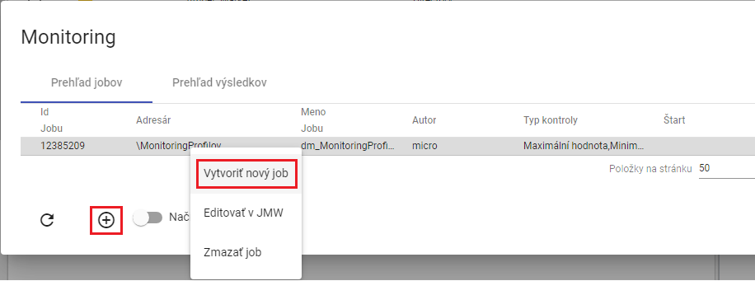

Image 475: Item "Create new job"

1. "A window called 'New Monitoring Job' will appear. Explanation of fields:"

* **[OLLAMA FORMATTING ERROR - MANUAL REVIEW NEEDED] „Kritériá“ - kritéria podľa ktorých sa profil monitoruje,**
* **[OLLAMA FORMATTING ERROR - MANUAL REVIEW NEEDED] „Zmena hodnoty“ - kritérium kontrolujúce zmenu hodnoty v monitorovanom profile. Profil je monitorovaný v stanovenom časovom intervale, ak sú všetky hodnoty v intervale rovnaké, zobrazí sa chybové hlásenie.( Profile: „Názov profilu“ No change in value in interval 27.3.2017 1:00:00 - 27.3.2017 4:00:00),**
* **[OLLAMA FORMATTING ERROR - MANUAL REVIEW NEEDED] „Monotónne“ - kritérium kontrolujúce monotónnosť hodnôt v monitorovanom profile v stanovenom intervale. Ak sa pri zvolenej stúpajúcej monotónnosti v časovom úseku nachádzajú hodnoty porušujúce stúpajúcu monotónnosť, zobrazí sa chybové hlásenie. (Profile: „Názov profilu“ Monotony condition of the series is not fullfilled at time point 6.4.2017 11:00:00),**
* **[OLLAMA FORMATTING ERROR - MANUAL REVIEW NEEDED] „Stúpajúce“ – kritérium kontroluje stúpavosť. Profil musí stále rásť.**
* **[OLLAMA FORMATTING ERROR - MANUAL REVIEW NEEDED] „Maximálna hodnota“ - kritérium kontrolujúce dosiahnutie maximálnej hodnoty v monitorovanom profile. Ak sa v hodnotách zvoleného profilu v stanovenom časovom intervale nachádza hodnota presahujúca zvolenú maximálnu hodnotu, zobrazí sa chybové hlásenie.(Profile: „Názov profilu“ 1.1.2013 0:00:00 > 14 is larger than allowed max: 8),**
* **[OLLAMA FORMATTING ERROR - MANUAL REVIEW NEEDED] „Minimálna hodnota“ - kritérium kontrolujúce dosiahnutie minimálnej hodnoty v monitorovanom profile. Funguje analogicky ako kritérium maximálnej hodnoty,**
* **[OLLAMA FORMATTING ERROR - MANUAL REVIEW NEEDED] „Chýbajúca hodnota“ - kritérium kontrolujúce počet chýbajúcich hodnôt v monitorovanom profile v stanovenom intervale. Ak počet chýbajúcich hodnôt v stanovenom intervale presiahne parameter „Chýbajuca hodnota“, zobrazí sa chybové hlásenie.(Profile: „Názov profilu“ Interval 1.1.2013 0:00:00 - 2.1.2013 0:00:00 contains 3 empty values.),**
* **[OLLAMA FORMATTING ERROR - MANUAL REVIEW NEEDED] „Rozdielna hodnota“ - kritérium kontrolujúce rozdiel medzi maximálnou a minimálnou hodnotou v monitorovanom profile v stanovenom intervale. Ak rozdiel max a min hodnoty v stanovenom intervale presiahne parameter „Rozdielna hodnota“, zobrazí sa chybové hlásenie.( Profile: „Názov profilu“ Difference in values was 12),**
* **[OLLAMA FORMATTING ERROR - MANUAL REVIEW NEEDED] „Začiatok intervalu (D:H:M:S)“ - je Interval začiatku monitorovania dát v profile. Vzťahuje sa relatívne k času spustenia akcie alebo k zadanému absolútnemu času,**
* **[OLLAMA FORMATTING ERROR - MANUAL REVIEW NEEDED] „Koniec intervalu (D:H:M:S)“ - je Interval konca monitorovania dát. Vzťahuje sa relatívne k času spustenia akcie alebo k zadanému absolútnemu času,**
* **[OLLAMA FORMATTING ERROR - MANUAL REVIEW NEEDED] „Časová zóna“ - je zóna v ktorej sa nachádza server na ktorom beží JMW. Zóna sa zohľadňuje pri posuvnom časovom okne, kedy sa podľa nej určuje lokálny čas spustenia akcie,**
* **[OLLAMA FORMATTING ERROR - MANUAL REVIEW NEEDED] „Zarovnanie“ - voľba zarovnanie umožňuje zarovnať časové okno dát monitorovaného profilu na nasledovné časové obdobia:**
  + **[OLLAMA FORMATTING ERROR - MANUAL REVIEW NEEDED] deň v platnom čase**
  + **[OLLAMA FORMATTING ERROR - MANUAL REVIEW NEEDED] hodinu v platnom čase**

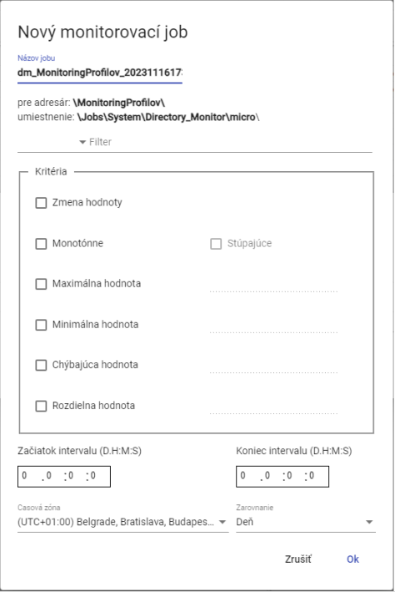

Picture 476: Window "New monitoring task"

1. The name of the job is already filled in by standard. In the field “Name of the job” you can enter a name for the job.
2. Click on the field to the left of the word "Filter", a window will appear in which you select the condition for the filter.

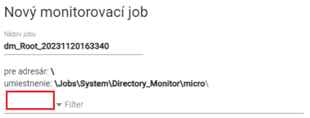

Image 477: Filter selection screen

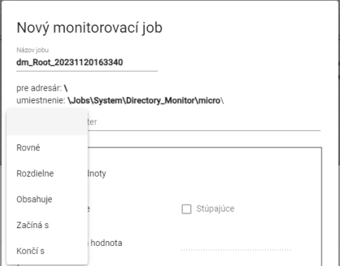

Image 478: Window for selecting conditions into filter

1. No valid translation found.



Image 479: Value for task to set on filter

1. In the block “Criteria” set criteria for monitoring.

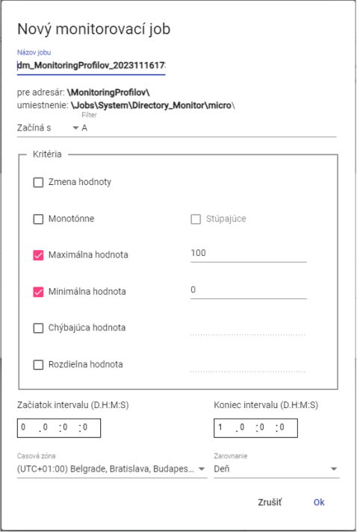

Image 480: Task of Job

1. Set the start and end of the interval.
2. You can choose a time zone and synchronization.
3. "Before creating the monitoring job, press the 'OK' button."
4. "In the 'Monitoring' window, a new monitoring job will be displayed."

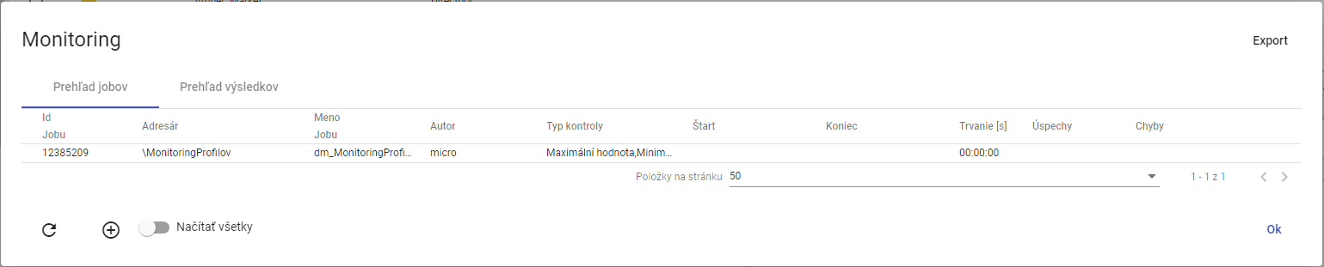

Image 481: Created Monitoring Job

### **[OLLAMA FORMATTING ERROR - MANUAL REVIEW NEEDED] Ako editovať job v JMW**

**[OLLAMA FORMATTING ERROR - MANUAL REVIEW NEEDED] Pre úpravu jobu postupujte:**

1. **[OLLAMA FORMATTING ERROR - MANUAL REVIEW NEEDED] Kliknite pravým tlačidlom myši na job a vyberte položku „Editovať v JMW“.**

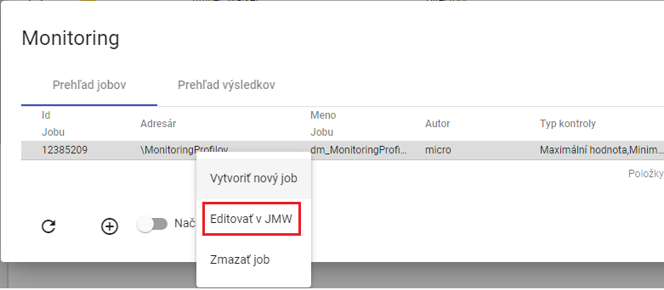

Image 482: Item "Edit in JMW"

1. **[OLLAMA FORMATTING ERROR - MANUAL REVIEW NEEDED] V novej záložke v prehliadači sa otvorí job v aplikácii „Job Manager“.**

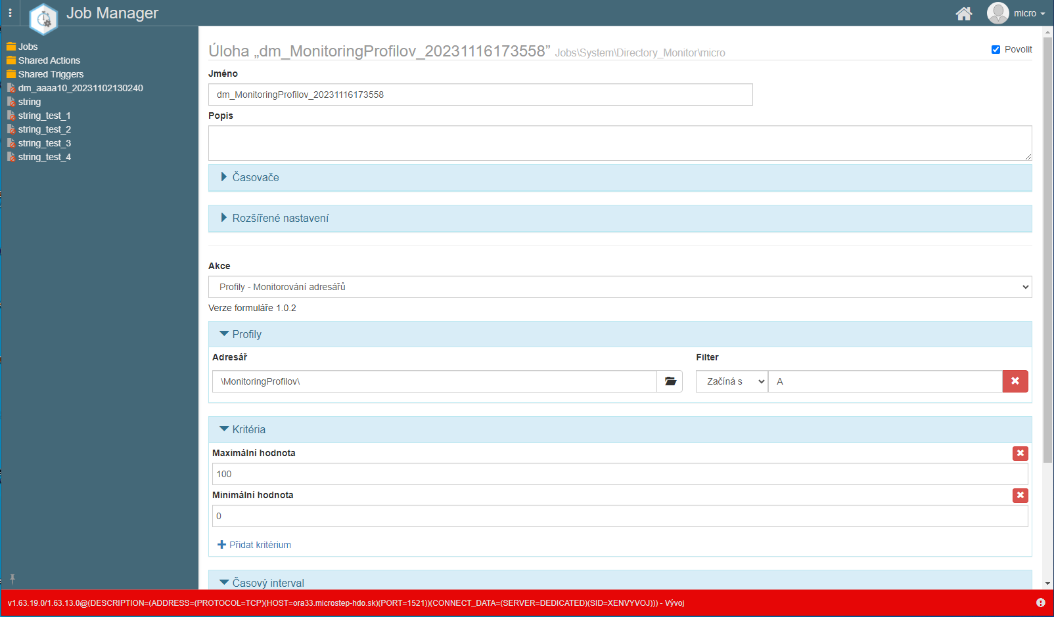

No valid translation found.

1. **[OLLAMA FORMATTING ERROR - MANUAL REVIEW NEEDED] Postup pre úpravu jobu sa nachádza v dokumentácii k aplikácii „Job Manager“.**

### **[OLLAMA FORMATTING ERROR - MANUAL REVIEW NEEDED] Ako zmazať job**

**[OLLAMA FORMATTING ERROR - MANUAL REVIEW NEEDED] Pre zmazanie jobu postupujte:**

1. **[OLLAMA FORMATTING ERROR - MANUAL REVIEW NEEDED] Kliknite pravým tlačidlom myši v okne „Monitoring“ na job, ktorý chcete zmazať.**

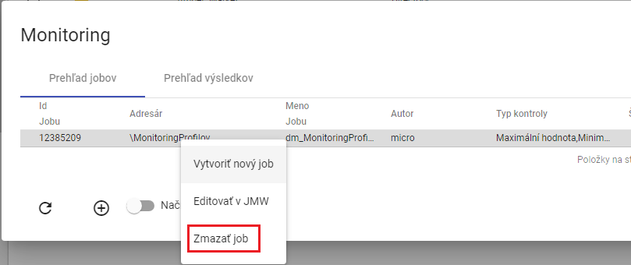

Image 484: Item "Wipe out jobs"

1. **[OLLAMA FORMATTING ERROR - MANUAL REVIEW NEEDED] Zobrazí sa okno pre potvrdenie vymazania, v ktorom stlačte tlačidlo „Áno“.**

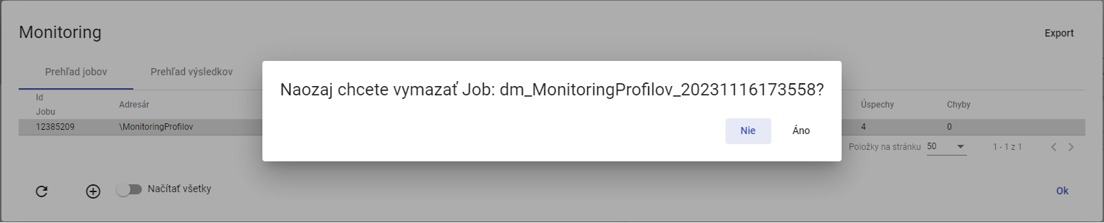

"Image 485: Window for confirmation of job deletion"

### **[OLLAMA FORMATTING ERROR - MANUAL REVIEW NEEDED] Ako exportovať monitorovacie joby a výsledky jobov**

**[OLLAMA FORMATTING ERROR - MANUAL REVIEW NEEDED] Pre exportovanie jobov v záložke „Prehľad jobov“ stlačte tlačidlo „Export“, ktoré sa nachádza v pravom hornom rohu okna „Monitoring“. Pre exportovanie výsledkov jobov zobrazte záložku „Prehľad výsledkov“ a stlačte tlačidlo „Export“. Stiahne sa CSV súbor.**

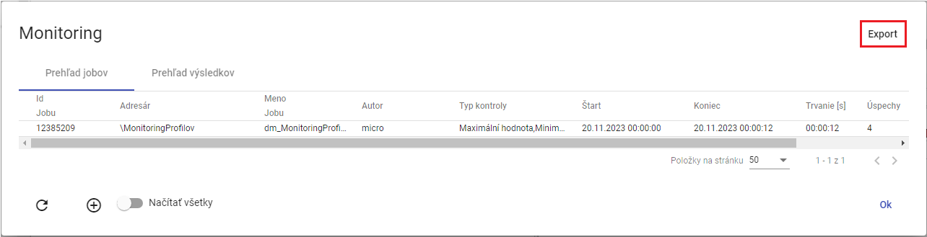

Image 486: Export button

### "To show all monitoring jobs"

Before displaying all monitoring jobs, click on the "Load All" button. In the "Monitoring" window, all monitoring jobs from the tree structure will be displayed.

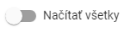

Image 487: Button "Load all"

### "If I were to restore the jobs list in the 'Monitoring' window"

"Before pre-filling the list of jobs click on the button located in the left bottom corner of the window 'Monitoring'."

### How to display an overview of results from a monitoring job

"In the 'Monitoring' window, display the 'Results Overview' tab. There is a list of running monitor jobs. If criteria for monitoring a profile are violated, in the 'Result' column will be displayed text 'ERR' and in the 'Detail' column there will be error description. If the criteria were met, the result is 'OK'."

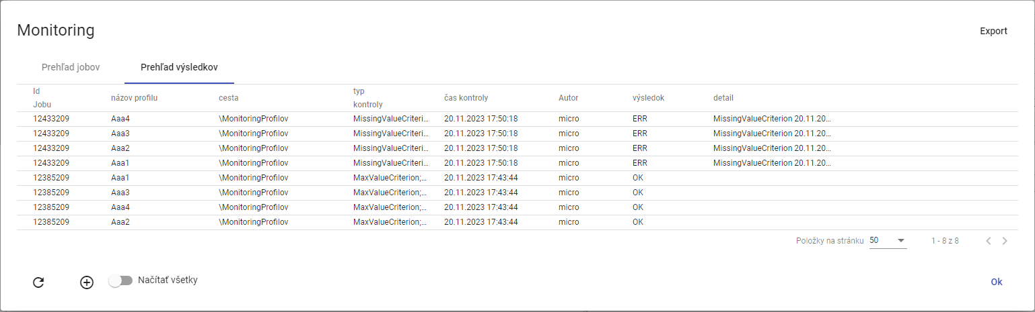

Picture 488: Bookmark "Overview of Results"

## Profile analysis

Analysis of profiles represents a static image at a given moment of calculation. This means that if someone deleted the profile, the analysis of profiles remains preserved. The analysis of profiles allows users to filter and sort data. Chapter 8.2.1 is concerned with the creation of an analysis of profiles.

If you close the profile analysis, you can reopen it. Reopening an existing profile analysis is covered in Chapter 8.2.2.

No valid translation found.

Exportation of the displayed data in profile analysis is detailed in Chapter 8.2.4.

### How to create a profile analysis

"Proceed before analysis of profiles:"

1. Click the right mouse button on the folder with profiles for which you want to create profile analysis in file structure.
2. "A window will appear where you click on the item 'Profile Analysis'."

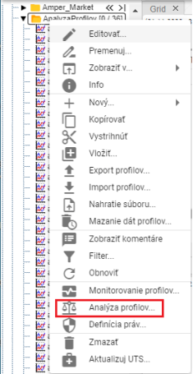

No valid translation found.

1. Another option is to display the address book with profiles in the "Inspector" window and click on the "Statistics" button, which can be found in the top right corner of the "Inspector" window.



Image 490: Statistics button

1. "A window called 'Analysis of Profiles' will appear."
2. "The standard option is 'Create new for period'."

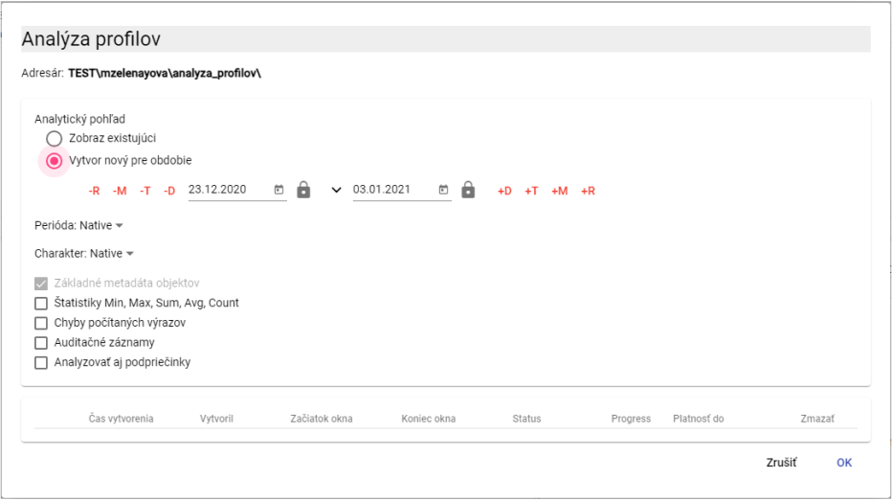

No valid translation found.

1. "Proceed to the period for which a profile analysis will be performed. Click on the button to display the default date range options."

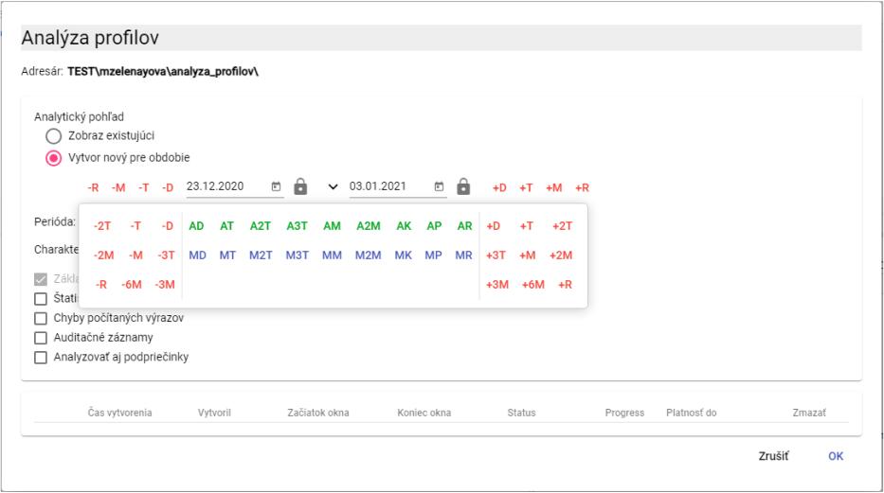

Picture 492: Selection of dates

1. "The standard value is 'Native' in the field 'Period'. If you want to enter another period, click on the field 'Period' and select a period."

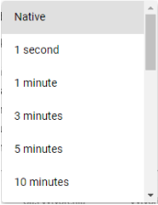

Picture 493: Period selection

1. Character profile is used to identify how values in the profile are transferred from coarse sampling to finer sampling. Standardly, in the "Character" field, the value is "Native". To select a character, click on the "Character" field and select either "Quantitative" or "Descriptive".

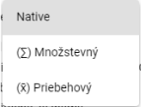

Character selection image 494

1. No valid translation found.

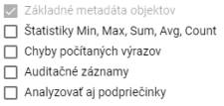

Image 495: Optional items in analysis

1. "If you want the error to be written in case of an occurrence, click on the checkbox ""Counted expressions errors"".
2. "Select the 'Audit Trail' policy, if you want to print out data: First Read, Last Read, First Write and Last Write."
3. "All descendants should be included in the analysis, click the box 'Analyze also descendants'."
4. "Click on the 'OK' button before creating profile analysis."
5. In the "Explorer" window, a new tab with the title "To:" will be created. The profile analysis presents a static image at the time of computation.

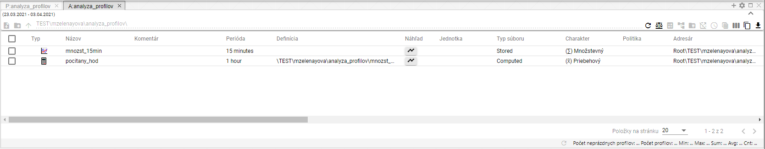

Picture 496: Created profile analysis

1. "In the analysis window profile tab, you can filter data. Place your mouse cursor on the name of the column in which you want to add a filter. A button for adding a filter will appear."



Picture 497: Button for setting filter

1. "Before sorting data in a column, place the mouse cursor on the name of the column. An arrow icon will appear. Clicking the button with an arrow icon sorts the data in the column."



Image 498: Sorting button for dates in columns

### "To display an existing profile analysis"

If you close the profile analysis and want to open it again, you can do so during the validity period of the profile analysis. The profile analysis has a 15-minute validity period after creation. This validity period can be extended.

Before opening an existing profile analysis, proceed:

1. No valid translation found.
2. Click to mark the analysis you want to display.

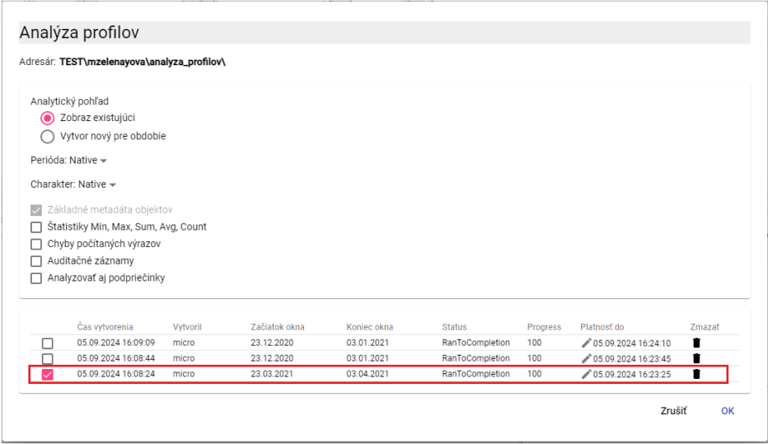

"Image 499: Displaying existing profile analysis"

1. Click on the "OK" button.
2. "In the window 'Explorer' will be displayed profile analysis."

### How to expire created profile analysis

"The validity of the profile analysis is standardly 15 minutes, but you can extend it."

Before extending the validity of analysis profiles, proceed:

1. In the window "Analysis profiles" in the row of analysis that you want to extend the validity, click on the button with a pencil icon.

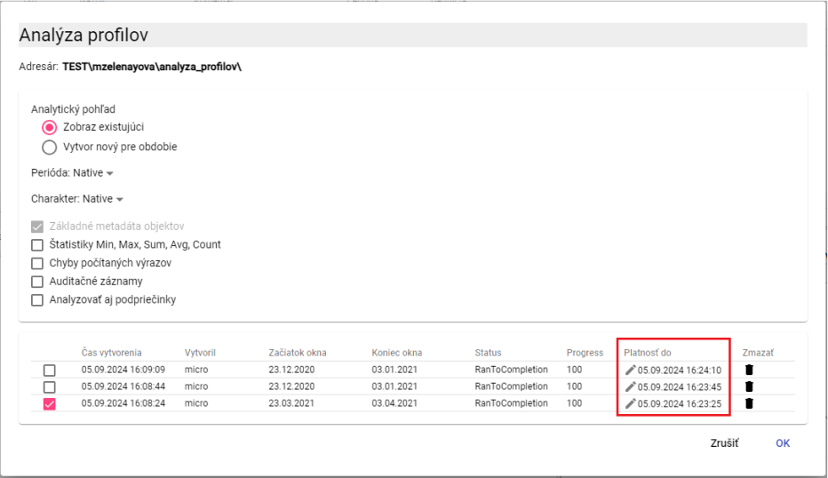

Picture 500: Polish currency (until)

1. "The 'Payment until' pole will become available for editing."

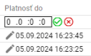

Image 501: Extension of profile analysis validity

1. No valid translation found.
2. Press the button now.
3. The validity of profile analysis is being extended.

### To export the displayed data in profile analysis

No valid translation found.

1. "Click on the button that is located in the top right corner of the window 'Explorer'."

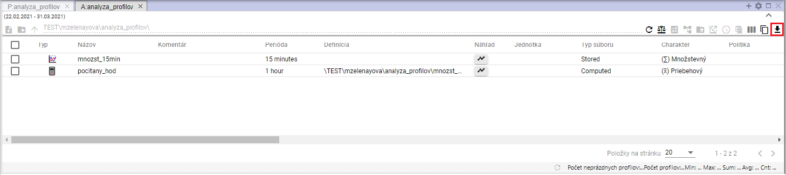

Image 502: Export button for analysis profiles

1. An export window will appear.

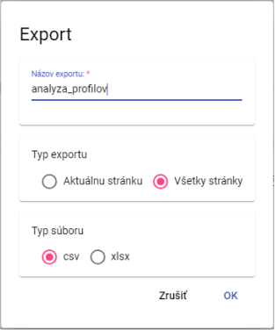

Picture 503: Window "Export"

1. "In the 'Export Type' section, the default setting is 'All pages'. All data is exported. If you select 'Current page', only displayed data is exported."
2. "In part 'Group Type' select group type for export."
3. "Click on the 'OK' button after confirming export."

## Report Manager

### How to create a new report

Before creating the report, please proceed:

* 1. "In the tree structure click with the right mouse button on the folder where you want to add a new report."
  2. "A menu will appear in which you can select the option 'New' with your mouse cursor and then choose the option 'Report'."

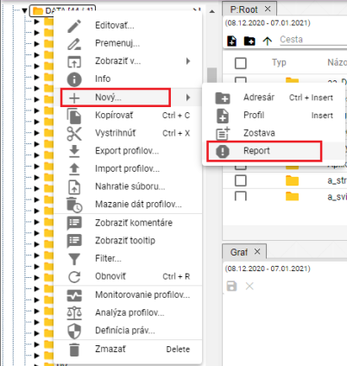

Image 504: Item "Report"

* 1. The "Report Manager" bookmark will appear, where you can enter data for the new report.

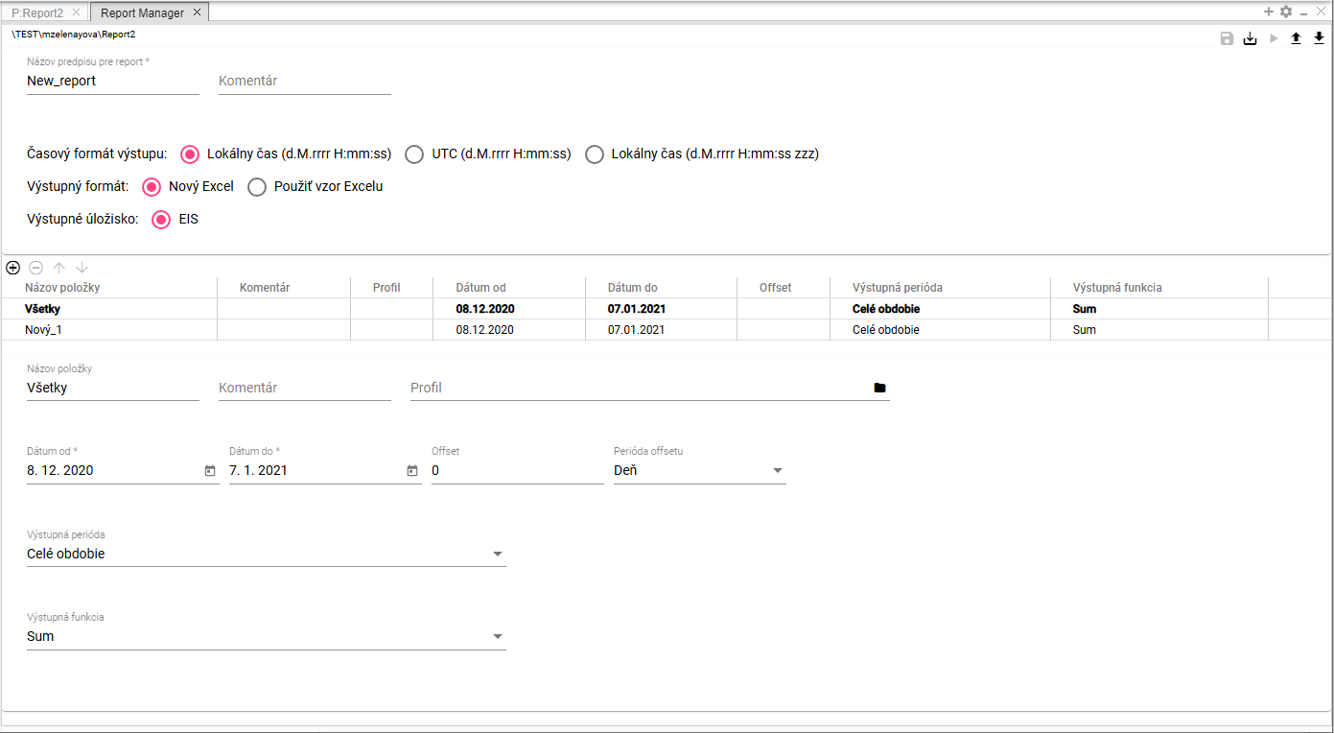

Picture 505: Tab "Report Manager"

* 1. In the field "Name of the rule for reporting", there is automatically the text "New_report". You can change this.

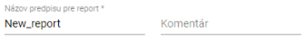

Image 506: Fields "Name of prescription for reporting" and "Comment"

* 1. You can write a comment in the "Comment" section.
  2. Choose the time format of output. By default, choose “Local Time (d.m.yyyy HH:mm:ss)".



Picture 507: Pole "Time format of output"

* 1. In the menu "Output format", select the output format for the report. By default, the choice is set to "New Excel".



Image 508: Pole "Output Format"

* 1. If you select the item "Use Excel template", the fields "Excel name" and "Sheet name in Excel" will be displayed.

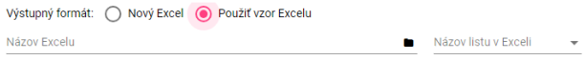

"Image 509: Fields for Excel task"

* 1. In the section called "File name of Excel", click on the button, which will display a window called "Select xlsx", in which you can search for an Excel file in a tree structure.

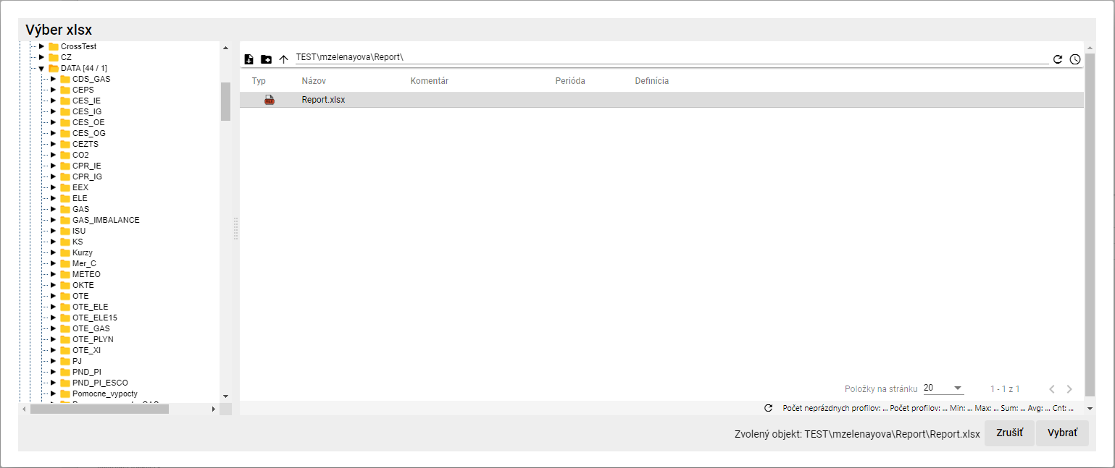

Image 510: Window "Select xlsx"

* 1. In the window "Select xlsx" after searching for Excel click the button "Select". The path to Excel will be filled in the field "Excel Name", Image 511.
  2. "Click on the field 'Sheet name in Excel' and select the sheet name."



The image 511: Fields filled "Name of Excel" and "Sheet name in Excel"

* 1. Fill in data for items.

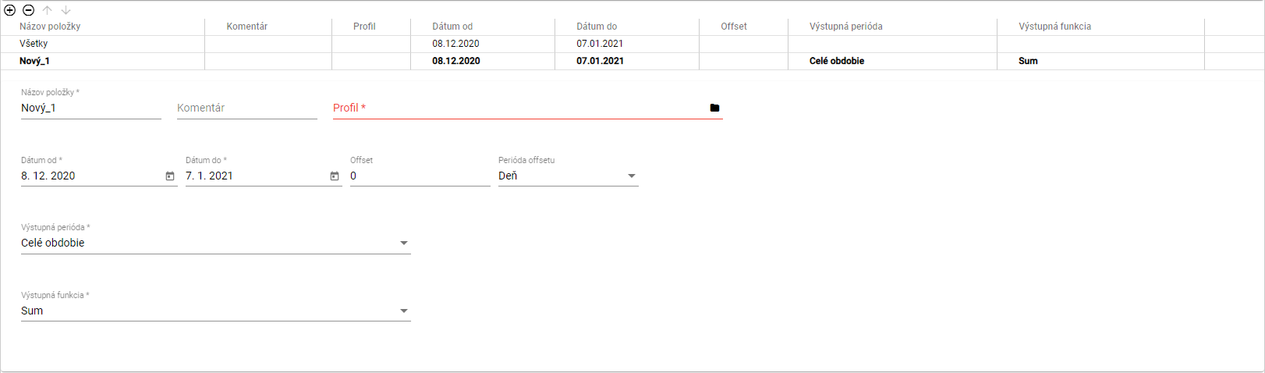

"Image 512: Task for items data"

* 1. "If you want to enter the same information for all items at once, click on 'All'. The information you input will be filled in for all profiles."
  2. "If you want to fill out the data for each profile separately, click on the item in the table that you want to enter data for."



Picture 513: Selected item in table

* 1. No valid translation found.
  2. In the field "Name of item", "New_1" is automatically filled. You can change it.
  3. You can write a comment on the blog "Commentary".
  4. In the "Profile" tab, write the path to your profile or click on the button and a window called "Select Profile" will appear.
  5. In the window "Choose profile" search for a profile and click on the button "Select".

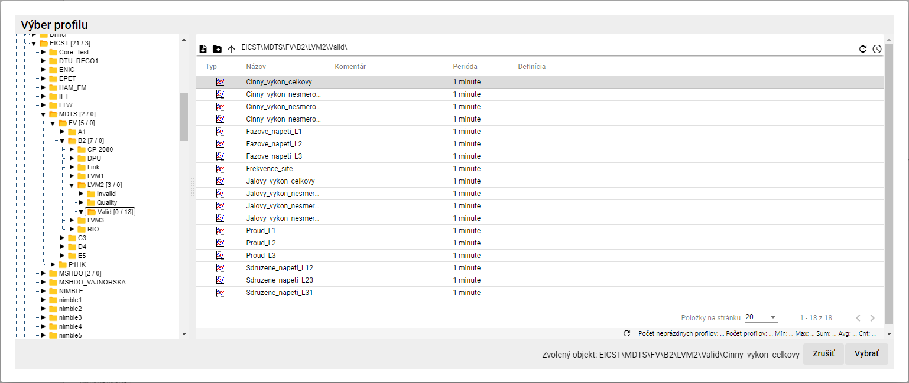

Image 514: Profile selection window

* 1. No valid translation found.
  2. In the menu "Offset" you can specify an offset.
  3. Choose an era during the "Offset Period."
  4. "Click on the field 'Output period' and from the displayed offer, select a period."
  5. Click into the field "Output function" and select a function.

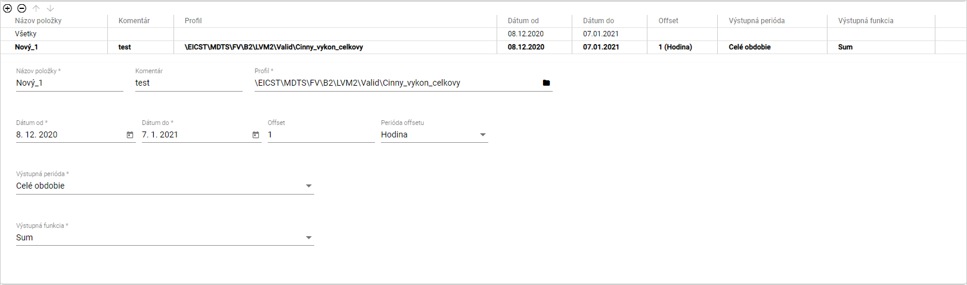

Picture 515: Filled data for item

* 1. No valid translation found.

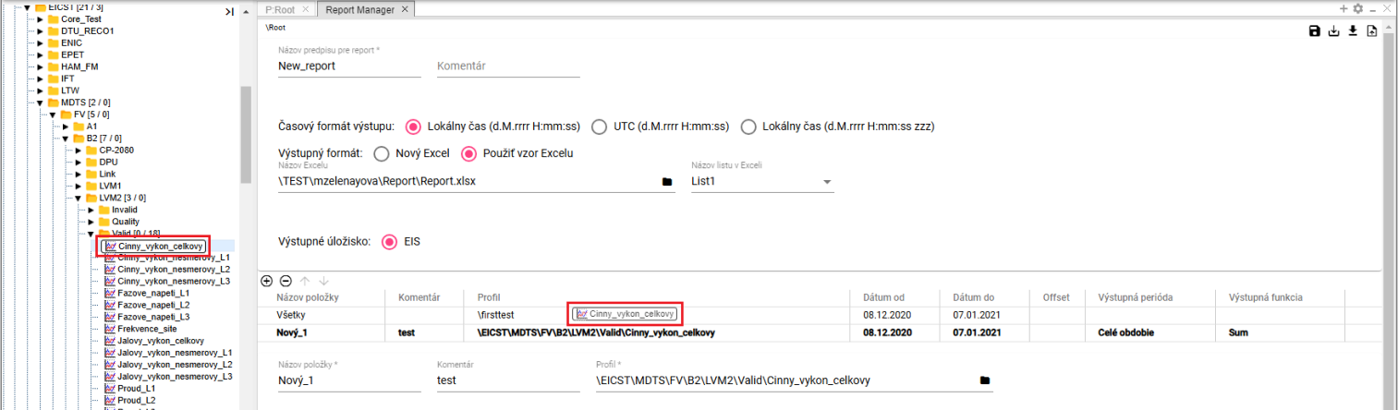

"Image 516: Profile transfer from a tree structure to a table"



Picture 517: Added profile from tree structure

* 1. No valid translation found.

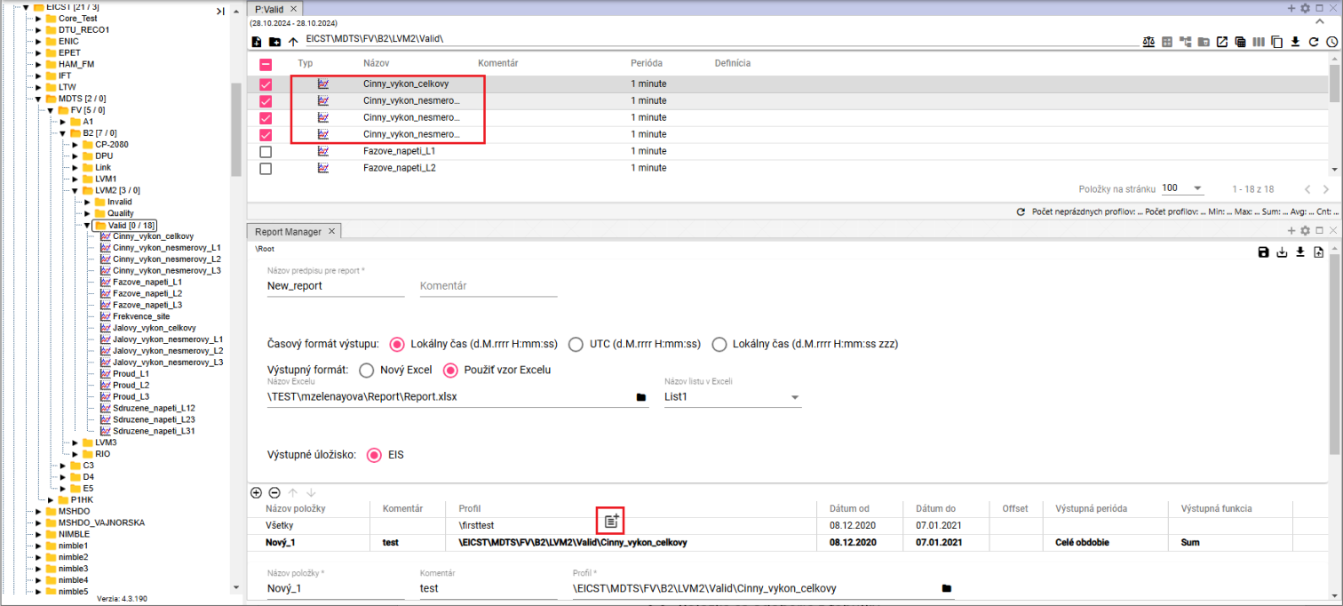

Image 518: Copying profiles from a table into the Report Manager using the Drag and Drop function.

* 1. You can add another item by pressing the button "."
  2. "If you want to remove an item, click on the item in the table and press the button. The item will be removed from the table."
  3. You can change the profile settings using the buttons.
  4. "To save the report, click on the button 'Save', located in the top right corner of the 'Report Manager' screen. The report will be saved to a folder structure where you created the report."



Picture 519: Save button

* 1. If you want to save the report to a different recipient, click on the button "Save as".
  2. A window called "New Report" will appear.
  3. In the menu "Path", set a path to a new recipient or search for an address book using the button ".".

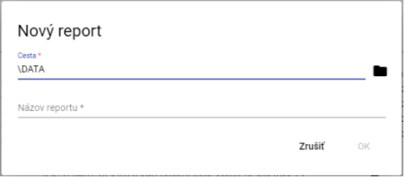

Image 520: Window "New Report""

* 1. In the field "Report title" write the title of the report.
  2. You will submit the report by pressing the "OK" button.
  3. "You will generate a report by pressing the button 'Generate Report', which can be found in the top right corner of the screen 'Report Manager'."



Image 521: Generate Report Button

* 1. "A window called 'Time period settings' will appear, where you can select the time period."

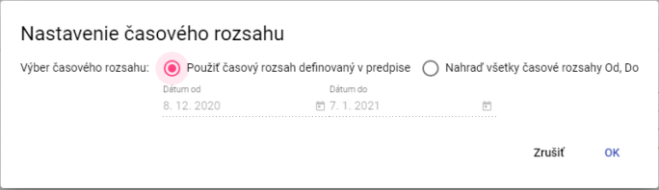

Picture 522: Window "Time settings"

* 1. Press the "OK" button before generating the report.
  2. "Before downloading the generated report, click on the 'Export' button in the top toolbar, which will open the 'Export' window."
  3. "In the 'Export' window, click on the 'Download' button located in the row generated by the report."

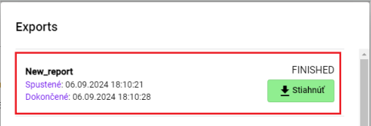

Image 523: Generated Report

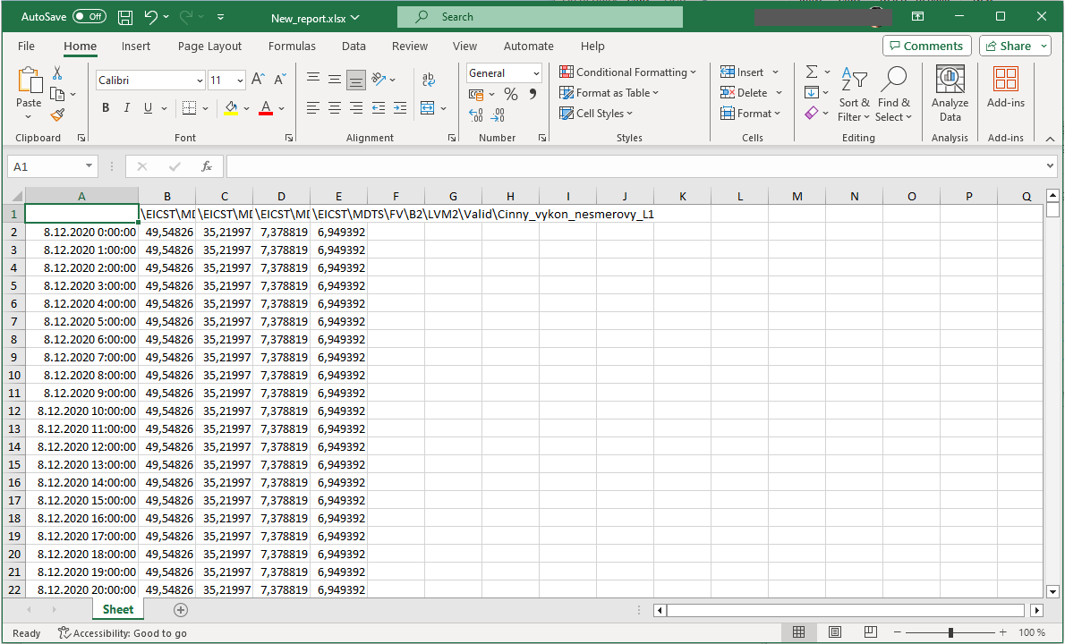

Image 524: Downloaded report

* 1. You can save the statement in "CSV" or "PGZ2" format on disk. To download the statement, click the "Save statement to disk..." button and choose the format in which the report should be downloaded. The report will be saved among the downloaded files in your computer.

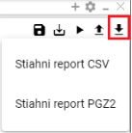

"Picture 525: Offered by a printer 'Save the composition to a disk...'"

### Rights for Report Manager

"Before 'Report Manager', it is possible to set rights:"

* The regular user does not have the right to “read”, will not open the form, nor pgz or pgz2.
* The user does not have the right to "Create", the button "Save as..." is not allowed and the option "New..." does not appear in the menu, nor is it possible to create a "Report".
* "The user is not allowed to click on „Write“, the button „Save“ will be disabled, and only the button „Save as...“ will be enabled and he/she will be able to save it to the disk."
* The user does not have permission to "Execute", the "Generate Report" button is also disabled.

## If I could restore deleted items from trash

"Items from your basket will be restored:"

1. "Show the basket content in tree structure or in the Explorer window, 4.14."



Picture 526: Tree in forest structure

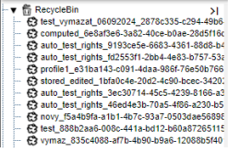

Image 527: Displaying basket contents in a tree structure

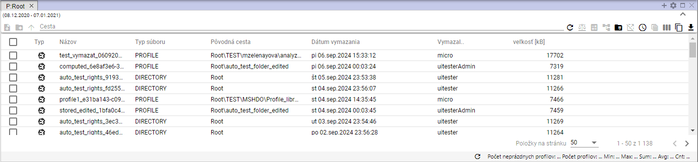

Picture 528: Image of contents of bag shown in browser window.

1. "Click on the right mouse button on the item in the basket which you want to restore."
2. "A selection will be shown where you can choose 'Restore from cart'."

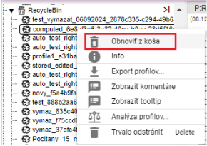

Image 529: Item "Restore from trash"

1. The window "Rebuild Collection" will be displayed.

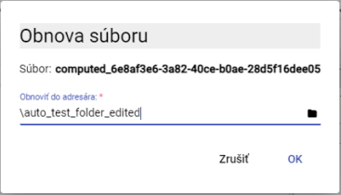

Picture 530: Window "Revival of the monastery"

1. In the "Restore to sender" folder is a path to the sender from which the file was deleted. If you want the file to be restored to another recipient, enter the path to the recipient or search for the recipient using the button .
2. "Press the 'OK' button after confirmation of the band's revival."



"Copyright 2025 MicroStep – HDO spol. s r.o."

No valid translation found.

*MicroStep-HDO s.r.o., Vajnorská 158, 831 04  Bratislava*

*www.microstep-hdo.com, e-mail: info@microstep-hdo.sk*